Mandatory Assignment

**Table of content**

1 Calculate the delays 1

1.1 Calculate the delay. The clock frequency is 16MHz 1

1.2 Calculate the delay. The clock frequency is 16MHz 1

1.3 Calculate the delay. The clock frequency is 16MHz 1

1.4 Calculate the delay. The clock frequency is 16MHz 2

1.5 Calculate the delay. The clock frequency is 16MHz 2

1.6 Calculate the delay. The clock frequency is 16MHz 3

1.7 Calculate the delay. The clock frequency is 16MHz 4

2 Create delays 5

2.1 Your microcontroller is connected to a 16MHz clock. Create a delay that is around $10µs$ (+- 5%): 5

2.2 Your microcontroller is connected to a 16MHz clock. Create a delay that is around $168µs$ (+- 5%): 5

2.3 Your microcontroller is connected to a 16MHz clock. Create a delay that is around $1ms$ (+- 5%): 6

# Calculate the delays

## Calculate the delay. The clock frequency is 16MHz

delay:

ldi r20, 86

loop1:

dec r20

brne loop1

Solution

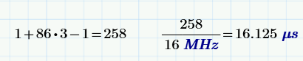

## Calculate the delay. The clock frequency is 16MHz

delay:

ldi r20, 100

loop1:

nop

dec r20

brne loop1

nop

nop

Solution

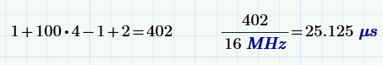

## Calculate the delay. The clock frequency is 16MHz

delay:

ldi r20, 200

loop1:

nop

dec r20

nop

nop

brne loop1

nop

nop

Solution

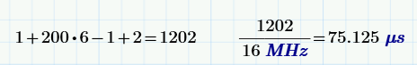

## Calculate the delay. The clock frequency is 16MHz

delay:

ldi r18, 180

loop2:

ldi r20, 199

loop1:

dec r20

brne loop1

dec r18

brne loop2

Solution

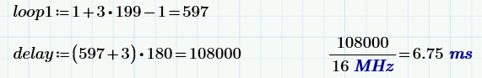

## Calculate the delay. The clock frequency is 16MHz

delay:

ldi r18, 11

loop2:

nop

ldi r20, 15

loop1:

nop

nop

dec r20

nop

brne loop1

nop

nop

dec r18

brne loop2

nop

nop

nop

Solution

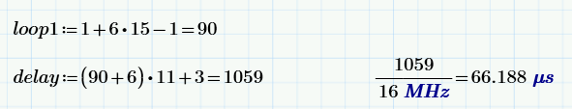

## Calculate the delay. The clock frequency is 16MHz

delay:

ldi r16, 14

loop3:

ldi r18, 11

loop2:

ldi r20, 15

loop1:

dec r20

brne loop1

dec r18

brne loop2

dec r16

brne loop3

Solution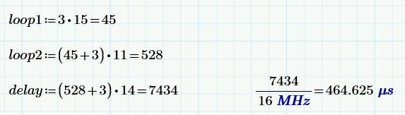

## Calculate the delay. The clock frequency is 16MHz

delay:

ldi r16, 14

loop3:

nop

ldi r18, 110

loop2:

nop

ldi r20, 150

loop1:

dec r20

brne loop1

nop

nop

dec r18

brne loop2

dec r16

nop

brne loop3

nop

nop

nop

Solution

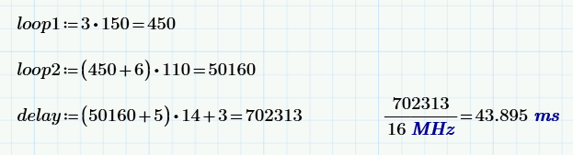

# Create delays

## Your microcontroller is connected to a 16MHz clock. Create a delay that is around $10µs$ (+- 5%):

Solution



You could choose a loop of 5 clocks and run it 32 times ($32*5=160$)

delay:

ldi r16, 32

loop1:

nop

nop

dec r16

brne loop1

## Your microcontroller is connected to a 16MHz clock. Create a delay that is around $168µs$ (+- 5%):

Solution



If you divide this number with 16, you get a round number: $\frac{2688}{16}=168$

So make a loop that take 16 clocks and run it 168 times:

delay:

ldi r16, 168

loop1:

nop

nop

nop

nop

nop

nop

nop

nop

nop

nop

nop

nop

nop

dec r16

brne loop1

## Your microcontroller is connected to a 16MHz clock. Create a delay that is around $1ms$ (+- 5%):

Solution



One way of doing this is to create an innerloop that takes 495 clocks. Then an outer loop that add 5 clocks, and then runs 32 times.

$$\left(495+5\right)*32=16000$$

delay:

ldi r17, 32

loop2:

ldi r16, 99

loop1:

nop

nop

dec r16

brne loop1

nop

nop

dec r17

brne loop2