Mandatory Assignment

**Table of content**

1 1-bit register triggering. 1

2 Latches 3

2.1 How are the latch on Figure 9 triggered? 3

2.1.1 Draw ‘Out’ on Figure 6 3

2.2 How are the latch on Figure 7 triggered? 4

2.2.1 Draw ‘Out’ on Figure 8 4

2.3 How are the latch on Figure 9 triggered? 5

2.3.1 Draw ‘Out’ on Figure 10, 5

2.4 How are the latch on Figure 11 triggered? 6

2.4.1 Draw ‘Out’ on Figure 12. 6

3 1-bit register 7

3.1 1-bit register High level triggered 7

3.2 1-bit register Low level triggered 8

3.3 1-bit register rising edge triggered 9

3.4 1-bit register falling edge triggered 10

# 1-bit register triggering.

Figure 1, Figure 2, Figure 3 and Figure 4 shows, 1-bit registers. Fill out the table below:

|  |  |
| --- | --- |
| Trigger |  |
| High level | Figure XX |
| Low level | Figure XX |
| Rising edge | Figure XX |
| Falling edge | Figure XX |

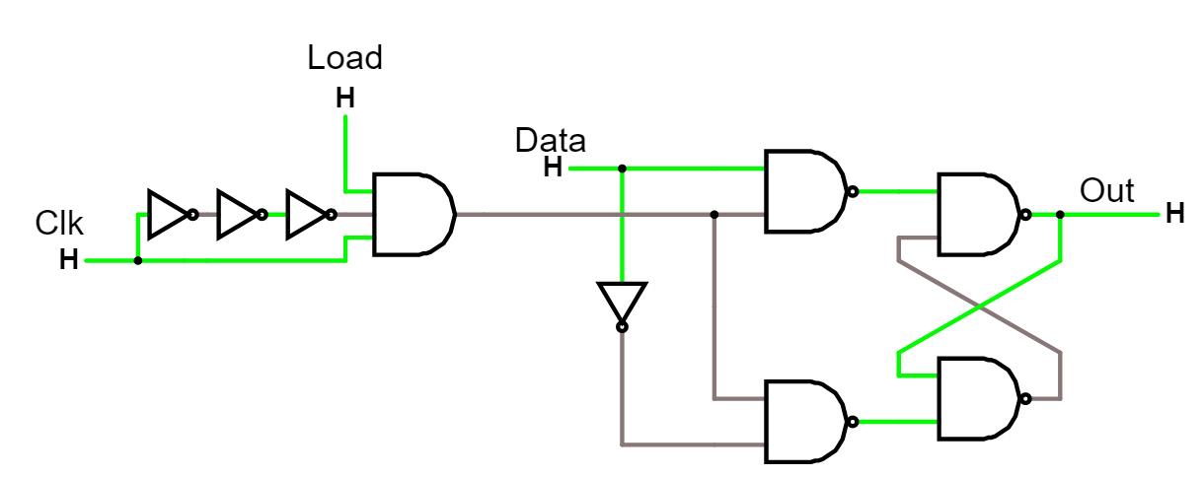

Figure 1: 1-bit register. [Simulation](http://falstad.com/circuit/circuitjs.html?cct=$+1+0.000005+0.03528660814588489+19+5+50%0AL+64+144+16+144+0+1+false+5+0%0A151+128+320+256+320+0+2+5+5%0A151+128+160+256+160+0+2+5+5%0AM+368+176+448+176+0+2.5%0Aw+256+272+256+288+0%0Aw+256+208+256+192+0%0Aw+368+272+256+208+0%0Aw+368+304+368+272+0%0Aw+368+208+256+272+0%0Aw+368+176+368+208+0%0A151+256+176+368+176+0+2+5+5%0A151+256+304+368+304+0+2+0+5%0AI+64+144+64+336+0+0.5+5%0Aw+128+176+128+240+0%0Aw+128+304+128+240+0%0Aw+128+144+64+144+0%0Aw+64+336+128+336+0%0Ax+-11+132+39+135+4+24+Data%0A150+-128+176+-32+176+0+3+0+5%0AL+-272+208+-320+208+0+1+false+5+0%0AL+-128+144+-128+96+0+1+false+5+0%0Aw+-32+176+128+176+0%0Ax+-155+75+-102+78+4+24+Load%0Aw+-240+208+-272+208+0%0Aw+-240+208+-224+208+0%0Ax+-344+190+-310+193+4+24+Clk%0Ax+381+167+419+170+4+24+Out%0Aw+-128+160+-128+144+0%0AI+-176+176+-128+176+0+0.5+5%0AI+-224+176+-176+176+0+0.5+5%0AI+-272+176+-224+176+0+0.5+5%0Aw+-272+176+-272+208+0%0Aw+-224+208+-128+208+0%0Aw+-128+192+-128+208+0%0A)

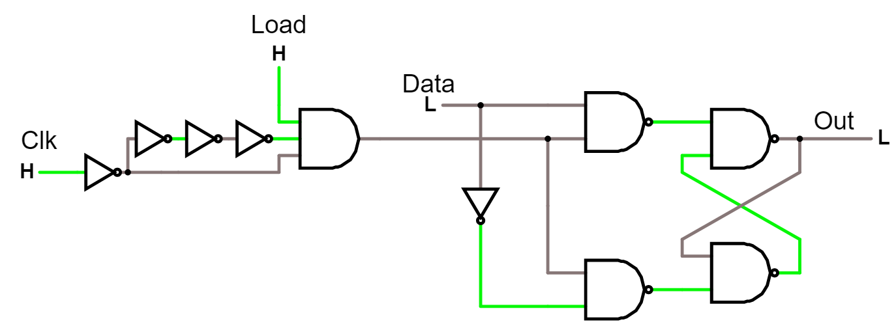

Figure 2: 1-bit register. [Simulation](http://falstad.com/circuit/circuitjs.html?cct=$+1+0.000005+0.03528660814588489+19+5+50%0AL+64+144+16+144+0+0+false+5+0%0A151+128+320+256+320+0+2+5+5%0A151+128+160+256+160+0+2+5+5%0AM+368+176+448+176+0+2.5%0Aw+256+272+256+288+0%0Aw+256+208+256+192+0%0Aw+368+272+256+208+0%0Aw+368+304+368+272+0%0Aw+368+208+256+272+0%0Aw+368+176+368+208+0%0A151+256+176+368+176+0+2+0+5%0A151+256+304+368+304+0+2+5+5%0AI+64+144+64+336+0+0.5+5%0Aw+128+176+128+240+0%0Aw+128+304+128+240+0%0Aw+128+144+64+144+0%0Aw+64+336+128+336+0%0Ax+-11+132+39+135+4+24+Data%0A150+-128+176+-32+176+0+3+0+5%0AL+-320+208+-368+208+0+1+false+5+0%0AL+-128+144+-128+96+0+1+false+5+0%0Aw+-32+176+128+176+0%0Ax+-155+75+-102+78+4+24+Load%0Aw+-240+208+-272+208+0%0Aw+-240+208+-224+208+0%0Ax+-374+186+-340+189+4+24+Clk%0Ax+381+167+419+170+4+24+Out%0Aw+-128+160+-128+144+0%0AI+-176+176+-128+176+0+0.5+5%0AI+-224+176+-176+176+0+0.5+5%0AI+-272+176+-224+176+0+0.5+5%0Aw+-272+176+-272+208+0%0Aw+-224+208+-128+208+0%0Aw+-128+192+-128+208+0%0AI+-320+208+-272+208+0+0.5+5%0A)

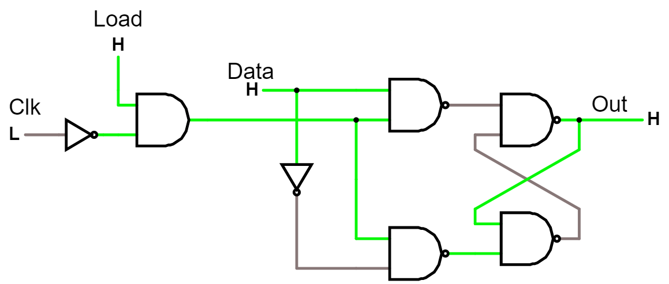

Figure 3: 1-bit register. [Simulation](http://falstad.com/circuit/circuitjs.html?cct=$+1+0.000005+0.03528660814588489+19+5+50%0AL+64+144+16+144+0+1+false+5+0%0A151+128+320+256+320+0+2+5+5%0A151+128+160+256+160+0+2+0+5%0AM+368+176+448+176+0+2.5%0Aw+256+272+256+288+0%0Aw+256+208+256+192+0%0Aw+368+272+256+208+0%0Aw+368+304+368+272+0%0Aw+368+208+256+272+0%0Aw+368+176+368+208+0%0A151+256+176+368+176+0+2+5+5%0A151+256+304+368+304+0+2+0+5%0AI+64+144+64+336+0+0.5+5%0Aw+128+176+128+240+0%0Aw+128+304+128+240+0%0Aw+128+144+64+144+0%0Aw+64+336+128+336+0%0Ax+-11+132+39+135+4+24+Data%0A150+-128+176+-32+176+0+2+5+5%0AL+-192+192+-240+192+0+0+false+5+0%0AL+-128+144+-128+96+0+1+false+5+0%0Aw+-32+176+128+176+0%0Ax+-155+75+-102+78+4+24+Load%0Ax+-246+170+-212+173+4+24+Clk%0Ax+381+167+419+170+4+24+Out%0Aw+-128+160+-128+144+0%0AI+-192+192+-144+192+0+0.5+5%0Aw+-128+192+-144+192+0%0A)

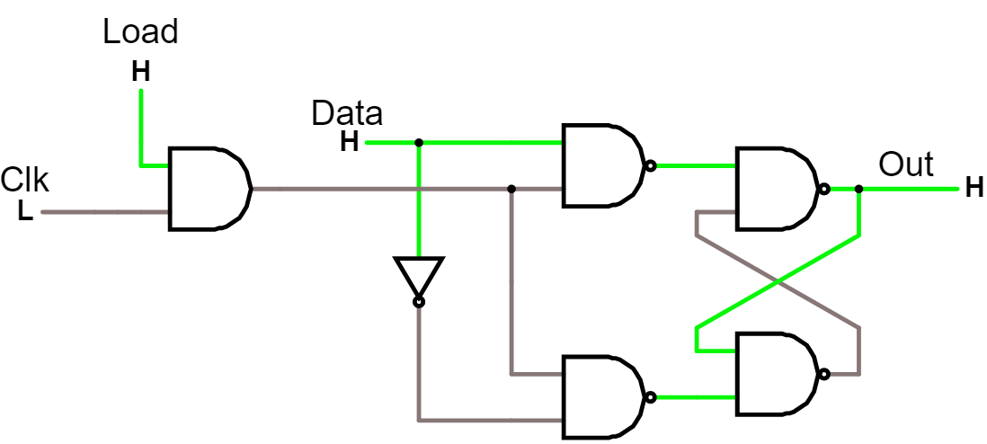

Figure 4: 1-bit register. [Simulation](http://falstad.com/circuit/circuitjs.html?cct=$+1+0.000005+0.03528660814588489+19+5+50%0AL+64+144+16+144+0+0+false+5+0%0A151+128+320+256+320+0+2+5+5%0A151+128+160+256+160+0+2+5+5%0AM+368+176+448+176+0+2.5%0Aw+256+272+256+288+0%0Aw+256+208+256+192+0%0Aw+368+272+256+208+0%0Aw+368+304+368+272+0%0Aw+368+208+256+272+0%0Aw+368+176+368+208+0%0A151+256+176+368+176+0+2+0+5%0A151+256+304+368+304+0+2+5+5%0AI+64+144+64+336+0+0.5+5%0Aw+128+176+128+240+0%0Aw+128+304+128+240+0%0Aw+128+144+64+144+0%0Aw+64+336+128+336+0%0Ax+-11+132+39+135+4+24+Data%0A150+-128+176+-32+176+0+2+0+5%0AL+-160+192+-208+192+0+0+false+5+0%0AL+-128+144+-128+96+0+1+false+5+0%0Aw+-32+176+128+176+0%0Ax+-155+75+-102+78+4+24+Load%0Ax+-226+178+-192+181+4+24+Clk%0Ax+381+167+419+170+4+24+Out%0Aw+-128+160+-128+144+0%0Aw+-128+192+-144+192+0%0Aw+-144+192+-160+192+0%0A)

Solution

|  |  |
| --- | --- |
| Trigger |  |
| High level | Figure 4 |
| Low level | Figure 3 |
| Rising edge | Figure 1 |
| Falling edge | Figure 2 |

# Latches

## How are the latch on Figure 9 triggered?

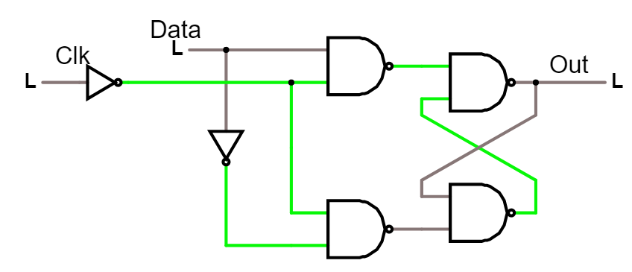

Figure 5 [Simulation](http://falstad.com/circuit/circuitjs.html?cct=$+1+0.000005+0.03528660814588489+19+5+50%0AL+64+144+16+144+0+0+false+5+0%0A151+128+320+256+320+0+2+0+5%0A151+128+160+256+160+0+2+5+5%0AM+368+176+448+176+0+2.5%0Aw+256+272+256+288+0%0Aw+256+208+256+192+0%0Aw+368+272+256+208+0%0Aw+368+304+368+272+0%0Aw+368+208+256+272+0%0Aw+368+176+368+208+0%0A151+256+176+368+176+0+2+0+5%0A151+256+304+368+304+0+2+5+5%0AI+64+144+64+336+0+0.5+5%0Aw+128+176+128+240+0%0Aw+128+304+128+240+0%0Aw+128+144+64+144+0%0Aw+64+336+128+336+0%0Ax+-11+132+39+135+4+24+Data%0AL+-80+176+-128+176+0+0+false+5+0%0Aw+-32+176+128+176+0%0Ax+-104+158+-70+161+4+24+Clk%0Ax+381+167+419+170+4+24+Out%0AI+-80+176+-32+176+0+0.5+5%0A)

Solution

Low level triggered

### Draw ‘Out’ on Figure 6

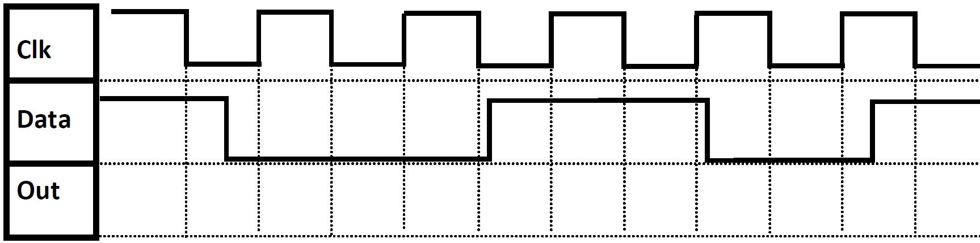

Figure 6

Solution

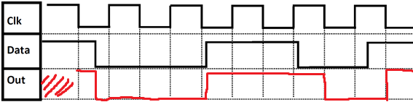

## How are the latch on Figure 7 triggered?

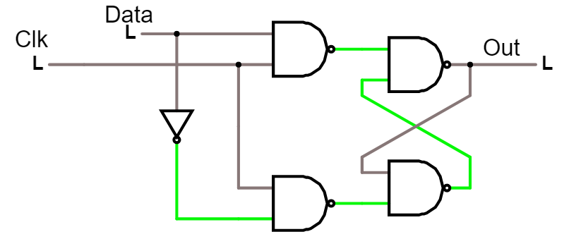

Figure 7. [Simulation](http://falstad.com/circuit/circuitjs.html?cct=$+1+0.000005+0.03528660814588489+19+5+50%0AL+64+144+16+144+0+0+false+5+0%0A151+128+320+256+320+0+2+5+5%0A151+128+160+256+160+0+2+5+5%0AM+368+176+448+176+0+2.5%0Aw+256+272+256+288+0%0Aw+256+208+256+192+0%0Aw+368+272+256+208+0%0Aw+368+304+368+272+0%0Aw+368+208+256+272+0%0Aw+368+176+368+208+0%0A151+256+176+368+176+0+2+0+5%0A151+256+304+368+304+0+2+5+5%0AI+64+144+64+336+0+0.5+5%0Aw+128+176+128+240+0%0Aw+128+304+128+240+0%0Aw+128+144+64+144+0%0Aw+64+336+128+336+0%0Ax+-11+132+39+135+4+24+Data%0AL+-32+176+-80+176+0+0+false+5+0%0Aw+-32+176+128+176+0%0Ax+-104+158+-70+161+4+24+Clk%0Ax+381+167+419+170+4+24+Out%0A)

Solution

High level triggered

### Draw ‘Out’ on Figure 8



Figure 8

Solution

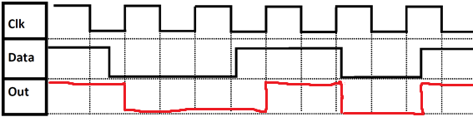

## How are the latch on Figure 9 triggered?

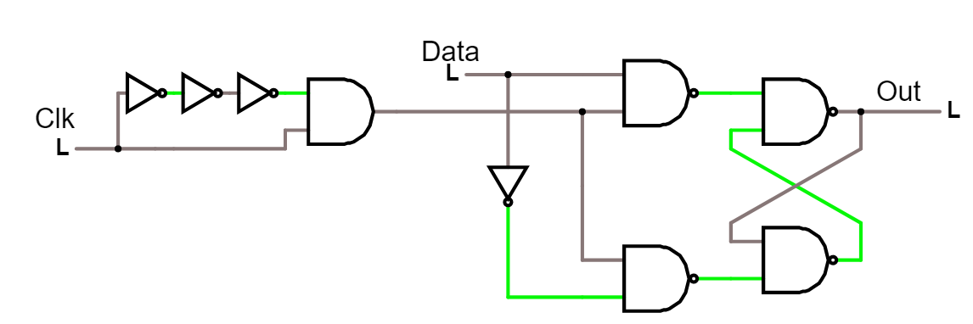

Figure 9: [Simulation](http://falstad.com/circuit/circuitjs.html?cct=$+1+0.000005+0.03528660814588489+19+5+50%0AL+64+144+16+144+0+0+false+5+0%0A151+128+320+256+320+0+2+5+5%0A151+128+160+256+160+0+2+5+5%0AM+368+176+448+176+0+2.5%0Aw+256+272+256+288+0%0Aw+256+208+256+192+0%0Aw+368+272+256+208+0%0Aw+368+304+368+272+0%0Aw+368+208+256+272+0%0Aw+368+176+368+208+0%0A151+256+176+368+176+0+2+0+5%0A151+256+304+368+304+0+2+5+5%0AI+64+144+64+336+0+0.5+5%0Aw+128+176+128+240+0%0Aw+128+304+128+240+0%0Aw+128+144+64+144+0%0Aw+64+336+128+336+0%0Ax+-11+132+39+135+4+24+Data%0A150+-128+176+-32+176+0+2+0+5%0AL+-272+208+-320+208+0+0+false+5+0%0Aw+-32+176+128+176+0%0Aw+-240+208+-272+208+0%0Aw+-240+208+-224+208+0%0Ax+-344+190+-310+193+4+24+Clk%0Ax+381+167+419+170+4+24+Out%0AI+-176+160+-128+160+0+0.5+5%0AI+-224+160+-176+160+0+0.5+5%0AI+-272+160+-224+160+0+0.5+5%0Aw+-272+160+-272+208+0%0Aw+-224+208+-128+208+0%0Aw+-128+192+-128+208+0%0A)

Solution

Rising Edge

### Draw ‘Out’ on Figure 10,



Figure 10

Solution

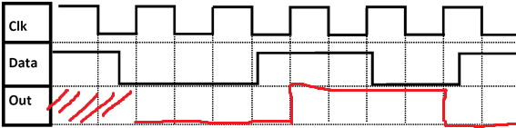

## How are the latch on Figure 11 triggered?

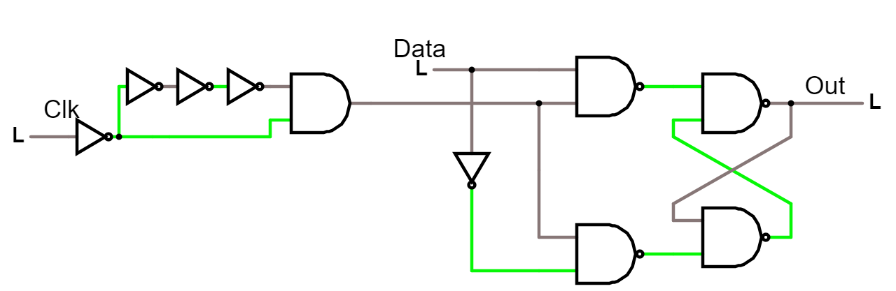

Figure 11: [Simulation](http://falstad.com/circuit/circuitjs.html?cct=$+1+0.000005+0.03528660814588489+19+5+50%0AL+64+144+16+144+0+0+false+5+0%0A151+128+320+256+320+0+2+5+5%0A151+128+160+256+160+0+2+5+5%0AM+368+176+448+176+0+2.5%0Aw+256+272+256+288+0%0Aw+256+208+256+192+0%0Aw+368+272+256+208+0%0Aw+368+304+368+272+0%0Aw+368+208+256+272+0%0Aw+368+176+368+208+0%0A151+256+176+368+176+0+2+0+5%0A151+256+304+368+304+0+2+5+5%0AI+64+144+64+336+0+0.5+5%0Aw+128+176+128+240+0%0Aw+128+304+128+240+0%0Aw+128+144+64+144+0%0Aw+64+336+128+336+0%0Ax+-11+132+39+135+4+24+Data%0A150+-128+176+-32+176+0+2+0+5%0AL+-320+208+-368+208+0+0+false+5+0%0Aw+-32+176+128+176+0%0Aw+-240+208+-272+208+0%0Aw+-240+208+-224+208+0%0Ax+-344+190+-310+193+4+24+Clk%0Ax+381+167+419+170+4+24+Out%0AI+-176+160+-128+160+0+0.5+5%0AI+-224+160+-176+160+0+0.5+5%0AI+-272+160+-224+160+0+0.5+5%0Aw+-272+160+-272+208+0%0Aw+-224+208+-128+208+0%0Aw+-128+192+-128+208+0%0AI+-320+208+-272+208+0+0.5+5%0A)

Solution

Falling Edge

### Draw ‘Out’ on Figure 12.



Figure 12

Solution

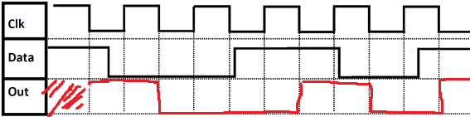

# 1-bit register

## 1-bit register High level triggered

A 1-bit register which is High-level triggered can be seen on Figure 13



Figure 13: 1-bit register. [Simulation](http://falstad.com/circuit/circuitjs.html?cct=$+1+0.000005+0.03528660814588489+19+5+50%0AL+64+144+16+144+0+0+false+5+0%0A151+128+320+256+320+0+2+5+5%0A151+128+160+256+160+0+2+5+5%0AM+368+176+448+176+0+2.5%0Aw+256+272+256+288+0%0Aw+256+208+256+192+0%0Aw+368+272+256+208+0%0Aw+368+304+368+272+0%0Aw+368+208+256+272+0%0Aw+368+176+368+208+0%0A151+256+176+368+176+0+2+0+5%0A151+256+304+368+304+0+2+5+5%0AI+64+144+64+336+0+0.5+5%0Aw+128+176+128+240+0%0Aw+128+304+128+240+0%0Aw+128+144+64+144+0%0Aw+64+336+128+336+0%0Ax+-11+132+39+135+4+24+Data%0A150+-128+176+-32+176+0+2+0+5%0AL+-160+192+-208+192+0+0+false+5+0%0AL+-128+144+-128+96+0+1+false+5+0%0Aw+-32+176+128+176+0%0Ax+-155+75+-102+78+4+24+Load%0Ax+-226+178+-192+181+4+24+Clk%0Ax+381+167+419+170+4+24+Out%0Aw+-128+160+-128+144+0%0Aw+-128+192+-144+192+0%0Aw+-144+192+-160+192+0%0A)

**TASK: Draw ‘Out’ on Figure 14**

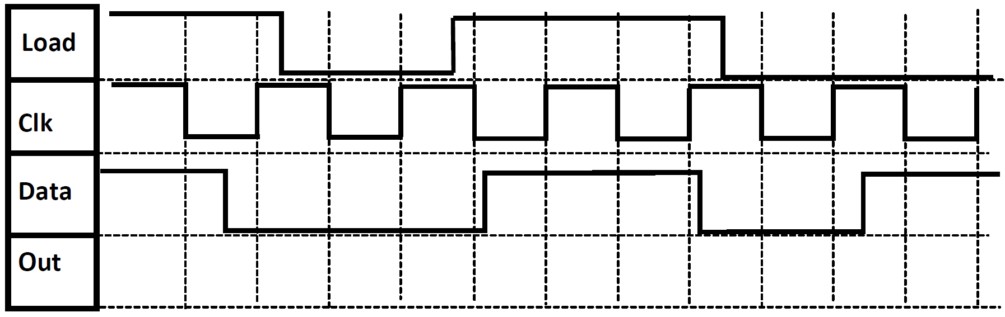

Figure 14

**SOLUTION**

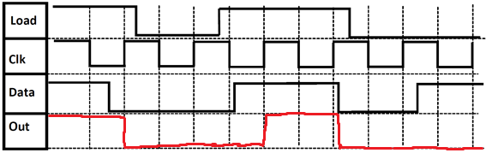

## 1-bit register Low level triggered

A 1-bit register which is low-level triggered can be seen on Figure 15



Figure 15 [Simulation](http://falstad.com/circuit/circuitjs.html?cct=$+1+0.000005+0.03528660814588489+19+5+50%0AL+64+144+16+144+0+0+false+5+0%0A151+128+320+256+320+0+2+0+5%0A151+128+160+256+160+0+2+5+5%0AM+368+176+448+176+0+2.5%0Aw+256+272+256+288+0%0Aw+256+208+256+192+0%0Aw+368+272+256+208+0%0Aw+368+304+368+272+0%0Aw+368+208+256+272+0%0Aw+368+176+368+208+0%0A151+256+176+368+176+0+2+0+5%0A151+256+304+368+304+0+2+5+5%0AI+64+144+64+336+0+0.5+5%0Aw+128+176+128+240+0%0Aw+128+304+128+240+0%0Aw+128+144+64+144+0%0Aw+64+336+128+336+0%0Ax+-11+132+39+135+4+24+Data%0AL+-80+176+-128+176+0+0+false+5+0%0Aw+-32+176+128+176+0%0Ax+-104+158+-70+161+4+24+Clk%0Ax+381+167+419+170+4+24+Out%0AI+-80+176+-32+176+0+0.5+5%0A)

**TASK: Draw ‘Out’ on Figure 16**

Figure 16

**SOLUTION**

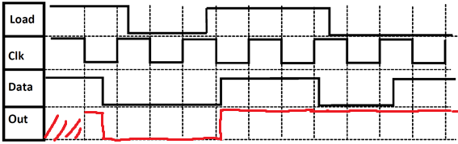

## 1-bit register rising edge triggered

A 1-bit register which is rising edge triggered can be seen on Figure 17



Figure 17: [Simulation](http://falstad.com/circuit/circuitjs.html?cct=$+1+0.000005+0.03528660814588489+19+5+50%0AL+64+144+16+144+0+1+false+5+0%0A151+128+320+256+320+0+2+5+5%0A151+128+160+256+160+0+2+5+5%0AM+368+176+448+176+0+2.5%0Aw+256+272+256+288+0%0Aw+256+208+256+192+0%0Aw+368+272+256+208+0%0Aw+368+304+368+272+0%0Aw+368+208+256+272+0%0Aw+368+176+368+208+0%0A151+256+176+368+176+0+2+5+5%0A151+256+304+368+304+0+2+0+5%0AI+64+144+64+336+0+0.5+5%0Aw+128+176+128+240+0%0Aw+128+304+128+240+0%0Aw+128+144+64+144+0%0Aw+64+336+128+336+0%0Ax+-11+132+39+135+4+24+Data%0A150+-128+176+-32+176+0+3+0+5%0AL+-272+208+-320+208+0+1+false+5+0%0AL+-128+144+-128+96+0+1+false+5+0%0Aw+-32+176+128+176+0%0Ax+-155+75+-102+78+4+24+Load%0Aw+-240+208+-272+208+0%0Aw+-240+208+-224+208+0%0Ax+-344+190+-310+193+4+24+Clk%0Ax+381+167+419+170+4+24+Out%0Aw+-128+160+-128+144+0%0AI+-176+176+-128+176+0+0.5+5%0AI+-224+176+-176+176+0+0.5+5%0AI+-272+176+-224+176+0+0.5+5%0Aw+-272+176+-272+208+0%0Aw+-224+208+-128+208+0%0Aw+-128+192+-128+208+0%0A)

**TASK: Draw ‘Out’ on Figure 18**



Figure 18

**SOLUTION**

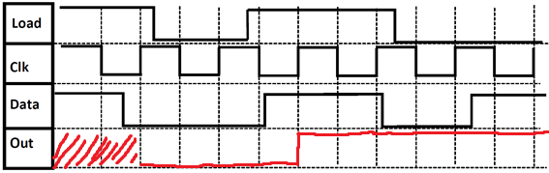

## 1-bit register falling edge triggered

A 1-bit register which is falling edge triggered can be seen on Figure 19.



Figure 19: 1-bit register. [Simulation](http://falstad.com/circuit/circuitjs.html?cct=$+1+0.000005+0.03528660814588489+19+5+50%0AL+64+144+16+144+0+0+false+5+0%0A151+128+320+256+320+0+2+5+5%0A151+128+160+256+160+0+2+5+5%0AM+368+176+448+176+0+2.5%0Aw+256+272+256+288+0%0Aw+256+208+256+192+0%0Aw+368+272+256+208+0%0Aw+368+304+368+272+0%0Aw+368+208+256+272+0%0Aw+368+176+368+208+0%0A151+256+176+368+176+0+2+0+5%0A151+256+304+368+304+0+2+5+5%0AI+64+144+64+336+0+0.5+5%0Aw+128+176+128+240+0%0Aw+128+304+128+240+0%0Aw+128+144+64+144+0%0Aw+64+336+128+336+0%0Ax+-11+132+39+135+4+24+Data%0A150+-128+176+-32+176+0+3+0+5%0AL+-320+208+-368+208+0+1+false+5+0%0AL+-128+144+-128+96+0+1+false+5+0%0Aw+-32+176+128+176+0%0Ax+-155+75+-102+78+4+24+Load%0Aw+-240+208+-272+208+0%0Aw+-240+208+-224+208+0%0Ax+-374+186+-340+189+4+24+Clk%0Ax+381+167+419+170+4+24+Out%0Aw+-128+160+-128+144+0%0AI+-176+176+-128+176+0+0.5+5%0AI+-224+176+-176+176+0+0.5+5%0AI+-272+176+-224+176+0+0.5+5%0Aw+-272+176+-272+208+0%0Aw+-224+208+-128+208+0%0Aw+-128+192+-128+208+0%0AI+-320+208+-272+208+0+0.5+5%0A)

**TASK: Draw ‘Out’ on Figure 20**



Figure 20

**SOLUTION**

