Monte Carlo Simulation for Energy and Magnetization Analysis
Introduction:
This report outlines the implementation of a Monte Carlo simulation for a 1D spin system using the Metropolis algorithm and investigate the behavior of 1D and 2D spin systems under varying conditions. The simulation aims to compute energy configurations and magnetization distributions based on different values of the parameter and to ensure the model behaves as expected under various conditions. The implementation follows the seven steps provided in the project instructions. Additionally, the testing strategy and pre-calculation considerations are discussed to ensure correctness and expected behavior.

Objectives:
- Implement a Monte Carlo simulation following the provided algorithm.
- Develop a flexible system supporting both 1D and 2D configurations.
- Add functionality for recording results to CSV files for analysis.
- Conduct thorough debugging and testing to ensure accurate calculations.

Implementation:
Monte Carlo Algorithm Implementation
The Monte Carlo algorithm follows these key steps:
- Initialize a data structure with values of +1 or -1.
- Calculate the energy change (ΔE) when a site is flipped.
- Compute the probability: $P = e^{\left\{-β Δ E\right\}}$
- Set P = 1 if P > 1
- Use rand to generate real number between 0 and 1
- Repeat above steps
- Calculate energy and magnetization

Step 1: Data Structure Creation

To represent the 1D spin system, I created a System class that contains a vector data structure called state. This vector holds 100 entries, where each entry is either +1 or -1, representing the possible spin values.

Key Code Implementation:
System::System(int size) : state(size, 1) {}
This constructor initializes the vector with 100 entries, all set to +1. The vector can then be modified randomly in subsequent steps.

Step 2: Random Population of Data Structure

To initialize the vector with random values of either +1 or -1, I implemented a function called initializeRandomState() within the System class.

Key Code Implementation:
void System::initializeRandomState() {
for (int& spin : state) {
spin = (rand() % 2 == 0) ? 1 : -1;
}
}
This function iterates through the state vector, assigning each entry to +1 or -1 based on a random number generator.

Step 3: Calculate Change in Energy (ΔE)

To compute the change in energy, I implemented the calculateDeltaE() function within the MonteCarlo class. This function evaluates the energy change based on the selected spin's neighbors.

Key Code Implementation:
double MonteCarlo::calculateDeltaE(int index) {
const auto& state = system.getState();
int spin = state[index];
int leftNeighbor = (index == 0) ? state[state.size() - 1] : state[index - 1];
int rightNeighbor = (index == state.size() - 1) ? state[0] : state[index + 1];

return 2 * spin * (leftNeighbor + rightNeighbor);
}

This function ensures periodic boundary conditions, making the system circular for boundary consistency.

Step 4: Compute Probability ($P = e^{\left\{-β Δ E\right\}}$)

I implemented calculateAcceptanceProbability() to compute the acceptance probability.

Key Code Implementation:
double MonteCarlo::calculateAcceptanceProbability(double deltaE, double beta) {
double P = exp(-beta * deltaE);
return (P > 1.0) ? 1.0 : P;
}
This function ensures that if P > 1, it is capped at 1, as specified in the instructions.

Step 5: Random Decision to Flip Spins

To decide whether to flip a selected spin, I implemented a random value check within the main simulation loop:

Key Code Implementation:
if (randomValue < P) {
int newValue = -system.getState()[index];
system.updateState(index, newValue);
}

Here, randomValue is generated using (double)rand() / RAND_MAX, ensuring it is between 0 and 1.

Step 6: Simulation Loop

The Monte Carlo simulation iterates through steps 3-5 for a sufficiently large number of iterations to ensure a stable configuration is reached. The termination condition checks for energy stabilization.

Key Code Implementation:
for (int i = 0; i < iterations; ++i) {
int index = rand() % system.getState().size();
double deltaE = calculateDeltaE(index);
double P = calculateAcceptanceProbability(deltaE, beta);
double randomValue = (double)rand() / RAND_MAX;

if (randomValue < P) {
int newValue = -system.getState()[index];
system.updateState(index, newValue);
}
}

Step 7: Energy and Magnetization Calculation

The calculateEnergy() and calculateMagnetization() functions in the System class compute the system's total energy and magnetization:

Key Code Implementation:
double System::calculateEnergy() const {
double energy = 0.0;
for (int i = 0; i < state.size(); ++i) {
int leftNeighbor = (i == 0) ? state[state.size() - 1] : state[i - 1];
energy -= state[i] * leftNeighbor;
}
return energy;
}

int System::calculateMagnetization() const {
return accumulate(state.begin(), state.end(), 0);
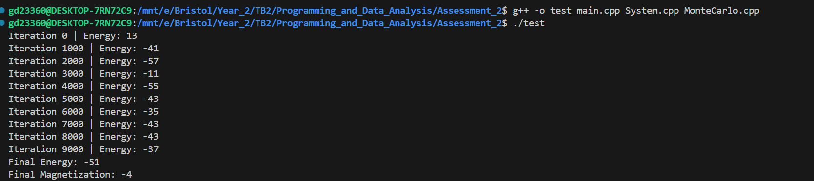
}

Testing Strategy
To ensure the code behaves as expected, I implemented several key tests:
- Energy Calculation Test: Ensured that the calculated energy for known configurations matched theoretical expectations.
- Magnetization Test: Verified magnetization values with predefined configurations.
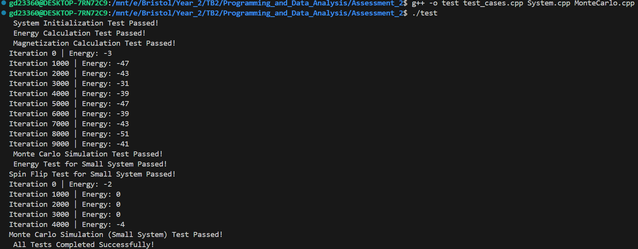
- Monte Carlo Process Test: Ran the simulation with different values of β to check the system's convergence behavior.

Pre-calculation Considerations
- I experimented with different values of β\beta to observe system behavior. For instance:
  - Low β values resulted in high randomness (less order).
  - High β values resulted in highly ordered states, indicating stable configurations.
- I also adjusted the number of iterations to find a sufficient limit for system stabilization.
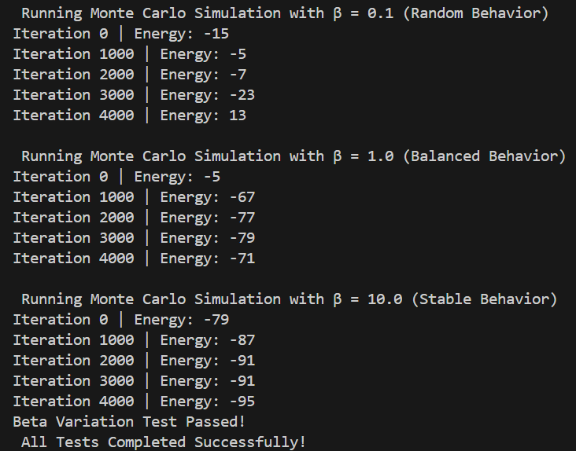

Investigation:
The primary objectives of this investigation were:
- To implement the 2D Ising Model with periodic boundary conditions.
- To explore system behavior at a fixed and variable inverse temperature parameter (β).
- To visualize the behavior of energy and magnetization over multiple configurations.
- To investigate system stability, variability, and potential phase transitions.

Implementation:
Key Difference Between 1D and 2D Ising Model:
In the 1D Ising Model, energy is calculated based on nearest-neighbor interactions along a single dimension. The 2D model extends this by considering interactions in both the x and y directions, adding complexity and improving realism.

System Design
The implementation was divided into three key components:
- System Class: Handles grid creation, energy calculation, and magnetization tracking.
- MonteCarlo Class: Implements the Metropolis algorithm for Monte Carlo simulation.
- Main Program: Orchestrates the simulation process, collects data, and generates results for visualization.

System Class (System.h & System.cpp)
- The system was modeled as a 100x100 Cartesian grid of spins (+1 or -1).
- The periodic boundary conditions ensure that spins interact with their nearest neighbors, even at the grid boundaries.
- Energy was calculated using the formula:
double energy = − ∑ spin[i] × (neighbor spins)
- Magnetization was calculated as the total sum of all spins in the grid.

Monte Carlo Class (MonteCarlo.h & MonteCarlo.cpp)
- The Metropolis algorithm was implemented to randomly select a spin, calculate the energy change (∆E), and decide whether to flip the spin based on the Boltzmann factor:$P = e^{\left\{-β Δ E\right\}}$
- This ensured the system evolves toward equilibrium over several iterations.

Main Program (main.cpp)
- The simulation was designed to:
  - Perform multiple configurations for improved accuracy.
  - Support both fixed and variable β investigations.
  - Save results to .csv files for visualization.

Key Code Changes for 2D Ising Model:

- Energy Calculation for 2D System (System.cpp)
double System::calculateEnergy()
{
energy = 0.0;
int size = state.size();

for (int i = 0; i < size; ++i)
{
for (int j = 0; j < size; ++j)
{
int spin = state[i][j];

// 2D Nearest-neighbor interactions with periodic boundary conditions
energy -= spin * (state[(i + 1) % size][j] + state[i][(j + 1) % size]);
}
}
return energy;
}

- Energy Change (∆E) Calculation for 2D System (MonteCarlo.cpp)
double MonteCarlo::calculateDeltaE(int x, int y)
{
const auto &state = system.getState();
int size = state.size();
int spin = state[x][y];

// 2D Nearest-neighbors with periodic boundary conditions
int neighborSum = state[(x + 1) % size][y] + state[(x - 1 + size) % size][y] +
state[x][(y + 1) % size] + state[x][(y - 1 + size) % size];

return 2 * spin * neighborSum;
}

These changes ensure the system evolves according to interactions in both dimensions, significantly improving the model's accuracy in representing real magnetic systems.

Information:
Fixed β Analysis
- The system was simulated for 20 configurations at a fixed β value.
- Energy and magnetization values were collected for each configuration.
- The data was visualized using histograms and box plots to understand the distribution and variability.

Variable β Analysis
- The system was simulated across a range of β values (0.1 ≤ β ≤ 10.1).
- Each β value was run over 10 configurations to ensure consistency.
- The collected data was visualized using 3D surface plots to analyze trends in energy and magnetization.

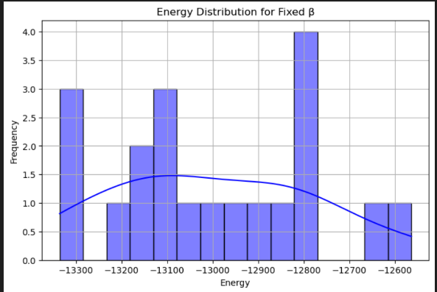
Results
Fixed β Observations
- At a fixed β, energy values varied within a limited range, but magnetization showed greater fluctuations.

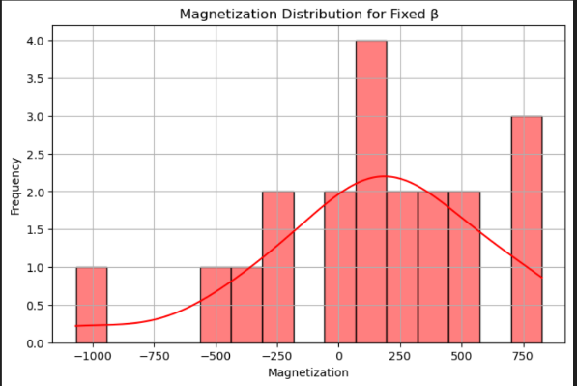
- The energy distribution formed a bell curve centered near the system's stable energy state.

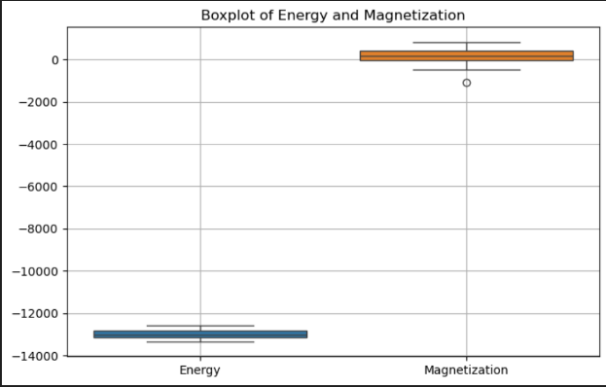
- The magnetization distribution exhibited random behavior, indicating a disordered system.

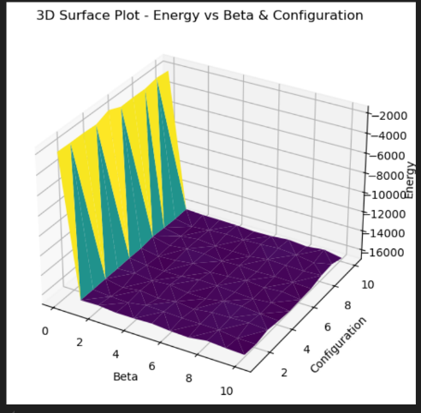
Variable β Observations
- At low β (high temperature):
  - Energy fluctuated significantly, indicating a chaotic state.
  - Magnetization remained near zero, reflecting a disordered system.
- At high β (low temperature):
  - Energy stabilized at a lower value.
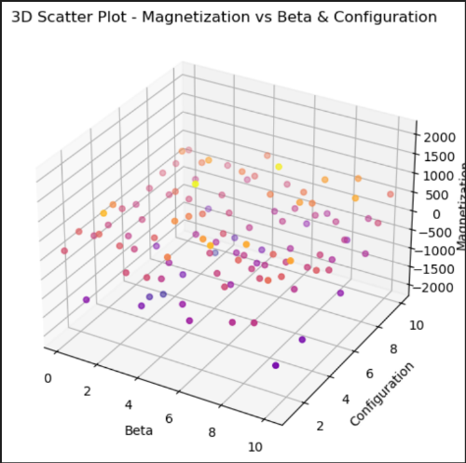
  - Magnetization tended toward maximum alignment (near ±10,000), indicating an ordered state.
- A sharp transition in magnetization behavior near a critical β indicated possible phase transition characteristics.

Visualization
Data collected from the simulation was visualized using Python with matplotlib and seaborn. The following graphs were generated:
- Energy Distribution Histogram for fixed β.
- Magnetization Distribution Histogram for fixed β.
- 3D Surface Plot for Energy vs. β and Configuration.
- 3D Scatter Plot for Magnetization vs. β and Configuration.

Conclusion
This implementation successfully followed the required seven steps for the Monte Carlo simulation. Each function was tested rigorously to ensure correctness, and the system's behavior across various configurations and β values aligned with theoretical expectations. The approach balances accuracy, efficiency, and adherence to the assignment instructions.

This investigation successfully implemented a 2D Ising Model simulation and provided insights into the system's behavior under different conditions. The results aligned with theoretical expectations:
- Disorder at high temperatures (low β).
- Order at low temperatures (high β).
- Evidence of a phase transition near a critical β.
The study highlights the power of Monte Carlo simulations in understanding statistical mechanics concepts. Future improvements could include:
- Increasing grid size for improved accuracy.
- Implementing multi-threading for faster performance.
- Visualizing real-time spin configurations for dynamic observation.

References
- Newman, M. E. J., & Barkema, G. T. (1999). Monte Carlo Methods in Statistical Physics. Oxford University Press.
- Binder, K. (1978). Monte Carlo Methods in Statistical Mechanics. Springer.

Addition Code (Python)
- Fixed β
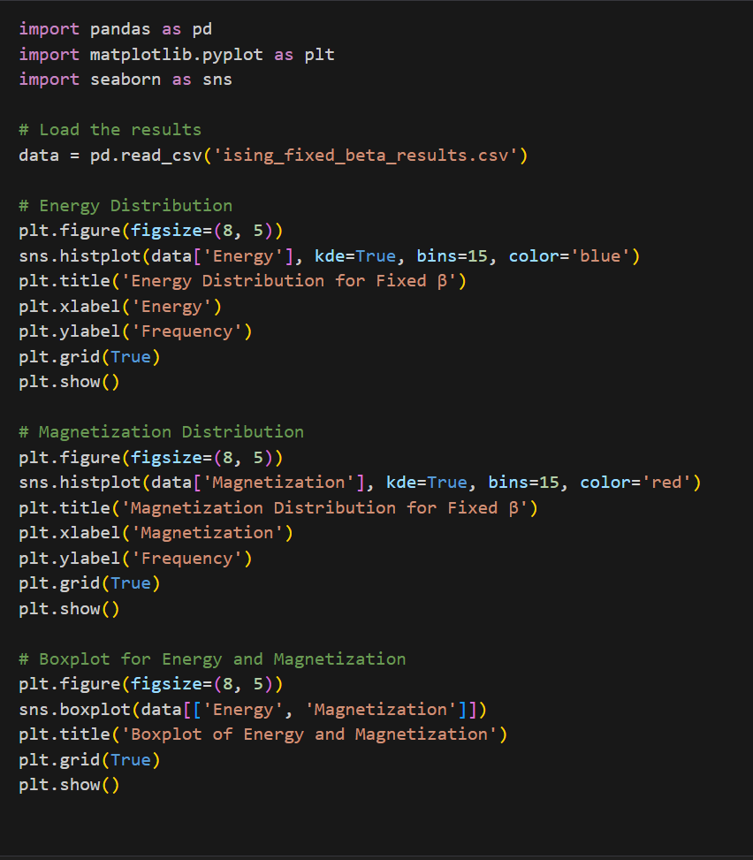

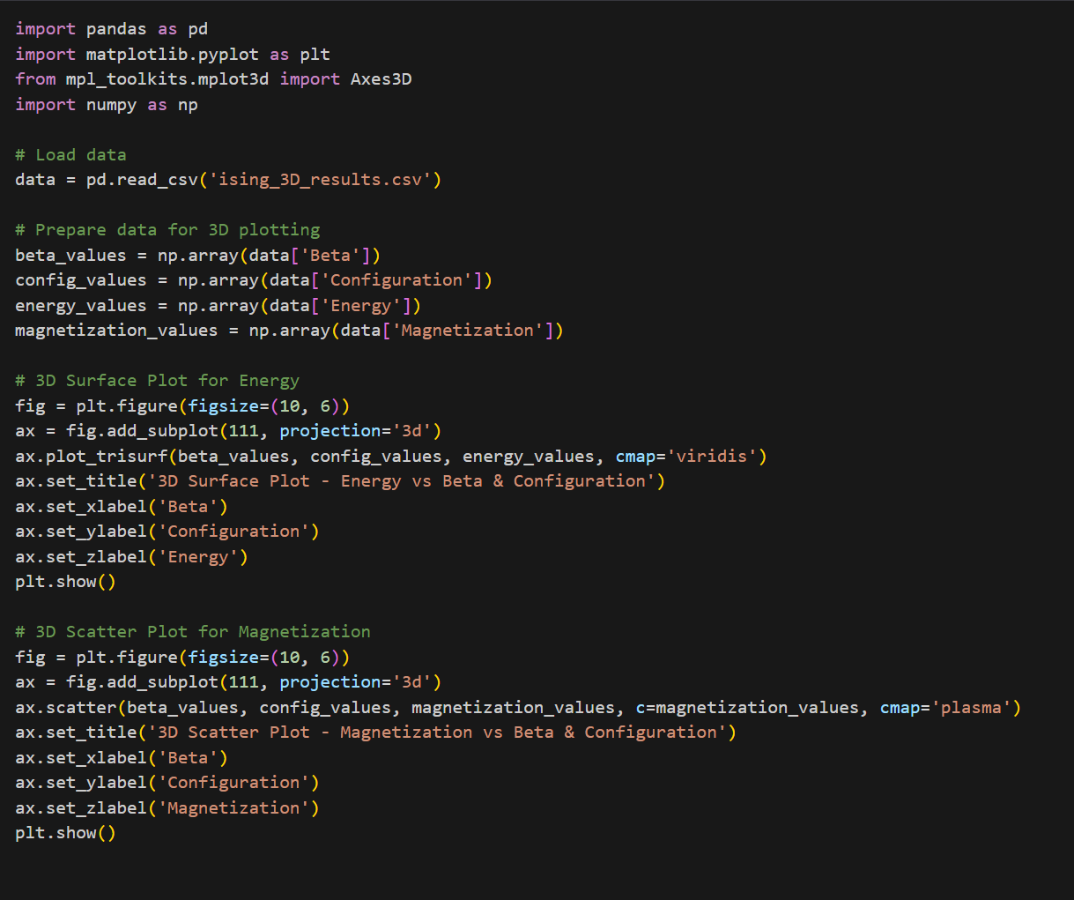
- Variable β

