**Testing Main Screen** **1**

Opening Screen With Phone Vertical (Camera On Top) 1

Opening Screen With Phone Vertical (Camera On Bottom) 2

**Opening Screen With Phone Horizontal (Camera To Left)** **3**

**Opening Screen With Phone Horizontal (Camera To Right)** **4**

**Testing Path Creation** **5**

**Recoding Cancelled Mid-Walk** **5**

**Recording Started And Completed** **9**

**Testing Bookmarks** **14**

**Book Marking A Walk** **14**

Test Description 14

**Deleting a Bookmark** **17**

**Path Reviews** **20**

Reviewing A path 20

Editing A Review 24

Path Photos **27**

Add A Photo to path 27

**Goals** **31**

Goal Is Created 31

**Path Color Changing** **34**

Walking A Walk 10 Times 34

**Group Walks** **38**

Group Walk Is Created 38

Group Walk Is Attended 41

**Bugs that were fixed** **44**

Distance was off by 1000 45

App Crashed On Deleting Path. 45

Review Dialog Box Displayed Photos Instead of Review. 45

Bug with Star Rating Not Updating. 46

Bug With Bookmark Not Updating. 46

# Testing Main Screen

These tests were performed to make sure that WikiWalks will not crash upon opening

## Opening Screen With Phone Vertical (Camera On Top)

* + 1. Test Description
* User opens WikiWalks application with phone in vertical position with camera placed at top of phone.
  + 1. Pre-conditions
* WikiWalks is installed on phone.
* User has phone in a vertical position with camera placed at top of the phone.
* Location Services are on
* Phone auto-rotation is on
  + 1. Post-conditions
* WikiWalks application closed
  + 1. Input Data

|  |  |
| --- | --- |
| Lat | Long |
| -34.4474 | 150.4471 |

* + 1. Result

Pass

* + 1. Steps

1. Test Step

Wiki Walks application is opened

Expected Test Results

WikiWalks Vertical Main Screen is displayed

Output

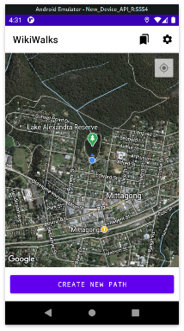

Result

Pass

## Opening Screen With Phone Vertical (Camera On Bottom)

* + 1. Test Description
* User opens WikiWalks application with phone in vertical position with camera placed at the bottom of phone.
  + 1. Pre-conditions
* WikiWalks installed on phone.
* User has hone in vertical position with camera placed at bottom of phone.
* Location Services are on
* Phone auto-rotation is on
  + 1. Post-conditions
* WikiWalks application closed
  + 1. Input Data

|  |  |
| --- | --- |
| Lat | Long |
| -34.4474 | 150.4471 |

* + 1. Result

Pass

* + 1. Steps

1. Test Step

User opens WikiWalks

Expected Test Results

WikiWalks vertical main screen is shown upside down

Output

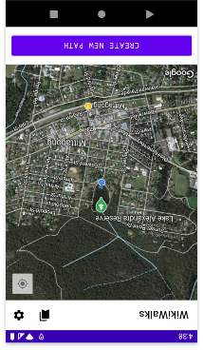

Result

Pass

## Opening Screen With Phone Horizontal (Camera To Left)

* + 1. Test Description
* User opens WikiWalks application with phone in a horizontal position with camera placed on the left of phone.
  + 1. Pre-conditions
* WikiWalks installed on phone.
* User has phone in vertical position with camera placed on the left of phone.
* Location Services are on
* Phone auto-rotation is on
  + 1. Post-conditions
* WikiWalks application closed
  + 1. Input Data

|  |  |
| --- | --- |
| Lat | Long |
| -34.4474 | 150.4471 |

* + 1. Result

Pass

* + 1. Steps

1. Test Step

User open WikiWalks

Expected Test Results

WikiWalks Horizontal Main Screen is displayed

Output

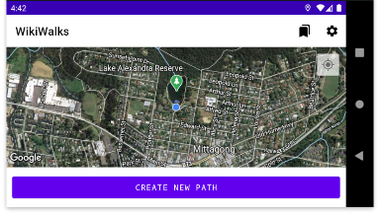

Result

Pass

## Opening Screen With Phone Horizontal (Camera To Right)

* + 1. Test Description
* User opens WikiWalks application with phone in a horizontal position with camera placed on the right of the phone.
  + 1. Pre-conditions
* WikiWalks installed on phone
* User has phone in vertical position with camera placed on the right of phone.
* Location Services are on
* Phone auto-rotation is on
  + 1. Post-conditions
* WikiWalks applications is closed
  + 1. Notes
    2. Input Data

|  |  |
| --- | --- |
| Lat | Long |
| -34.4474 | 150.4471 |

* + 1. Result

Pass

* + 1. Steps

1. Test Step

User opens WikiWalks

Expected Test Results

WikiWalks Horizontal Main Screen is displayed

Output

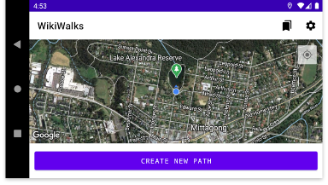

Result

Pass

# Testing Path Creation

## Recoding Cancelled Mid-Walk

* + 1. Test Description
* User starts a walk however instead of uploading the walk upon completion they cancel the walk instead.
  + 1. Pre-conditions
* WikiWalks installed on phone
* Location Services are on
  + 1. Post-conditions
* Walk not uploaded to WikiWalks server
* Statistics updated for distance walked
  + 1. Input Data

|  |  |  |
| --- | --- | --- |
|  | Lat | Long |
| Start | -34.4474 | 150.4471 |
|  | -34.4475 | 150.4474 |
|  | -34.4473 | 150.4475 |
|  | -34.4471 | 150.4477 |
|  | -34.4470 | 150.4477 |
|  | -34.4468 | 150.4478 |
| Stop | -34.4465 | 150.4479 |

* + 1. Result

Pass

* + 1. Steps

1. Test Step

User opens WikiWalks

Expected Test Results

WikiWalks Main Screen is shown

Output

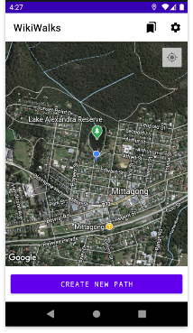

Result

Pass

1. Test Step

User presses “CREATE NEW PATH” button

Expected Test Results

WikiWalks New Path screen shown with greyed-out “STOP RECORDING” button.

Output

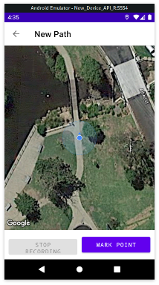

Result

Pass

1. Test Step

User starts their walk

Expected Test Results

White line shown,

“STOP RECORDING” button turns purple after the user has walk about 100 meters.

Output

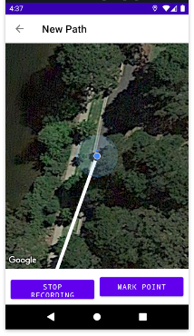

Result

Pass

1. Test Step

User presses back arrow in top left corner to exist walk without uploading the path.

Expected Test Results

Walk not uploaded to WikiWalks server and screen returns to WikiWalks Main Screen.

Output

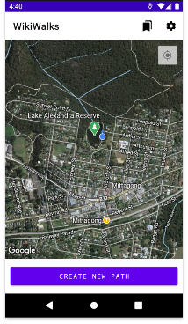

Result  
 Pass

* + 1. Pre-Condition

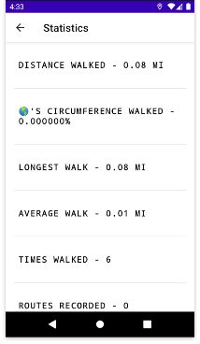

* + 1. Post-Condition

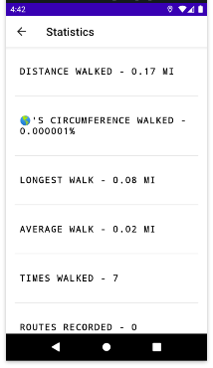

Result

Pass

## Recording Started And Completed

* + 1. Test Description
* User starts walk and completes walk to be uploaded
  + 1. Pre-condition
* WikiWalks installed on phone
* User statistics checked
  + 1. Post-condition
* Walk not uploaded
* Statistics updated for distance walked
* Path named “Recording Test Uploaded To WikiWalks Server”
  + 1. Input Data

|  |  |  |
| --- | --- | --- |
|  | Lat | Long |
| Start | -34.4474 | 150.4471 |
|  | -34.4475 | 150.4474 |
|  | -34.4473 | 150.4475 |
|  | -34.4471 | 150.4477 |
|  | -34.4470 | 150.4477 |
|  | -34.4468 | 150.4478 |
| Stop | -34.4465 | 150.4479 |

* + 1. Result

Pass

* + 1. Steps

1. Test Step

User opens WikiWalks

Expected Test Results

WikiWalks Main Screen is shown

Output

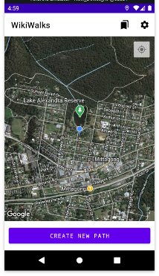

Result

Pass

1. Test Step

User presses “CREATE NEW PATH” button

Expected Test Results

WikiWalks New Path screen is displayed

Output

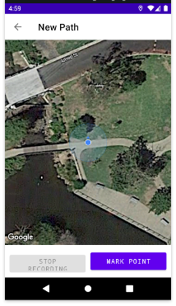

Result

Pass

1. Test Step

User starts their walk

Expected Test Results

White line shown,

“STOP RECORDING” button turns purple after the user has walk about 100 meters.

Output

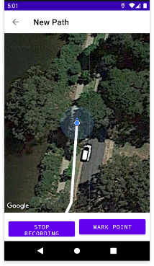

1. Test Step

User presses “STOP RECORDING” button

Expected Test Results

Submit walk prompt shown

Output

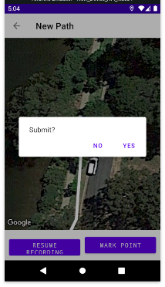

Result

Pass

1. Test Step

User selects “YES”

Expected Test Results

Dialog box appears asking user to name walk

Output

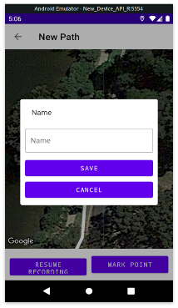

1. Test Step

* User enters in text box “Recording Test Uploaded To WikiWalks Server” and presses “SAVE” button.

Expected Test Results

* Return to main screen with a toast confirming “Saved route successfully!”

Output

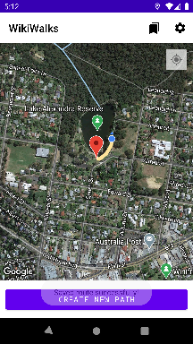

* + 1. Pre-condition

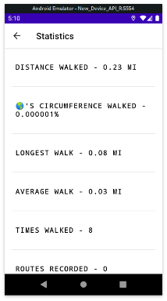

* + 1. Post-Condition

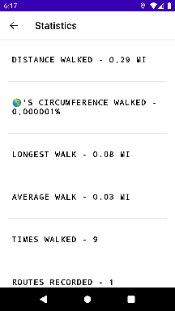

Result

Pass

# Testing Bookmarks

## Book Marking A Walk

## Test Description

* A walk is bookmarked so that it can be easily accessed by the user
  + 1. Pre-conditions
* WikiWalks is installed on the phone.
  + 1. Post-conditions
* Walk added to bookmarks
* WikiWalks application is closed
  + 1. Input Data

|  |  |
| --- | --- |
| Lat | Long |
| -34.4474 | 150.4471 |

* + 1. Result

Pass

* + 1. Steps

1. Test Step

User opens WikiWalks

Expected Test Results

WikiWalks Main Screen is displayed

Output

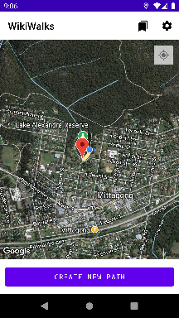

result

Pass

1. Test Step

User clicks path marker

Expected Test Results

Path screen is displayed

Output

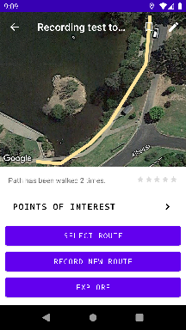

Result

Pass

1. Test Step

User clicks bookmark walk button in top left corner

Expected Test Results

Button changes from seethough to white

Output

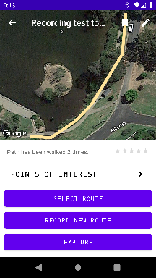

Result

Pass

* + 1. Pre-Condition

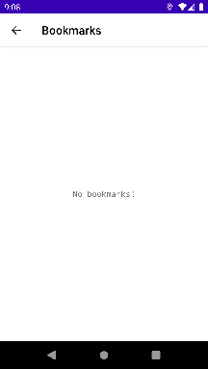

* + 1. Post-Condition

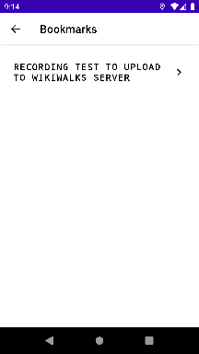

## Deleting a Bookmark

* + 1. Test Description
* A walk that has previously been bookmark is removed from bookmarks
  + 1. Pre-conditions
* WikiWalks installed on phone
* A walk has been added to bookmarked walks
  + 1. Post-conditions
* Selected bookmark is removed from bookmarks
  + 1. Input Data

|  |  |
| --- | --- |
| Lat | Long |
| -34.4474 | 150.4471 |

* + 1. Result

Pass

* + 1. Steps

1. Test Step

User opens WikiWalks

Expected Test Results

WikiWalks Main Screen is displayed

Output

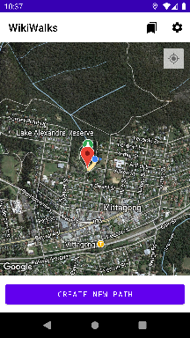

Result

Pass

1. Test Step

User clicks bookmark button

Expected Test Results

Bookmark screen shown with “RECORDING TEST TO UPLOAD TO WIKIWALKS SERVER”

Output

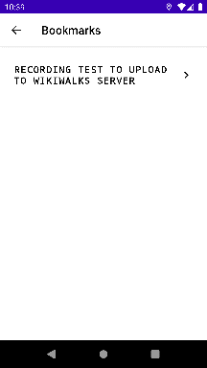

Result

Pass

1. Test Step

User clicks “RECORDING TEST TO UPLOAD TO WIKIWALKS SERVER”

Expected Test Results

Screen changes “RECORDING TEST TO UPLOAD TO WIKIWALKS SERVER” path screen

Output

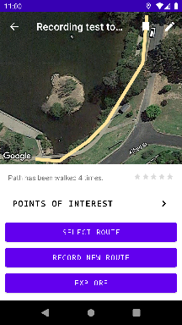

Result

Pass

1. Test Step

User clicks bookmark walk button in top left corner

Expected Test Results

Button changes from white to see through

User clicks bookmark button

Output

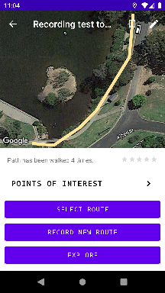

Result

Pass

* + 1. Post-Condition

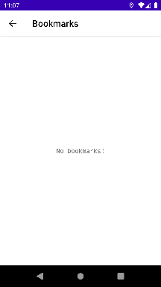

# Path Reviews

## Reviewing A path

* + 1. Test Description
* A user writes a review of a path
  + 1. Pre-conditions
* WikiWalks installed on phone
* User has selected a path they wish to review
  + 1. Post-conditions
* Review is uploaded to WikiWalks server
  + 1. Input Data

|  |  |
| --- | --- |
| Lat | Long |
| -34.4474 | 150.4471 |

* + 1. Result

Pass

* + 1. Steps

1. Test Step

* User selects path they wish to review

Expected Test Results

* Path screen of selected path is displayed

Output

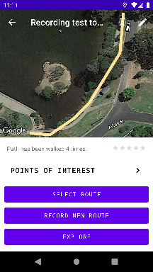

Result

Pass

1. Test Step

User scrolls menu to review button shown

Expected Test Results

Review button shown

Output

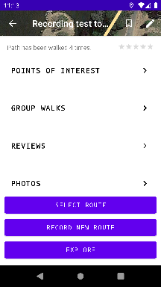

result

Pass

1. Test Step

User clicks “Review”

Expected Test Results

Review screen is displayed

Output

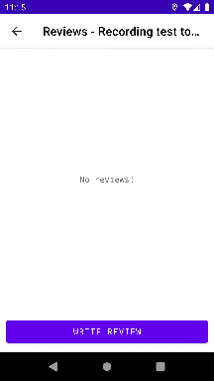

Result

Pass

1. Test Step

User clicks “WRITE REVIEW” button

Expected Result

Dialog box asking for review and star rating is shown

Output

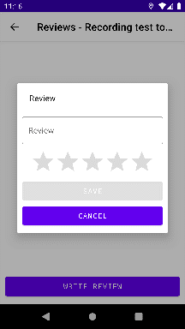

Result

Pass

1. Test Step

User enters review of walk and gives rating

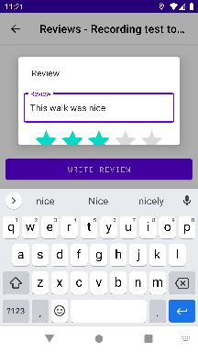

1. user clicks save

Review is uploaded

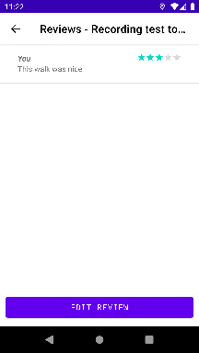

## Editing A Review

* + 1. Test Description
* A review of a walk is edited
  + 1. Pre-conditions
* WikiWalks installed on phone
* Walk has selected a path they wish to review
  + 1. Post-conditions
* Review is uploaded to WikiWalks Server
  + 1. Input Data

|  |  |
| --- | --- |
| Lat | Long |
| -34.4474 | 150.4471 |

Result

Pass

Steps

1. Test Step

User selects path they wish to edit their review of

Expected Test Results

Path screen of selected path is shown

Output

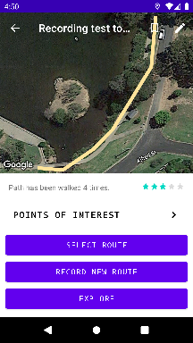

Result

Pass

1. Test Step

User scrolls menu to “REVIEWS” button and presses it

Expected Test Results

Walks review screen is displayed

Output

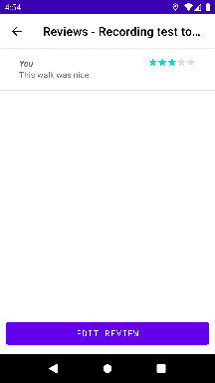

Result

Pass

1. Test Step

User clicks “Edit Review”

Expected Test Results

Dialog is shown that allows user to modify review

Output

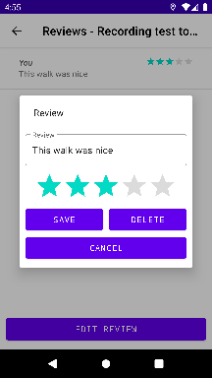

Result

Pass

1. Test Step

User edits review and presses “SAVE"

Expected result

Updated review is displayed and uploaded review is displayed

Output

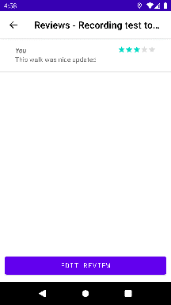

Result

Pass

# Path Photos

## Add A Photo to path

* + 1. Test Description
* A photo is uploaded to a path from the users phone’s gallery
  + 1. Pre-conditions
* WikiWalks installed on phone
* User has selected a path they wish to add photo of
* User has previously taken a picture of part of the walk
  + 1. Post-conditions
* Image is uploaded to WikiWalks Server
  + 1. Input Data

|  |  |
| --- | --- |
| Lat | Long |
| -34.4474 | 150.4471 |

* + 1. Result

Pass

* + 1. Steps

1. Test Step

Selects path they wish to edit their review of

Expected Test Results

Path screen of selected path is shown

Output

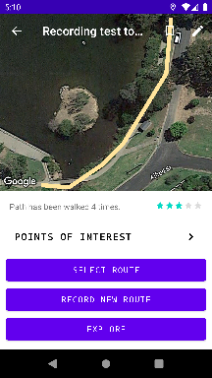

Result

Pass

1. Test Step

User scrolls menu to photos button

Expected Test Results

Review button shown

Output

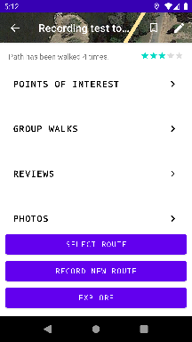

Result

Pass

1. Test Step

User clicks “Photos”

Expected Test Results

Photos screen shown and option to add photo shown

Output

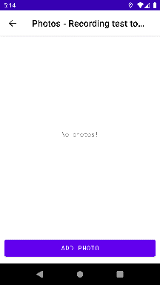

Result

Pass

1. Test Step

User clicks “add photo” button

Expected Result

Dialog box appears asking user to select photo from gallery or camera and write a caption

Output

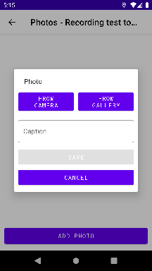

Result

Pass

1. Test Step

Users selects phot from gallery and adds a caption

Expected output

Image is shown in dialog box along with caption

output

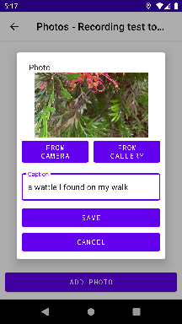

1. Test step

User clicks “SAVE” button

Expected output

Photo uploaded to WikiWalks Server and shown in photos menu

Output

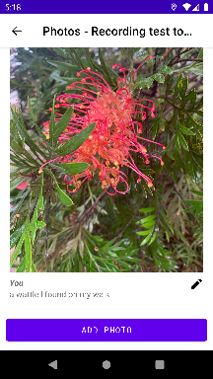

Result

Pass

# Goals

## Goal Is Created

* + 1. Test Description
* A Distance goal is created by the user and saved to the phone
  + 1. Pre-conditions
* WikiWalks Installed on Phone
* User has navigated to settings menu
  + 1. Post-Conditions
* User closes WikiWalks
  + 1. Result

Pass

* + 1. Steps

1. Test Step

User selects “GOALS” in settings menu

Expected Test Results

Goals menu shown with button to “SET GOAL” displayed

Output

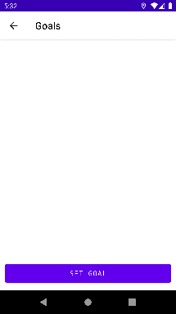

Result

Pass

1. Test Step

User presses set goal button

Expected Test Results

Goals dialog box displayed

Output

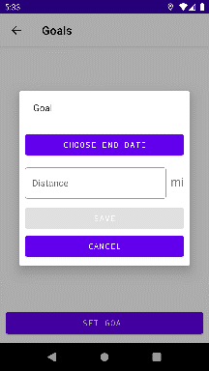

Result

Pass

1. Test Step

User sets goal end date and distance they wish to walk

Expected Test Results

Photos screen shown and option to add photo displayed

Output

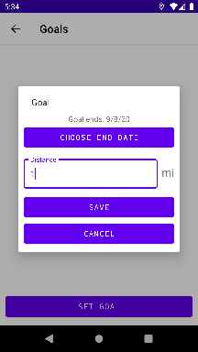

Result

Pass

1. Test Step

User clicks “Save” button

Expected Result

Goal is saved to device

Output

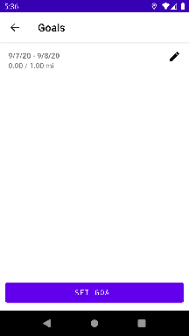

Result

Pass

# Path Color Changing

## Walking A Walk 10 Times

* + 1. Test Description
* A walk is walked 10 times this changes the color of the path shown
  + 1. Pre-conditions
* WikiWalks installed on phone

Post-conditions

* Path color changes on path map
* If user had previously created a goal distance of the goal is updated
  + 1. Result

Pass

* + 1. Steps

1. Test Step

Selects path they wish to walk

Expected Test Results

Path screen of selected path is shown

Output



Result

Pass

1. Test Step

User Selects Route

Expected Test Results

Route Selection Menu Shown

Output



Result

Pass

1. Test Step

User walks the selected route once and then repeats it until it has been walked ten times.

Expected Test Results

Path changes colour and PATH HAS BEEN WALKED 10 TIMES is displayed next to the star rating

Output

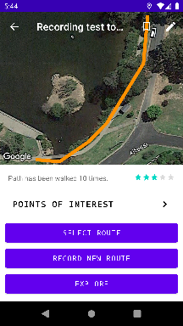

Result

Pass

1. Test Step

User returns to Main screen by pressing back arrow

Expected Result

Orange path is now shown on path map instead of yellow path

Output

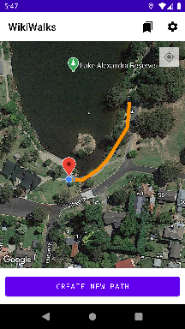

Result

Pass

* + 1. Post Conditions



After walk

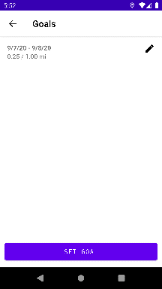

If goal was competed

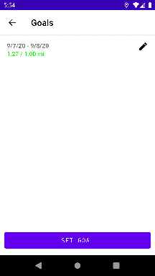

# Group Walks

## Group Walk Is Created

* + 1. Test Description
* A group walk is created
  + 1. Pre-conditions
* WikiWalks installed on phone
* User has selected path they wish to create a group walk for
  + 1. Post-Conditions
* User closes WikiWalks
  + 1. Results

Pass

* + 1. Steps

1. Test Step

User Scrolls to Group Walk for selected path

Expected Test Results

Goals menu shown with button to set goal displayed

Output

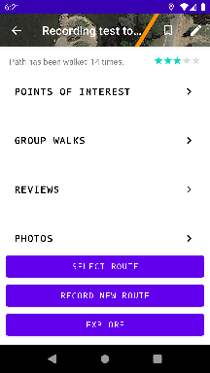

Result

Pass

1. Test Step

User presses set “GROUP WALKS” button

Expected Test Results

Group walk menu shown

Output

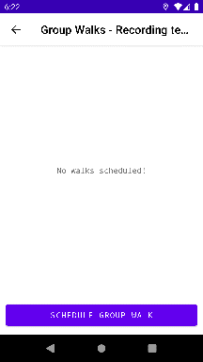

Results

Pass

1. Test Step

Users presses “SCHEDULE GROUP WALK” button

Expected Test Results

Group walk dialog box shown

Output

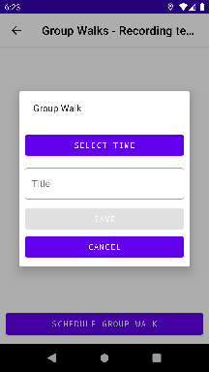

Results

Pass

1. Test Step

User enters details of group walk and presses “SAVE” button

Expected Result

Group walk is uploaded to WikiWalks server and new group walk is shown in the group walk menu

Output

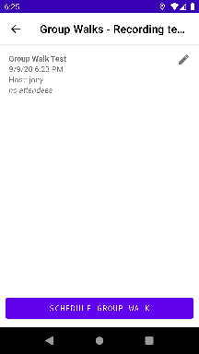

Result

Pass

## Group Walk Is Attended

* + 1. Test Description
* A group walk is created by a user and is then uploaded to the wikiwalks server
  + 1. Pre-conditions
* WikiWalks installed on phone
* User has selected path they wish to attend group walk on
  + 1. Post-Conditions
* User closes WikiWalks
  + 1. Result

Pass

* + 1. Steps

1. Test Step

User Scrolls to Group Walk for selected path

Expected Test Results

Goals menu shown with button to set goal displayed

Output

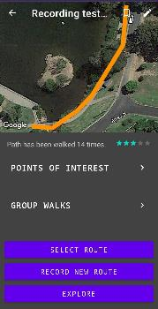

Result

Pass

1. Test Step

User presses “GROUP WALKS” button

Expected Test Results

Group walk menu shown

Output

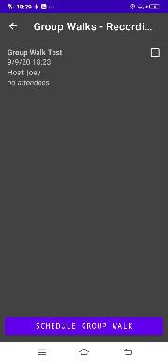

Result

Pass

1. Test Step

Users presses selects group walk they wish to attend

Expected Test Results

A confirmation dialog box is shown

Output

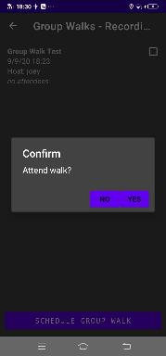

Result

Pass

1. Test Step

User selects “YES

Expected Result

Group walk attendees is updated and the user is listed in the attendees

Output

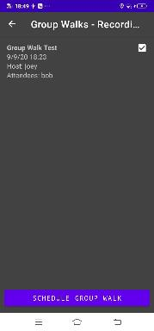

Result

Pass

# Bugs that were fixed

Bugs that were found in testing and fixed:

## Distance was off by 1000

﻿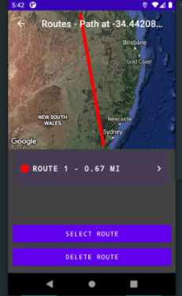

* + - 1. Fixed by Joseph Lunt by making the distance shown not be divided by 1000.

## App Crashed On Deleting Path.

* + 1. Fixed by Tyler O'Neill by setting the main screen to show after a path was deleted instead of the path screen of that path which no longer existed.

## Review Dialog Box Displayed Photos Instead of Review.

﻿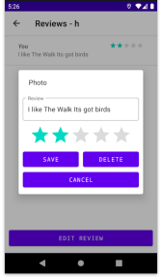

* + 1. Fixed by Tyler O’Neill by making the Reviews Dialog boxes tile request the review string and not the photo string.

## Bug with Star Rating Not Updating.

* + 1. Fixed by Tyler O'Neill by adding a listen that would call to update the review fragment.

## Bug With Bookmark Not Updating.

* + 1. Fixed by Tyler O’Neill by fixing the request code so that bookmarks are updated.