**make** [**www.kfangtech.com**](http://www.kfangtech.com) **point to fang-kuinai.rhcloud.com**

**1. DNS Zone File =>**

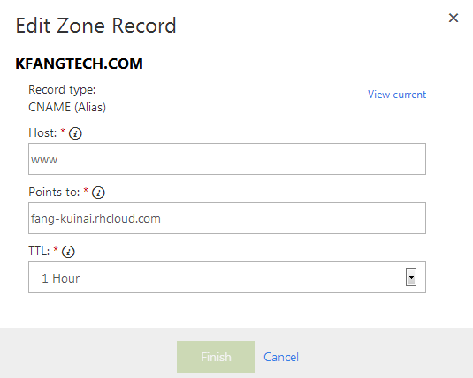

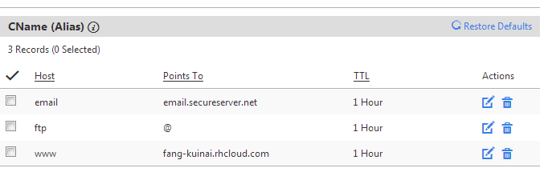

**2 Add CName Alias on OpenShift**



**3. Forwarding: Redirect kfangtech.com to** [**www.kfangtech.com**](http://www.kfangtech.com)

