**GoTechnology®**

hub2 – Patch Notes v1.9

# About this Document

## Purpose

This document provides a brief overview of the changes made between V1.8 and V1.9 of hub2, along with where further details of each change can be found within the updated functional specification, in addition to a listing of completed bug fixes and known issues.

# Fixed Issues

The following issues have been fixed in version 1.9 of hub2

|  |  |  |
| --- | --- | --- |
| Case | Title [sic] | Details |
| 50885 | Tag ITRs are not listed alphabetically on Tagged Item Search Results | The Tag ITRs Results are displayed as a list on the Tagged Item Search Results, these should have been displayed alphabetically by ITR Name but weren’t. This has now been corrected. |
| 49441 | No History Logged when Hub User is edited on the Authorised Person Table | When the Hub User field was changed on the Authorised Person table this wasn’t recorded in the History section.  This has been fixed and now the change in user is correctly recorded |
| 46850 | Digital Document: Character Limit for Comments | The Digital Documents have a comment limit of 1000 characters but the largest the comment field can be is a few lines. This normally doesn’t give enough space to write large comments.  From v1.9 it’s now possible for the user to determine how large the comment box can be allowing much larger comments to be completed. |
| 47880 | On Mobile, buttons appear to be overlapping with other buttons | When on mobile some of the buttons that are normally displayed side by side changed to be displayed one on top of the other to make more space. When this happens, the buttons appeared to be overlapping.  Now on smaller screens there is an increase margin between the top and bottom of buttons to prevent this. |

# Known Issues

A full list of “Known Issues” can be found at <https://gotechnology.github.io/>

# Features

The following functionality has been added in v1.9:

Functional:

* Import Performance Improvements
* Custom Fields: Job Cards
* Improved Styling
* Additional Tag and Cable Fields
* Digital Document: Signature, Date & Comments
* Digital Document: Set Comment Size
* Digital Document: Task Table Section Timeouts
* Custom Field Limit
* Child Exports: Included Sign Off Fields

## Import Performance Improvements

The length of time hub2 takes to import large data sets has been significantly reduced due to improvements in the efficiency of the data handling process. Import Performance is a key focus for future releases, so we anticipate further improvements in future.

The following chart shows the baseline time for adding or updating data via the Tag Import, based on the number of rows added or updated.

1. Chart showing the time taken for adding data via the Tag Import, based on number of Tags added
2. Chart showing the time taken for updating data via the Tag Import, based on number of Tags updated

## Custom Fields: Job Cards

**For more detail see Section 42 (Custom Fields) of the hub2 Functional Specification.**

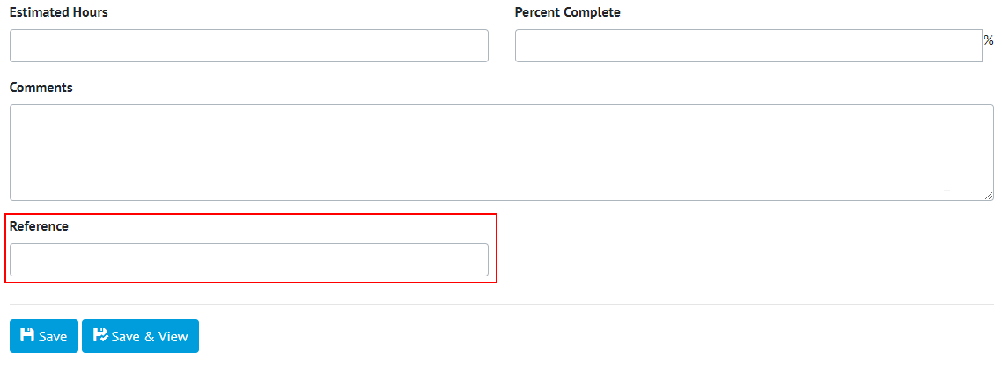

1. Screenshot of the Job Card Edit Page with an example custom field ‘Reference’ Highlighted

The Custom Fields feature has been extended to allow fields to be added to Job Cards. Job Card Custom Fields will be available on the View and Edit screens for Job Cards, as well as Imports and Exports. The fields will also be available on the Job Card Custom Detail Reports.

## Additional Tag and Cable Fields

**For more detail see Section 16.3.1.2 (Tagged Item Entity) of the hub2 Functional Specification.**

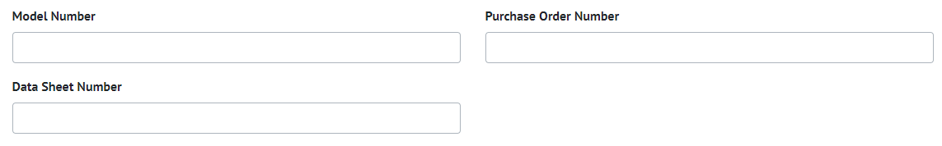

1. Screenshot of the Cable Edit Page showing new fields

The following fields have been added to Tags and Cables

* Model Number
* Purchase Order Number
* Data Sheet Number

All of these are free text fields with a limit of 100 characters.

## Digital Document: Signature, Date & Comments

**For more detail see Section 34.4.1.1.c (Digital Document Task Section) of the hub2 Functional Specification.**

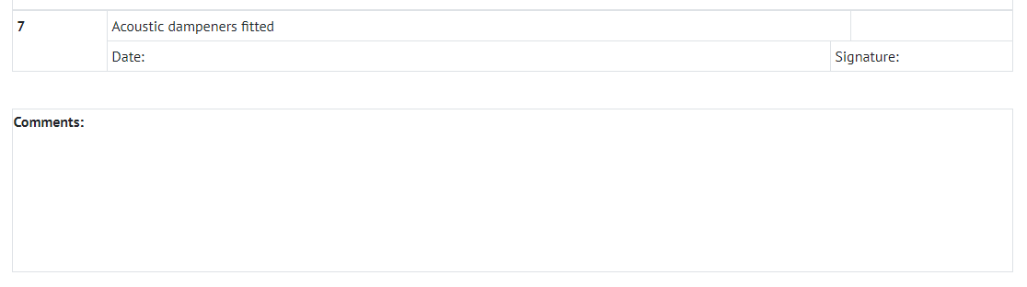

1. Screenshot of the Signature, Date & Comments Task Type

For Digital Documents a new Task Type has been added as Date, Signature and Comments. This allows the user to enter a Signature (Authorised Person), Date and Comment for any Task. If the Task is required all three fields must be completed for the Task to be considered complete.

## Digital Document: Set Comment Size

**For more detail see Section 34.4.1.1.c (Digital Document Task Section) of the hub2 Functional Specification.**

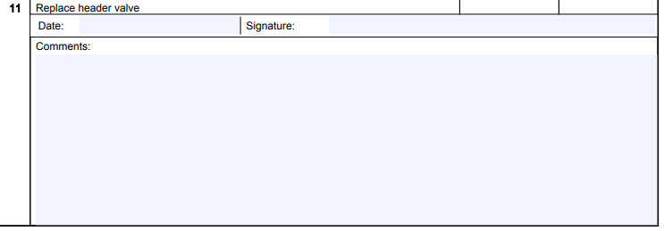

1. Screenshot of the Long Comment type with 12 lines



1. Screenshot of the Inline Comment type

The amount of space available for comments on Digital Document Tasks is now configurable, allowing the space to more accurately reflect the requirement of the Task. When configuring a Digital Document Task, it is now possible to choose an Inline Comment which will be displayed alongside the Task detail, or a Long Comment which will be displayed below the task. When a Long Comment is selected, a further option allows the configuration of the number of lines to be available between 1 and 20 lines.

## Digital Document: Task Table Section Timeouts

The process of designing a Digital Document may take an extended amount of time, during which it is possible that the current session may time out. To avoid data loss, the Digital Document Task Table section now automatically recovers any work which was in progress while re-authentication takes place. Previously, this work would have been lost.

## Custom Field Limits

**For more detail see Section 43.1 of the hub2 Functional Specification.**

For performance reasons, there is now a limit of 20 on the number of Custom Fields which can be added to any single type.

## Child Exports: Included Sign Off Fields

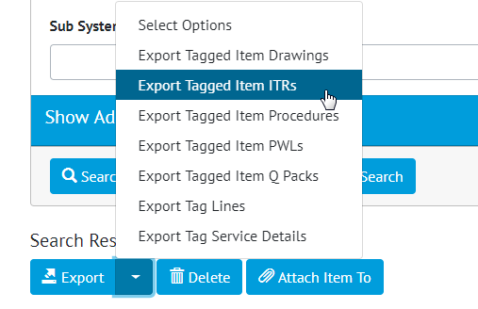

1. Navigating to Child Exports of Tags



1. Sign Off fields included in Tag ITRs Export

Sign Off Fields are now included when exporting Tag ITRs and Tag PWLs from the Tagged Item pages (e.g. Tag, Test Pack, etc).