**GoTechnology®**

hub2 – Patch Notes v1.10

# About this Document

## Purpose

This document provides a brief overview of the changes made between V1.9 and V1.10 of hub2, along with where further details of each change can be found within the updated functional specification, in addition to a listing of completed bug fixes and known issues.

# Fixed Issues

The following issues have been fixed in version 1.10 of hub2

|  |  |  |
| --- | --- | --- |
| Case | Title [sic] | Details |
| 51117 | Search Labels Updated | Search labels which were longer than required (for example “Tag ITR Test Reference” instead of “Test Reference”) have been shortened in v1.10 |
| 51481 | Import could often fail on 20k plus Rows | Certain complex Imports containing over 20,000 rows could fail.  This has been resolved by the Import Improvements detailed later in this document |
| 51291 | Import fails on deleting more than 500 Tags. | When deleting Tags the import could fail to complete.  This has been improved by the changes made to the Imports in v1.10 but further work is still required to increase the Delete Limit. |
| 50014 | Skyline Full page Report – Underscores (“_”) would sometimes make it hard to see the next line. | When a Handover had a name like “MCC_SS3425_234” the underscore would often make it difficult to read the line below.  The text spacing on the Skyline Report has been improved to prevent this issue |
| Case | Title [sic] | Details |
| 50885 | Tag ITRs are not listed alphabetically on Tagged Item Search Results | The Tag ITRs Results are displayed as a CSV List on the Tagged Item Search Results, these should have been displayed alphabetically by ITR Name but weren’t. This has now been corrected. |
| 50677 | Ref Table Menu Extends off the screen | When you have a large number of custom fields, depending on the monitor size the Reference Table fields might stretch off the screen.  This has been resolved by allowing 3 columns for Reference Table when needed. |
| 49441 | No History Logged when Hub User is edited on the Authorised Person Table | When the Hub User field was changed on the Authorised Person table this wasn’t recorded in the History section.  This has been fixed and now the change in user is correctly recorded |
| 46850 | Digital Document: Character Limit for Comments | The Digital Documents have a comment limit of 1000 characters but the largest the comment field can be is a few lines. This normally doesn’t give enough space to write large comments.  From v1.9 it’s now possible for the user to determine how large the comment box can be allowing much larger comments to be completed. |
| 47880 | On Mobile Buttons appear to be overlapping with other buttons | When on mobile some of the buttons that are normally displayed side by side changed to be displayed one on top of the other to make more space. When this happens, the buttons appeared to be overlapping.  Now on smaller screens there is an increase margin between the top and bottom of buttons to prevent this. |
| 50993 | Import – Result Files are not created for large Tag Imports | For Large Imports the result file creation was causing timeout errors.  In version 1.9 we have changed the way the result files are created to use MessageBox instead of JSON and this allow much larger files to be saved without issue. |

# 

# Known Issues

A full list of “Known Issues” can be found at <https://gotechnology.github.io/>

# Features

The following functionality has been added in v1.10:

Functional:

* Import Improvements
* Digital Documents Results: Images
* Digital Document Results: On Screen Improvements
* Additional Aliased Fields: Operation, Operation Type & Phase
* New Procedure Fields
* New Drawing Fields
* Job Card Assignment
* Scheduled Report Screens

API:

* API – Additional Entities
* API – Level Header Changes

## Import Performance Improvements

The length of time hub2 takes to import large data sets has been significantly reduced due to improvements in the efficiency of the data handling process. Import Performance is a key focus for future releases, so we anticipate further improvements in future.

The following chart shows the baseline time for adding or updating data via the Tag Import, based on the number of rows added or updated.

1. Chart showing the time taken for adding data via the Tag Import, based on number of Tags added
2. Chart showing the time taken for updating data via the Tag Import, based on number of Tags updated

## Digital Document Results: On Screen Improvements

**For more detail see Section 36.2.1 – Completing a Digital Document: On Screen Edit of the hub2 Functional Specification.**

The Digital Document Result page has been improved to make it easier to record progress.

Each Task Type (Date, Signature, Checkbox and Comments) have now been given their own row.

In addition, each Digital Document Task can now be minimised to make it easier to view the information required.

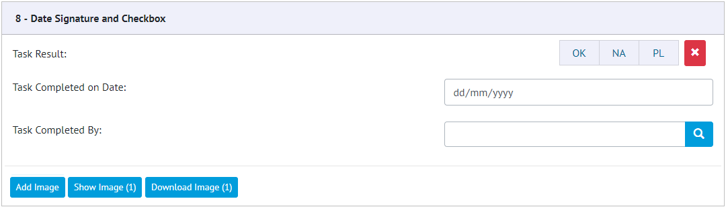

1. Example of a Digital Document Task with a Checkbox, Date and Signature

## Digital Document Results: Task Images

**For more detail see Section 36.2 – Completing a Digital Document of the hub2 Functional Specification.**

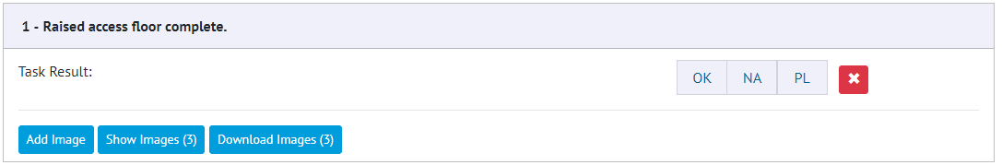

1. Task with Button to Add, View and Download Images

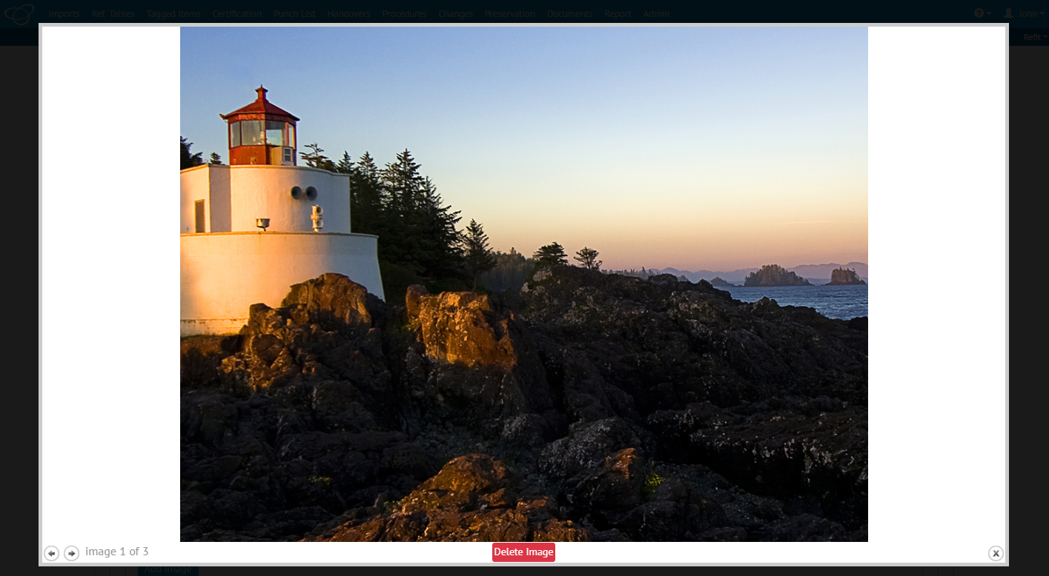

1. Example of the Image Preview Dialogue

The ability to attach Images directly against any Task in a Digital Document has been added allowing supporting images such as photographs to be added against the Task. These images can then be viewed on screen or downloaded directly from the system. The images are then added to the generated PDF Document.

## Additional Aliased Fields: Operation, Operation Type & Phase

**For more detail see Sections 23.3.2, 23.3.3 and 14.3.16 of the Functional Specification**

Operation, Operation Type and Phase Fields can now be aliased in the Level A Add Edit screen.

## New Procedure Fields

**For more detail see Sections 3.1.3.2, 30.2.2.1, 30.2.3.1, 30.2.3.2.d, 37.3.5, 37.4, 45.3.1.2, 45.4 of the Functional Specification.**

The following fields have been added to the Procedure screens for viewing and editing: Tagged Items (Grid), Comments, Document Owner and Assigned To. The Issue By and Issue Date fields have also been renamed to Authorised For Issue By and Authorised For Issue Date. Procedures can now be assigned to Authorised Persons and notifications will be sent out on assignment.

## New Drawing Fields

**For more detail see Sections 24.3.2.2 – Drawings**

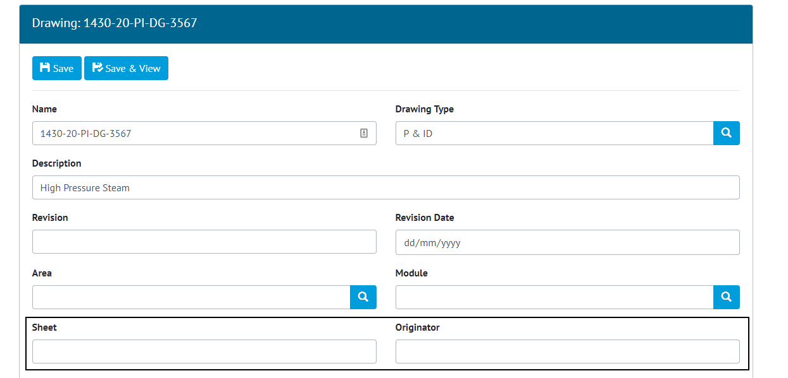

1. Screenshot of the Drawing Edit page with the new Sheet and Originator Fields Highlighted

Two new fields have been added to the Drawing Section: Sheet and Originator. These are free text fields with limits of 30 and 50 characters respectively.

## Job Card Assignment

**For more detail see Sections 372., 37.3.5, 37.4.1, 23.3.1.2 and 23.4 of the Functional Specification**

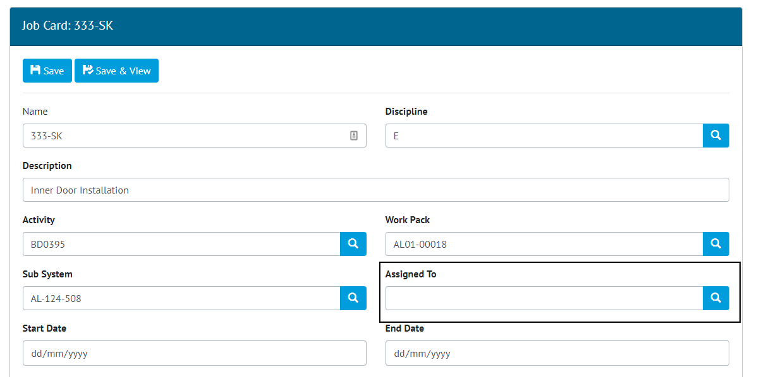

1. Screenshot of the Job Card Edit Page with new Assigned To Field Highlighted

Job Cards can now be assigned to users in the same manner as Tag ITRs and Punch List Items. As with Tag ITRs and Job Cards when a user is assigned to a Job Card a notification is sent to that user.

## API – Additional Entities

Added As Built Drawings, MOC’s and Handover entities to the API. As Built Drawings and MOC’s work in the same manner as other entities however Handovers only allow you to get and update the Handover.

## API - Level Header Changes

The level headers for the API have been changed from to X-qedi-Level to X-GoTechnology-Level and from api-version to X-GoTechnology-API-Version. In the future all API Headers will be prefixed with X-GoTechnlogy to keep them consistent.