# Changes in v1.11

## About this Document

### Purpose

This document provides a brief overview of the changes made between V1.10 and V1.11 of hub2, along with where further details of each change can be found within the updated functional specification, in addition to a listing of completed bug fixes and known issues.

## Fixed Issues

The following issues have been fixed in version 1.11 of hub2

### Fixed Issues

|  |  |  |
| --- | --- | --- |
| Case | Title [sic] | Details |
| 51959 | Emails are no separated by commas on the Scheduled Report View page | The emails on the Scheduled Report View page are not split out by commas as they are on the Edit page.  This has been fixed by splitting the emails addresses onto separate lines to make them easier to read. |

## Known Issues

A full list of “Known Issues” can be found at <https://qedi-gotechnology.github.io/>

## Features

The following functionality has been added in v1.11:

Functional:

* Import Improvements
* Materials Register
* Job Card Status
* Scheduled Reports Filtering
* Flexible Sign Off Panels

API:

* API – Flexible Sign Offs on Tag ITRs

### Import Performance Improvements

The length of time hub2 takes to import large data sets has been further reduced due to improvements in the efficiency of the data handling process. Import Performance is a key focus for future releases, so we anticipate further improvements in future.

### Materials Register

**For more detail see Sections 14.3.15 – 14.3.18, Section 23.3.5 of the Functional Specification**

A Materials Register has been added to hub2, to allow users to record the materials required for each Job Card Operation. Materials can be managed in the Material Reference Table, and can be assigned to Operations along with further details of the Purpose and Status of the assignment.

The following Reference Tables have been added to support this:

* Material
* Material Purpose
* Material Status
* Material Type

For convenience, Materials can be assigned to Operations on the Operation View page, and similarly Operations can be assigned to Materials on the Material View page.

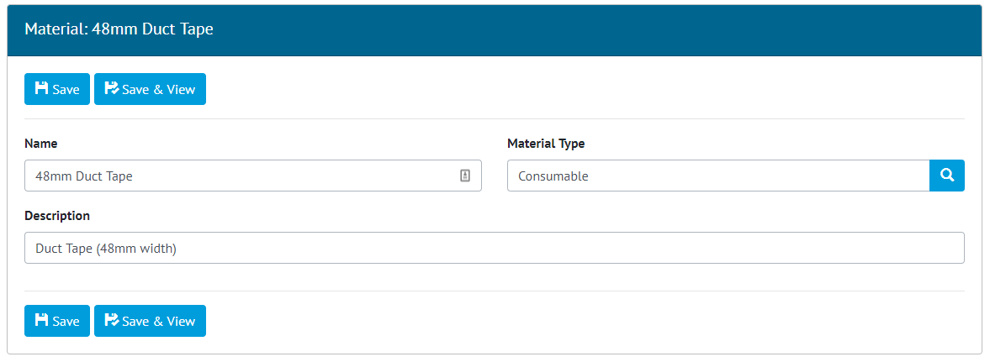

1. Example of adding a Material to the Material Reference Table

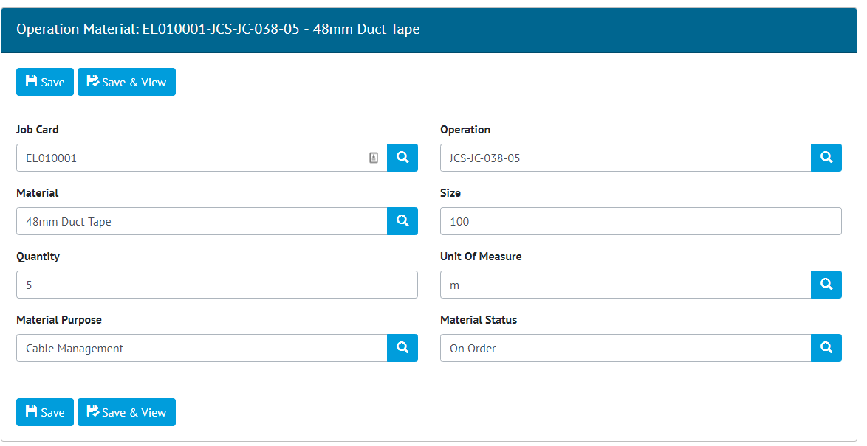

1. Example of Allocation of a Material to an Operation

### Job Card Status

**For more detail see Section 14.3.1.12 – Job Card Status, Table 107 - Job Card Entity, 23.4 - Job Card Validation and 37.6 – Notifications in the Functional Specification**

It is now possible to set the status of a Job Card, by picking a value from a new Reference Table: Job Card Status. The list of statuses which can be assigned is configurable by adding or removing entries from this Reference Table. Each entry has an optional flag ‘Locks Job Card’ which can be set to prevent changes being made to the Job Card while the Job Card is assigned that status.

If the Job Card is assigned to an Authorised Person (with a corresponding User account), that person will receive a notification when the status is changed.

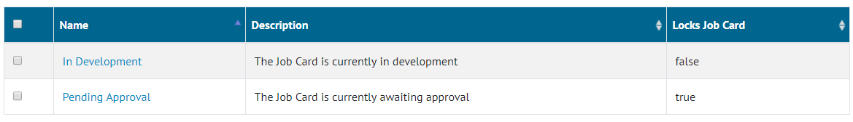

1. Example of Job Card Statuses in the Reference Table search results

### Scheduled Report Filtering

**For more detail see Section 44 – Scheduled Reports in the Functional Specification**

Scheduled Reports can now be filtered using the same set of filters available for other reports in hub2. A new Edit Filter button has been added to the Scheduled Reports page to allow filters to be configured. The filter will then be picked up and applied each time the scheduled report is run.

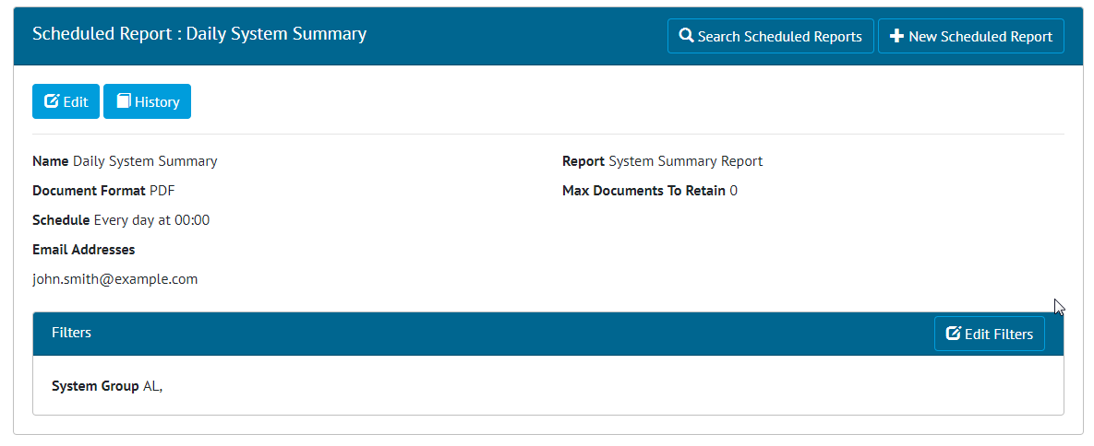

1. Example of filters applied to a Scheduled Report

### Flexible Sign Off Panels

**For more detail see Section 22.2.3 – Tag ITR View Page and Section 32.2.4.1 – Punch List Item View Page in the Functional Specification**

The Sign Off Panels on the Tag ITR and Punch List Item View pages have been extended to allow them to sign off any flexible sign off. This allows a user with sign off permissions on these items to complete the relevant sign offs for the Tag ITR on Punch List Item on the View screen. Previously only the final sign off could be completed in this way.

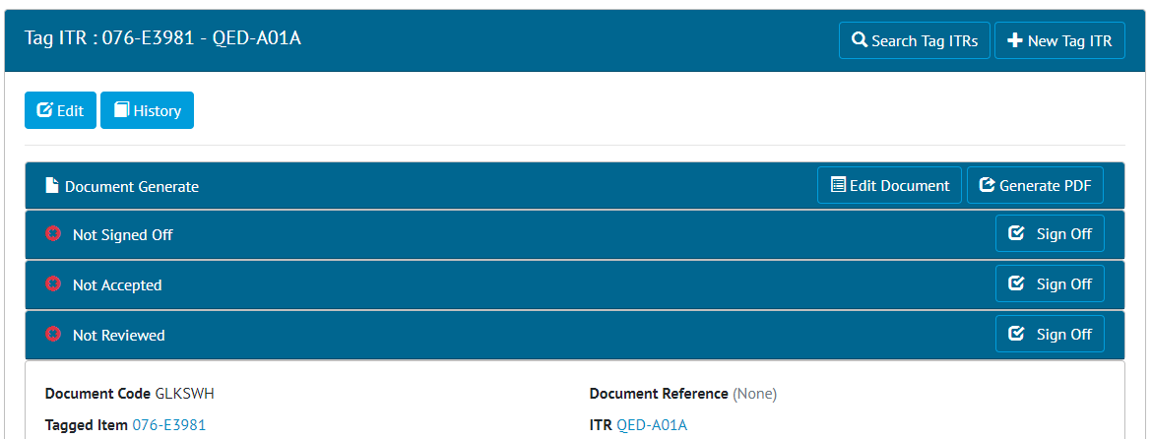

1. Example of Tag ITR View page with multiple Sign Off buttons

### API - Flexible Sign Offs on Tag ITR API

**For more detail see the Swagger Documentation for v1.11**

The Flexible Sign Offs for Tag ITRs can now been completed via the RESTful API. This allows an API client to get the required signoffs for each Tag ITR and then complete them.