**Wood Commissioning**

hub2 – Patch Notes v1.12

# About this Document

## Purpose

This document provides a brief overview of the changes made between V1.11 and V1.12 of hub2, along with where further details of each change can be found within the updated functional specification, in addition to a listing of completed bug fixes and known issues.

# Fixed Issues

The following issues have been fixed in version 1.12 of hub2

|  |  |  |
| --- | --- | --- |
| Case | Title [sic] | Details |
| 51315 | The User of Forward Slash (/) or Backwards Slash (\) prevented the Search or API from being used | If the name of an item in hub2 used a “\” or “/”, this this would prevent the item from being able to be updated using the API, or from being searched in hub2.  This issue has now been fixed and these characters will no longer break the search functionality. |
| 53603 | Tag ITR Template is missing flexible sign offs | The Tag ITR Template Downloaded directly from the Import Page does did not contain the available flexible sign offs.  This has now been resolved and the Tag ITR Template includes all the Flexible Sign Offs |
| 53863 | Upload Template Button on ITR View page was always visible even if User lacked permission to upload | The Upload ITR Template button on the ITR View page was visible to all users even if they didn’t have the correct permission to upload ITRs.  Clicking the button would result in the user getting a Permission Denied error but the button has now been hidden if the user doesn’t have the correct permission. |

# 

# Known Issues

A full list of “Known Issues” can be found at <https://qedi-gotechnology.github.io/>

# Features

The following functionality has been added in v1.12:

Functional:

* New Planning Section
* Flexible Approvals on Work Packs
* Procedure Templates and Generation
* Procedure Custom Reports
* Work Pack MOCs
* Punch List Item Detailed Description
* MOC Detailed Description and Response
* Completion Status Name

API:

* Tag ITR Digital Document Result API
* Tag ITR Digital Document Result PDF API
* Work Pack Graph API

## New Planning Section

**For more detail see Section 24 – Planning of the Functional Specification**

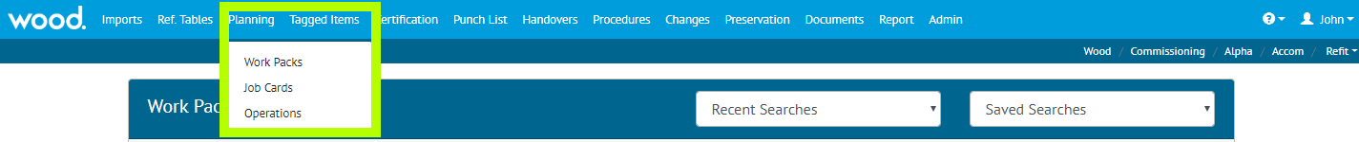

1. Screenshot showing the new Planning Section on the Menu Bar highlighted in yellow

There is a new Planning section been added in v1.12, this section contains Work Packs, Job Cards and Operations. Each of these sections have been expanded with new functionality and new fields including

* The ability to progress a Job Card through the completion of Operations
* The ability to assign a Work Pack or a Job Card to an Authorised Person with email notification when items are assigned.
* The ability to add Attachments to either a Work Pack or a Job Card
* The ability to create a Digital Document for each Work Pack Type
* Flexible Sign Offs for each Work Pack including a Work Pack Completion Status
* Signed Off and Accepted Dates/By on the Job Card including a Job Card Status
* The ability to Lock a Work Pack or Job Card depending on the Work Pack Completion Status or the Job Card Status

## Flexible Approvals on Work Packs

**For more detail see Section 24.3.12 – Work pack Approval – Planning of the Functional Specification**

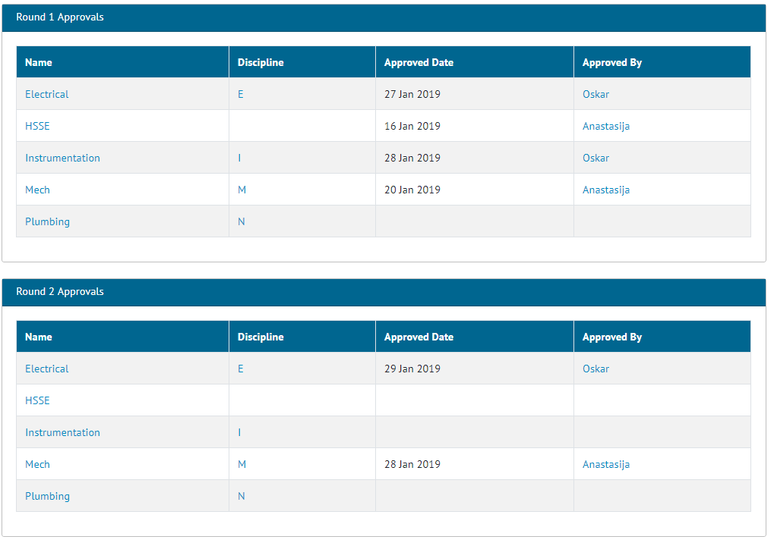

1. Screenshot showing the Approval section of the View page of the Work Packs

When a Work Pack is created it normally goes through several approval Rounds by various different functions before it can be actioned. These approvals can now be tracked within hub2 with the ability to add multiple rounds and Disciplines to each Work Pack.

## Procedure Templates and Generation

**For more detail see Section 36.3 – Certificate Templates: Word Document of the Functional Specification**

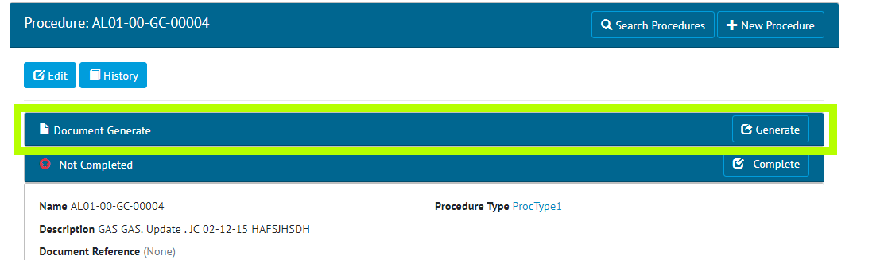

1. Screenshot of the Procedure Section with the Document Generated Highlighted in Yellow

It is now possible to raise a bookmarked DOTX Temple against a Procedure Type and then use the Template to create a Procedure document. This document will use the bookmarks to populate key information from the Procedure onto the document.

## Procedure Custom Reports

**For more detail see Section 43.4.1 – Creating/Editing Reports – Detailed Report of the Functional Specification**

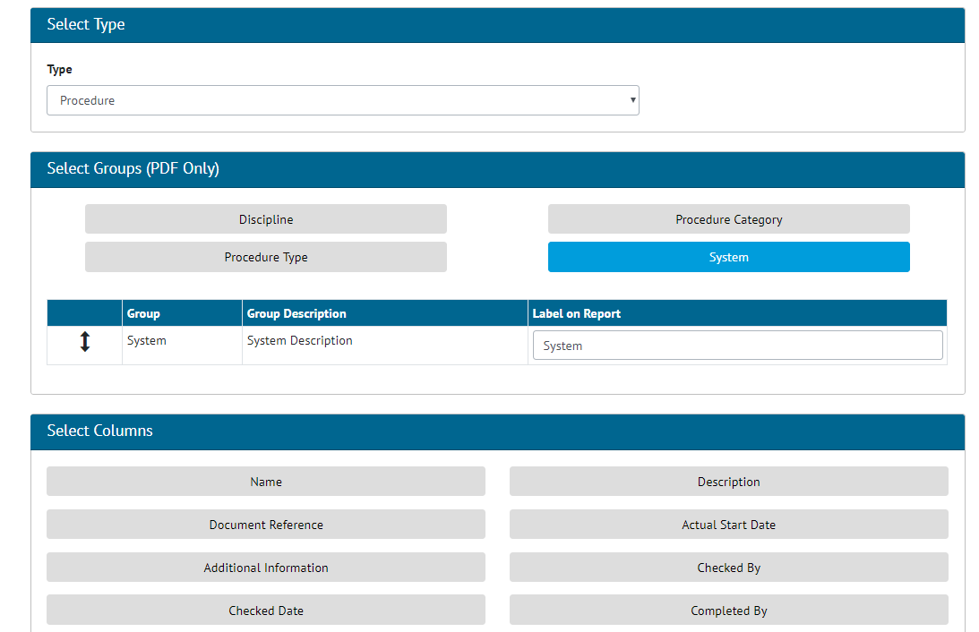

1. Screenshot of the Detailed Report Screen with the Procedure Report Type Selected

It is now possible to create a Custom Detail Report for Procedure, this report is made in the same way as the existing Detail Reports for Tag ITR, Tag PWL etc. The Custom Fields for Procedure are available for use on the report if required.

## Work Pack MOCs

**For more details see Section 29 – MOCs of the Functional Specification**

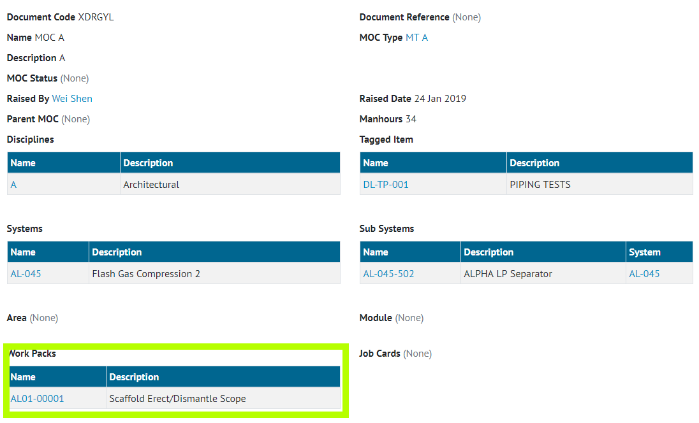

1. Screenshot of the MOC View Page with the new Work Pack Section highlighted

It’s now possible to raise an MOC directly against one or more Job Card. This allows MOCs to be scoped directly against a Work Pack when required.

## MOC Detailed Description and Response

**For more details see Section 29 – MOCs of the Functional Specification**

Two additional fields have been added to the MOC – Detailed Description and Response. Detailed Description allows for a more details then the standard description on the nature of the MOC. While Response allows for a detailed answer to the MOC to be input. Both fields have a 4000-character limit.

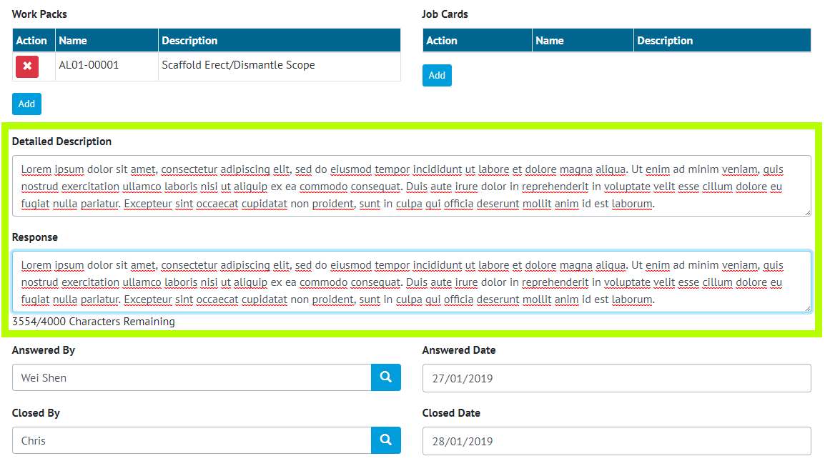

1. Screenshot of the MOC Details Page with the new Detailed Description and Response fields highlighted

## Punch List Item Detailed Description

**For more details see Section 33.3.2 – Punch List Items Entity of the Functional Specification**

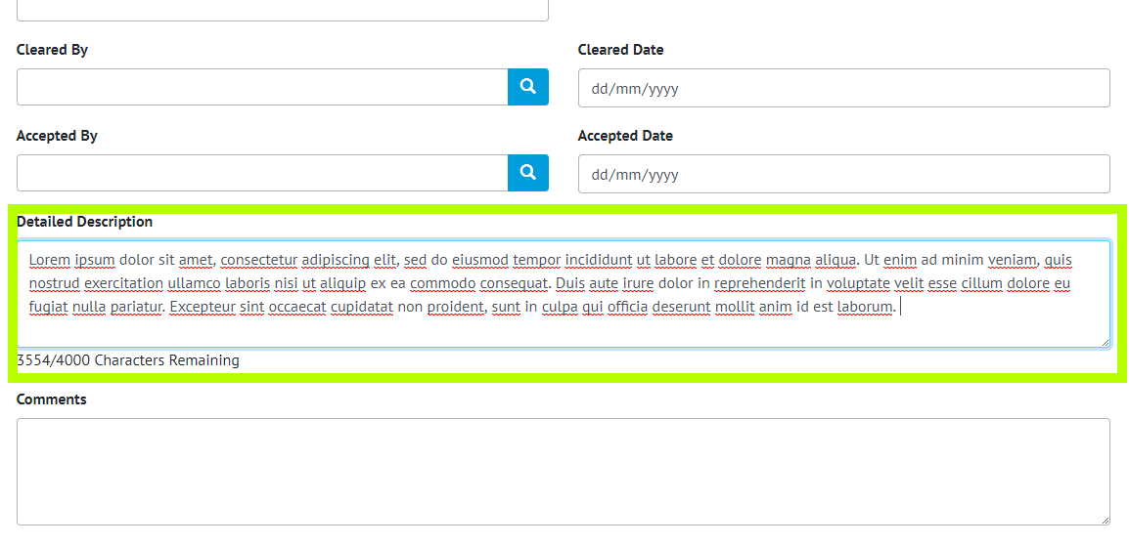

1. Screenshot of the Punch List Item Details page with the new Detailed Description Field Highlighted

A new field has been added to Punch List Items called Detailed Description, this new field has a limit of 4000 characters and allows further details on the Punch List outside the normal 255-character description to be added.

## Completion Status Name

The fields for Completion Status (Tag ITR, Preservation, Job Card and Work Pack) have all been increased to 50 characters to allow a large status to be set.

## Tag ITR Digital Document Result API

**For more detail see the Swagger Documentation for v1.12**

Tag ITR Digital Document Results data can now be accessed and updated via the API. This allows an API user to get the full set of data on a Tag ITR Digital Document and then update and complete them using the Restful API, in a JSON format.

## Tag ITR Digital Document Result PDF API

**For more detail see the Swagger Documentation for v1.12**

Tag ITR, Tag PWLs, Handovers and MOC Digital Documents can now be generated via the API, returning either a PDF or Word Template.

## Work Pack Graph API

**For more detail see the Swagger Documentation for v1.12**

The Work Pack API now includes an additional End Point know as Graph. This allows an API user to get the Work Pack with additional related data concerning associated Job Cards, Operations, MOCs and Attachments.