**GoTechnology® hub2**

v1.21 Release Notes

# About this Document

## Purpose

This document provides a brief overview of the changes made between V1.20 and V1.21 of GoTechnology hub2, along with where further details of each change can be found within the updated functional specification, in addition to a listing of completed bug fixes and known issues.

# Fixed Issues

The following issues have been fixed in version 1.21 of GoTechnology hub2

|  |  |  |
| --- | --- | --- |
| Case | Title [sic] | Details |
| 61343 | Issue when Importing Operations | When importing Operations, if rows do not have data in the Is Complete and Percent Complete columns, they are marked as invalid because data is required, however these columns are not mandatory.  This has now been fixed by defaulting Is Complete to false during imports, when neither field is populated |
| 61802 | Update Bookmark List for Procedures | The bookmark for Procedure System was not available on the “Get Bookmark List”.  This has now been fixed and Procedure System appears as a bookmark |
| 61000 | Import Issue when Deleting | If an Import sheet had a duplicate delete request it would fail.  This has now been fixed and the 2nd request to delete will be rejected as a repeated row on the Import. |

# 

# Known Issues

A full list of “Known Issues” can be found at <https://gotechnology.github.io/>

# Features

The following functionality has been added in v1.21:

* Level Selection improvements
* Local Storage on Add/Edit Pages
* Tag ITR Summary Report – Task-Level Reporting
* Handover Dossier Cover Sheets
* Flexible Sign Off on PWLs
* Custom Fields on Tag ITRs

## Level Selection Improvements

**For more details please see section 6 – Level Select and Section 49 – User Settings of the v1.21 Functional Specification**

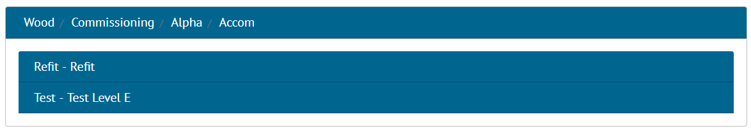

1. New Level Select Screen

The Level Select screen has been improved so that the accordion panels have been replaced by a simple list, with a breadcrumb trail at the top keeping track of which levels have so far been selected. This has been further improved by automatically selecting the next level when there is only one choice available.

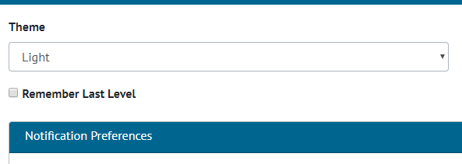

1. New Remember Last Level Option in User Settings

There is also now a “Remember Last Level” feature to allow users to be automatically taken back to the last Level E they were working on when they log in to hub2, with an alert notifying the user they have been automatically logged into that Level E. This feature is on by default.

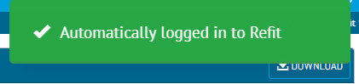

1. Alert notifying user they have automatically been logged in to a Level E

Even if this setting is not enabled, users with access to just one Level E will now be logged in to that Level E automatically, rather than having to go through the Level Select screen.

## Local Storage on Add/Edit Pages

**For more details please see section 9.1.2 – Edit Page of the v1.21 Functional Specification**

Most Add Edit pages will now persist any user input which would previously be lost if a user’s session needed to be reauthenticated during the users save request. The page will reload with their changes still in place, and a warning will be displayed to inform the user the information has not been saved. Clicking save a second time with a re-authenticated session will save the data permanently.

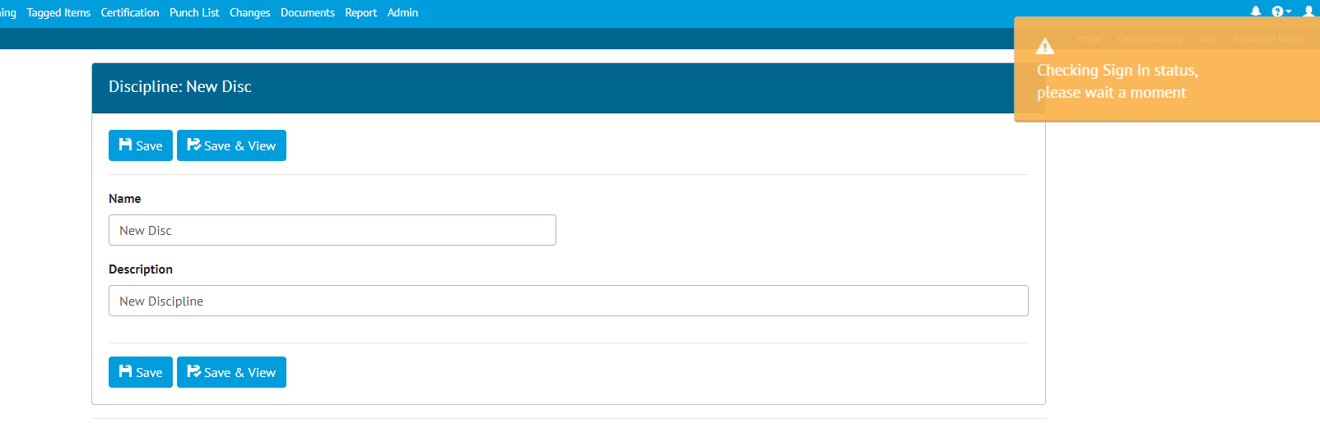

1. Checking user’s sign in status

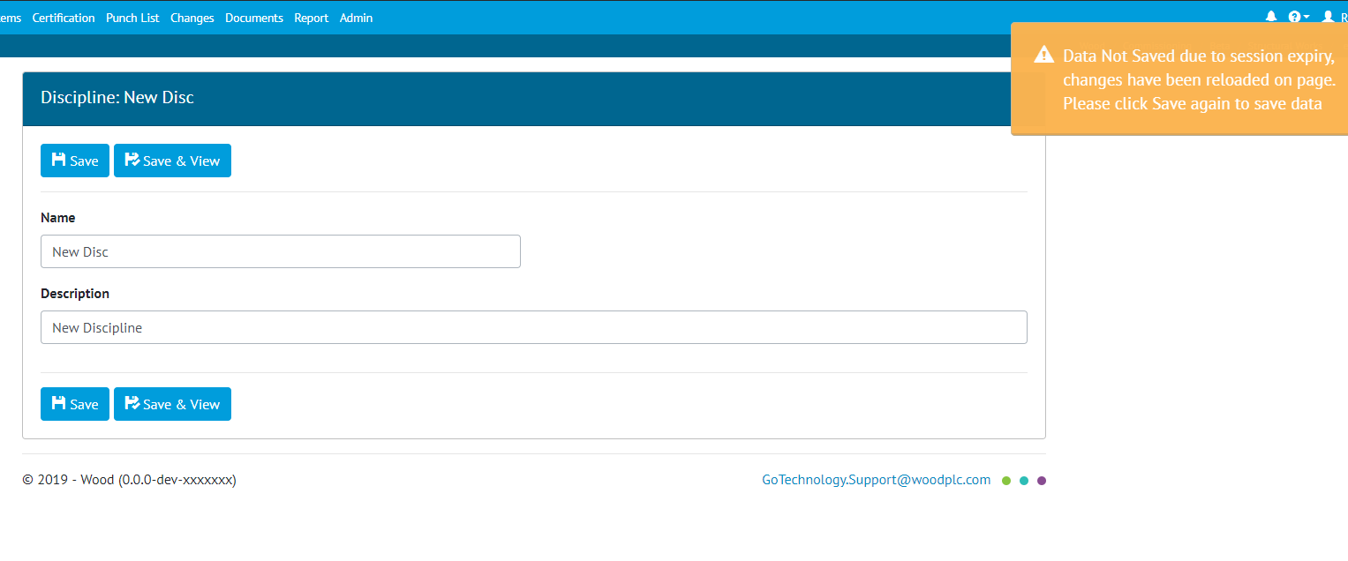

1. Data not saved but persisted on screen to be saved again.

## Tag ITR Summary Report – Task-Level Reporting

**For more details please see section 44.4.2.1.4 of the v1.21 Functional Specification**

Tag ITR Summary Reports now allow the option to add columns which show the counts and progress of Tasks belonging to Tag ITRs within the current report grouping.

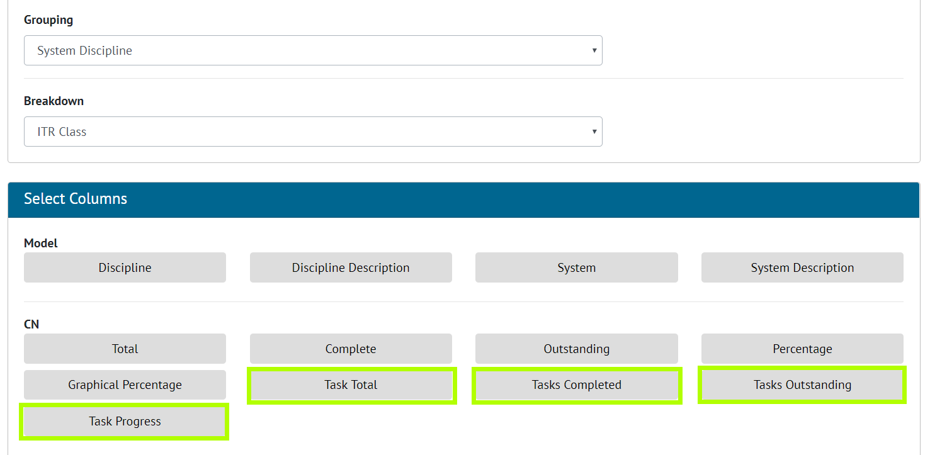

1. Adding Task columns while creating Summary Reports

The Task Summary columns are now available for each of the Groupings and Breakdowns available for Tag ITR Summary Reports.

## Handover Dossier Cover Sheets

**For more details please see section 38 - Cover Sheet of the v1.21 Functional Specification**

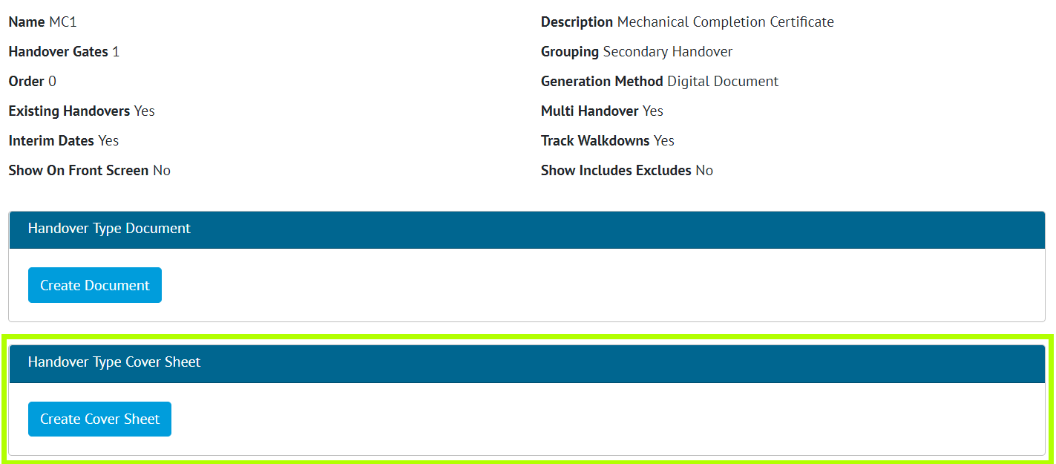

1. Screenshot of the Handover Type View Page with the new Cover Sheet Section Highlighted

A Cover Sheet document can now be created for Handover Dossiers by creating one for the Handover Type. When the Handover Documentation is generated, the Cover Sheet will be the first document in the downloaded file. Bookmark rows and tables may be added to the Cover Sheet, the order of these are configurable to the user’s preference. Additional styling options such as displaying the logos and choosing the font size of the bookmark area are available to the user also.

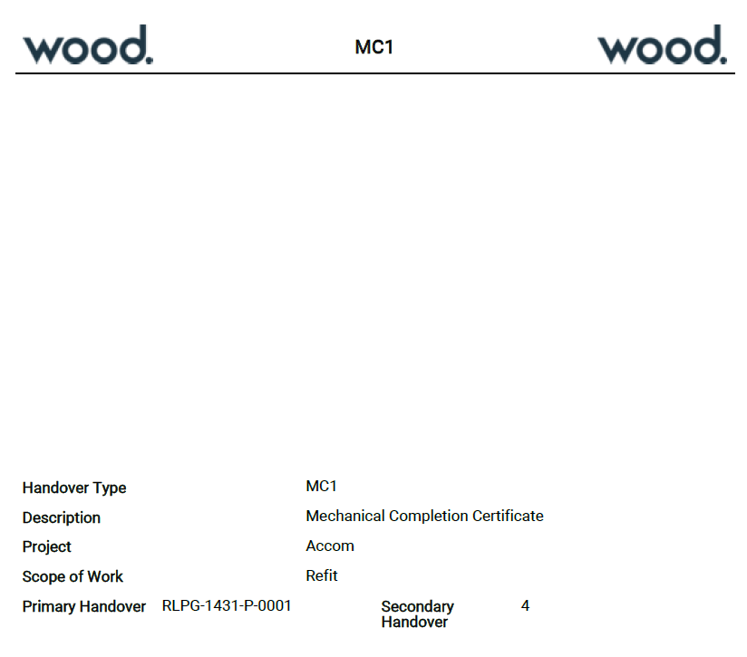

1. Example layout of Handover Type Cover Sheet

## Flexible Sign Offs on PWLs

**For more details please see section 30 – Preservation of the v1.21 Functional Specification**

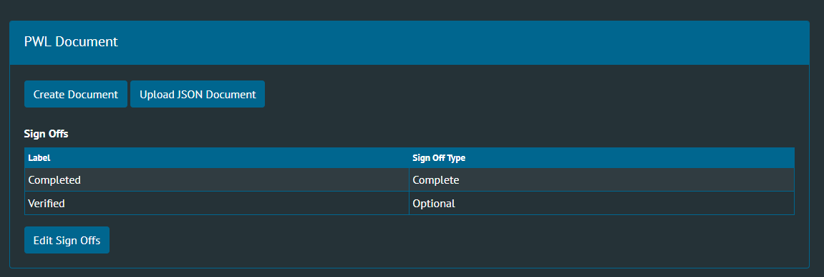

1. Screenshot of PWL Flexible Sign Offs

Flexible Sign Offs have been added to PWLs and Tag PWLs. This allows configuration of different signoffs for each PWL. Tag PWLs will then have the appropriate sign offs available based on the PWL.

## Custom Fields on Tag ITRs

**For more details please see section 47.3.13 – Tag ITR Custom Value of the v1.21 Functional Specification**

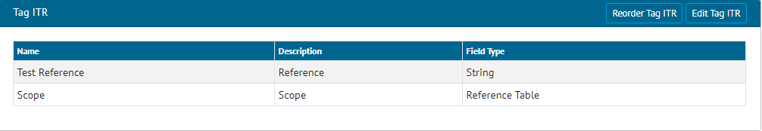

1. Screenshot of Tag ITR Custom Fields

It is now possible to create Custom Fields on Tag ITRs. This allows the user to create string, date, boolean or a new reference table for Tag ITRs. These new custom fields will appear on the Tag ITRs View, Add/Edit pages, Imports/Exports and Tag ITR reports.