**GoTechnology® hub2**

v1.22 Release Notes

# About this Document

## Purpose

This document provides a brief overview of completed bug fixes between V1.21 and V1.22 of GoTechnology hub2.

## About Version 1.22

V1.22 is a maintenance release only, with no new features. Development effort has instead focused on our upcoming mobile app, details of which will be announced soon.

# Fixed Issues

The following issues have been fixed in version 1.22 of hub2

|  |  |  |
| --- | --- | --- |
| Case | Title [sic] | Details |
| 62889 | Editable Headers Not Editable in PDF if the Same Header Label is Used | When a Digital Document was created with two editable headers with the same name, the values were not editable when generated to PDF. |
| 62891 | Digital Document Creation – Tasks appear to be Required | On the Digital Document creation screen, the checkbox which indicates that a task is required was ticked even if the task was not required. |
| 61326 | Notification icon remains highlighted after notifications are cleared | The on-screen notification icon in the page header remained highlighted, even when all notifications were cleared. Clearing notifications now correctly clears the status icon. |
| 62847 | Some values incorrectly formatted as dates in search results | When values which have a similar content to common date formats were displayed within search results, they were being converted to a date format for display on-screen. |
| 63042 | Reports not filtering on certain Boolean fields | When reports were generated using filters such as ‘Is Validated’ on Tags, certain filters were not applied |
| 62994 | Custom fields not appearing in Punch List Item Detailed Report with certain filters | When certain custom fields were included in the Punch List Item Detailed Report, the values were not being returned if the report was filtered by Sub System, System or Phase. |

# Known Issues

A full list of “Known Issues” can be found at <https://gotechnology.github.io/>

# Features

The following functionality has been added in v1.22:

* New Digital Document Default Weighting

## New Digital Document Default Weighting

For Digital Document’s tasks, the default weighting is now set to 1 (previously 0). This ensures progress for all Digital Documents is recorded at Task Level by default. Weighting can be manually adjusted as required.

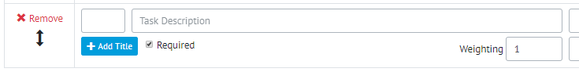

1. New Default weighting for tasks