**GoTechnology® hub2**

v1.25 Release Notes

# About this Document

## Purpose

This document provides a brief overview of completed bug fixes between V1.24 and V1.25 of GoTechnology hub2.

# Fixed Issues

The following issues have been fixed in version 1.25 of hub2

|  |  |  |
| --- | --- | --- |
| Case | Title | Details |
| 63888 | Double Validation message on Work Pack API | When attempting to sign off a Work Pack with an outstanding MOC or Job Card, the validation message would be sent twice in the 422 Response.  This has now been fixed and only one message is sent |
| 60952 | Completion Grid PDF Table Names | On the PDF Report from the Completions Grid the Grids for ITR, PLIs and MOCs all used the same header text (Name). This has been changed to say “ITR”, “PLI” and “MOC” to avoid confusion. |
| 64571 | Tag ITR Export doesn’t correctly filter from the Tag Search Screen. | When Exporting Tag ITRs from the Tag Search screen, some filters such as the Drawing filter were not correctly applied and so would be missed, causing the Tag ITRs Export to have all records instead of just those relating to the selected Tags.  This has now been fixed and the Tag ITRs correctly Export. |
| 63022 | API – The Latest Flexible Sign Offs are returned via the API instead of the sign offs from the Digital Document | When a GET request is sent for an item with Flexible Sign Off (i.e. Tag ITRs) via the API, the request would show the sign offs from the latest revison of the Digital Document associated with the item, instead of the historical Revision in use by that specific item.  This meant it could be impossible to sign off items which used an old set of sign offs.  This has now been fixed and the sign offs for the correct revision are now displayed. |
| 64257 | Validation incorrectly prevents Task Tables from being updated | When updating a Task Table and removing Cells from an existing row, the Validation designed to make sure that all Rows had an equal Cellspan would prevent the table being saved as it was incorrectly still counting the cellspans of the removed cell.  This has now been fixed and cells can now be removed from existing tables. |
| 64661 | Importing a Tag PWL with Sign Offs would always be classed as changed even when no changes were made | When importing a Tag PWL with a Sign Off that had previously been completed the system would incorrectly class the Sign Off as changed in the Import Result file, even if this was not the case.  This has now been fixed and the system correctly shows only changes to the Sign Off details when a change has actually been made. |

# 

# Known Issues

A full list of “Known Issues” can be found at <https://gotechnology.github.io/>

# Features

## Assurance Section

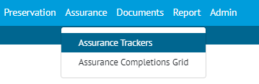

1. Menu of hub2 showing the new Assurance Section

An Assurance section has been added to hub2 that can be activated on request. This section allows for additional Digital Documents to be added outside the normal Tag ITR processes, and is intended to allow for information which would normally be stored in separate spreadsheets or databases to be recorded here instead.

Examples of information which may be useful to store in this section include:

* Construction Readiness Check Lists
* Operation Readiness Trackers
* Asset Integrity Check Lists

Each of these would be created as a new Tracker Type and given it’s own Digital Document (like an ITR or PWL) These Digital Documents can be processed by associating them with a Assurance Tracker.

### Data Structure

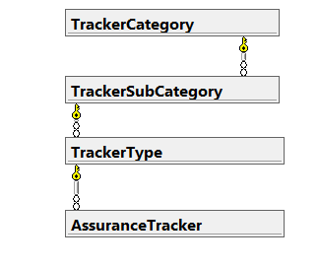

1. Data Structure of the Assurance Section

### Report

A Detailed Report for each Assurance Tracker can be made using the Detailed Report Creation Tool, and a Summary Report grouped by Tracker Type can be made using the Summary Report Creation Tool.

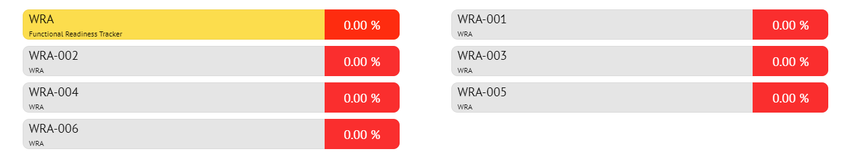

1. Screenshot of the Assurance Tracker Completions Grid

There is also an Assurance Tracker Completions Grid, available from the Assurance section of the menu. This will show the Assurance Tracker Types on the first page and then clicking into each Tracker Type will show each Assurance Tracker under the Type with the Progress of the associated Digital Document shown against it.

Unlike the standard Completions Grid there is no detailed page available when clicking on a Assurance Tracker on this page.

## Digital Document – Drop Down Options

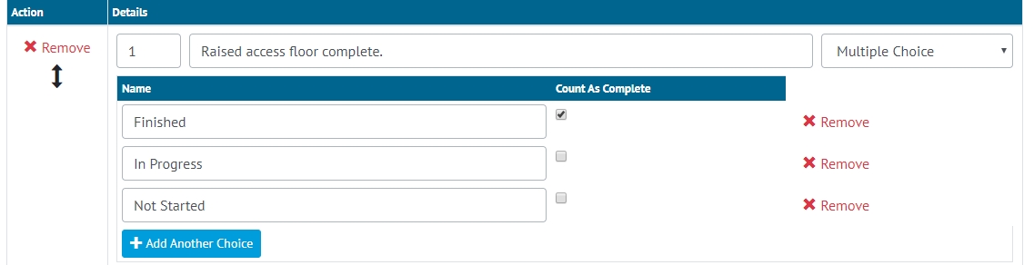

1. Screenshot of the Digital Document Edit page for a Multiple Choice Task

When Creating or Editing an existing Digital Document there is a new Task Type of Multiple Choice.

When Multiple Choice is selected the user can set up a Drop Down List that will appear on the PDF and On screen.

When an option that is counted as completed is selected this will consider the Task to be completed and will increase the Percentage Complete. At least one of the options must be set to be “Count as Completed” for each Multiple Choice Task.

This new option is available on all sections with Digital Document including ITRs, PWL, Work Packs, Handovers and the new Assurance Section.

**NOTE: The Drop Down Functionality currently doesn’t work on the Digital Document screen in our Mobile Application, but does work with the PDFs which can be used in the Mobile Application.**

## Completions Grid – Overall Tab

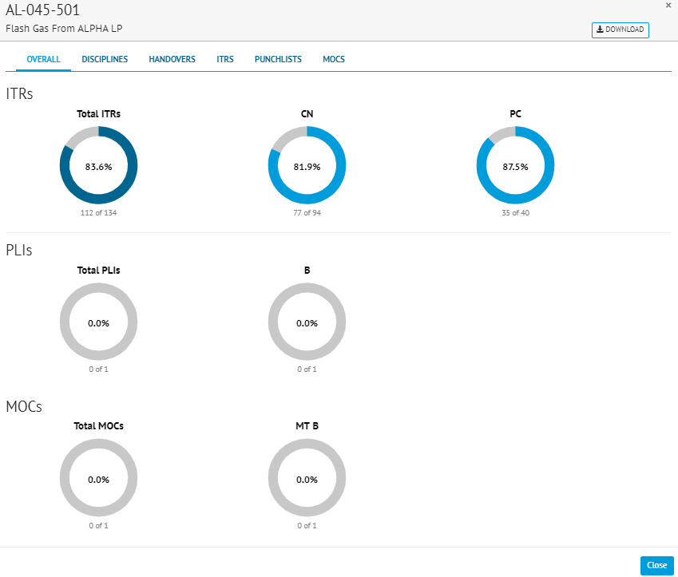

An Overall Tab has been added to the Completion Grid Detail Page, as the new primary page when selecting a System, Sub System or Level. This overall tab shows the Progress on ITRs by Class, Punch List by Category and MOCs By Type with donut style charts.

The Chart can be exported to PDF by using the Download Button in the top right corner.