# About this Document

## Purpose

This document provides a brief overview of completed bug fixes between V1.25 and V1.26 of GoTechnology hub2.

# Fixed Issues

The following issues have been fixed in version 1.26 of hub2

|  |  |  |
| --- | --- | --- |
| Case | Title | Details |
| 64919 | Phase not Aliased on Tracker Type Add/Edit screen | The Phase field on the Add/Edit screen of the Tracker Type screen showed “Phase” instead of the alias value even when an alias had been set.  This has now been fixed and the Alias value for Phase is correctly shown. |
| 64906 | Report error when running a report with empty groupings | When creating a Detailed Report and selecting a Group that can have no value set i.e. Area. If that grouping was the First Grouping shown then the report would fail to generate.  This has now been fixed and the reports correctly generate |
| 64783 | Imports fail if a column called “Details” is included | When performing an Import in hub2 any columns that are included on the Import that are not valid causes an error message to appear. If the user uses a column called “Details” the import instead fails to run and no error message is given.  This has now been fixed so Details shows an appropriate error message when included on an Import |
| 64910 | Handover Reports duplicate Handover data | If a Handover Report is created with two Handovers with the same grouping, the data for one of those Handovers would be repeated for both Handovers. i.e. If you had an MCC and PCC Handover then the dates for MCC Handovers would also appear on the PCC column.  This has now been fixed so the correct data is shown for each Handover. |
| 65050 | Preservation Report doesn’t filter by Signed Off Date | When running a Preservation Report, and using one of the Signed Off Dates as a filter, the report would ignore this filter.  This has been fixed and signed off filters now work with the Preservation Report. |

# 

# Known Issues

A full list of “Known Issues” can be found at <https://gotechnology.github.io/>

# Features

## PWL Look Ahead Report

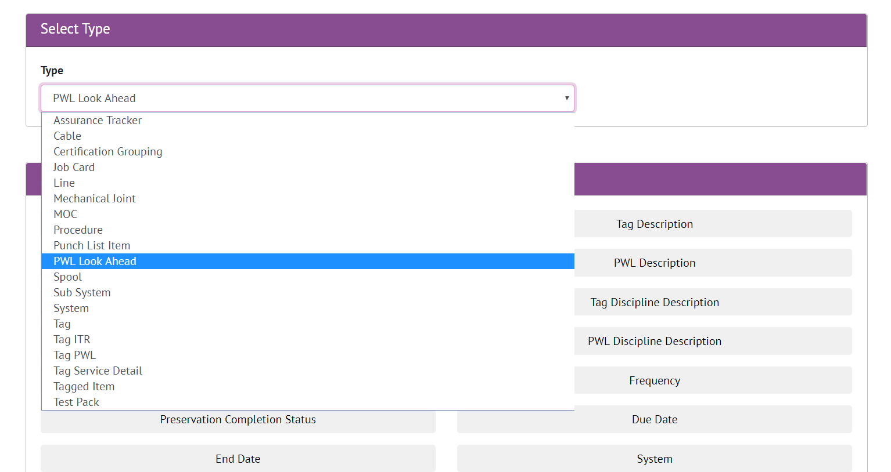

1. Screenshot of the Detailed Report Page with the PWL Look Ahead Report selected

The ability to create a custom detail report for the Tag PWL Lookahead Section has been added. This report shows the Preservation due in the next month assuming that the current Preservation schedule is maintained, and matches the data shown in the Preservation Look Ahead Section.