# Changes in v1.3

## About this Document

### Purpose

This document provides a brief overview of the changes made between V1.2 and V1.3 of hub2, along with where further details of each change can be found within the updated functional specification, in addition to a listing of completed bug fixes and outstanding known issues.

## Fixed Issues

### Issues fixed in V1.3 of hub2

| Case | Title [sic] | Details |
| --- | --- | --- |
| 47682 | ‘Drawing Type – Wrong Header’ | The header on the Drawing Type Add and Edit page was corrected from “Activity” to “Drawing Type” . |
| 47669 | Import – data is updated via Simulate import | The Tag Sub System, Procedure System and various MOC columns were incorrectly updated via Simulated imports. |
| 47667 | Digital Document – Signed Off Data displayed under incorrect column in PDF | In rare circumstances, a Digital Document could be created in such a way that the Sign Offs would display in the wrong order. This has now been fixed and Sign Offs always appear under the correct header. |
| 47087 | Azure Redis Cache fails to reconnect automatically | Distributed caching is used as part of the hub2 solution to allow repeatedly accessed data to be retrieved more quickly. Automatic reconnection has been added to facilitate recovery should cache occur. |
| 47747 | Admin – Deleting Level A Aliases | When attempting to delete an Alias from the Level A admin screen, the screen does not update and the aliases are not deleted. This has now been fixed. |
| 47727 | Tagged Item – Incorrect Tag Type for new Tagged Items | When creating a new Tagged Item the Type could occasionally be set incorrectly. This has been corrected. |

## Outstanding Issues

A full list of “Known Issues” can be found at <https://qedi-gotechnology.github.io/>

## Features

The following functionality has been added in v1.3.

* API
* Queued Imports
* Custom Fields Searching
* Equipment Type to PWL
* Multi Tag ITRs – Table Bookmarks
* Q-Pack Reports
* Light Theme
* Loops Added
* Parent Tags Added
* Import Results Column Order
* Import Results Summary
* Total Field for Summary Count Reports
* Bookmark Tidy-up
* Future Dates on Validation Imports
* Subset of Users in Authorised Person Popup
* Add Button in Parent Items View Page
* Generate Buttons on Search Pages
* Mock ITRs
* Additional Filters on Attachment Search
* Prevent API Fields being used in Entities Names
* Better Quality Logos
* User Name on Import Results Search
* Company on Digital Document
* Handover Filters Order
* Remove Import File Button

### API

**Full Details in Swagger API Specification, and supporting document**

An API has been added to hub2 to allow data in most ‘Reference Tables’ to be Read, Created, Updated and Deleted. Full details of the API are available on request.

### Queued Imports

**Full Details in 37.1 - Imports Definition, 37.1.6 – Enqueue Import & 37.1.10 – Import Result Email**

Full and Simulated Imports now operate in a queued fashion where, once an Import is submitted, Users can now continue to use different pages and sections of hub2 while the Import is processed in the background.

Once complete a notification email will be sent to the user, informing them of the Import results.

### Custom Fields Searching

**Full Details in 39.2.3 – Custom Fields - Editing Custom Values**

Custom Fields were added in v1.2 and allowed Users with the appropriate permissions to create new fields to be present on Tagged Items. In V1.3 these Custom Fields will also appear on the appropriate Search pages to allow their use in locating any related records.

### Equipment Type to PWL

**Full Details in Section 32.2 Equipment Type to PWL**

An Equipment Type to PWL Review page has been added under the Preservation menu which works in a similar way to the already available Equipment Type to ITR Review, allowing comparison between the appropriate Auto Allocation and the actual assignment of PWLs.

If any changes are required in this regard, they can be made quickly and easily from the new page.

### Multi Tag ITRs – Table Bookmarks

**Full Details in 33.2.1.3 Certification Output - Table Bookmarks**

Table bookmarks can now be added to DOTX Templates to allow population of list based information, such as Tag Drawings.

Setup involves two or more bookmarks: The first bookmark is known as the table bookmark and defines the basic contents of the table (for example a list of Tag Drawings).

Each additional bookmark defines the column of information to be displayed, for example a bookmark for Name and a bookmark for Description.

### Q-Pack Reports

**Full Details in 38.5.2 Q Pack Reports**

The following Q Packs reports have been added:

* QPR - Q Pack Progress Report
* QDR – Q Pack Detailed Report
* QBR – Q Pack Task Breakdown Report

### Light Theme

### 

1. Comparison of the hub2 themes with the previous dark theme on the left and the new, lighter theme on the right.

Following User feedback, the default theme for hub2 has been changed from dark to light. In future versions, Users will be able to select which theme they prefer.

### Loops Added

**Full Details in Section 12.3.7 – Reference Tables: Loop & 15.3.1 – Tagged Item**

Loops have been added to the Reference Table and can now be linked with Tags and Cables.

### Parent Tags Added

**Full Details in Section 12.3.9 – Reference Table: Parent Tag & 15.3.1 – Tagged Item**

Parent Tags have been added to the Reference Table and can now be linked with any Tagged Item.

### Import Results Column Order

**Full Details in 37.1.8.1.b – Imports and Exports – XLSX Results**

The Import Results have been improved to match the column ordering and selection of the source Import file.

For example, if an Import is performed with the Description column as the first column and then the Name column second, the result files will also use this order. Similarly, if a column is omitted from an Import file it will also be omitted from the result file.

### Import Result Summary

**Full Details in 37.1.8 – Imports and Exports – Import Result Sheets**

The Import Result Summary has been changed so the “To Be Added”, “To Be Updated” and “To Be Deleted” rows only appear in a Simulate Import, and the “Added”, “Updated” and “Deleted” rows only appear in the Full Import.

The Validation Import now has a row called “Validated” to make it clear which rows are validated.

### Total Field for Custom Summary Count Reports

**Full Details in 38.4.1.c – Reporting – Available Breakdowns**

When creating Custom Summary Reports previously only Completed, Outstanding and Percentage values could be chosen for each Count Breakdown.

For version 1.3 it is also possible to add a Total column which will display the full number of items within that category (for example “Total ITRs” within a System).

### Bookmark Improvements

**Full Details in 33.2.1 – Certification Output - Bookmarks**

Changes to bookmarking within hub2 have increased compatibility with documents created for older GoTechnology® products.

In addition a new Validate button has been added to the ITR View page which, when used, will check the allocated dotx template and provide feedback on the validity of any bookmarks used.

### Future Dates on Validation Imports

**Full Details in 37.1.7.2 – Imports and Exports – Date Check**

Fields which don’t allow future dates are now validated as part of a Validation Import, providing feedback to the User if the date chosen is not acceptable.

### Subset of Users in Authorised Person Popup

**Full Details in 12.3.2.2 – Reference Tables – Authorised Persons Permissions**

Filtering has been added to the “User” popup on the Authorised Person screen to only show those with access to the selected Level C.

### Add Button in Parent Items View Page

**Full Details in Multiple View Page Sections – Tag, Cable, Piping, Procedure, Procedure Skelton**

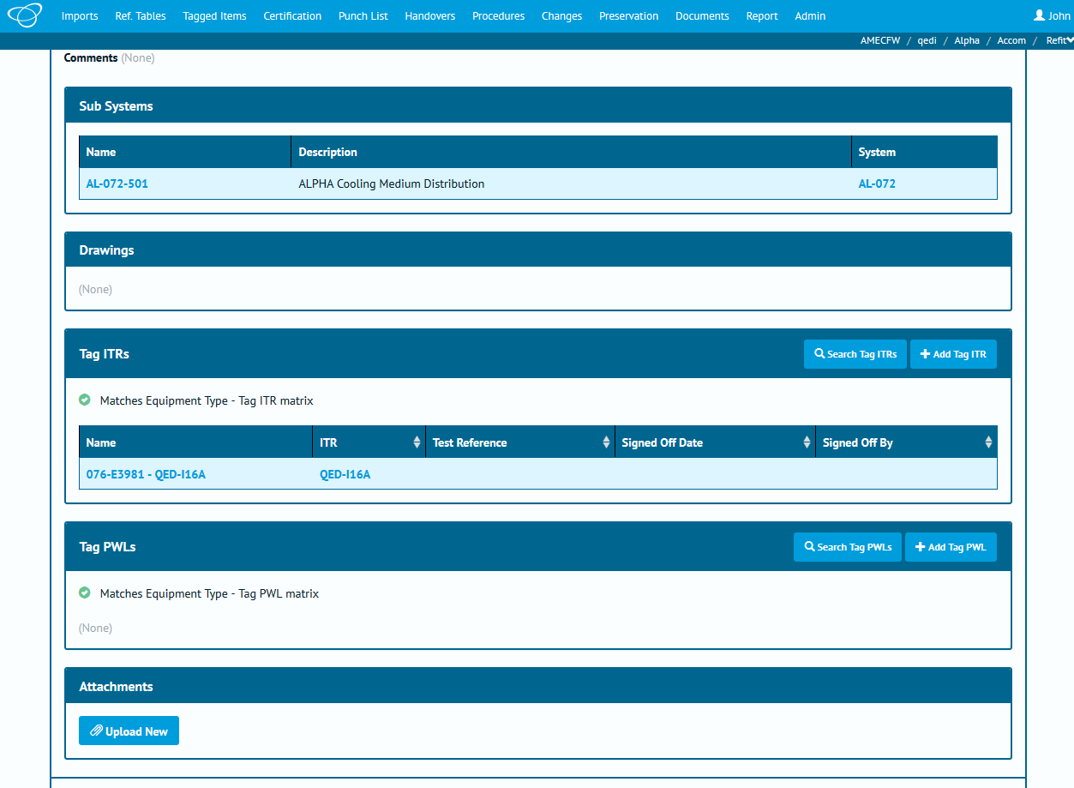

1. Screenshot of the Tag page with “Add Tag ITR” highlighted in orange and “Add Tag PWL” highlighted in purple.

It's now possible to add “child” items, such as Tag ITR and Tag PWLs, via the “parent” page with the addition of an “Add” button above the appropriate grid.

### Generate Buttons on Search Pages

**Full Details in Multi Search Page Sections - Tag ITR, Tag PWL, MOC, Handover and Tag Q Step**

Generation of multiple documents from the search page has been extended to include Tag Q-Packs, Tag PWLs, MOCs and Handovers.

### Mock ITRs

**Full Details in Section 23.3.1.2 - ITR: Entity Listing**

A field has been added to the ITR report that allows a ITR to be marked as a mock or fake ITR. These ITRs can then be excluded from counts of ITRs on the ITR Search page and the ITR Summary and ITR Detailed Report.

In a future version, it is anticipated this functionality will be extended to allow Mock ITRs to be excluded on other report types.

### Additional Filters on Attachment Search

**Full Details in Section 31.1.2.1 – Attachment Search**

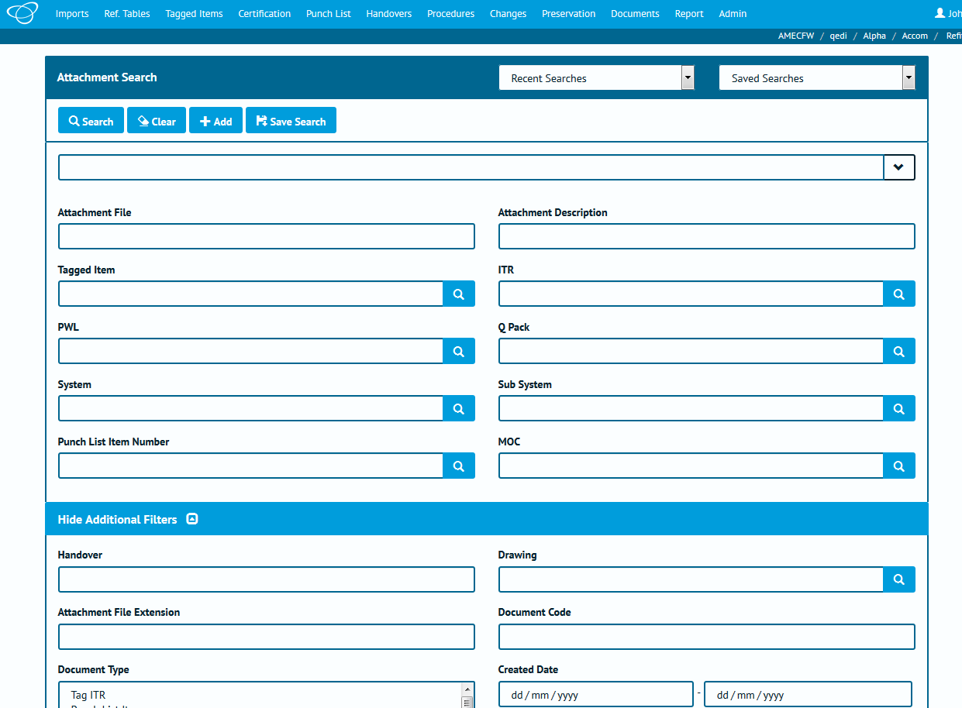

1. Screenshot of the Attachment page with the new filters highlighted in orange.

Filters have been added to the Attachment search page to allow to search based on the name of the item the Attachment has been associated with (for example Tagged Item, MOC, etc.)

### Prevent API Fields being used in Entities Names

**Full Details in Section 3.2 – General – Data Rules**

Additional Validation checks have been put in place on all “Name” fields (for example Tag Name, or System Name) to prevent them containing ! (exclamation mark) or ; (semi-colon) characters.

These characters are restricted due to requirements of the newly released API.

### Better Quality Logos

The logos that are included in hub2 are now stored in a higher resolution.

### User Name on Import Results Search

User Name is now available as a search filter on the Import Logs Search page.

### Company on Digital Document

Digital Documents now populate the Authorised Persons Company in the Company column automatically.

### Handover Filters Order

The filters on the Handover page have been reordered so that items related to the grouping appear at the top of the search page. For example, for the Sub System Discipline Handover, the Sub System and Discipline filters will be listed at the top of the page.

### Remove Import File Button

A “Remove” button has been added to the Import page to allow an already selected import file to be removed, without selecting a new file.