**GoTechnology® hub2**

v1.37 Release Notes

# About this Document

## Purpose

This document provides a brief overview of the changes made between V1.36.2 and V1.37 of GoTechnology hub2, along with where further details of each change can be found within the updated functional specification, in addition to a listing of completed bug fixes and known issues.

# Known Issues

A full list of “Known Issues” can be found at <https://qedi-gotechnology.github.io/>

# Features

The following functionality has been added in v1.37:

* Linking to a Documentum Repository
* Add an Attachment from Documentum
* Check for Updates in Documentum

## Linking to a Documentum Repository

**For more details, please see section 3.2.2.2 of the v1.37 Functional Specification**

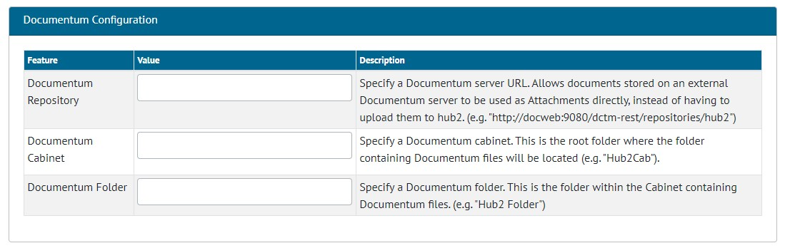

1. Documentum Configuration on the Level E Edit Page

hub2 allows files and attachments to be linked from Documentum and connected to entities within hub2. To configure the connection with Documentum, contact your Focal Point or the Support Team.

## Add an Attachment from Documentum

**For more details, please see section 17.4.2.3 of the v1.37 Functional Specification**

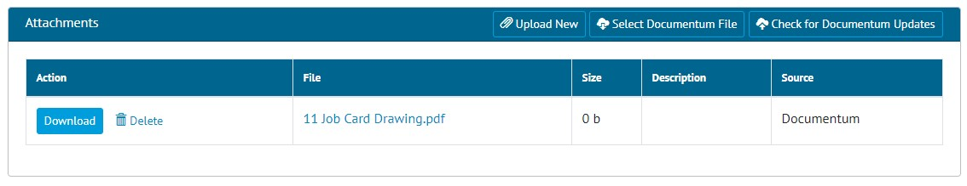

1. The Job Card View page, showing a PDF sourced from Documentum

Once the connection to a Documentum Repository has been configured, they can be pulled through into hub2. In all places where you can add an attachment, it will now be possible to select a file from Documentum.

For example, to add a Documentum file to a Job Card, view the Job Card and click the “Select Documentum File” button. The Documentum File Picker will open.

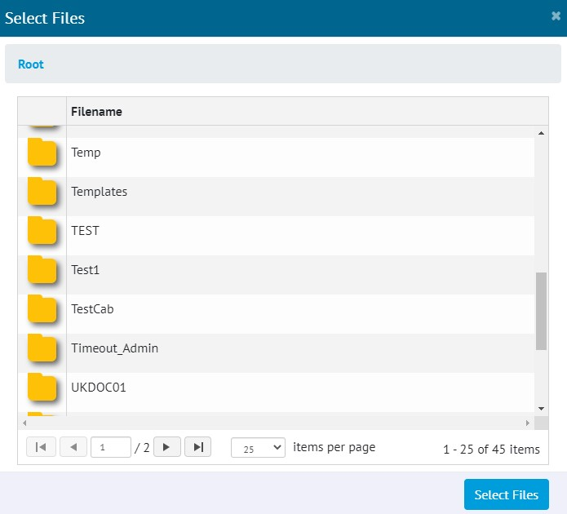

1. Documentum File Picker

Once a file has been selected in the File Picker, it will be added to the list of Attachments. Users may then download and view this file, as they would with any other attachment in hub2.

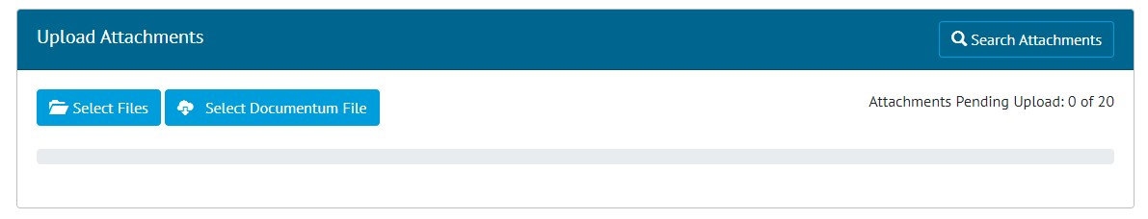

1. Selecting Documentum files on the Attachments Screen

Alternatively, go to Documents -> Attachments, click ‘Add’, click ‘Select Documentum File’.

## Check for Updates in Documentum

**For more details, please see section 17.4.3.3 of the v1.37 Functional Specification**

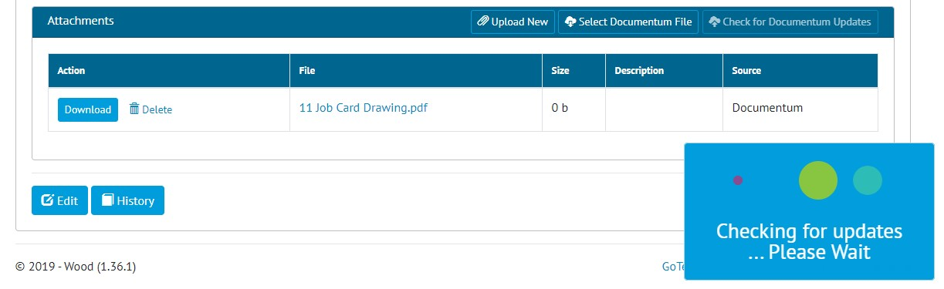

1. Checking for updates to Documentum files

To check whether a file has been modified in Documentum since it was added in hub2, click the “Check for Documentum Updates” button on the Job Card View page.

Any files that have updates available will be listed with the option to link the updated version if wanted.

A “Check for Update” button can also be found by going to Documents -> Attachments, viewing an attachment and clicking the Edit button.

# Companion App Features

Version 1.8 of our GoTechnology hub2 Companion Application is also being released alongside GoTechnology hub2 v1.37. The following new functionality has been added to the App.

* Sync Tag ITRs, Punch List Items and Tag PWLs between a device and hub2.

The application can be downloaded from the App Store or the Google Play Store at the following links

* Apple: <https://apps.apple.com/us/app/gotechnology-companion-app/id1485718605>
* Google: <https://play.google.com/store/apps/details?id=com.wcs.hub2DigitalDocuments&hl=en_GB>

## Sync

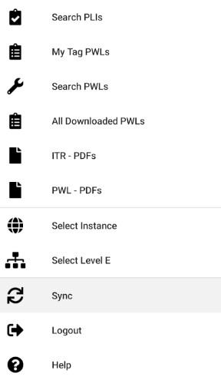

1. New “Sync” menu item

To sync your device with hub2, tap to open the menu, and then tap on the new “Sync” item. To begin syncing, tap on the “Start” button.

When a device is synced, any changes made to Tag ITRs, Tag PWLs and Punch List Items on the device will be uploaded to hub2. Any changes that have been made in hub2 since the last sync will be downloaded to the device.

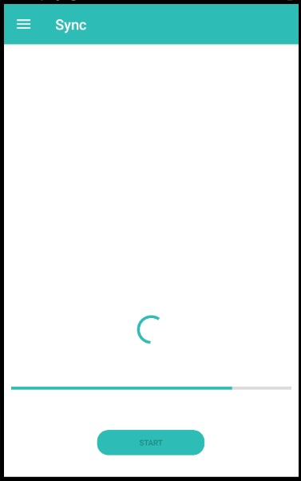

1. Sync in progress

A progress bar is shown while the sync is taking place.

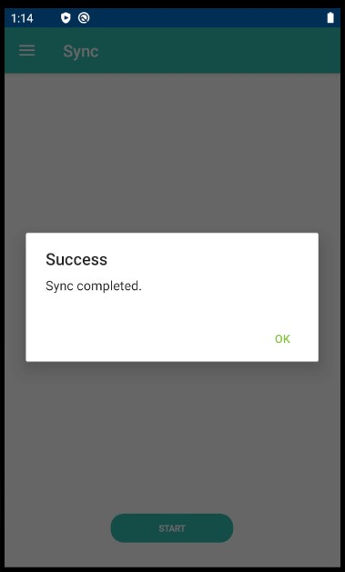

1. Sync completed