V1.43 Release Notes

GoTechnology hub2

1. About this Document

Purpose

This document provides a brief overview of the changes made between V1.42.1 and V1.43 of GoTechnology hub2, along with where further details of each change can be found within the updated functional specification, in addition to a listing of completed bug fixes and known issues.

1. Fixed Issues

The following issues have been fixed in version 1.43 of hub2

|  |  |  |
| --- | --- | --- |
| Case | Title [sic] | Details |
| 81580 | Failing Tag PWL Import | If a Tag PWL import was missing the PWL column, the import was not successful and a message was displayed asking the user to contact the Support Team. This has been improved so that a message is now displayed that explains that the PWL column is missing and must be added for the import to run. |
| 85787 | Pagination missing on Procedures grid | When viewing a Procedure Handover, a list of Procedures is displayed. This list was missing any pagination buttons, meaning that it was only possible to view the first few procedures. The page buttons are now displayed so that it is possible to view the next procedures. |
| 85770 | Scheduled Reports Results | On the Scheduled Reports Results page it was possible to see report results from other levels. This has been corrected so that only Scheduled Reports that belong to the current level are displayed. |
| 80332 | Level E Name bookmark not populated in App | Sometimes the Level E Name bookmark was not being populated on digital documents on the Companion App. This has been fixed. |
| N/A | Error when signing off Tag ITRs | If a digital document header field contained a backslash character – “\”, then an error occurred when saving the digital document. This has been modified so that the document will save successfully when header fields contain backslashes. |
| 90379 | Skylines paging | There was an issue where on some Skylines nothing happened when clicking the paging buttons on the ITRs grid on the pop-up. This has been fixed. |
| 89528 | Deletion of ITRs | Some ITRs could not be deleted successfully. This issue has been resolved so that it is now possible to delete them and error handling has been added. |

1. Known Issues

A full list of “Known Issues” can be found at <https://qedi-gotechnology.github.io/>

1. Features

The following functionality has been added in v1.43:

* Soft delete
* Raising PLIs on Tag PWLs
* Authorised Person Detailed Report
* Rejection Reasons in emails
* Task limit increased
* Process Builder stage rejection behaviour
* Process Builder Detailed Report
* API - Updating Custom Values on PLIs

1. Companion App Features

Version 1.13 of our GoTechnology hub2 Companion Application has also been released alongside GoTechnology hub2 v1.13. The following new functionality has been added to the App.

* Raising PLIs on Tag PWLs
* New filters on Tag ITR Search
* New filters on Tag PWL Search
* Custom Fields on PLIs

The application can be downloaded from the App Store or the Google Play Store at the following links

* Apple: <https://apps.apple.com/us/app/gotechnology-companion-app/id1485718605>
* Google: <https://play.google.com/store/apps/details?id=com.wcs.hub2DigitalDocuments&hl=en_GB>

1. Soft Delete

**For more details, please see section 12 – Soft Delete of the v1.43 Functional Specification**

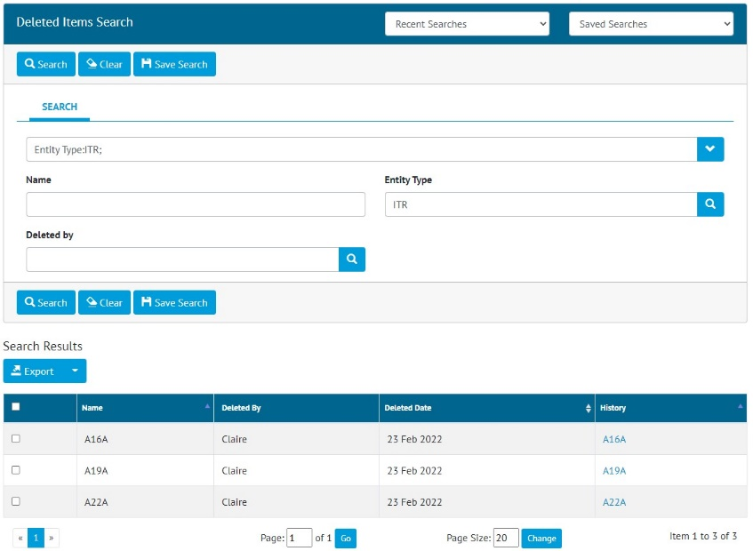

1. The Deleted Items Search page showing deleted ITRs

Soft delete has been added to a number of entities within hub2. This means that if these items are deleted a record will be maintained allowing Admin users to see what has been removed.

To view the deleted items, go to Admin -> Deleted Items -> Select an Entity Type -> Click Search. **Note, that there must always be an Entity Type selected to return any results.**

The search results show who deleted an item and when and has a link to the full history of that item.

Soft delete applies to the following items:

* All entities under Refs table menu
* Work packs
* Job cards
* Operations
* All Tagged Items (Cables, Tags, Spools, Lines, Mechanical Joints, Test packs, Tag Sets)
* Tag ITRs
* Multi Tag ITRs
* Punch lists and Punch List items
* Procedures (Procedure Sections, Steps, Skeletons, Skeleton Sections, Skeleton Steps etc.)
* Tag PWLs
* MOCs
* Assurance Trackers
* Documents (As Built Drawings)

1. Raising PLIs on Tag PWLs

It is now possible to ensure that Punch List Items are raised during the completion of a Tag PWL document, when specific task answers are made.

1. Specifying the check box answer for Punch List Items

To configure this feature, go to Ref. Tables -> Digital Check Box Types and edit one. In the Punch List Check Box field select one of the checkbox options, for example “PL” above. If you do not want to use this feature, select “No checks raise punch lists”.

1. Creating a new PLI after clicking the PL answer on a Tag PWL Task

Then when completing a digital document, if a user clicks the “PL” checkbox option a pop-up will be displayed where the details of the new Punch List Item can be entered. It will not be possible to save the digital document without creating a Punch List Item for each task where this checkbox has been selected.

1. Edit/Delete PLI buttons on a Tag PWL Task

After saving the document the task will have new buttons for editing/deleting the associated Punch List Item.

1. Authorised Person Detailed Report

**For more details, please see section 43 – Custom Reports of the v1.43 Functional Specification**

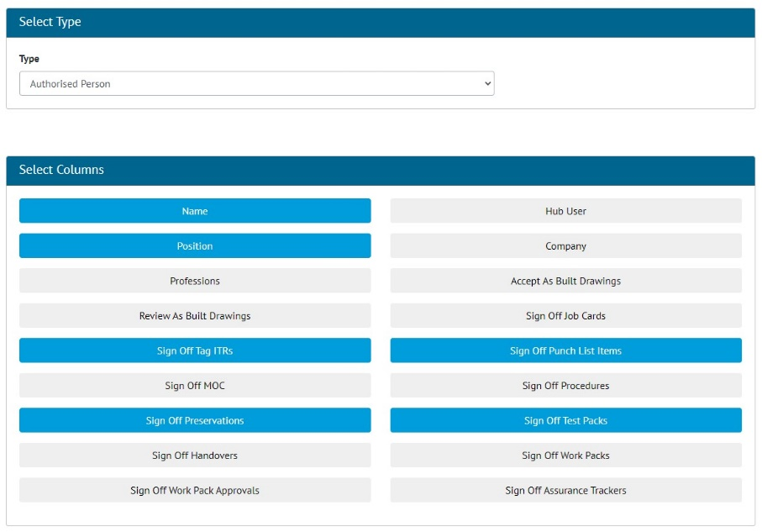

1. Creating an Authorised Person Detailed Report

Detailed Reports can now be generated for Authorised Persons. To create one, go to Reports -> Create New Detailed Report -> select Authorised Person as the Type, and then choose the fields to include on the report.

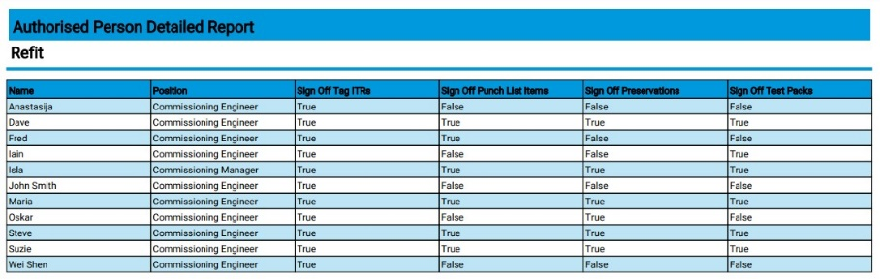

1. Example of an Authorised Person Detailed Report

To run the Report, go to Report -> Report List and click on the new report. Choose filters if desired and click Run PDF or Run Excel.

1. Rejection Reasons in Emails

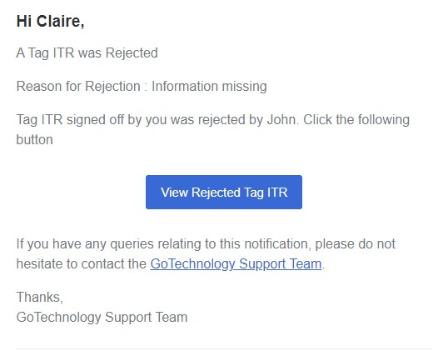

1. A Tag ITR rejection email showing the Rejection Reason

When a Tag ITR is rejected, a notification email is sent to the users who signed it off. This email now includes the Rejection Reason given by the user who rejected it.

This change also applies to the emails sent when a Tag PWL is rejected.

1. Task Limit Increased

Digital documents previously had a limit of 100 tasks. This has been increased so it is now possible to create digital documents that have up to a maximum of 200 tasks.

1. Process Builder Stage Rejection Behaviour

**For more details, please see section 45 – Process Builder of the v1.43 Functional Specification**

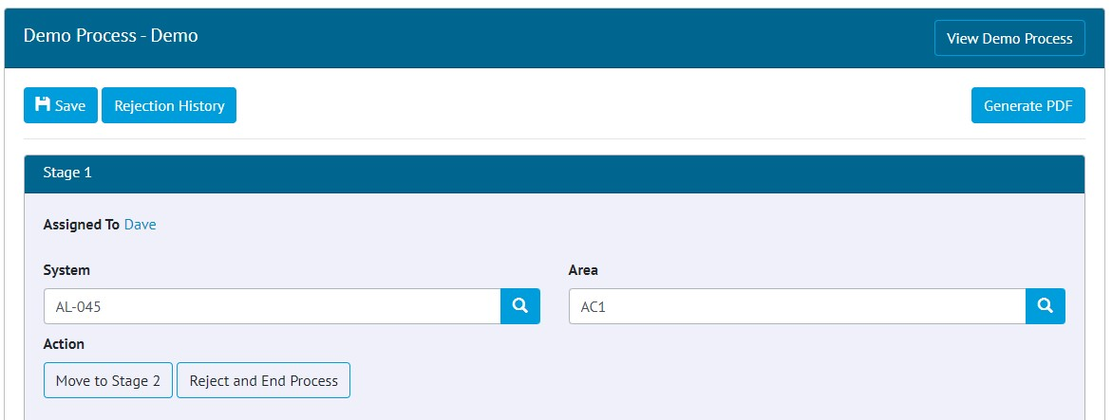

1. A rejected process showing the values previously entered for this stage

When a Process is rejected to an earlier Stage, it now retains the values that were previously entered for that stage, so there is no need to gather that information again. Any necessary changes can be made and then the Process can continue to the next Stage.

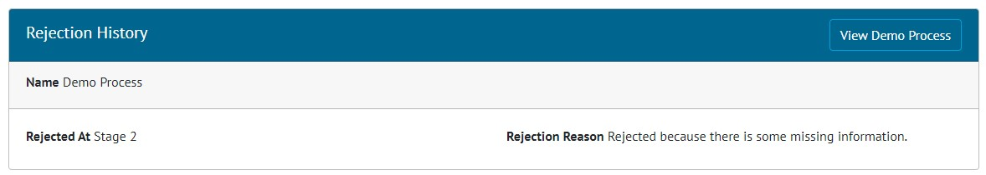

1. The new Rejection History view

There is a new Rejection History button at the top of the Process Document page. This displays all the rejection history in a single place making it easier to follow.

1. Process Builder Detailed Report

**For more details, please see section 45 – Process Builder of the v1.43 Functional Specification**

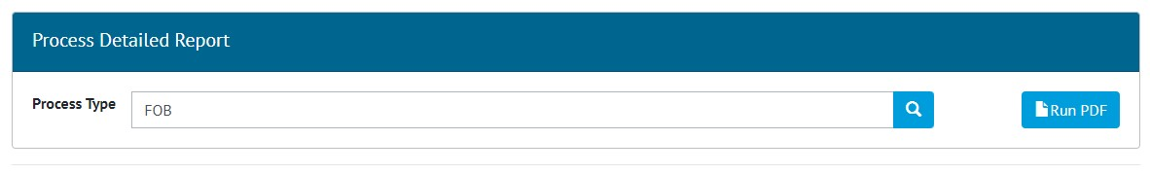

1. The Process Builder Detailed Report generation screen

There is now a Detailed Report available in the Process Builder. To generate this go to Process Builder -> Detailed Report -> Select a Process Type -> Click Run PDF.

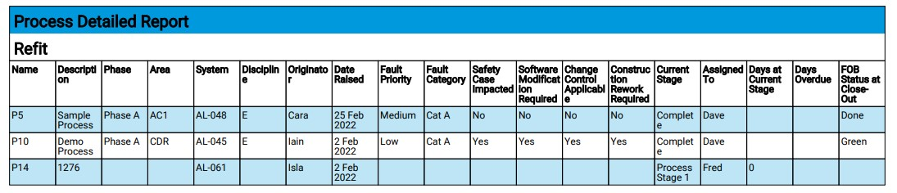

1. Example of a Process Builder Detailed Report

The columns will only be populated if there are fields on the Process Type with the same names.

1. API - Updating Custom Values on PLIs



1. Swagger page showing new API PUT endpoint

The API now includes support for updating Custom Values on Punch List Items. There is a new PUT endpoint that allows the custom values on a Punch List Item to be updated.

For more information see the Swagger page: https://yourHub2Instance/swagger

1. App - Raising PLIs on Tag PWLs

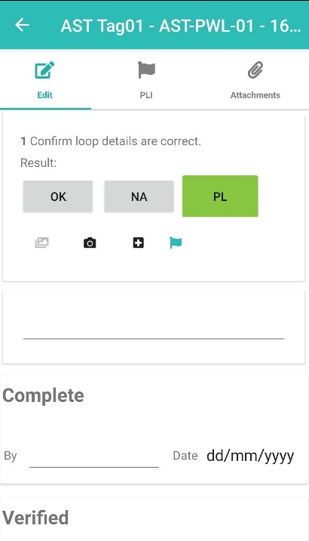

1. Tag PWL Document screen showing PLI flag where a PLI has been raised against a task

The app also now ensures that Punch List Items are raised for every digital document task where the “PL” check box was chosen, if the PWL uses a Digital Check Box Type which has this feature turned on.

When the user taps the “PL” checkbox they will be taken to the Add PLI screen where the details can be entered. A PLI flag icon is then displayed by the task. To edit the PLI, tap the flag icon. The PLIs can also be found on the PLI tab.

The new PLI will be uploaded to hub2 when the Tag PWL is uploaded, or the device is synced.

1. App - New filters on Tag ITR Search

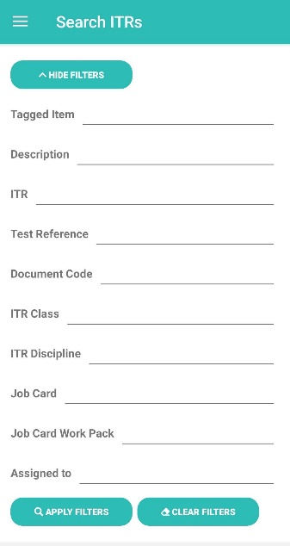

1. The new filters on the Tag ITR Search screen

There are new search filters available for Tag ITRs. These are:

* ITR Discipline
* Tagged Item Description

1. App - New filters on Tag PWL Search

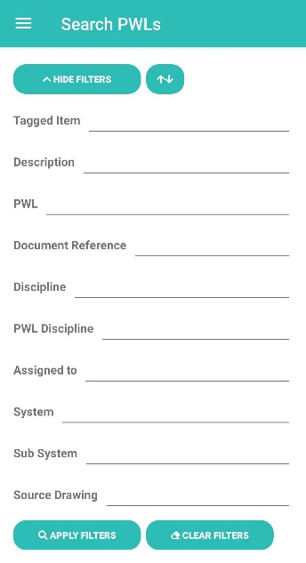

1. The new filters on the Tag PWL Search screen

There are new search filters available for Tag PWLs. These are:

* PWL Discipline
* Tagged Item Description

1. App - Custom Fields on PLIs

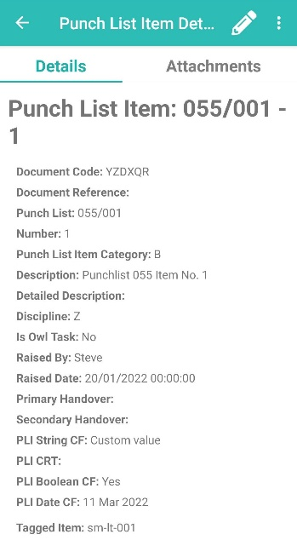

1. Custom Fields called “PLI String CF”, “PLI Boolean CF”, “PLI CRT” and “PLI Date CF” shown on the View PLI screen

Custom Fields are now available on Punch List Items on the App. The fields are shown when viewing a PLI, and they can be edited, and the new values are then uploaded to hub2 when syncing the App.

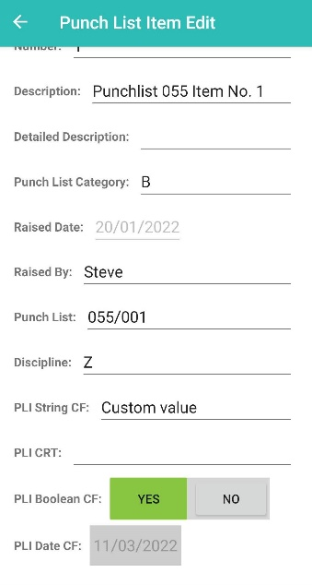

1. Custom Fields called “PLI String CF”, “PLI Boolean CF”, “PLI CRT” and “PLI Date CF” shown on the Edit PLI screen