V1.51.1 Release Notes

GoTechnology hub2

1. About this Document

Purpose

This document provides a brief overview of the changes made between V1.51 and V1.51.1 of GoTechnology hub2. This includes some minor new functionality and completed bug fixes.

1. Fixed Issues

The following issues have been fixed in version 1.51.1 of hub2.

|  |  |  |
| --- | --- | --- |
| Case | Title [sic] | Details |
| 129077 | Incorrect warning message | Users reported receiving a warning message when signing off a Tag ITR that stated that Punch List Items must be created first. In this case, the necessary Punch List Items already existed, so the message should not have been displayed. This has been corrected so that the message no longer appears, and it is possible to complete the sign off. |

1. Features

The following functionality has been added in v1.51.1:

* Improved text wrapping in digital documents
* Attachment file names in Tag ITR documentation

1. Improved Text Wrapping

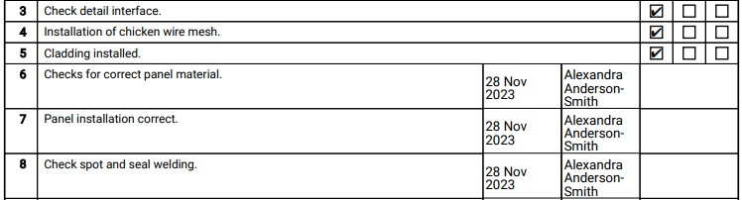

1. Example of long names in PDF

Text wrapping has been updated so that Sign Off Names appear on **fully signed off and generated** PDF certificates. This applies to Task Sign Offs and Sign Offs at the bottom of the page.

1. Attachment File Names in Tag ITR Documentation

Attachment file names are now displayed at the top of each Attachment page when generating documentation. This applies:

* When Tag ITRs are generated with Attachments.
* Where Attachments are included in Handover Dossiers.