# Piece Class Testing

## Input



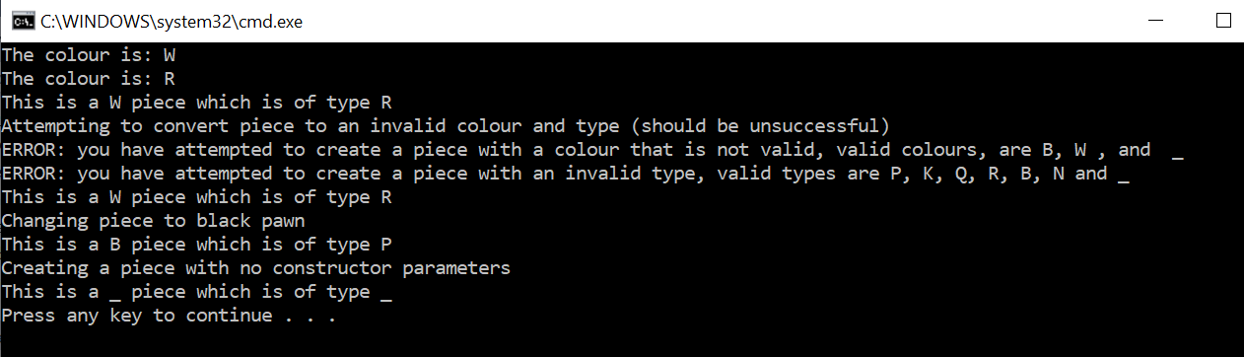

## Output