This contains the printed outputs for the PIECE and RULES classes.

The code is found in TESTING_piece_and_rules.cpp

“(positive test)” indicates the outcome should be 1 (True)

“(negative test)” indicates the outcome should be 0 (False)

# Piece Class function testing

## Output for the code which tests the Piece Class

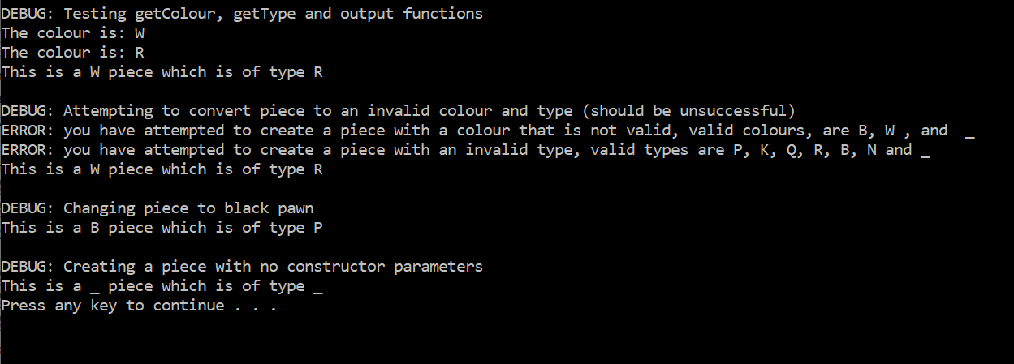

# Rules Class function testing

## Initial moveLegal base conditions

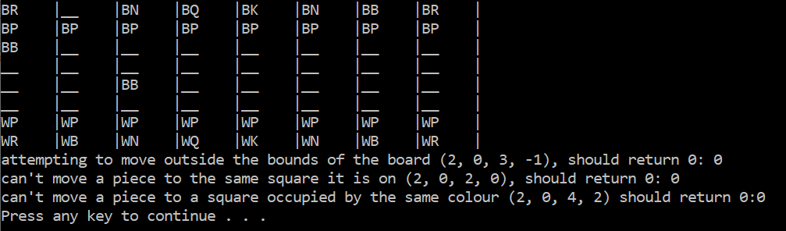

## Pawn_rules Output

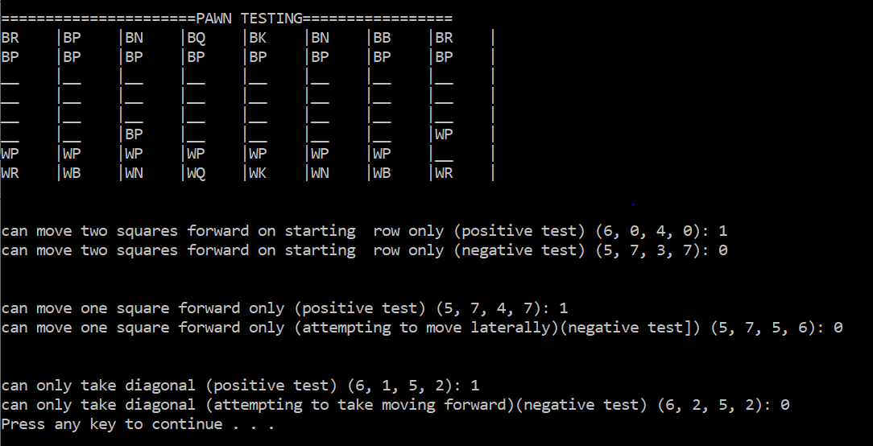

## Rook_rules Output

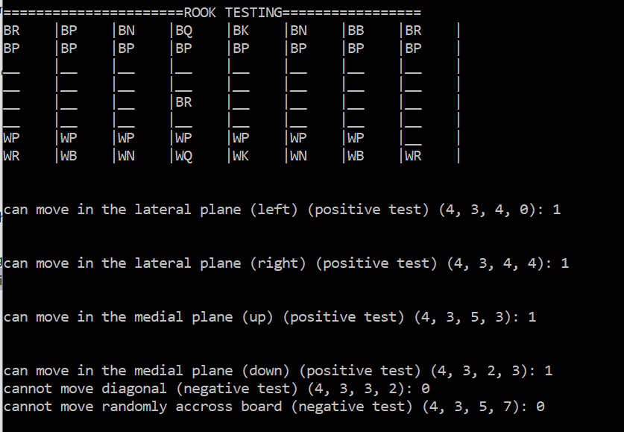

## Bishop_rules Output

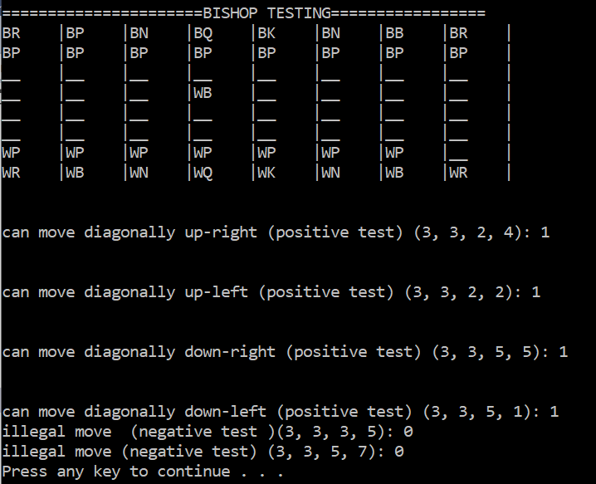

## Queen_rules Output

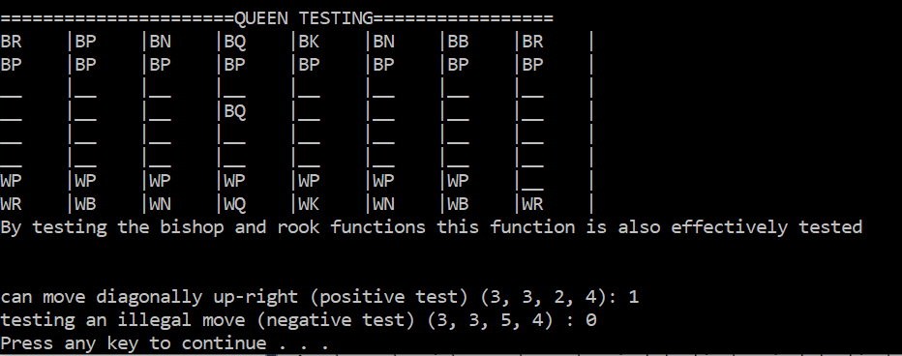

## Knight_rules Output

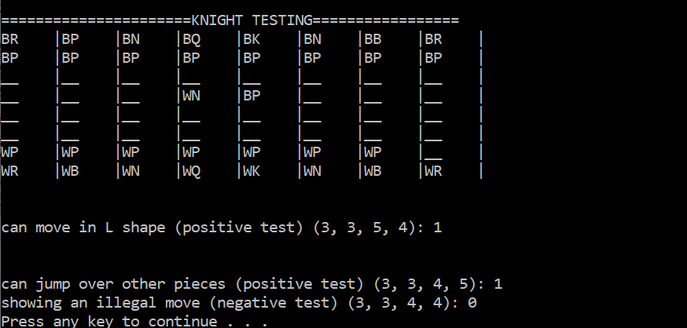

## King_Rules Output

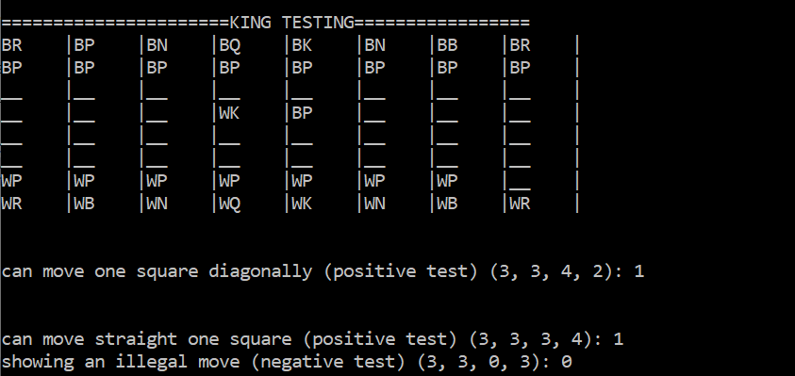

## Final moveLegal Condition

The final check in the moveLegal function is to make sure that making the move would not leave the king in check (this can either happen through moving the king directly or through a discovery)

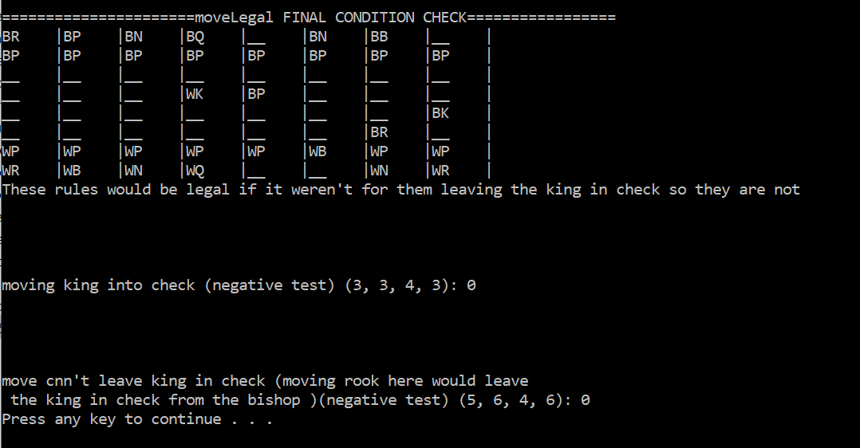

## incheck and square attack Output

