Creating Tax Assessments
LaptopPrice pipeline on a draft-return extract. Short name: TaxCreate.

Problem Statement
A revenue desk has to create an assessment (tax_due) from a messy extract of 920 draft returns. Wages, business income, capital gains, deductions and credits arrive as "$62,000". The state rate is "5.50%". Dependents, pages, stars and tax year carry words ("2 dependents", "8-page", "4 stars", "Not Available"). About 16% of bills are $0 after credits. A mean guess (~$6,300) is a weak pre-check.

Solution Strategy
- Strip $ and commas from five money columns; add gross_income = wages + business + capgains.
- Parse %, stars, dependents, pages; encode missing tax year as 0.
- EDA: heatmap, dependents box, state-rate box, tax_due histogram.
- <5 uniques → one-hot; ≥5 → train-only mean tax_due. 80/20, rs=42.
- RandomForestRegressor vs Linear/Ridge and a mean-assessment baseline.

Solution
Hold-out 184 rows, leakage-safe encode, default 100-tree forest:
Test MAE | Test R² | Mean-baseline MAE | Linear MAE / R²
$1,149 | 0.923 | $4,849 | $1,478 / 0.893
gross_income dominates impurity (~0.75) and permutation importance. Deductions and credits come next — the same levers a desk uses. Linear is already strong because the target is a noisy statutory formula; the forest picks up brackets and late-file surcharges the line misses. Workpaper counts correlate with the bill (0.71) but are activity, not an input — drop them for a creation task.
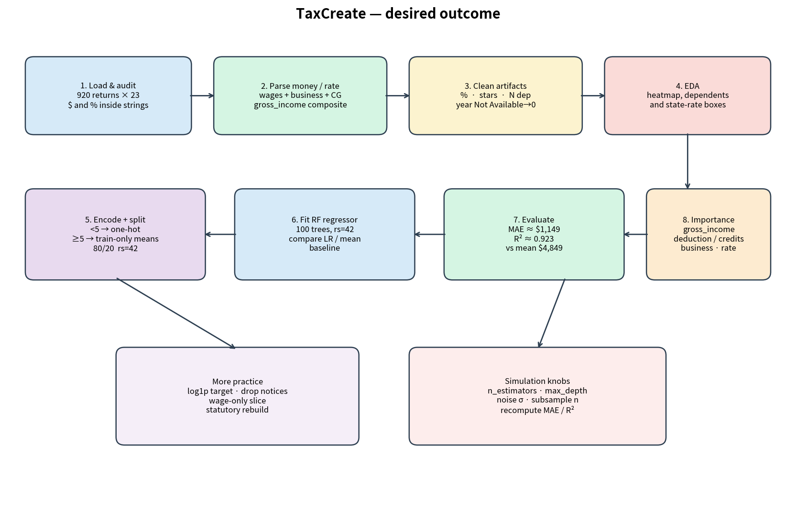
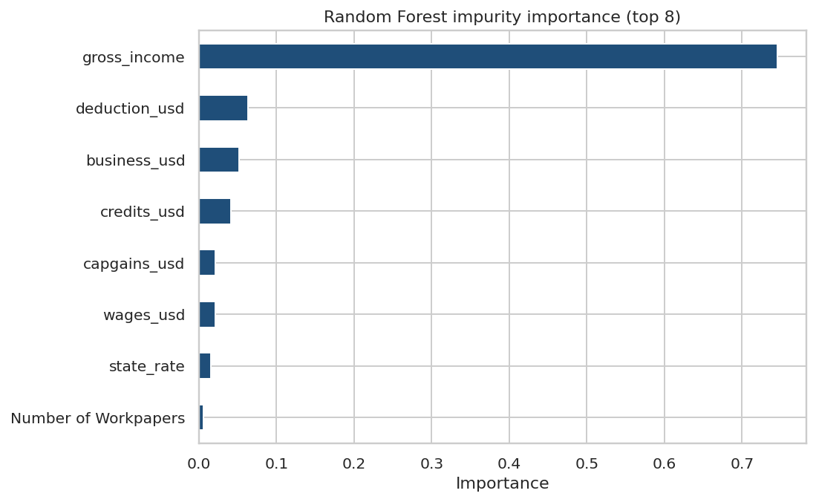

Key Takeaways
- Parse money and percents before you model. .astype(str) keeps the cell rerunnable.
- Forest MAE $1,149 vs mean $4,849 (~18% of mean tax_due). A pre-check, not a posted assessment.
- Once $ and % are gone, linear already explains most of the bill. That is the tax-creation lesson.
- Do not treat notice or workpaper counts as causes of tax_due.
- Same pipeline: payroll withholding, VAT invoices, property-tax bills, customs duties.

