PTEdu — 1-page summary
Education adaptation of PTIntro · tensors + 4→16→3 roster net · not a grading engine

Problem Statement
The first PyTorch lab (PTIntro / Iris) hides a unit problem: every column is centimetres. A registrar table is not. Attendance (%), study hours, prior GPA (0–4), and assignment average (0–100) cannot share one Linear layer until they are scaled. We need the same tensor + training-loop contract on a 180-student roster with three outcome bands — support, on-track, honors — without pretending the scores are grades.

Solution Strategy
Synthetic but clustered roster (60 per band). Encode bands 0/1/2 as long. Stratified 80/20 (12 per band on test). Train-only z-score, then 4→16 ReLU→3 with Adam 0.01 × 150 full-batch epochs. Score with eval() + no_grad + argmax. Replay Sequential+SGD, a scaled class-mean baseline, and an unscaled Adam run so the unit mismatch is a measured cost. XOR drill keeps the ReLU honest. Four-audience memo for IR / SIS / dean / family.

Solution
Metric | Value | Metric | Value
Roster | 180 × 4 + band | Split | 144 / 36 (12 each)
Scaled CE | 1.01 → 0.012 | Scaled test acc | 97.22% (35/36)
Only miss | 1 on-track → honors | Raw-unit Adam | 69.44%
Sequential + SGD | 97.22% | Class-mean (scaled) | 97.22%
Support vs rest | 100% | XOR hidden / linear | 100% / 47.5%
Architecture 4 → 16 (ReLU) → 3 logits, 131 parameters. CrossEntropyLoss on raw logits. Scaling is the sector lesson; the net does not beat a class-mean on this table.
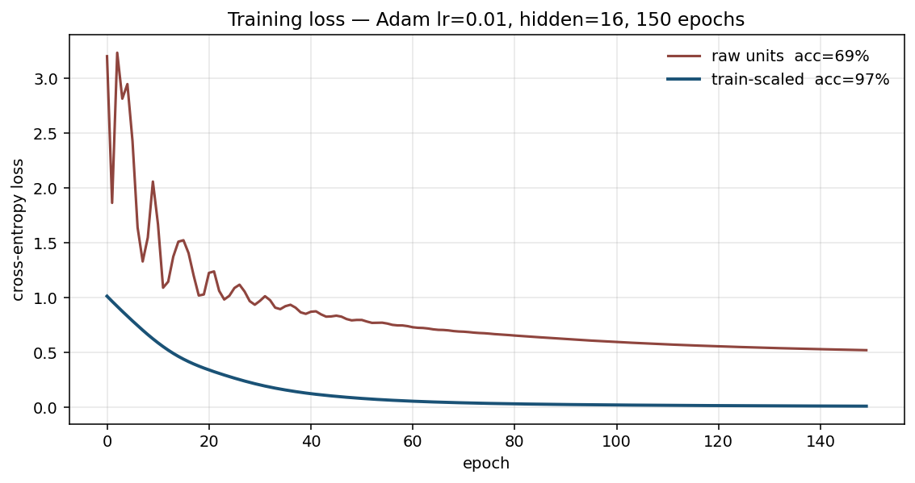
Raw units stall. Scaled features drop CE to 0.012. Confusion: 35/36; the miss is the on-track / honors overlap.

Key Takeaways
- Same PyTorch contract as PTIntro: float32 features, long labels, zero_grad → forward → CE → backward → step.
- Scale with the training mean/sd only. Using test statistics, or skipping scale, is the silent failure mode on rosters.
- 97% here matches a class-mean baseline. Quote the loop and the scale gap (97 vs 69), not a product accuracy.
- Support separates; on-track overlaps honors — same geometry as setosa vs the two Iris species.
- Not a grading engine, early-alert system, or placement tool. A counselor still owns the band.

