PTIntro — 1-page summary
What is PyTorch · tensors, factories, nn.Module, Iris 4→16→3 · short name PTIntro

Problem Statement
Introduce tensors as NumPy’s cousin and prove the five-line training contract classifies something real. Course notes cover list→tensor, zeros/ones/arange/linspace/*_like, a custom Module, and a 150-row Iris challenge. The gap: no local CSV, no sklearn-free split, no alternates, no knob cell.

Solution Strategy
pandas + NumPy + CPU PyTorch. Encode species 0/1/2 as long. Stratified 80/20 (10 flowers/class on test). Train 4→16 ReLU→3 with Adam 0.01 × 100 full-batch epochs. Score with eval() + no_grad + argmax. Replay as Sequential+SGD and as a NumPy class-mean baseline. Add setosa-vs-rest and XOR so ReLU is not decoration. Expose hidden / lr / epochs / label-noise.

Solution
Metric | Value | Metric | Value
Train / test | 120 / 30 (stratified) | Parameters | 131
Final CE loss | 0.098 | Test accuracy | 96.67% (29/30)
Misses | 1 versicolor → virginica | Class-mean baseline | 93.33%
Sequential + SGD | 96.67% @ 200 ep, lr=0.05 | Setosa vs rest | 100%
XOR + hidden ReLU | 100% | XOR linear (no hidden) | 47.5%
Architecture 4 → 16 (ReLU) → 3 logits. CrossEntropyLoss applies log-softmax internally — do not softmax first.
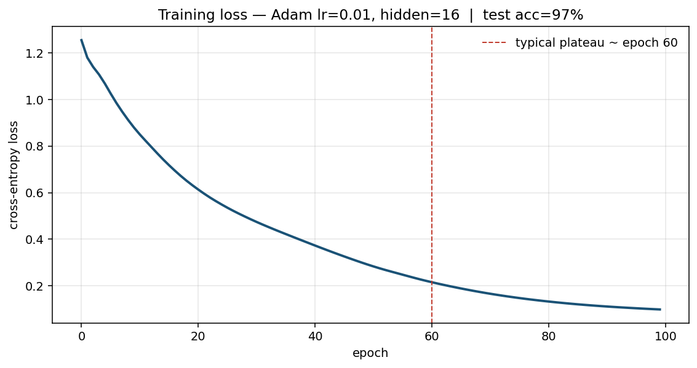
Loss 1.25 → 0.10, flattening near epoch 60. Confusion: 29/30; the only miss is versicolor → virginica.

Key Takeaways
- Tensors are shaped buffers plus a device and a tape — not a new kind of math.
- Features float32, class indices long. Getting that pair wrong is the #1 CrossEntropy crash.
- Call model(x), never model.forward(x). Call eval() and no_grad() together at test time.
- Iris is almost linearly separable on petals. High accuracy here certifies the loop, not a production botanist.
- The hidden ReLU earns its keep on XOR, not on Iris. Turn the simulation knobs before you add layers.

