Predicting Laptop Prices
Feature engineering on unit-bearing specs → Random Forest. Short name: LaptopPrice.

Problem Statement
A merchandising team wants a first-pass estimate of list price from the spec sheet. The catalog (823 laptops, 19 columns) stores RAM, SSD, HDD, GPU memory, OS bit-width, star ratings, and CPU generation as text with units (“8 GB”, “64-bit”, “4 stars”, “10th”). Raw object dtypes block any regressor. The target Price is right-skewed (median ₹64,990, mean ₹76,745, max ₹441,990), so a mean guess is a weak screen and tail errors will dominate RMSE.

Solution Strategy
- Parse unit strings to integers; add total_storage = SSD + HDD; drop the parts.
- Clean artifacts with an idempotent .astype(str) chain. Encode missing generation as 0.
- EDA: numeric heatmap plus RAM / GPU boxplots before any model.
- Cardinality rule: <5 uniques → one-hot (drop_first); ≥5 → target-mean encoding fit on train only.
- RandomForestRegressor(rs=42) vs Linear/Ridge and a mean-price baseline. Report MAE + R².

Solution
Hold-out 165 rows, leakage-safe encode, default 100-tree forest:
Test MAE | Test R² | Mean-baseline MAE | Linear MAE / R²
₹12,401 | 0.725 | ₹31,232 | ₹16,450 / 0.660
Top impurity: processor_name (0.56), total_storage (0.12), GPU memory, review counts, RAM type. Permutation importance on the test fold keeps the CPU family first but lifts RAM next to GPU — the encoding was hogging splits. Full-frame target means barely changed the score here (every brand appears on both sides of the split); the safe pattern is still the one to copy.
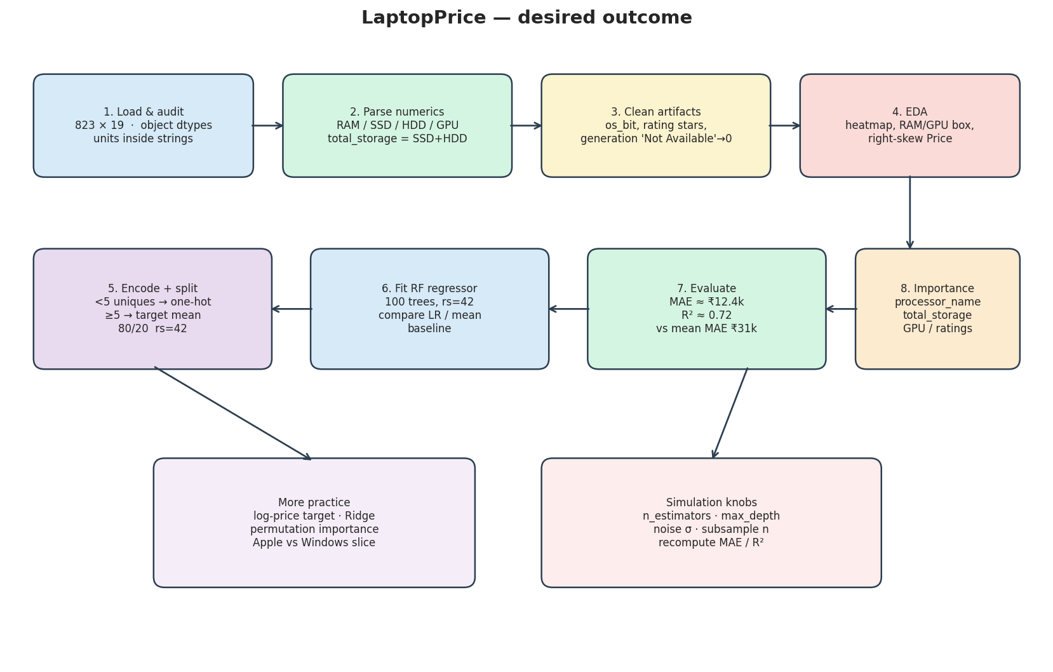
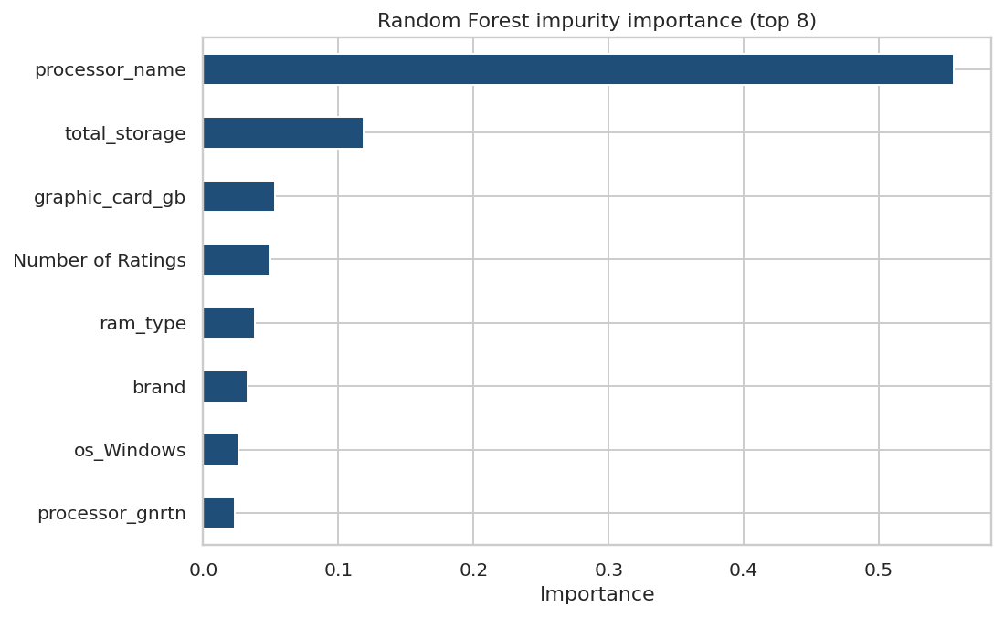

Key Takeaways
- Strip units before you model. The .astype(str) prefix keeps cleaning cells rerunnable.
- A default forest cuts MAE from ₹31k to ₹12.4k (~16% of mean price). That is a listing screen, not a checkout quote — workstation tails still miss by tens of thousands.
- Target-encoded CPU family dominates impurity importance; confirm with permutation before you brief merchandising.
- Review counts are not a design lever: they arrive after the product sells. Drop them for a spec-only card (R² dips only a little).
- Same pipeline transfers to used cars, phones, rents, cameras, and hotel ADR — any table where capacity hides inside unit strings.

