Student At-Risk Classification
students.csv · 7,200 cleaned SIS codes · Random Forest · short name EduRisk

Problem Statement
Flag whether a student is on-track (o) or at-risk (r) from 23 categorical SIS marks (attendance, homework, prior GPA, advisor contact, setting). Missing advisor values are stored as “?”; roster-flag is constant; a missed at-risk flag is the costly error. The table is a synthetic teaching extract — not a live district warehouse.

Solution Strategy
Recode “?” → “u” in advisor and drop 8 exact duplicates. Plot status balance, attendance × status, and prior-GPA × status; rank a temporary factorize encoding and draw a 12 × 12 heatmap (target excluded). Drop roster-flag. LabelEncode every remaining column. Freeze an 80/20 split at random_state=42. Fit RandomForestClassifier(random_state=42). Report accuracy, the confusion matrix, and Gini importances. Compare a decision tree, one-hot logistic regression, an attendance-majority rule, and mutual information. Sweep max_depth, dropped features, label-flip %, and training n.

Solution
Cleaned frame: 7,200 × 24, 2,073 unknown advisors recoded to u, 8 duplicates dropped, 3,832 on-track / 3,368 at-risk (53.2 / 46.8). After dropping roster-flag: X_train (5,760 × 22), X_test (1,440 × 22). LabelEncoder maps o→0, r→1. Default RF test accuracy = 0.763; confusion matrix [[601, 159], [183, 497]] — 183 missed at-risk flags on this seed. Attendance Gini ≈ 0.211, then homework ≈ 0.083, prior-gpa ≈ 0.065. An attendance-majority rule scores 0.707; one-hot logistic regression (66 dummies) reaches 0.797. Depth-1 forest ≈ 0.65; depth 8 ≈ 0.75. Factorize |corr| can rank homework first — Gini and MI both restore attendance as the driver.
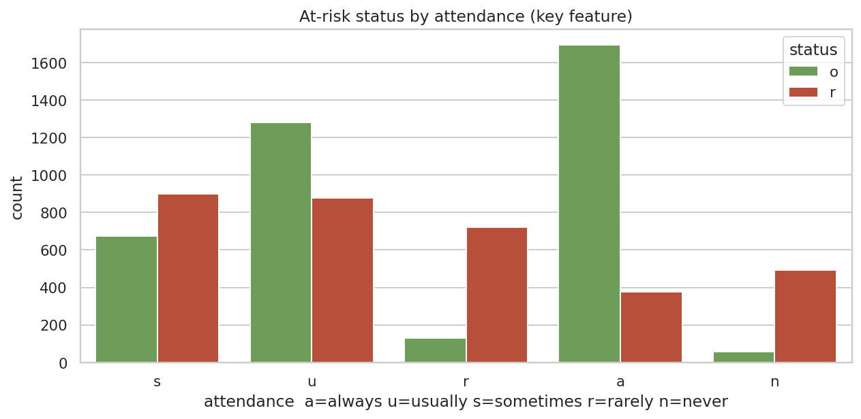
Attendance nearly partitions the tails. Always-present students lean on-track; rarely/never lean at-risk. Sometimes/usually overlap.
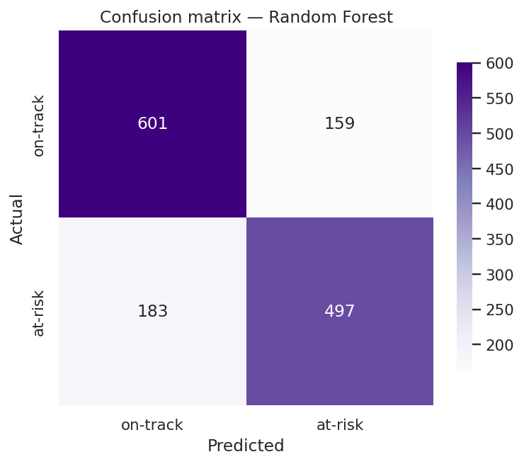
Hold-out confusion matrix. Bottom-left (183) is the costly cell: actual at-risk, predicted on-track.

Key Takeaways
- Showing up is the loud clue in this codebook. Prior GPA band is not enough on its own.
- Treat “?” as its own level. Imputing the brief-contact mode invents an advisor visit nobody logged.
- A 12-feature heatmap must be 12 × 12 — drop status before .head(12). Factorize |corr| is a sketch.
- LabelEncoder is enough for RF; one-hot if you also fit logistic regression.
- Score the costly cell (actual r, predicted o), not only accuracy. Thresholds buy recall with extra alarms.
- Do not grade, place, or deny aid from this model. Synthetic codes, counselor in the loop.

