Mushroom Edibility Classification
UCI mushrooms.csv · 8,124 field-guide codes · Random Forest · short name MushEdib

Problem Statement
Predict whether a mushroom is edible (e) or poisonous (p) from 22 categorical field marks (cap, gill, stalk, odor, spore print, habitat). Missing stalk-root values are stored as the character “?”, veil-type is constant, and a false edible is the costly error. The table is a 1987 codebook — not a photograph of a cap you picked today.

Solution Strategy
Clean “?” → “u” in stalk-root and drop exact duplicates (none here). Plot class balance, odor × class, and cap-color × class; rank a temporary factorize encoding and draw a 12 × 12 heatmap (target excluded). Drop veil-type. LabelEncode every remaining column. Freeze an 80/20 split at random_state=42. Fit RandomForestClassifier(random_state=42). Report accuracy, the confusion matrix, and Gini importances. Compare a decision tree, one-hot logistic regression, an odor-majority rule, and mutual information. Sweep max_depth, dropped features, label-flip %, and training n.

Solution
Cleaned frame: 8,124 × 23, 2,480 unknown roots recoded to u, 0 duplicates, 4,208 edible / 3,916 poisonous (51.8 / 48.2). After dropping veil-type: X_train (6,499 × 21), X_test (1,625 × 21). LabelEncoder maps e→0, p→1. Default RF test accuracy = 1.000; confusion matrix [[843, 0], [0, 782]] — zero false edibles on this seed. Odor Gini ≈ 0.192, then gill-size ≈ 0.132, gill-color ≈ 0.120, spore-print-color ≈ 0.078, ring-type ≈ 0.071. An odor-majority rule already scores 0.985; odor = none is the mixed leftover. Factorize |corr| leaders: odor 0.58, spore-print-color 0.56, ring-type 0.56. Depth-1 forest ≈ 0.87; depth 8 = 1.0. Fifty labelled rows already reach ≈ 0.94. One-hot logistic regression (116 dummies) also hits 1.0 on this split.
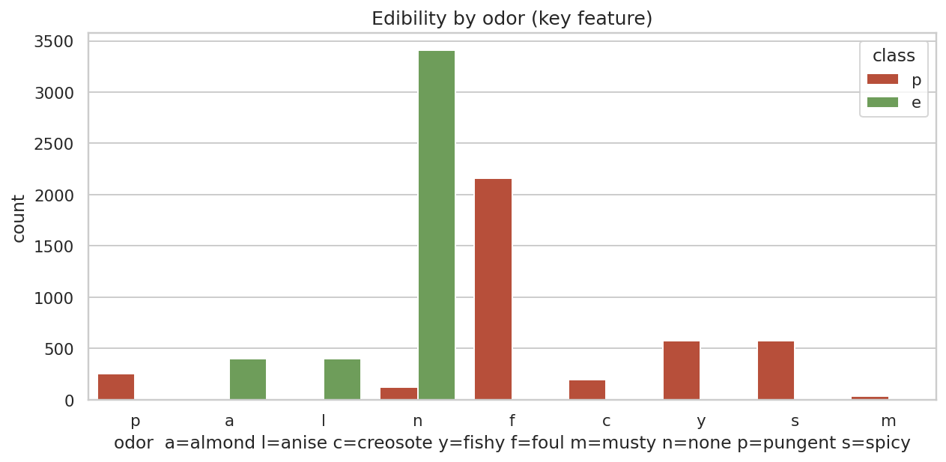
Odor nearly partitions the table. Almond and anise sit with edible; foul, fishy, spicy, pungent, creosote, musty sit with poisonous.
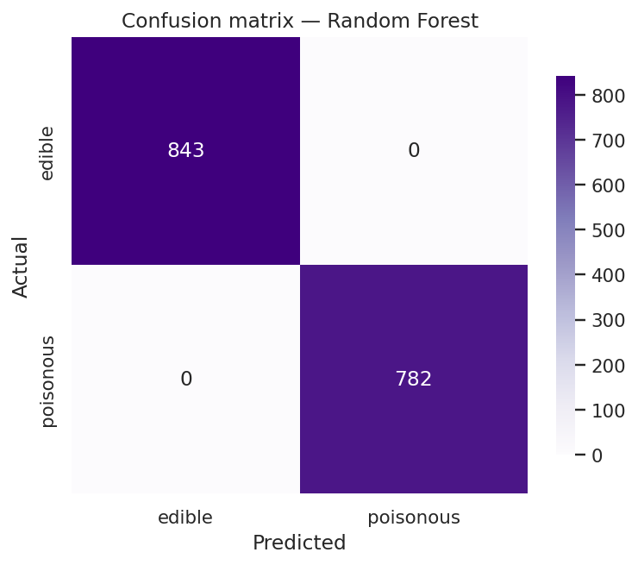
Hold-out confusion matrix for the default forest. Off-diagonal is empty on seed 42. That is a property of this codebook, not of mushrooms in general.

Key Takeaways
- Smell is the giveaway in this book of drawings. Cap color is not.
- Treat “?” as its own level. Imputing the bulbous mode invents a root nobody recorded.
- A 12-feature heatmap must be 12 × 12 — drop class before .head(12).
- LabelEncoder is enough for RF; one-hot if you also fit logistic regression or kNN.
- Score the costly cell (actual p, predicted e), not only accuracy.
- Do not forage, plate, or triage from this model. External validity is the missing feature.

