RFM + K-Means Bank Customer Segmentation
Short name: BankRFM · Core extract (18,310 postings → 3,250 CIF) · Dec 2010–Dec 2011

Problem Statement
A retail bank has posting-level activity and needs relationship groups it can treat differently — protect, nurture, win-back — without a labelled training set. Postings are the wrong grain: twelve card swipes is activity, not twelve customers. Missing CustomerID (~22%) and reversals cannot join a segment. Monetary is heavily right-skewed (commercial wires), so a raw-scale K-Means would be a whale detector, not a behaviour model.

Solution Strategy
Clean to posted flow (drop NA CIF, Quantity > 0, UnitAmount > 0). Collapse to Recency / Frequency / Monetary against snapshot = max(TxnDate)+1 day. Compress skew with log1p, z-score, choose k from elbow + silhouette + treatment capacity, fit K-Means (k=4, n_init=10, seed=42), name bins from median R/F/M in dollars and days, and use PCA only as a 2-D slide (98% of scaled variance).

Solution
Clean book: 13,892 postings, 3,250 CIF, $2.59M posted flow. RFM medians — Recency 90 days, Frequency 2 postings, Monetary $86 (mean $797; max $134k). Elbow flattens after k=4; silhouette ~0.55. PCA: PC1 80% (+F +M −R, a value axis), PC2 18% (recency contrast).
Segment (k=4) | n | % CIF | % flow | Med R / F / $
Relationship core (cl. 1) | 554 | 17.0 | 87.0 | 10 d / 13 txn / $1,961
New / light user (cl. 2) | 632 | 19.4 | 1.7 | 16 d / 2 txn / $63
Slipping mid-book (cl. 3) | 851 | 26.2 | 9.7 | 93 d / 4 txn / $260
Dormant / at-risk close (cl. 0) | 1,213 | 37.3 | 1.6 | 222 d / 1 txn / $29
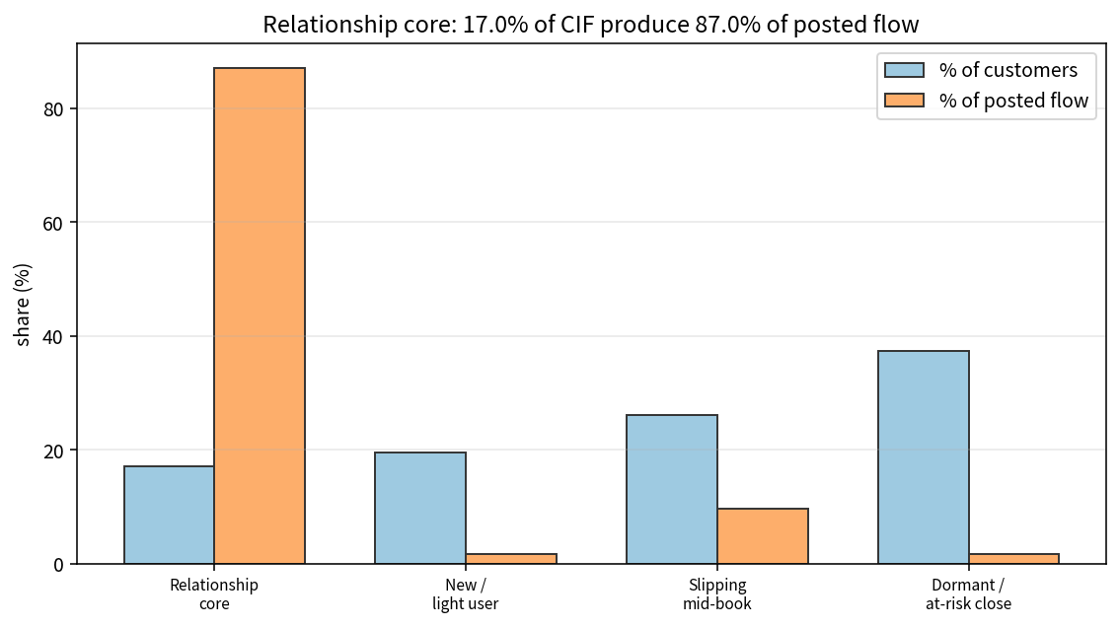

Key Takeaways
- Log first, then scale. Clustering raw Monetary is a commercial-wire detector.
- Name clusters from original-unit medians. Cluster integers shuffle with seed and k.
- 17% of CIF produce 87% of observed posted flow — protect the core; slipping mid-book is the cheapest win-back.
- PCA is a picture (98% in 2-D here), not the model. Frequency must be nunique(TxnNo), not product-line count.
- Not a credit decision and not a Call Report. Refit before quoting another charter’s k.

