RFM + K-Means Customer Segmentation
Short name: CustSeg · Online Retail extract (36,110 lines → 3,496 customers) · Dec 2010–Dec 2011

Problem Statement
A gift retailer has invoice-level sales and needs customer groups it can treat differently — win-back, nurture, protect — without a labelled training set. Line items are the wrong grain: 30 SKUs on one ticket is one visit. Missing CustomerID (~25%) and returns cannot join a segment. Monetary and Frequency are heavily right-skewed, so a raw-scale K-Means would be a whale detector, not a behaviour model.

Solution Strategy
Clean to paid sales (drop NA CustomerID, Quantity > 0, UnitPrice > 0). Collapse to Recency / Frequency / Monetary against snapshot = max(InvoiceDate)+1 day. Compress skew with log1p, z-score, choose k from elbow + silhouette + campaign capacity, fit K-Means (k=4, n_init=10, seed=42), name bins from median R/F/M in pounds and days, and use PCA only as a 2-D slide (92% of scaled variance).

Solution
Clean book: 26,369 line items, 3,496 customers, £572,260 revenue, 81% UK. RFM medians — Recency 59 days, Frequency 2 invoices, Monetary £59 (mean £164; max £23,181). Silhouette 0.325 at k=4 vs 0.320 at k=3. PCA: PC1 71% (+F +M −R, a value axis), PC2 21% (recency contrast).
Segment (k=4) | n | % cust | % rev | Med R / F / £
Champions (cl. 2) | 582 | 16.6 | 63.7 | 12.5 d / 7 inv / £278
Recent occasional (cl. 3) | 715 | 20.5 | 7.1 | 17 d / 2 inv / £47
Slipping mid-value (cl. 0) | 930 | 26.6 | 23.3 | 79 d / 3 inv / £111
Lost / hibernating (cl. 1) | 1,269 | 36.3 | 5.8 | 170 d / 1 inv / £21
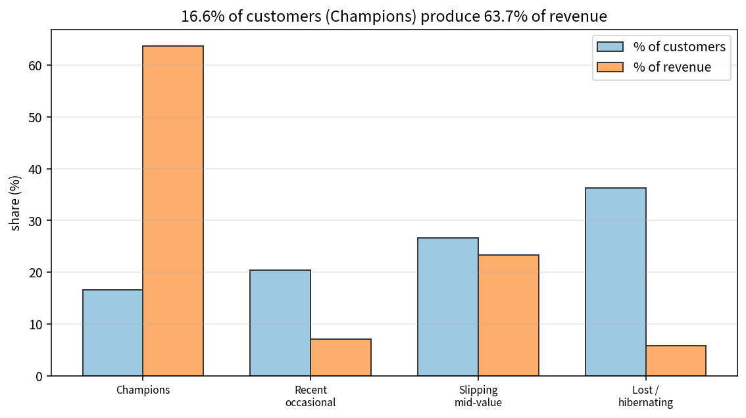

Key Takeaways
- Log first, then scale. Clustering raw Monetary is a wholesale-detector.
- Name clusters from original-unit medians. Cluster integers shuffle with seed and k.
- 17% of customers produce 64% of observed revenue — protect Champions; slipping mid-value is the cheapest win-back.
- PCA is a picture (92% in 2-D here), not the model. Frequency must be nunique(InvoiceNo), not line-item count.
- This file is an extract (36k rows), not the full 541k UCI dump — refit before quoting another paper’s k=3 story.

