Creating Loan Offers
LaptopPrice / TaxCreate pipeline on a draft application book. Short name: LoanOrig.

Problem Statement
A lending desk has to create an offered principal (offer_amount) from 920 messy applications. Income, debt, request, down payment and reserves arrive as "$72,000". The note rate is "7.25%". Term, borrowers, bureau band and vintage carry words ("36-month", "2 borrowers", "4 stars", "Not Available"). Offers are right-skewed (median $20k, mean $53k) because mortgages sit in the tail. Guessing the book average misses by about $55k.

Solution Strategy
- Strip $ and commas from five money columns; add net_capacity = income − other debt.
- Parse %, stars, borrowers, term; encode missing vintage as 0.
- EDA: heatmap, borrowers box, bureau-star box, offer histogram.
- <5 uniques → one-hot; ≥5 → train-only mean offer. 80/20, rs=42.
- RandomForestRegressor vs Linear/Ridge and a mean-offer baseline. Drop requested_usd as a stress test.

Solution
Hold-out 184 rows, leakage-safe encode, default 100-tree forest:
Test MAE | Test R² | Mean-baseline MAE | Linear MAE / R²
$5,153 | 0.982 | $54,658 | $8,250 / 0.972
requested_usd dominates (corr 0.98, impurity ~0.96) because the teaching policy is roughly min(ask, capacity). Linear already reaches R² 0.97 once $ and % are gone. The forest’s extra lift is the product/term tail and a mild rate–size trade. Inquiry and trade counts are file texture, not origination levers. Drop the ask in practice cell 2 to see the capacity block stand on its own.
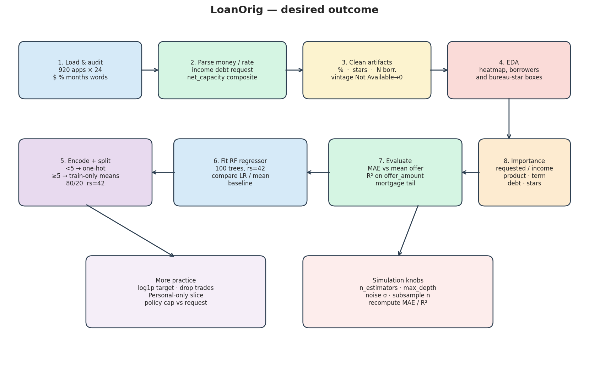
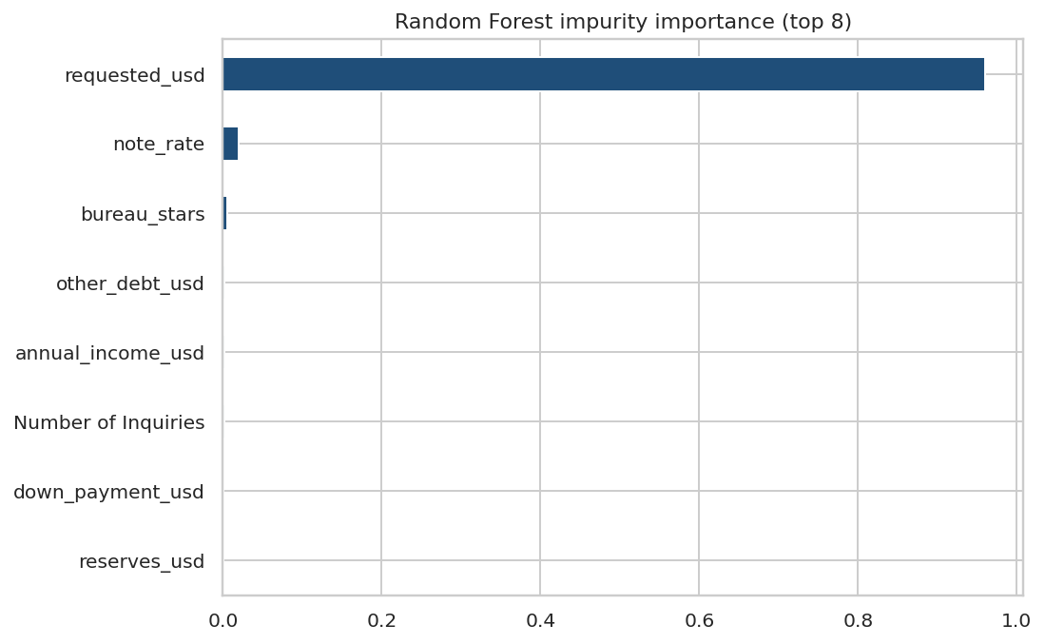

Key Takeaways
- Parse money, percents, and count-words before you model.
- Forest MAE $5.2k vs mean $54.7k. A book pre-check, not a commitment letter.
- The ask is not a leak if the desk actually sees it; it is a leak if you want a capacity-only offer.
- Wrong task for approve/reject — use Banking_Logistic_Regression / Bank_LogLoss_Cost.
- Same pipeline: limit increases, deposit openings, insurance sum-assured, trade facilities.

