Predicting Student Exam Scores
LaptopPrice pipeline on a student roster. Short name: ExamPred.

Problem Statement
An institutional-research desk wants a first-pass estimate of exam_score from 920 messy course records. Study time arrives as "12.0 hours", prior performance as "3.40 GPA", attendance as "91.0%", load as "15 cr". Partners, term length, effort stars and cohort carry words. Scores sit around 73 with a 10-point spread. Guessing the roster average misses by about 7.7 points.

Solution Strategy
- Strip hours / GPA / % / cr; add study_load = study_hours + prep_hours.
- Parse stars, partners, term; encode missing cohort as 0.
- EDA, then <5 uniques one-hot / ≥5 train-only means. 80/20, rs=42.
- Forest vs linear vs mean baseline. Then drop effort_stars and refit the pre-exam card.

Solution
Hold-out 184 rows, leakage-safe encode, default 100-tree forest:
With stars MAE / R² | Pre-exam MAE / R² | Mean-baseline MAE | Linear (with stars)
2.33 / 0.912 | 5.10 / 0.541 | 7.72 | 2.34 / 0.914
effort_stars corr with the score is 0.94 — the band was cut from the same performance, so the first model is a reconstruction, not a forecast. Drop the stars and study_load, prior GPA, hours and attendance take over. Linear already matches the forest on the with-stars card because the teaching DGP is nearly linear.
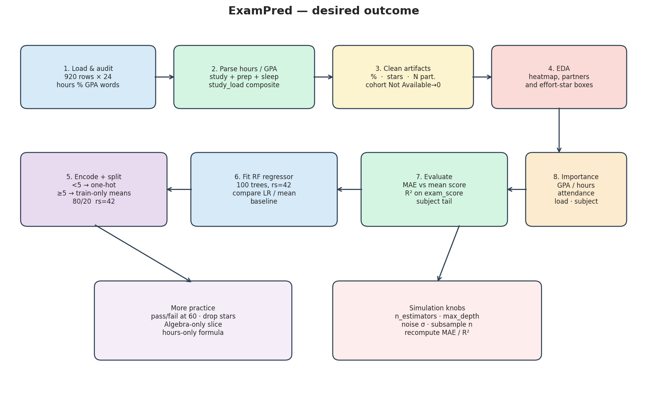
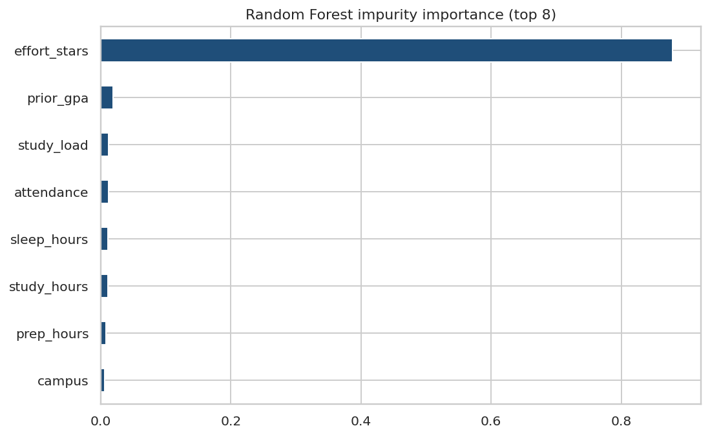

Key Takeaways
- Parse units before you model. .astype(str) keeps cells rerunnable.
- Always quote two cards: with the leaky band and without it.
- 5.1-point pre-exam MAE is a study-plan signal, not a posted grade.
- Assignment and office-hour counts are term texture, not day-one inputs.
- Same pipeline: midterm→final, homework→course mark, certification batteries.

