Incident Priority Classification
incidents.csv · 6,799 cleaned RMS codes · Random Forest · short name CrimRisk

Problem Statement
Flag whether a recorded incident is priority (p) or routine (r) from 21 categorical RMS marks (weapon, injury, offense, district, clearance). Missing clearance values are “?”; file-flag is constant; a missed priority case is the costly error. The unit is an incident row — not a person. The extract is synthetic.

Solution Strategy
Recode “?” → “u” in clearance and drop 11 exact duplicates. Plot priority balance, weapon × priority, and district × priority; rank a factorize encoding and draw a 12 × 12 heatmap. Drop file-flag. LabelEncode every remaining column (p→0, r→1). Freeze 80/20 at random_state=42. Fit RandomForestClassifier(random_state=42). Report accuracy, the costly cell, and Gini importances. Compare a decision tree, one-hot logistic regression, a weapon-majority rule, and mutual information. Sweep depth, dropped features, label-flip %, and training n. Gate go-live with the implementation checklist.

Solution
Cleaned frame: 6,799 × 22, 1,848 unknown clearances recoded to u, 11 duplicates dropped, 3,393 priority / 3,406 routine. After dropping file-flag: X_train (5,439 × 20), X_test (1,360 × 20). Default RF test accuracy = 0.773; confusion matrix [[503, 164], [145, 548]] — 164 missed priority cases. Weapon Gini ≈ 0.242, injury ≈ 0.106, offense ≈ 0.087. Weapon-majority rule scores 0.730; one-hot logistic regression (62 dummies) reaches 0.785. Dropping weapon+injury collapses accuracy to ≈ 0.54. Factorize |corr| ranks injury first; Gini and MI restore weapon.
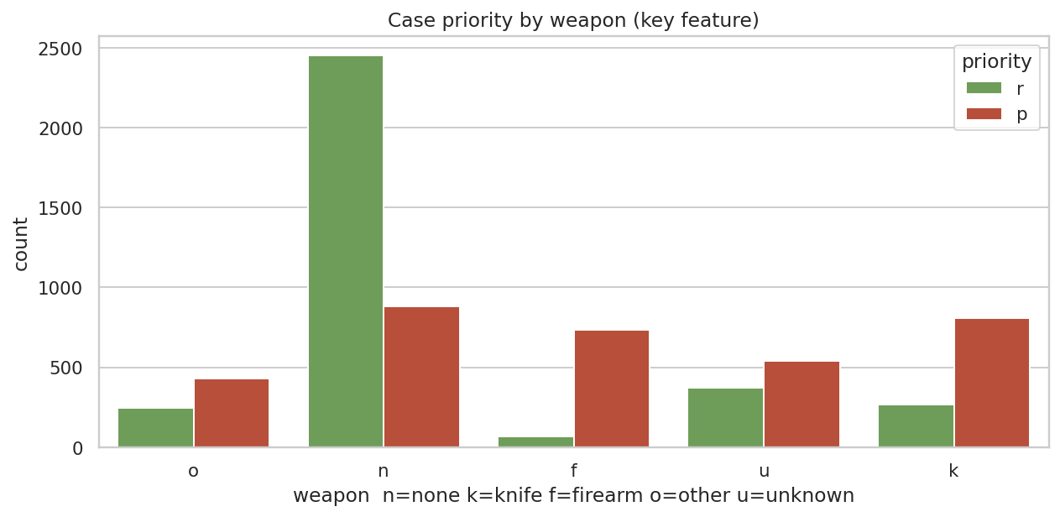
Firearm and knife lean priority; no weapon leans routine. Unknown weapon is mixed.
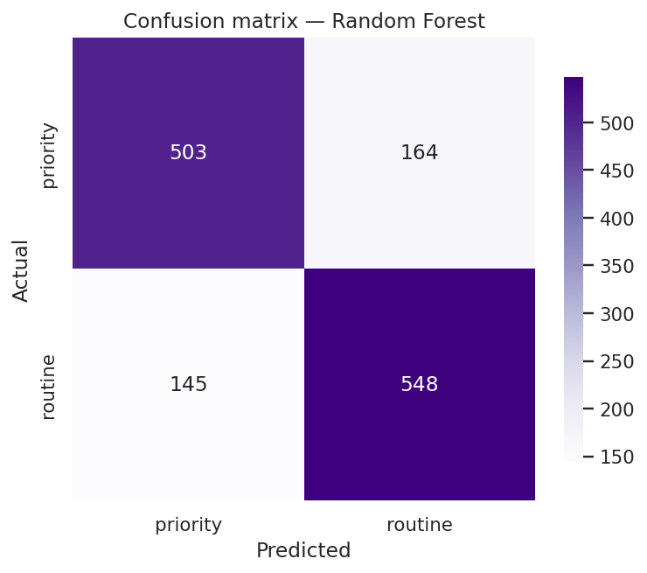
Hold-out CM. Top-right (164) is the costly cell: actual priority, predicted routine.

Key Takeaways
- Weapon is the loud clue in this codebook. District is not.
- Treat “?” as its own level. Document that u collides with some manuals’ “unfounded”.
- LabelEncoder maps p→0, r→1. Score missed priority, not only accuracy.
- A 0.77 hold-out is case triage practice — not a risk score for a person.
- Do not add race, ethnicity, or tract proxies. Do not write the flag to a charging file.
- Use the implementation checklist (shadow mode, override log, kill switch) before any RMS job.

