RFM + K-Means Tourism Guest Segmentation
Short name: TourRFM · Booking extract (14,354 lines → 3,111 guests) · Dec 2010–Dec 2011

Problem Statement
A hotel / DMO book has stay-level activity and needs guest groups it can treat differently — protect loyalists, convert first-timers, win back coolers — without a labelled training set. Line items are the wrong grain: seven suite nights is one stay, not seven guests. Missing GuestID (~22%) and cancellations cannot join a segment. Monetary is right-skewed (group allotments), so raw-scale K-Means would be a wholesale detector, not a behaviour model.

Solution Strategy
Clean to stayed nights (drop NA GuestID, Quantity > 0, UnitRate > 0). Collapse to Recency / Frequency / Monetary against snapshot = max(StayDate)+1 day. Compress skew with log1p, z-score, choose k from elbow + silhouette + treatment capacity, fit K-Means (k=4, n_init=10, seed=42), name bins from median R/F/M in dollars and days, and use PCA only as a 2-D slide (97% of scaled variance).

Solution
Clean book: 10,857 stayed lines, 3,111 guests, $3.88M spend. RFM medians — Recency 105 days, Frequency 2 bookings, Monetary $179 (mean $1,247; max $123k). Elbow flattens after k=4; silhouette ~0.51. PCA: PC1 76% (+F +M −R), PC2 21% (recency contrast).
Segment (k=4) | n | % guests | % spend | Med R / F / $
Loyal / repeat (cl. 0) | 511 | 16.4 | 82.0 | 12 d / 11 bk / $3,369
Recent first-timers (cl. 3) | 600 | 19.3 | 2.4 | 14 d / 2 bk / $110
Cooling repeaters (cl. 1) | 824 | 26.5 | 13.3 | 109 d / 3 bk / $487
Lost / lapsed (cl. 2) | 1,176 | 37.8 | 2.2 | 233 d / 1 bk / $56
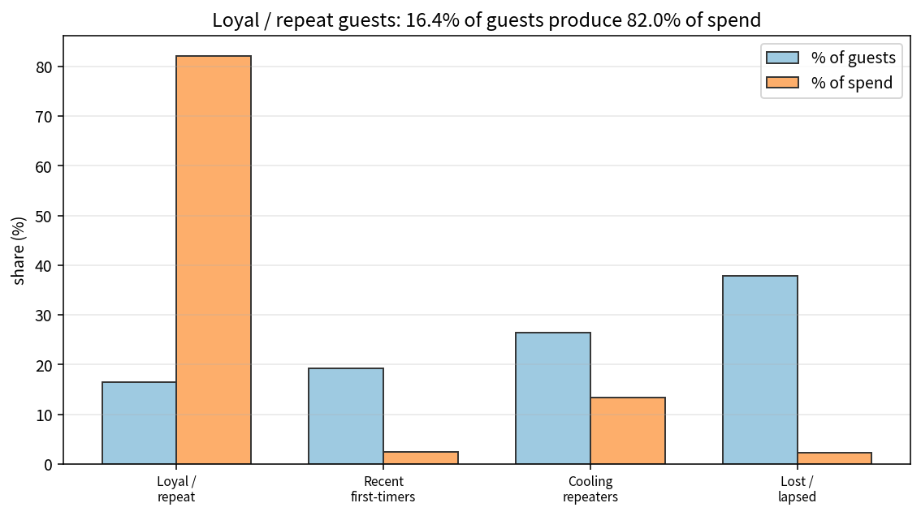

Key Takeaways
- Log first, then scale. Clustering raw Monetary is a group-allotment detector.
- Name clusters from original-unit medians. Cluster integers shuffle with seed and k.
- 16% of guests produce 82% of observed spend — protect loyalists; cooling repeaters are the cheapest win-back.
- PCA is a picture (97% in 2-D here), not the model. Frequency must be nunique(BookingNo), not night count.
- Not a yield engine and not an STR filing. Refit before quoting another property’s k.

