Ex1.  
2 thuộc tính quan trọng nhất của Hash Function:  
- Tính xác định duy nhất  
- Phân bố đều

## Ex2.

Hash Table with hash Function h(i) = (2i+5) mod 11

|  |  |  |  |  |  |  |  |  |  |  |  |
| --- | --- | --- | --- | --- | --- | --- | --- | --- | --- | --- | --- |
| Vị trí | 0 | 1 | 2 | 3 | 4 | 5 | 6 | 7 | 8 | 9 | 10 |
| Khóa i | 12 | 44 | 13 | 88 | 23 | 94 | 11 | 39 | 20 | 16 | 5 |
| h(i) | 29 | 93 | 31 | 181 | 51 | 193 | 27 | 83 | 45 | 37 | 15 |
| Giá trị | 7 | 5 | 9 | 5 | 7 | 6 | 4 | 6 | 1 | 4 | 4 |

Collisions handled by chaining:

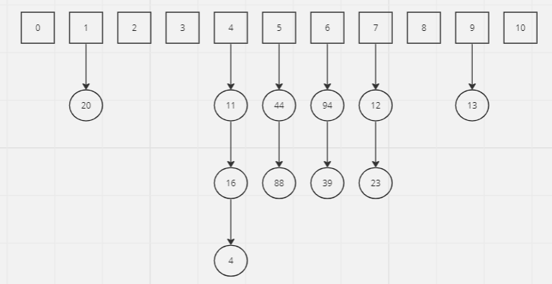

Collisions handled by linear probing:

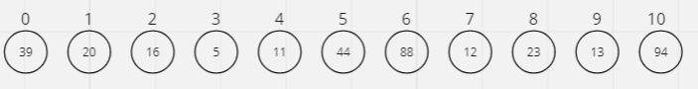

## Ex3.

|  |  |  |  |  |  |  |  |  |  |  |
| --- | --- | --- | --- | --- | --- | --- | --- | --- | --- | --- |
| Vị trí | 0 | 1 | 2 | 3 | 4 | 5 | 6 | 7 | 8 | 9 |
| Khóa i | 1 | 3 | 18 | 8 | 23 | 35 | 11 | 36 | 20 | 16 |
| h(i) | 4 | 6 | 21 | 11 | 26 | 38 | 14 | 39 | 23 | 19 |
| Giá trị | 4 | 6 | 4 | 11 | 9 | 4 | 14 | 5 | 6 | 2 |

Collisions handled by chaining:

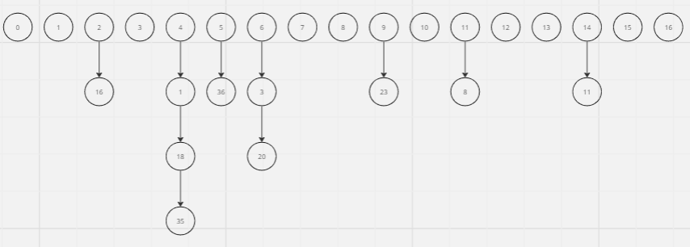

Collisions handled by linear probing:

