Walchand College of Engineering, Sangli

Computer Science & Engineering

Third Year

**Course Name:**

**Software Engineering Tools**

**Course Code: 5CS351**

**Assignment No-4**

**Name : Akash Babu Misal**

**PRN: 21520005**

**Title – GitHub**

Q 1. Create a repository on GitHub named SET Lab and add files into it (you can add implementation files of previous assignment) perform below operations on it. (Add screenshot as an answer to every question)

1. Perform commit on added files

2. Perform update to the existing files (show history)

3. Create another branch

4. Create pull request

5. Perform merging of both branches

6. Perform Fork operation

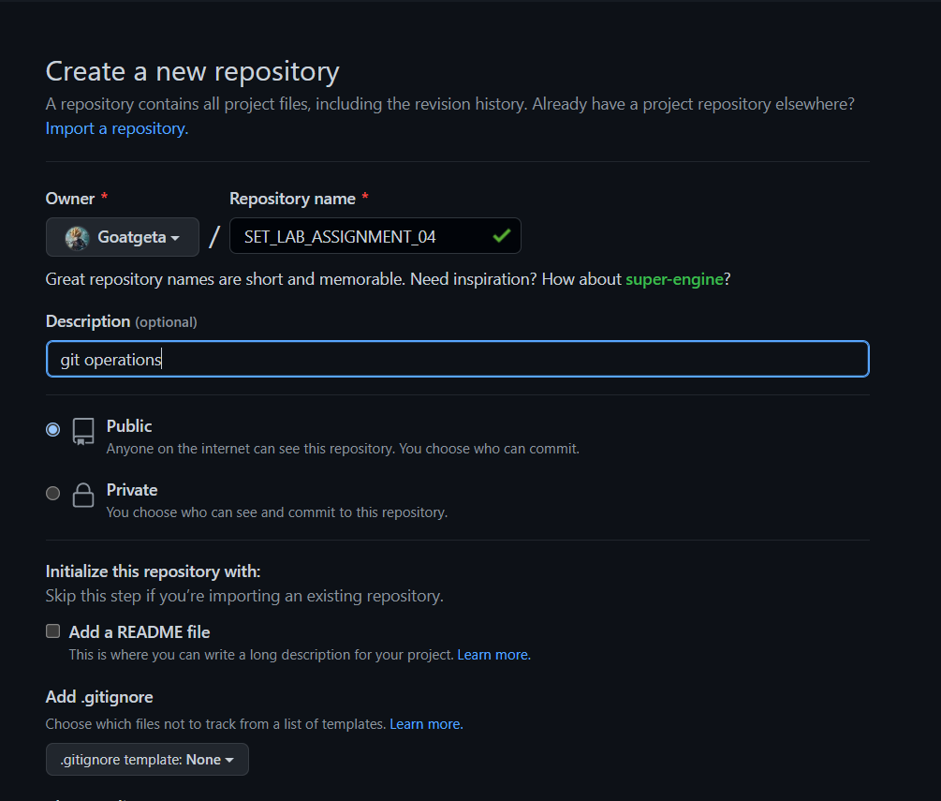

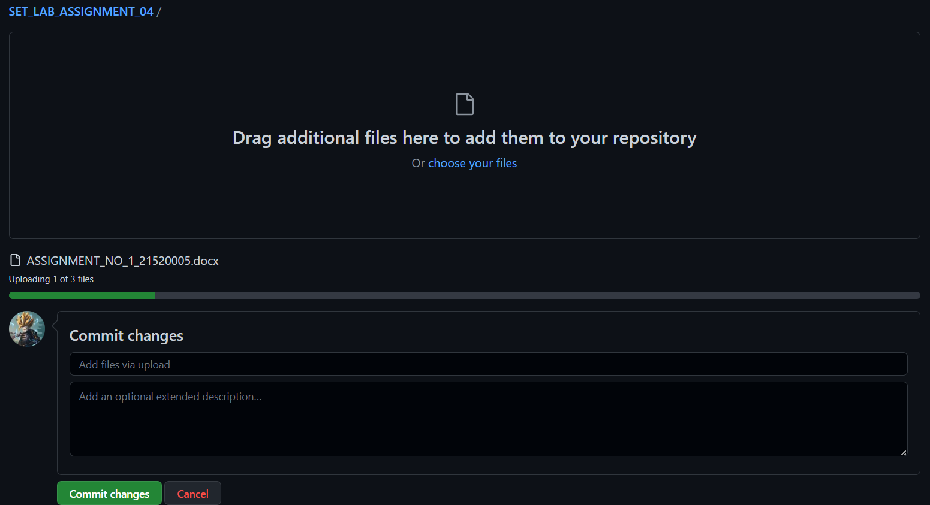

**Q 2. For the diagram given below create a GitHub repository and perform operations given in the diagram. (Perform commit operations as given)(Add screenshots as an answer to this question)**

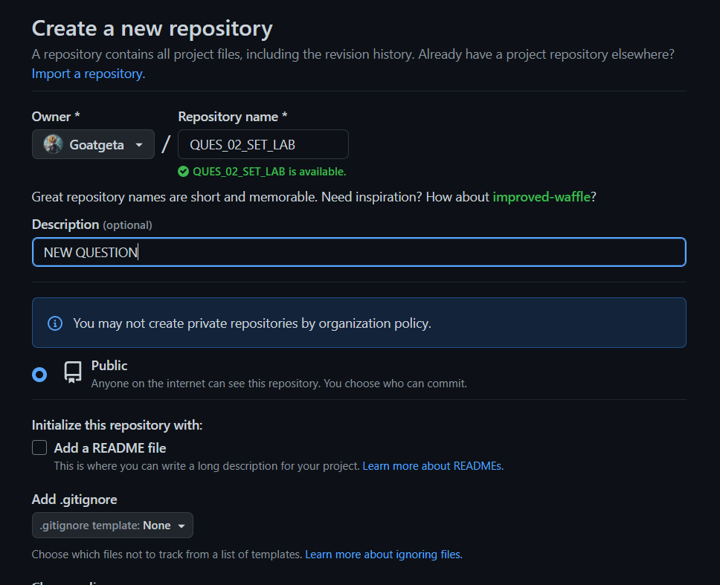

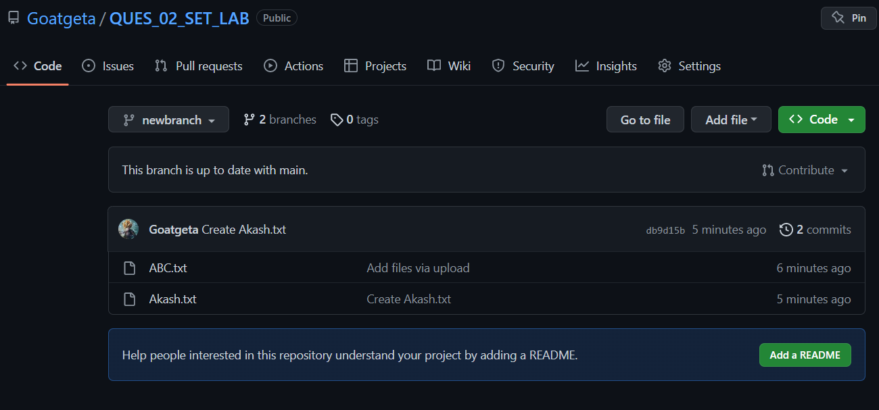

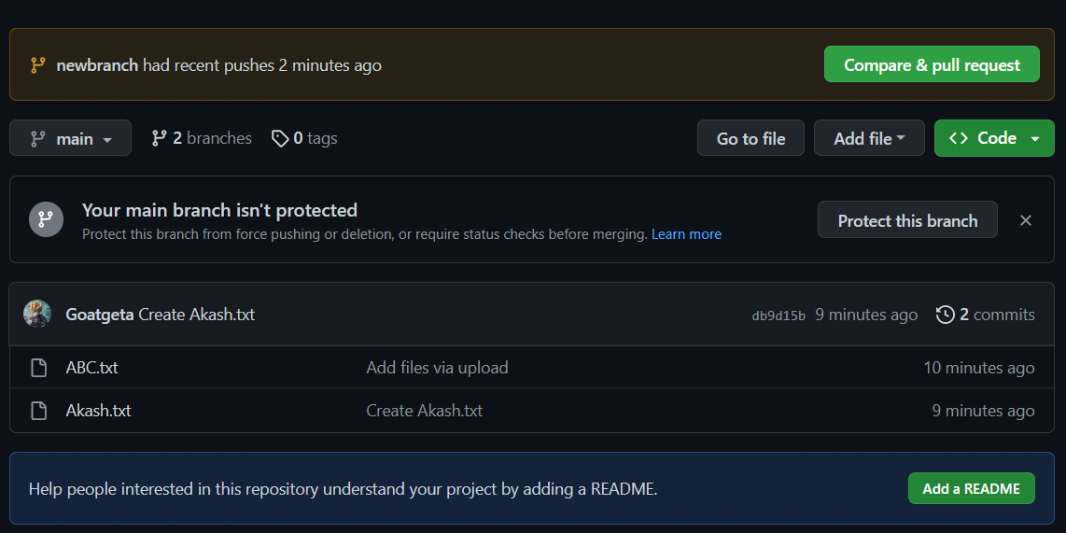

**Q 3. What is GitHub desktop? How to install GitHub on local machine? Install GitHub on your local machine and access repository created in question no 1 (add screenshots).**

**Ans –**

GitHub Desktop is an open-source application that lets you interact with GitHub via a graphic user interface (GUI) instead of relying on a command line or web browser. GitHub Desktop incentivizes you and your team to work together while employing best practices with Git and GitHub.

GitHub Desktop enables developers to activate commands such as repository creation, pull requests, and commits with just a simple click. This extra convenience adds an extra element of flexibility to working with Git and collaborating with other developers.

So, to sum it up, Git is a version control system that helps you manage your code and keep track of it, and GitHub is a cloud-based hosting platform that enables developers to manage their Git repositories. GitHub Desktop is an application that lets users interact better with GitHub through a GUI.

The installation of GitHub Desktop is as simple as any other Windows application installation. All you need to do is:

Open a browser.

Visit desktop.github.com.

Click Download for Windows (64bit).

When prompted, click Run.

Allow the installation to download and install.

Once the installation completes, GitHub Desktop will launch.

Q 4. Differentiate in between GitHub, Git and GitLab.  
  
**GitLab:**   
GitLab is a repository hosting manager tool that is developed by GitLab

Inc and is used for the software development process. It provides a variety of

management by which we can streamline our collaborative workflow for

completing the software development lifecycle. It also allows us to import the

repository from Google Code, Bitbucket, etc.

GitLab also provides free private repository.

It allows users to make public repository.

GitLab also provides free private repository. 

**GitHub:**   
GitHub is a repository hosting service tool that features collaboration and

access control. It is a platform for programmers to fix bugs together and host open

source projects. GitHub is designed for the developers and to help them track their

changes into a project through the repository.

GitHub allows users to have free private repository but with a maximum of three

collaborators.

It allows users to have unlimited free repository.

GitHub allows users to have free private repository but with a maximum of three

collaborators.

**Git :**

Git is a version control system that lets you manage and keep track of your

source code history. GitHub is a cloud-based hosting service that lets you manage

Git repositories. If you have open-source projects that use Git, then GitHub is

designed to help you better manage them.

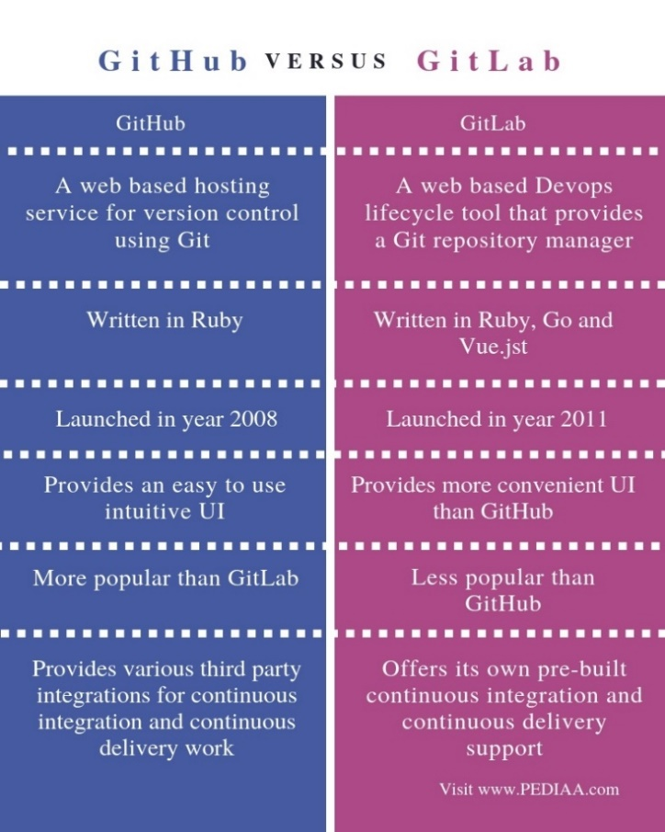

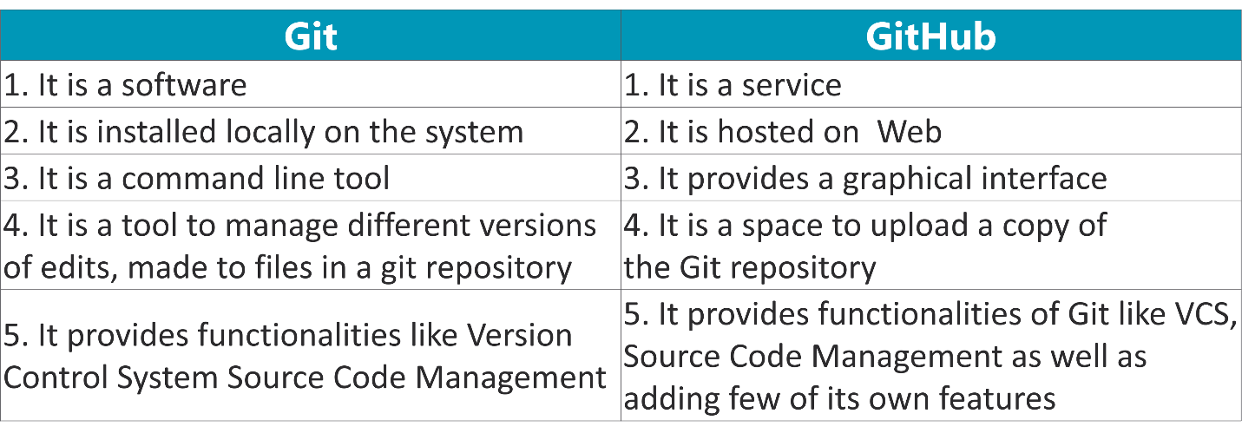

**Q . 5 What is version control? Explain with example.**

Version control is a system that manages the changes made to files over time. It is commonly used in software development to keep track of code changes and to allow multiple developers to work on the same codebase simultaneously. Version control systems (VCS) allow developers to work on different branches of the codebase, track changes, and merge changes made by different team members.

One of the most popular version control systems is Git, which is used by many developers and organizations around the world.

Example -

Here's an example to illustrate how version control works using Git:

Suppose a team of developers is working on a project to build a web application. They start by creating a Git repository on a central server, which acts as a hub for all the code changes.

Each developer creates a local copy of the repository on their computer and starts working on a feature or fixing a bug. They make changes to the code and then use Git to commit those changes to their local repository. Each commit represents a new version of the code with specific changes.

Once they are done working on their feature or bug fix, they push their changes to the central server. Other team members can then pull those changes into their own local repository and continue working on the code.

If two or more team members make changes to the same file, Git will automatically detect the conflicts and prompt the developers to resolve them. Git provides tools to merge changes made by different developers and ensure that the final version of the code is consistent and error-free.

With version control, the team can keep track of all the changes made to the code, roll back to previous versions if necessary, and collaborate efficiently without stepping on each other's toes. It provides a reliable and scalable way to manage code changes over time, which is essential for software development projects of all sizes.