Walchand College of Engineering, Sangli

Computer Science & Engineering

Third Year

**Course Name:**

**Software Engineering Tools**

**Course Code: 5CS351**

**Assignment No-6**

**Name : Akash Babu Misal**

**PRN: 21520005**

**Q1) What is Microsoft’s VSS? Provide the information of VSS tool with respect to below points.**

**a. Owner/ developer**

**b. Brief information/introduction**

**c. Basic operations involved.**

**d. Advantages**

**e. Disadvantages**

**Ans –**

Microsoft's VSS (Volume Shadow Copy Service) is a technology that allows Windows operating systems to create snapshots of one or more volumes at a point in time, which can be used for backup, restoration, or other purposes. It is a built-in feature of the Windows operating system, and it is used by backup and recovery software to create consistent backups of data, even if the data is in use or being updated at the time of the backup. VSS coordinates the activities of several system components, including the VSS service, writers, providers, and requesters to create a snapshot, and it is widely used in enterprise environments to ensure data availability and disaster recovery.

1. **Owner/developer:** Microsoft Volume Shadow Copy Service (VSS) is a proprietary technology developed by Microsoft Corporation.
2. **Brief information/introduction:** VSS is a Windows service that provides the ability to create a snapshot or a point-in-time copy (also known as a shadow copy) of one or more volumes on a Windows system. The snapshot is a read-only copy of the volume, which can be used for backup, restoration, or other purposes. VSS is typically used by backup and recovery software to create consistent backups of data, even if the data is in use or being updated at the time of the backup.
3. **Basic operations involved:** VSS operates by coordinating the activities of several system components, including the VSS service, writers, providers, and requesters. When a request to create a snapshot is received, VSS signals the writers to prepare their data for backup, and then asks the storage provider to create the snapshot. The snapshot is then made available to the requester, which can use it for backup or other purposes. After the backup is complete, VSS signals the writers to clean up any temporary files or other artifacts created during the backup process.
4. **Advantages:** The key advantages of VSS are: It allows backup software to create consistent backups of data, even if the data is in use or being updated at the time of the backup. It provides a mechanism for creating point-in-time copies of data, which can be used for disaster recovery or other purposes. It is integrated with the Windows operating system, making it easy to use and deploy. It is supported by a wide range of backup and recovery software, making it a widely adopted standard.
5. **Disadvantages:** Some of the potential disadvantages of VSS include: It may consume a significant amount of system resources, particularly during the backup process. It may not be compatible with all types of storage devices or backup software. It may not be suitable for all types of data or backup scenarios. It may require specialized knowledge to configure and use.

**Q 2. Create a SVN repository and perform below operations on that repository using SVN. Also explain below operations.**

**a. Revert**

**b. Import**

**c. Checkout**

**d. Commit**

**e. Update**

**f. Copy**

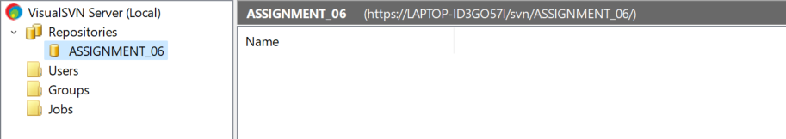

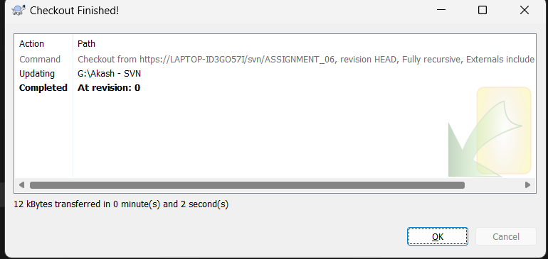

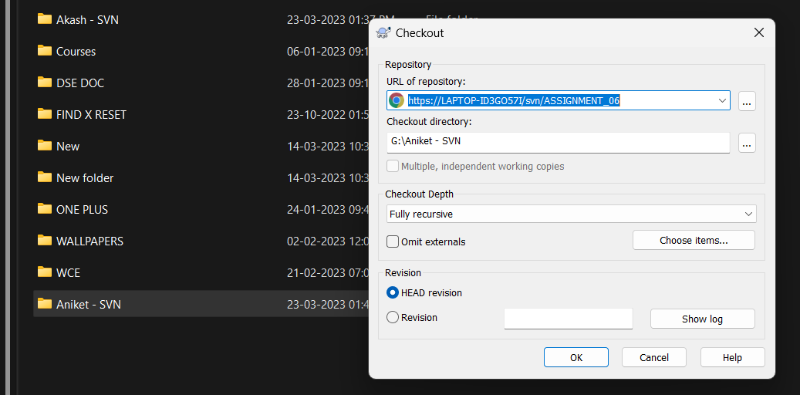

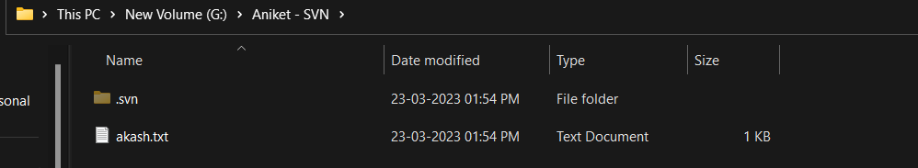

**Q 4. Differentiate Between The Git & SVN Repository?**

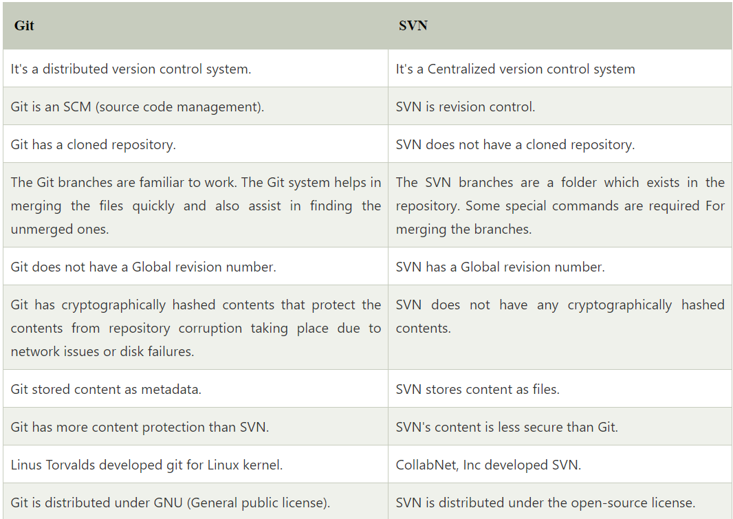

**Q 5. What is “branch”, “tag” And “trunk” In SVN?**

In SVN (Subversion), which is a version control system, the terms "branch", "tag", and "trunk" are used to describe different ways of organizing and managing the codebase:

**Branch:** A branch is a copy of the codebase that is created to allow developers to work on a new feature or make changes without affecting the main codebase. It is a separate version of the codebase that can be worked on independently of the main codebase. Once the changes are complete, the branch can be merged back into the main codebase.

**Tag:** A tag is a snapshot of the codebase at a particular point in time. It is typically used to mark a release or a significant milestone in the development process. Tags are read-only copies of the codebase, and they are not meant to be modified.

**Trunk:** The trunk is the main line of development in the codebase. It is where the latest version of the code is stored, and it is the basis for creating branches and tags. The trunk is where all changes to the codebase are initially made, and it is where branches are merged back into when their changes are complete. In SVN, these terms are used to help organize and manage the codebase and to provide a clear structure for developers to work within. By using branches, tags, and the trunk, developers can work on new features or make changes without disrupting the main codebase, and they can create snapshots of the codebase at particular points in time for reference or release purposes.

**Q 6. How CVS is different from SVN?**

CVS (Concurrent Versions System) and SVN (Subversion) are both version control systems used for managing software development projects. While they share some similarities, there are also some key differences between the two: **1) Architecture:** CVS uses a client-server architecture, where the central repository is managed by a server and accessed by clients. SVN uses a client-server architecture as well, but it also supports a distributed version control model, where every client has a copy of the entire repository.

**2) Repository structure:** CVS stores its repository in a flat-file format, where each file has its own version history. SVN stores its repository in a hierarchical directory structure, where each directory has its own version history.

**3) Atomic commits**: CVS does not support atomic commits, meaning that changes made to multiple files cannot be committed as a single unit. SVN supports atomic commits, allowing changes made to multiple files to be committed together as a single transaction.

**4) File locking:** CVS requires files to be locked before they can be edited to prevent conflicts. SVN uses a "copy-modify-merge" approach, where users can edit files without locking them, and conflicts are resolved when changes are merged back into the repository.

**5) Renaming and moving files:** CVS does not handle file renaming and moving well, which can cause confusion and errors in the version history. SVN handles file renaming and moving more gracefully, preserving the version history of renamed and moved files.

Overall, SVN is considered to be a more modern and flexible version control system than CVS, with better support for larger projects and distributed teams. However, CVS is still used by some organizations and may be preferred for smaller projects or those with simpler requirements**.**