Walchand College of Engineering, Sangli

Computer Science & Engineering

Third Year

**Course Name:**

**Software Engineering Tools**

**Course Code: 5CS351**

**Assignment No-9**

**Name : Akash Babu Misal**

**PRN: 21520005**

**Q 1. What are the prerequisites for installing the Selenium.**

1. **Java Development Kit (JDK):** Selenium requires Java to run. You can download and install the JDK from the official Oracle website.
2. **Integrated Development Environment (IDE**): You will need an IDE to write and execute your Selenium code. Some popular IDEs include Eclipse, IntelliJ IDEA, and NetBeans.
3. **Selenium Webdriver:** Selenium Webdriver is the core component of Selenium, and it allows you to control a web browser using code. You can download the Selenium Webdriver from the official Selenium website.
4. **Language Bindings:** Selenium supports a variety of programming languages, including Java, Python, C#, and Ruby. You will need to install the language bindings for your chosen language.
5. **Browser Drivers:** Selenium Webdriver communicates with the web browser using a browser driver. You will need to download and install the appropriate browser driver for the browser you want to automate.

Once you have installed these prerequisites, you can install Selenium using a package manager or by downloading the Selenium standalone server from the official Selenium website.

**Q 2. Install Selenium tool on your machine (Provide screen shots for successful installation and login)**

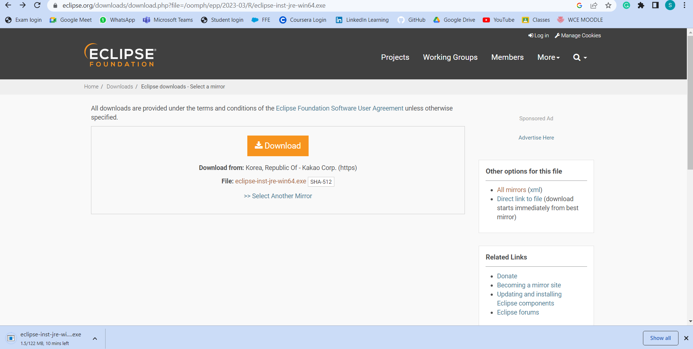

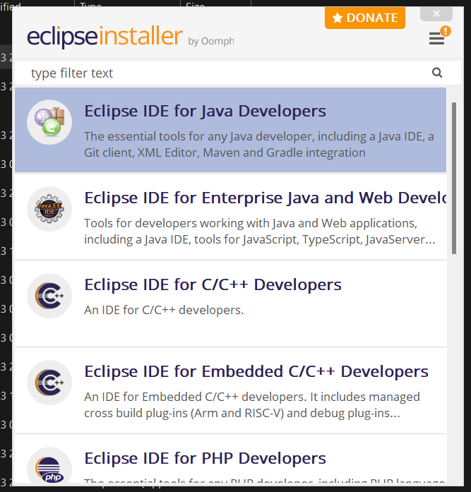

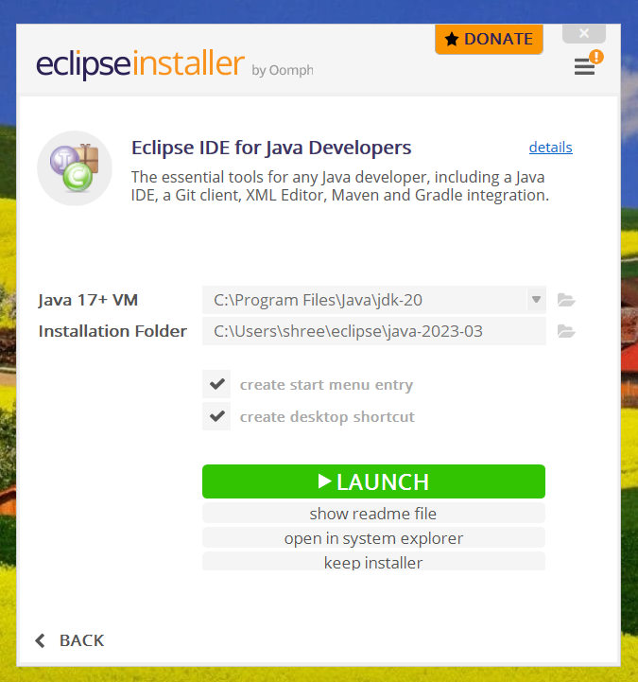

Install chrome driver

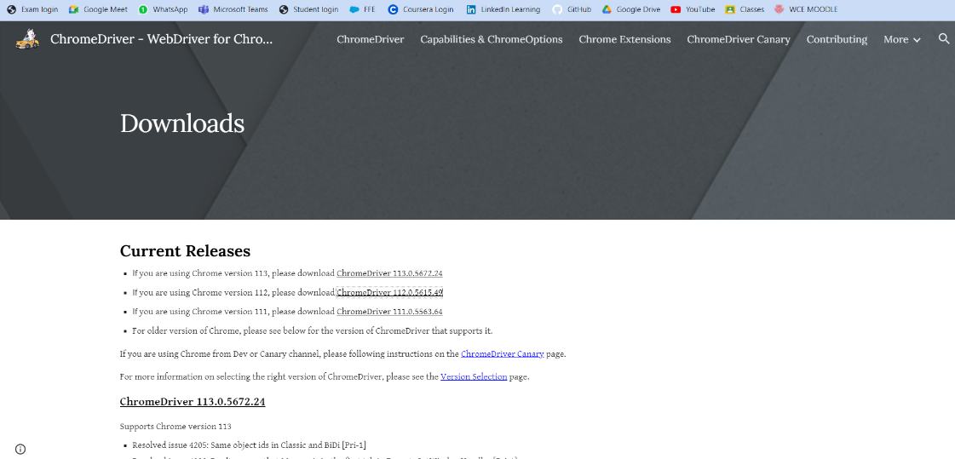

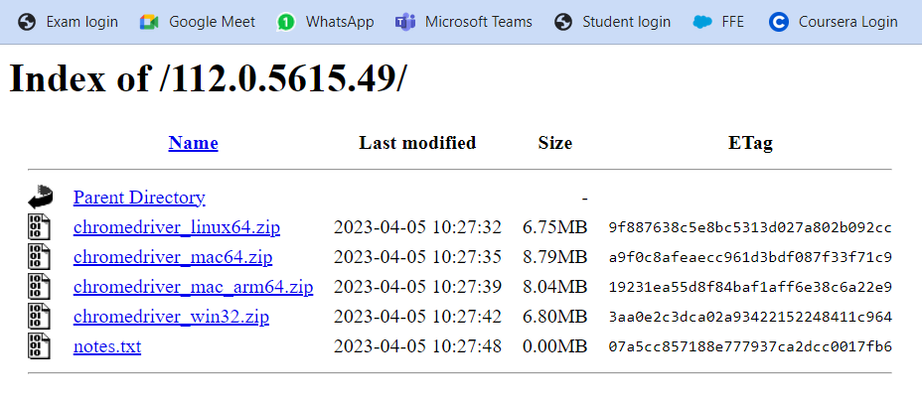

Install selenium server then install selenium webdriver for Java

**Q 3. Using Selenium tool create multiple test cases (at least 10) on any application/project that you have implemented.**

**Perform below tasks**

**a. Create New test project as SETProject**

**b. Create a test plan as SETProjectTestPlan**

**c. Create a build as SETProjectBuild**

**d. Create test suite as Test Suite 1 under SETProject**

**e. Create Test cases in Selenium Tool**