Walchand College of Engineering, Sangli

Computer Science & Engineering

Third Year

**Course Name:**

**Software Engineering Tools**

**Course Code: 5CS351**

**Assignment No-3**

**Name : Akash Babu Misal**

**PRN: 21520005**

**Title - Study of Project Management Tool (Jira)**

Q 1 . Create a project (give name of your project) in Jira, use template as Scrum and add your team members into this project.

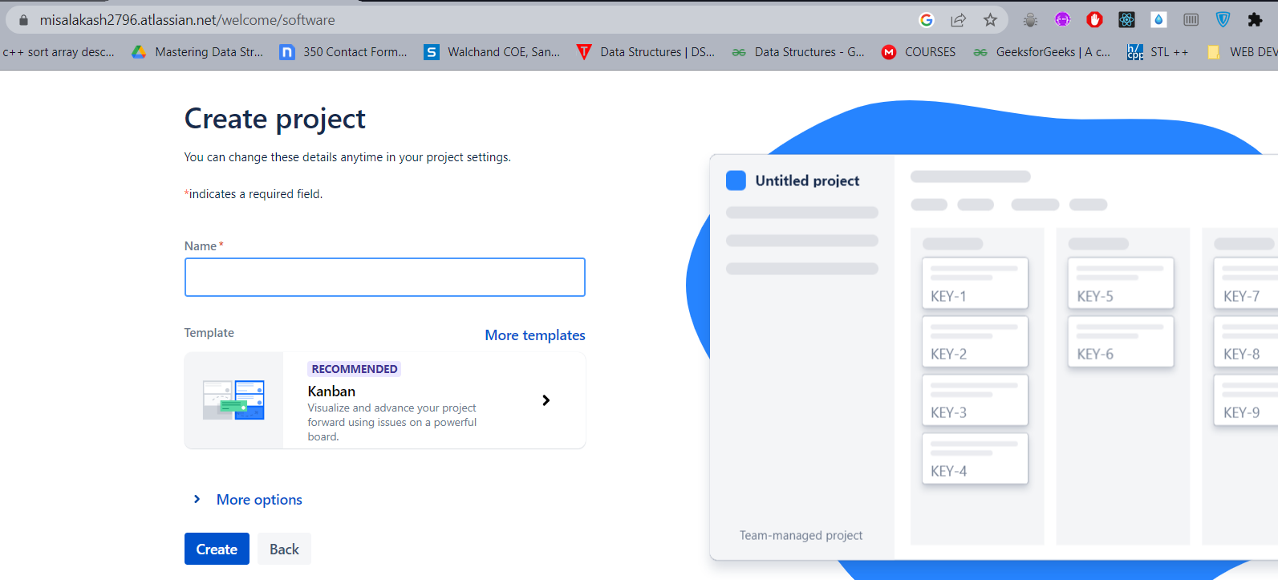

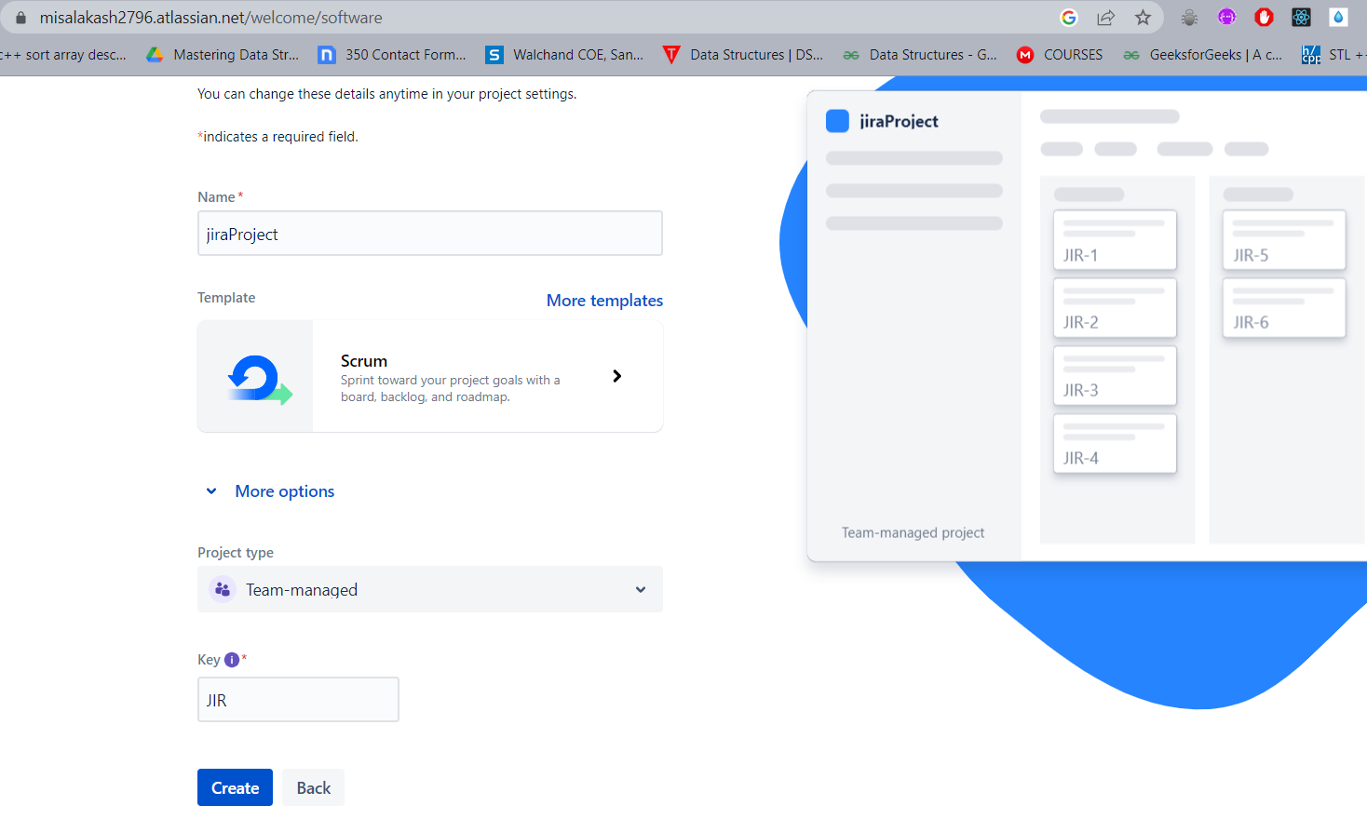

Q 2 . Create an Epic into above project (main requirement of your project, e.g Creating a web application for student result generation).

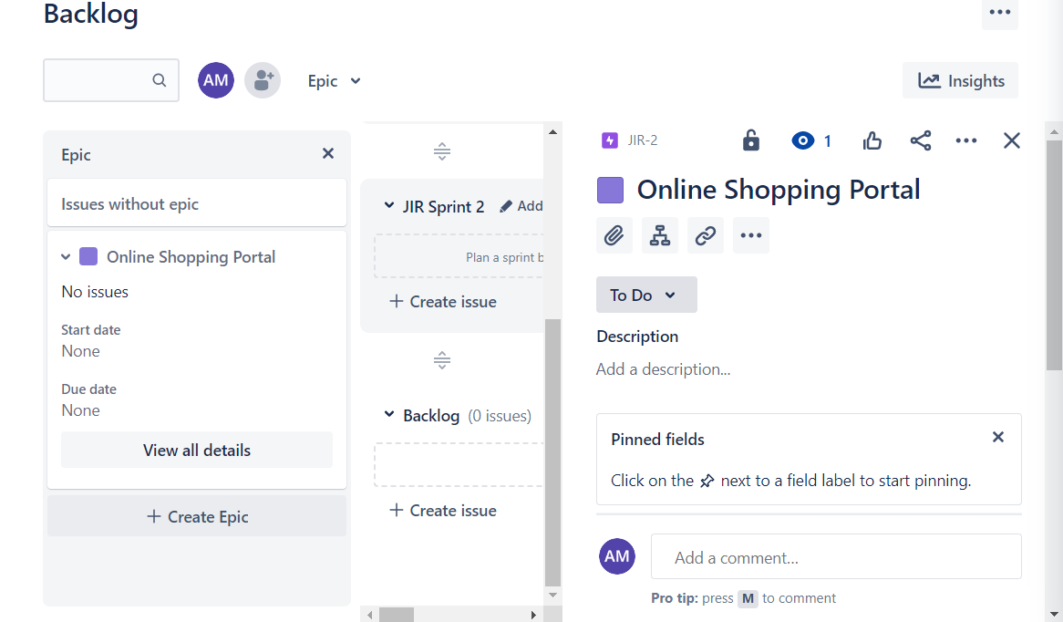

Q 3. Create at least 5 user stories with respect to above epic for your project.

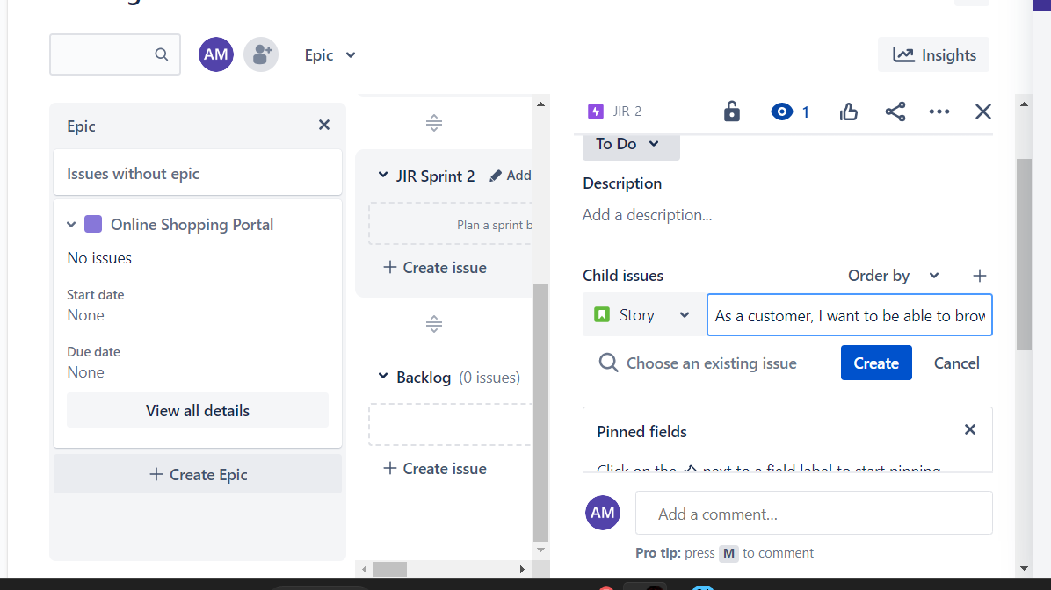

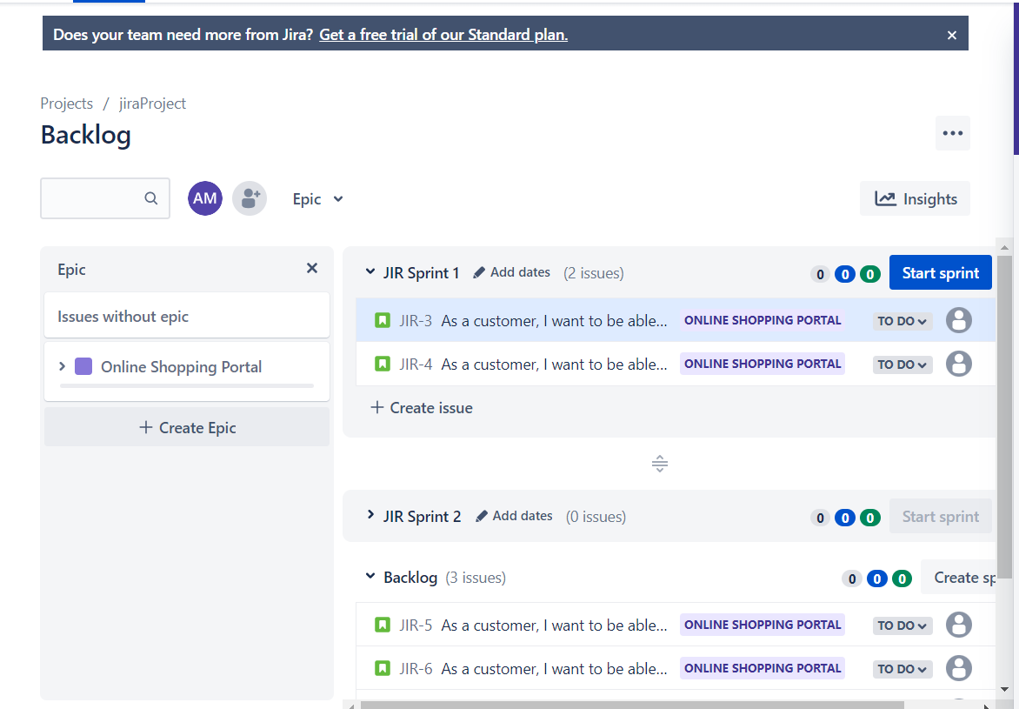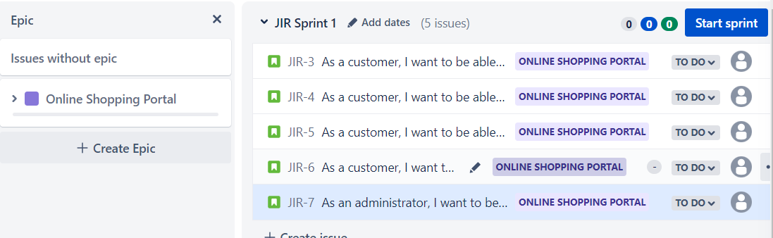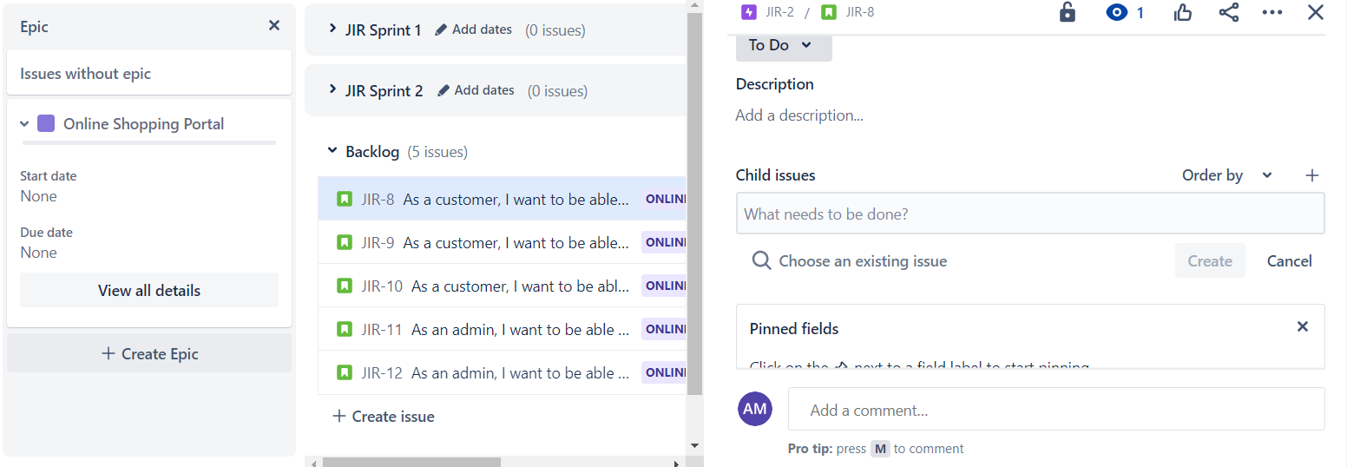

Q 4 Create at least 2 subtasks for every user story. Assign user stories to your team members.

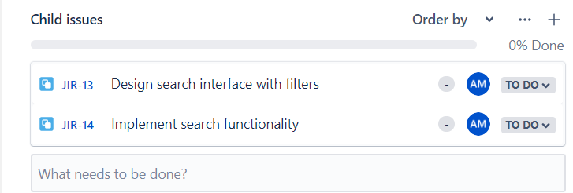

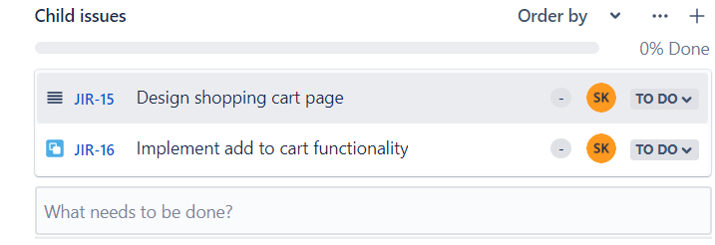

Q 5 Create sprints for every use stories and prioritize them according to your tasks. Assign time period for every user story.

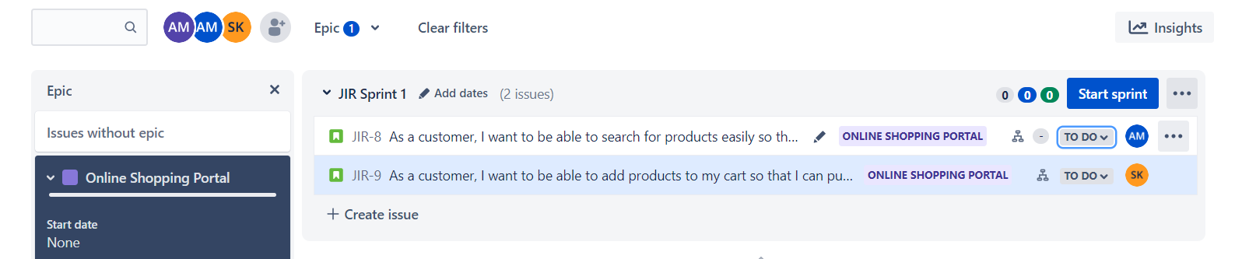

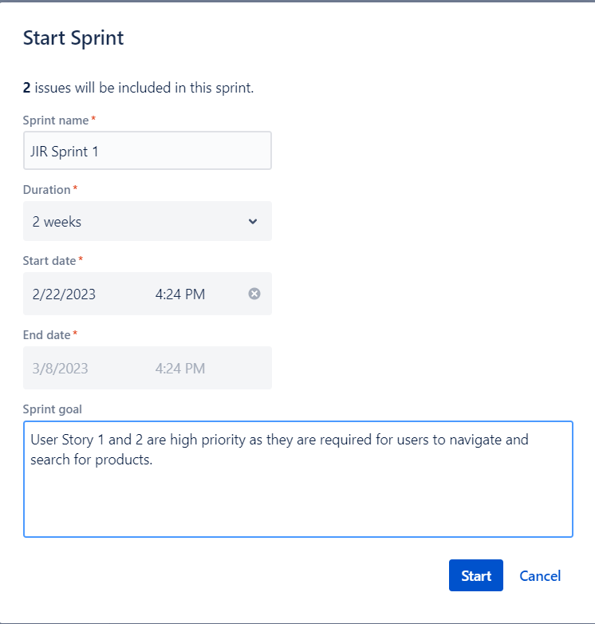

Q 6 Update the status of some user stories as To Do, In Progress or Completed according to sprints (add appropriate comments).

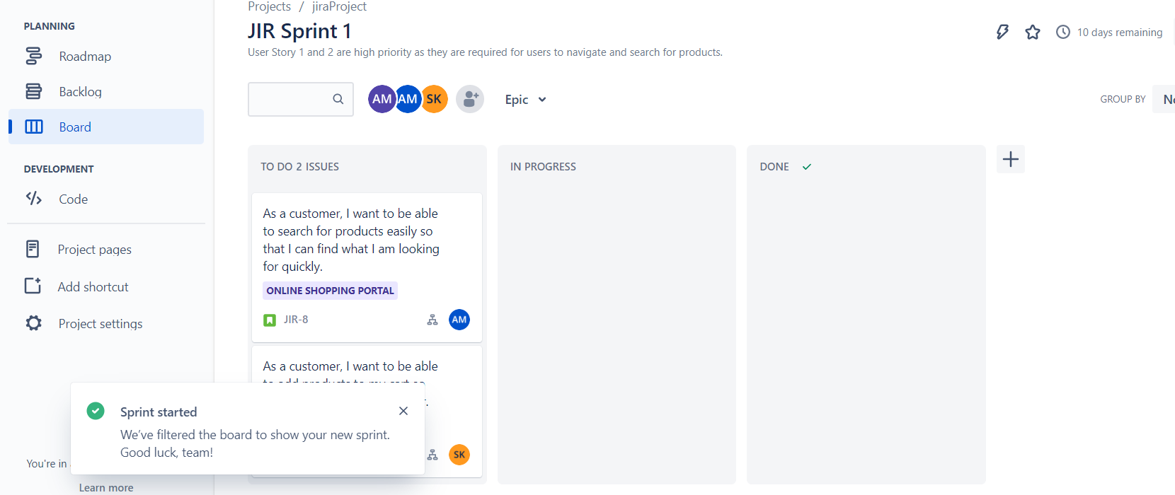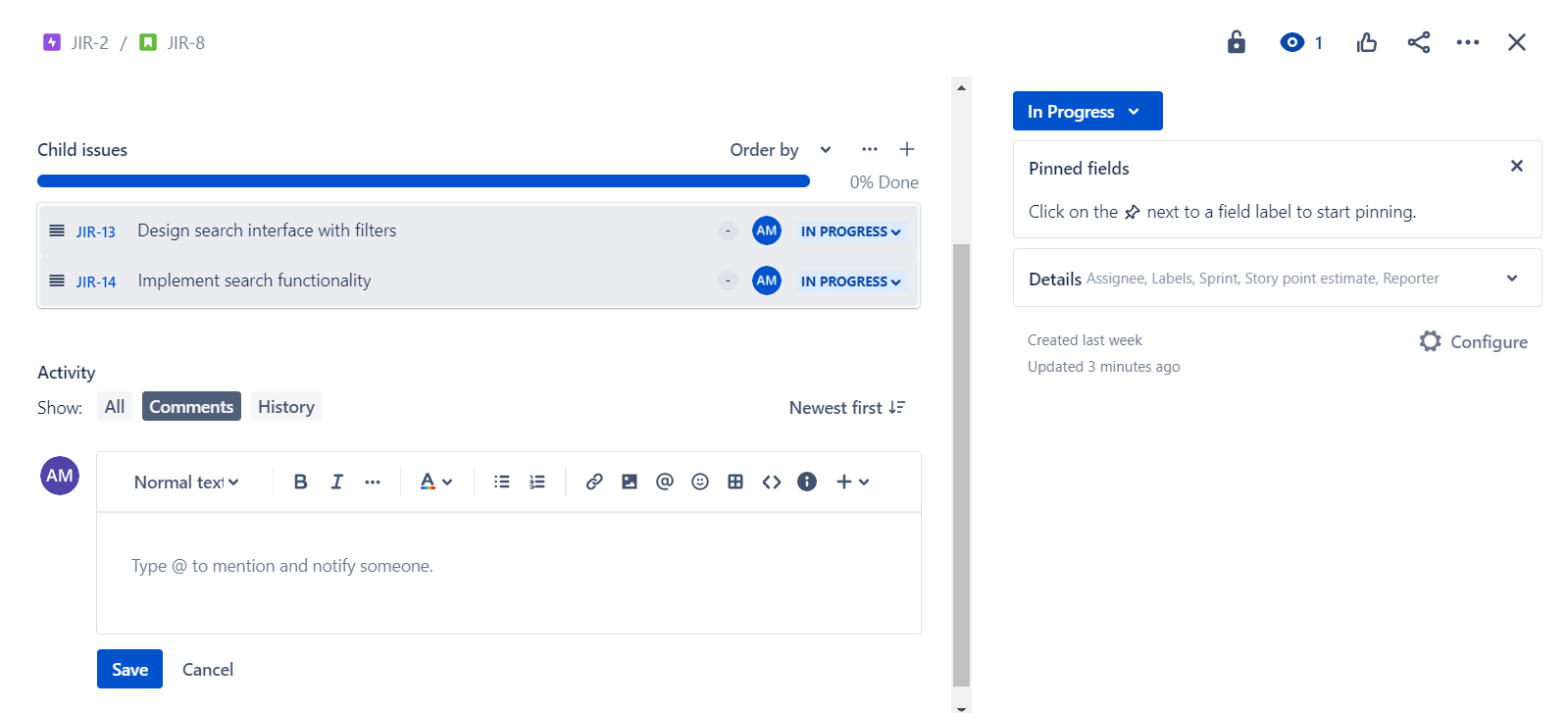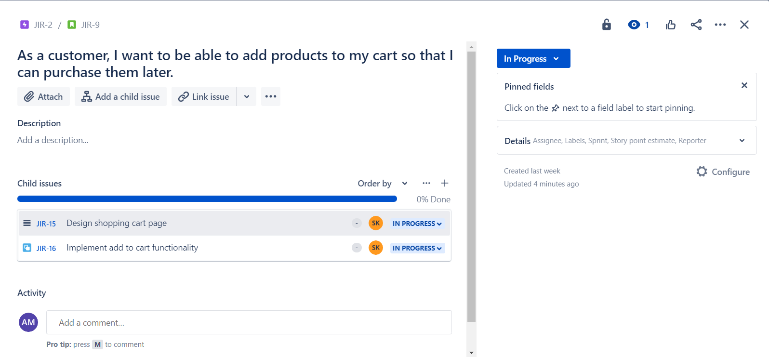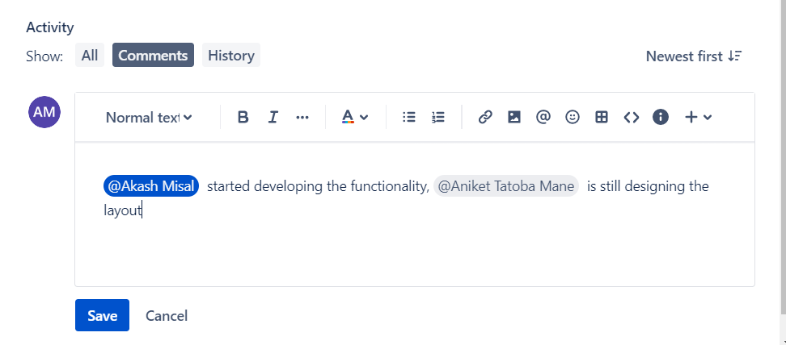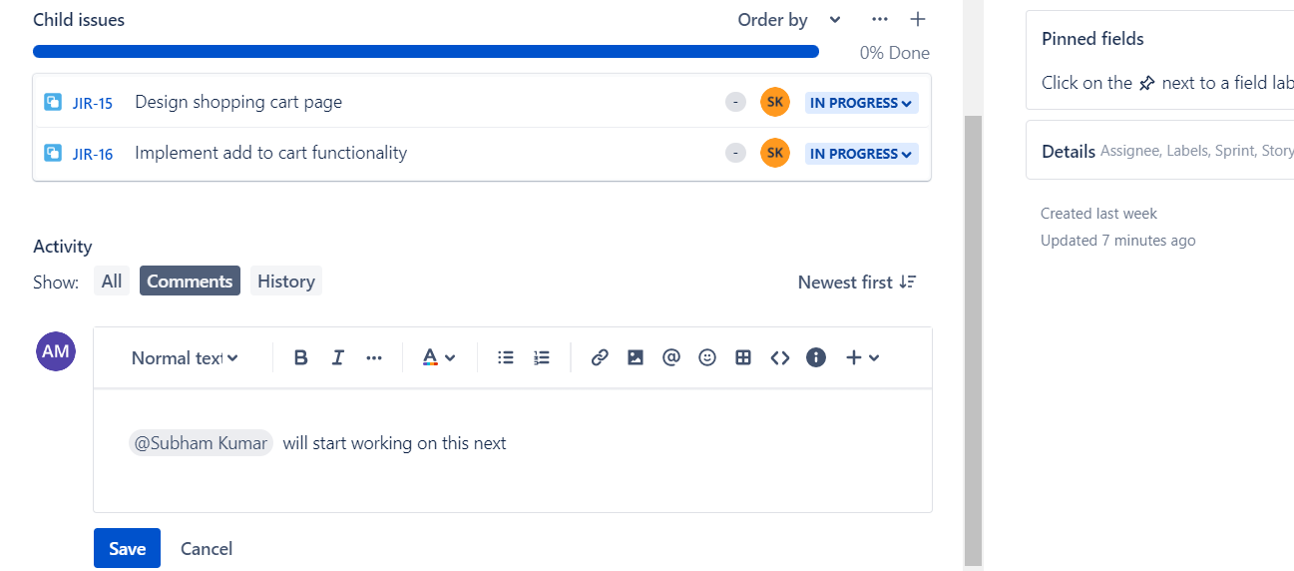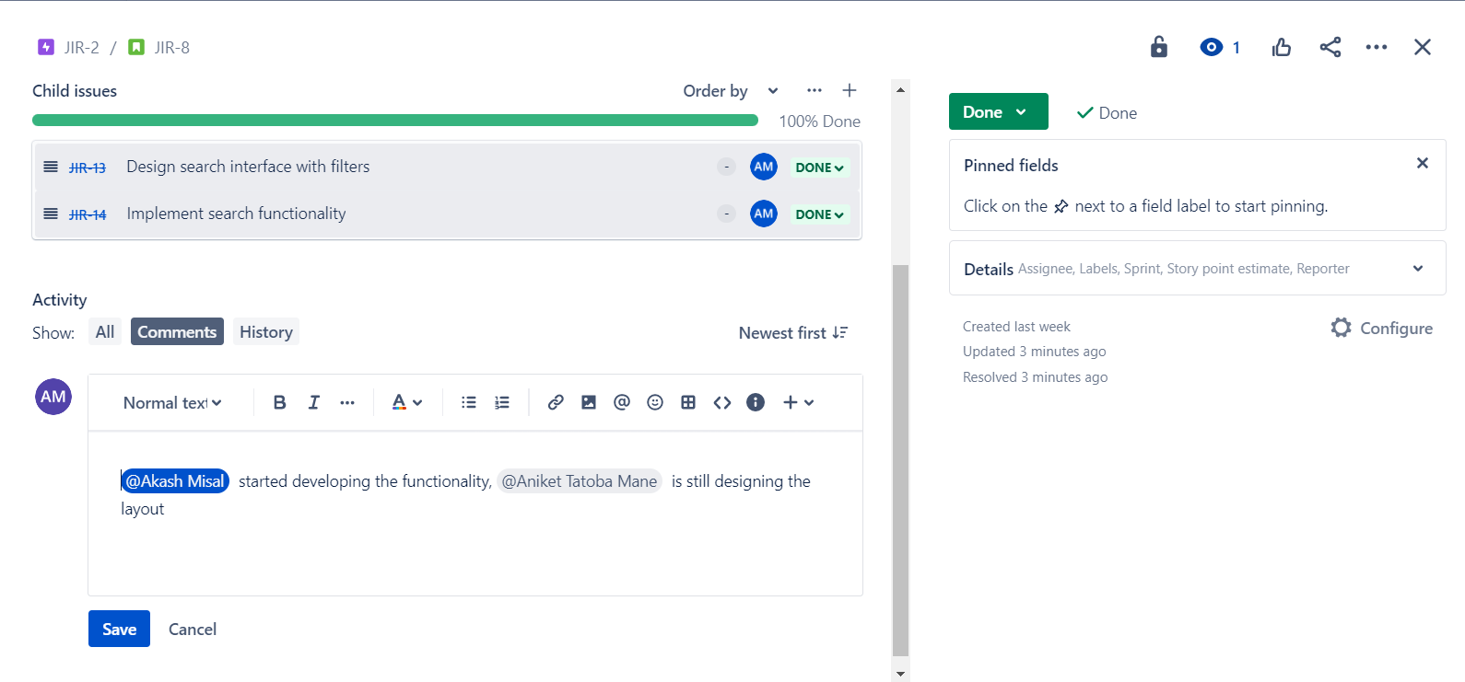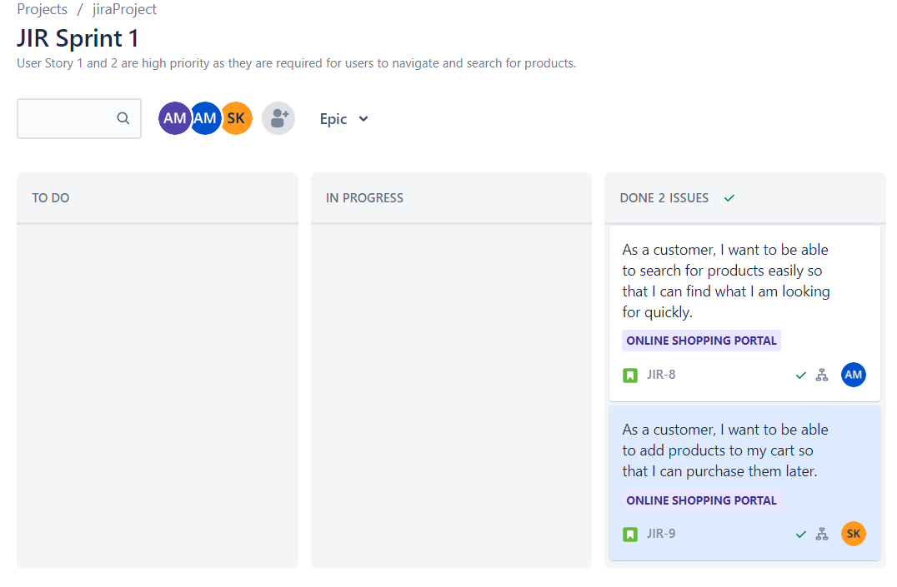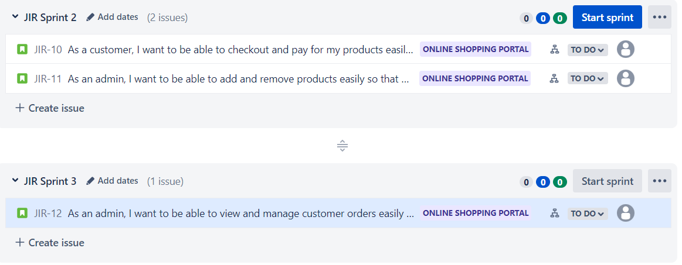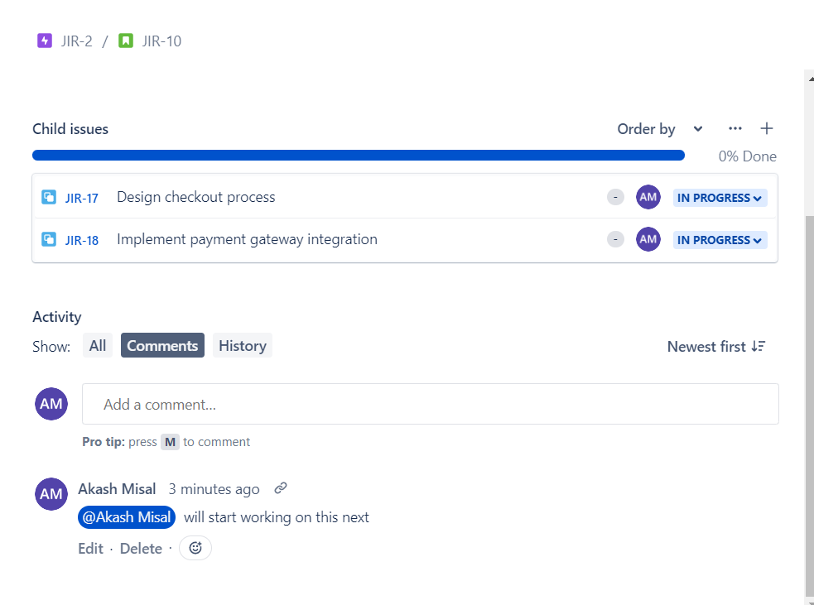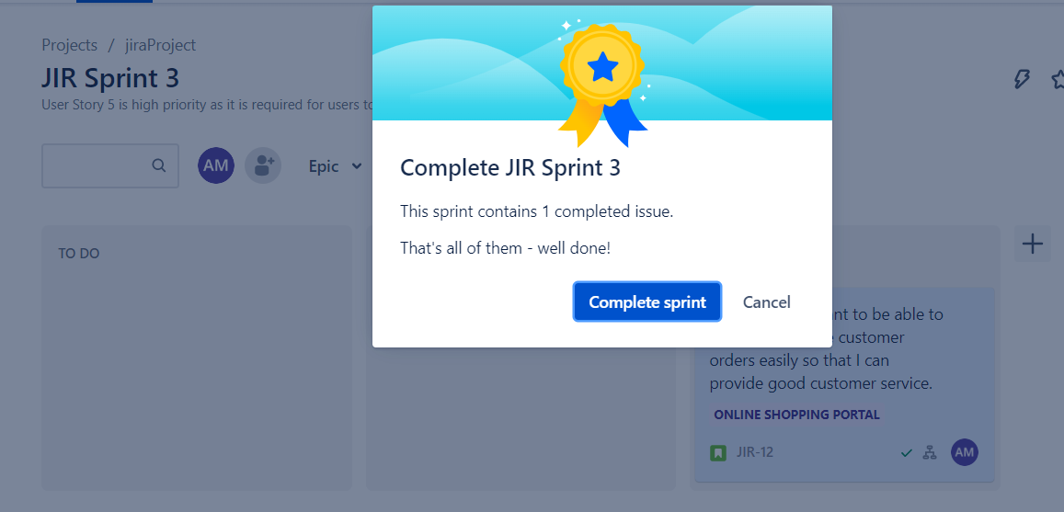

Q 7 . Create a bug/issue for respective user story and epic and assign to respective member.

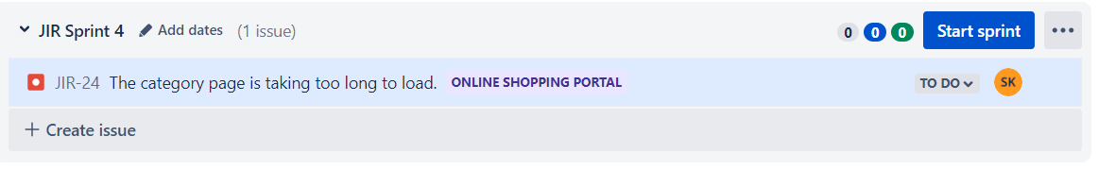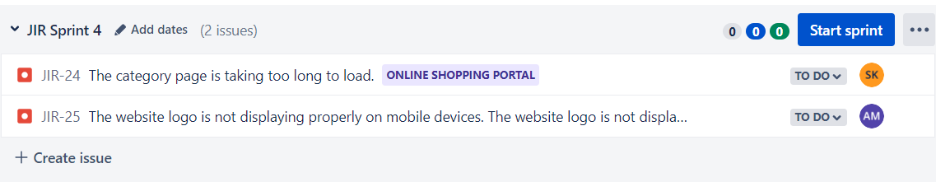

Q 8 Display reports (Burnup chart, Burndown chart) w.r.t your created project.



