WoodLink WIL Documentation
Table of Contents
1. Documentation Overview 1
2. Git Branch Strategy 1
main 1
develop 1
release 1
hotfix 1
staging 1
3. WoodLink Database 1
3.1 Supabase Project Details 1
3.2 Member Access 2
3.3 Database Platform 2
4. Database Tables 3
5. Relationships and Constraints 4
6. Authentication 6
7. Row Level Security 7
8. Storage 8
9. Environment and Application Connection 9
10. Database Connectivity and Security 11
10.1 Security Configuration 12
11. GitHub, QA and Evidence Portfolio 14
12. README and Developer Setup 19
Recommended setup information to add to the README 19
13. Deployment and Release Documentation 20
Release process 20
Release notes 20
13.1 Release Notes – Version 1.0.0 20
Added 20
Security 21
DevOps 21
Testing 21
Documentation 21
Changed 21
Fixed 21
Removed 21
Known Issues 21
Future Enhancements 21
Previous Releases 21
18. Final Task 2 Submission Link 21
19. Final Verification Notes 22
14. Requirements-to-Feature Mapping 22
15. Documentation Evidence Verification Checklist 24

1. Documentation Overview

2. Git Branch Strategy
The supplied README defines the following branch structure. This section is retained as the project source description.

main
Production-ready branch. Contains fully tested and deployed code. Releases are merged into main and direct commits should not be made.

develop
Integration branch. Feature branches merge here first and this branch is used to test that the system works together.

release
Release preparation branch. Used for final testing and bug fixes before merging into main and back into develop. The README states that it is deleted after the merge.

hotfix
Emergency-fix branch for critical production issues. Fixes are merged back into both main and develop.

staging
Staging branch intended to mirror production for final testing. The earlier branch README states that Azure Staging is deployed from this branch, while the v1.0.0 release notes state that all Azure dependencies were removed. This hosting statement must be verified against the final repository before submission.

3. WoodLink Database
WoodLink uses Supabase PostgreSQL as its database. The database supports the website, Node.js API and Android application.

3.1 Supabase Project Details
- Supabase Project: INSY7315 Project (production branch, free plan)
- Region: West EU (Ireland), eu-west-1
- Project ID: hgpwxbmkkerbobtvnjx
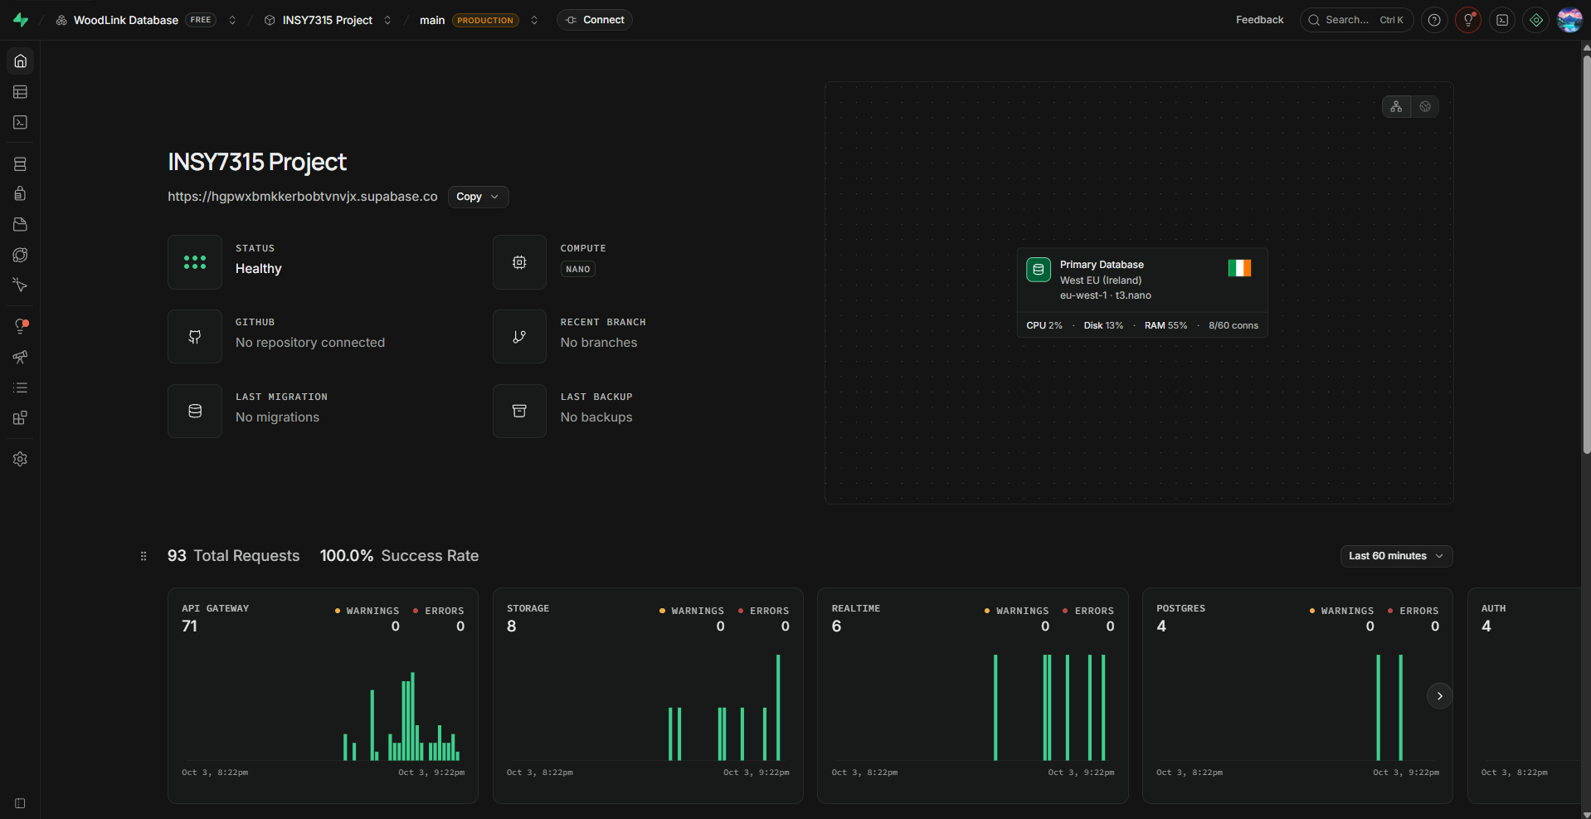
Figure 1. Supabase project overview.

3.2 Member Access
- Andile Nkonyane - ST10474534
- Kennedy II Mwashusha - ST10197888
- Nairon Cossa - ST10255547
- Rico Baloi - ST10441543
- Simphiwe Mathenjwa - ST10258505

3.3 Database Platform
- PostgreSQL 17.6.1.166
- Supabase Auth 2.197.0
- PostgREST 14.5
- Supabase exposes tables through the Data API.
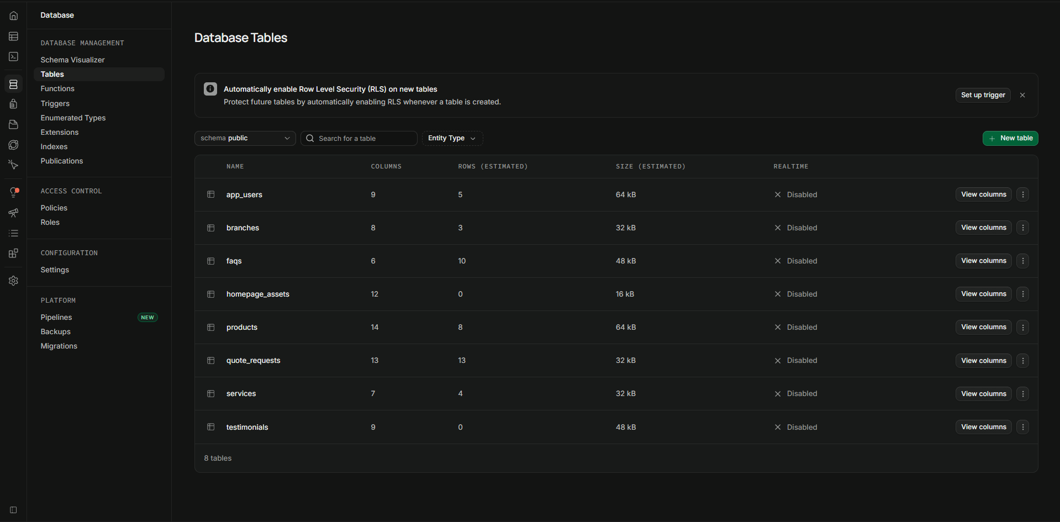
Figure 2. Supabase database tables.

4. Database Tables
Table | Purpose
app_users | User profiles and roles
branches | Three branch details
products | Product catalogue
quote_requests | Customer quote requests
services, faqs, testimonials, homepage_assets | Website and mobile application content
Figure 3. Database table view supporting the documented table structure.

5. Relationships and Constraints
- Every table has its own primary key.
- app_users.id links to auth.users(id), and deleting a login also deletes the profile.
- testimonials.rating must be between 1 and 5.
- The supplied README states that quote branch and product values are stored as plain text rather than being enforced as foreign-key relationships.
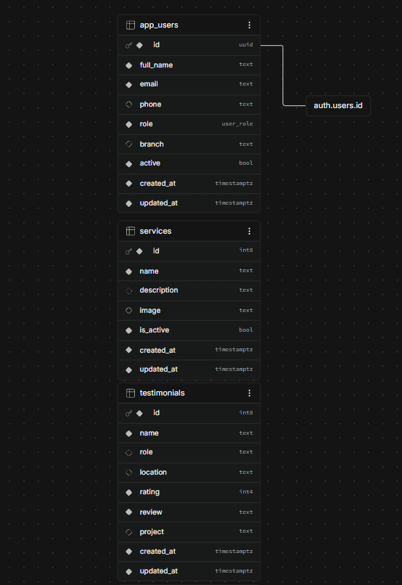
Figure 4. Database relationship/schema evidence.
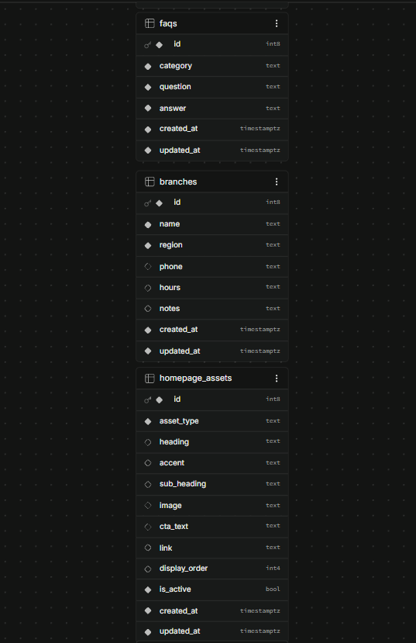
Figure 5. Additional schema evidence.
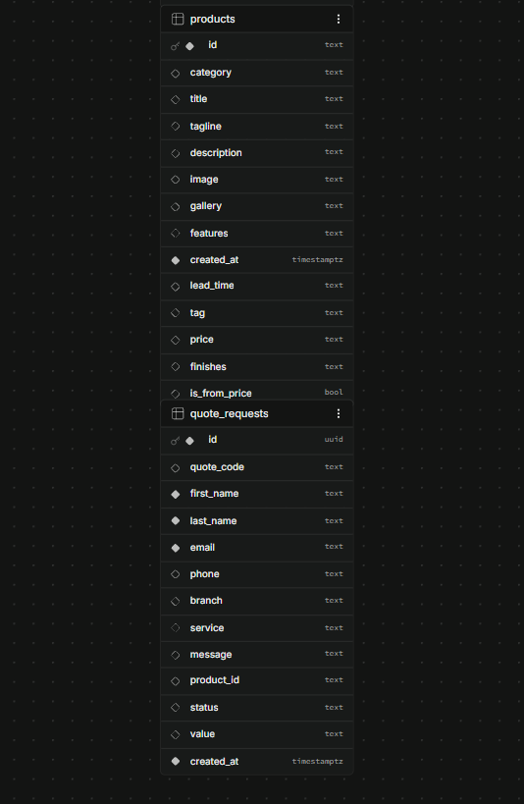
Figure 6. Additional schema/table evidence.

6. Authentication
- Supabase Auth uses the email provider.
- Email confirmation is enabled.
- Anonymous sign-ins are disabled.
- Roles are stored in app_users.role: Admin, branch managers and Customer.
- The functions is_admin, is_staff and get_user_branch support role checks.
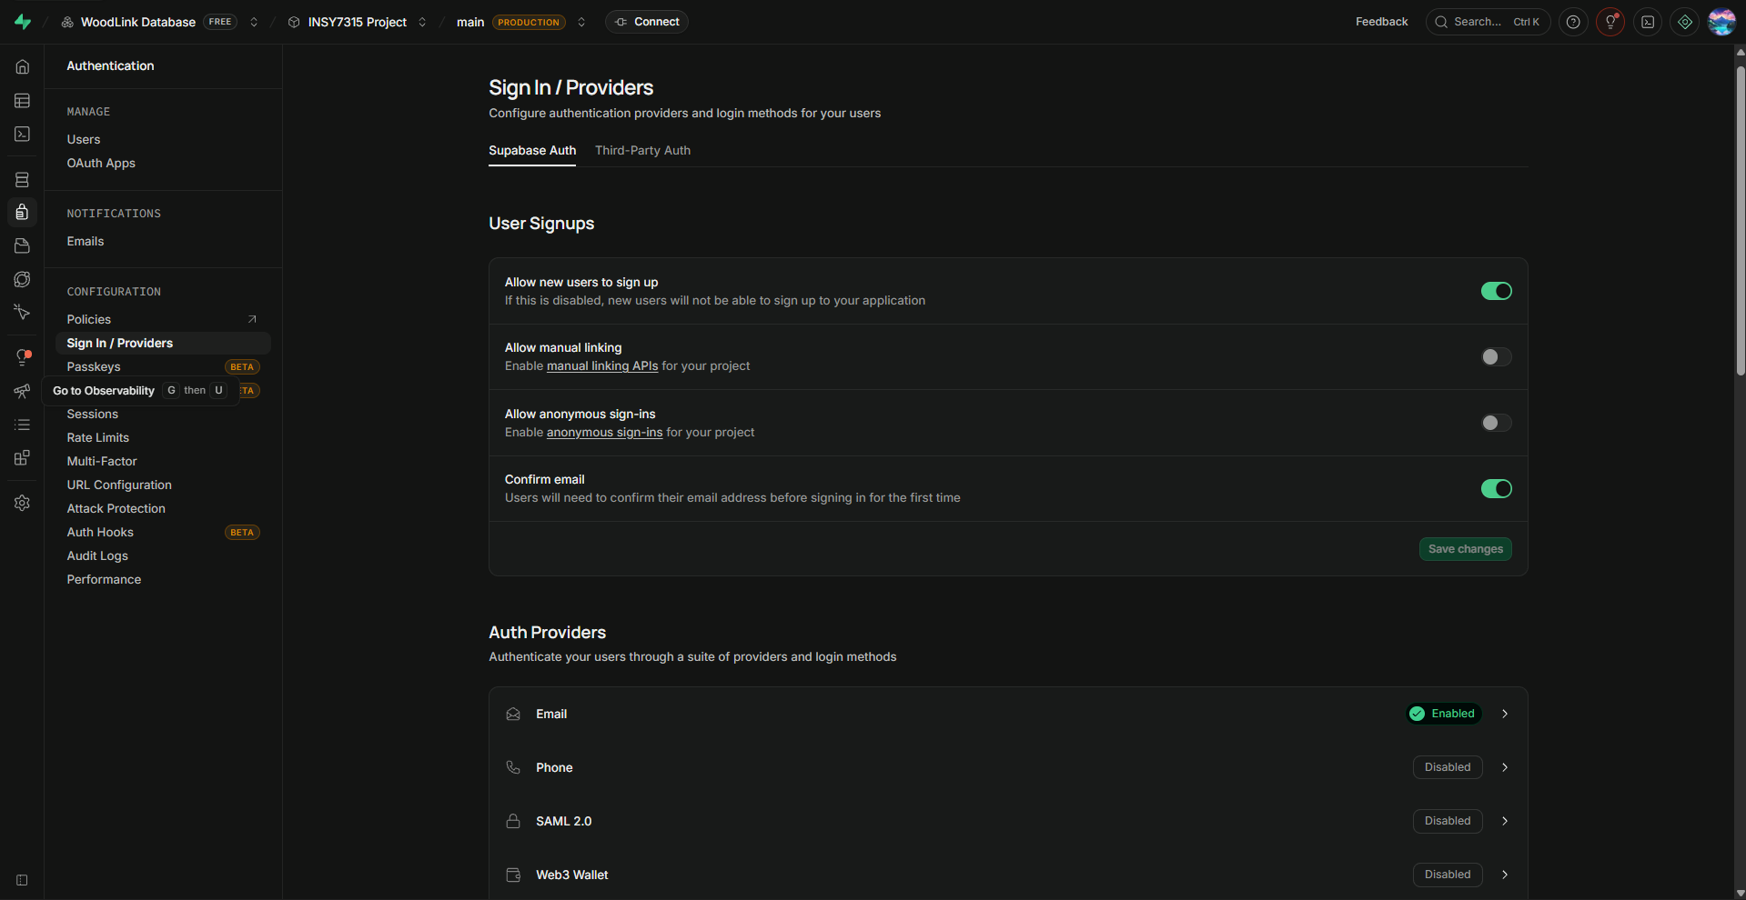
Figure 7. Supabase authentication configuration.

7. Row Level Security
- The release notes state that Row Level Security is enabled on all Supabase tables.
- The release notes also list a known issue: RLS policies still need to be created for all tables except app_users. This is different from the earlier setup text that said policies had already been created, so the final Supabase dashboard state should be checked before submission.
- The Node API performs database reads and writes using the server-side secret key. The secret value itself is never included in this document.
- app_users is excluded from the RLS-policy known-issue statement in the v1.0.0 release notes.
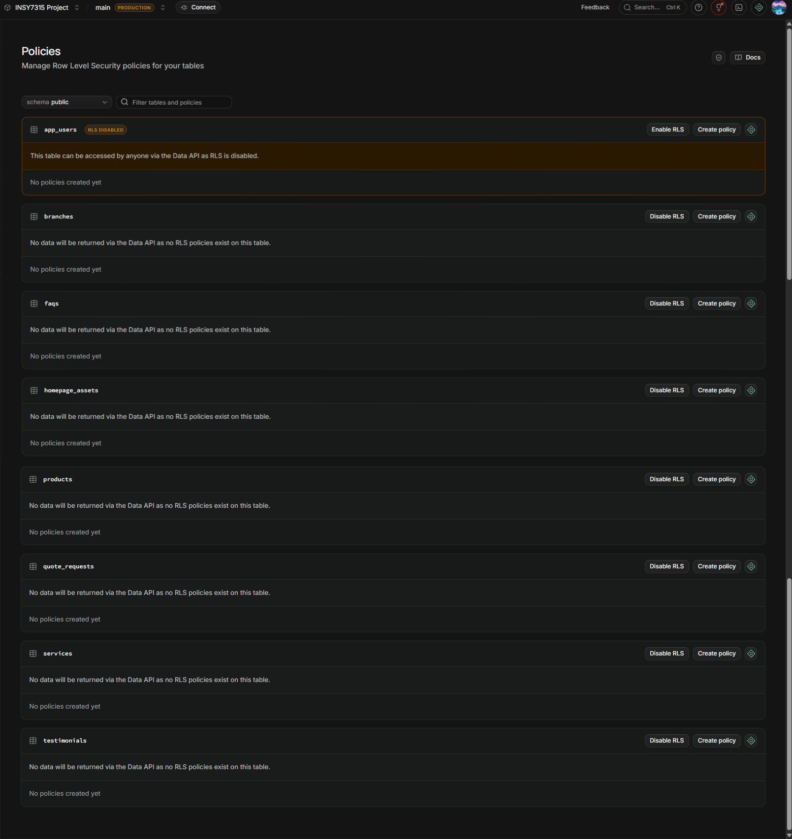
Figure 8. Row Level Security configuration.
Documentation note: the statement that the Node API uses the secret key should be treated as sensitive architecture information. The secret value itself must never be placed in this document, README, screenshots or GitHub.

8. Storage
- Public bucket: woodlands-assets.
- Default file limit: 50 MB.
- The supplied README states that any file type is allowed.
- Two policies are documented: Public Access for viewing and Admin Uploads for uploads.
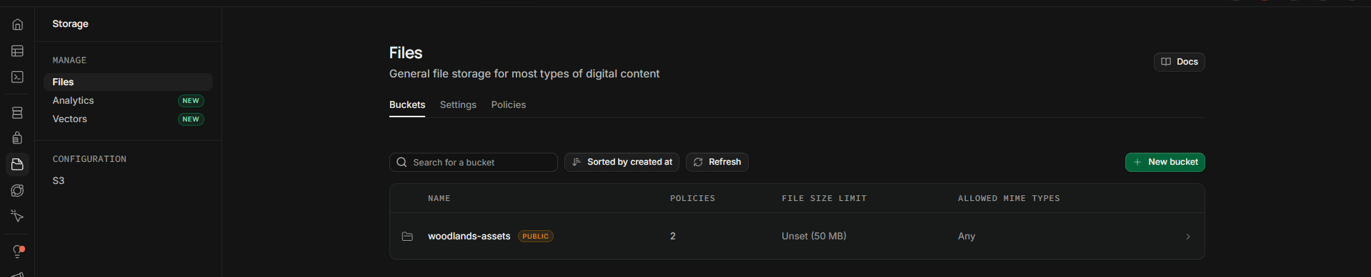
Figure 9. Storage configuration.
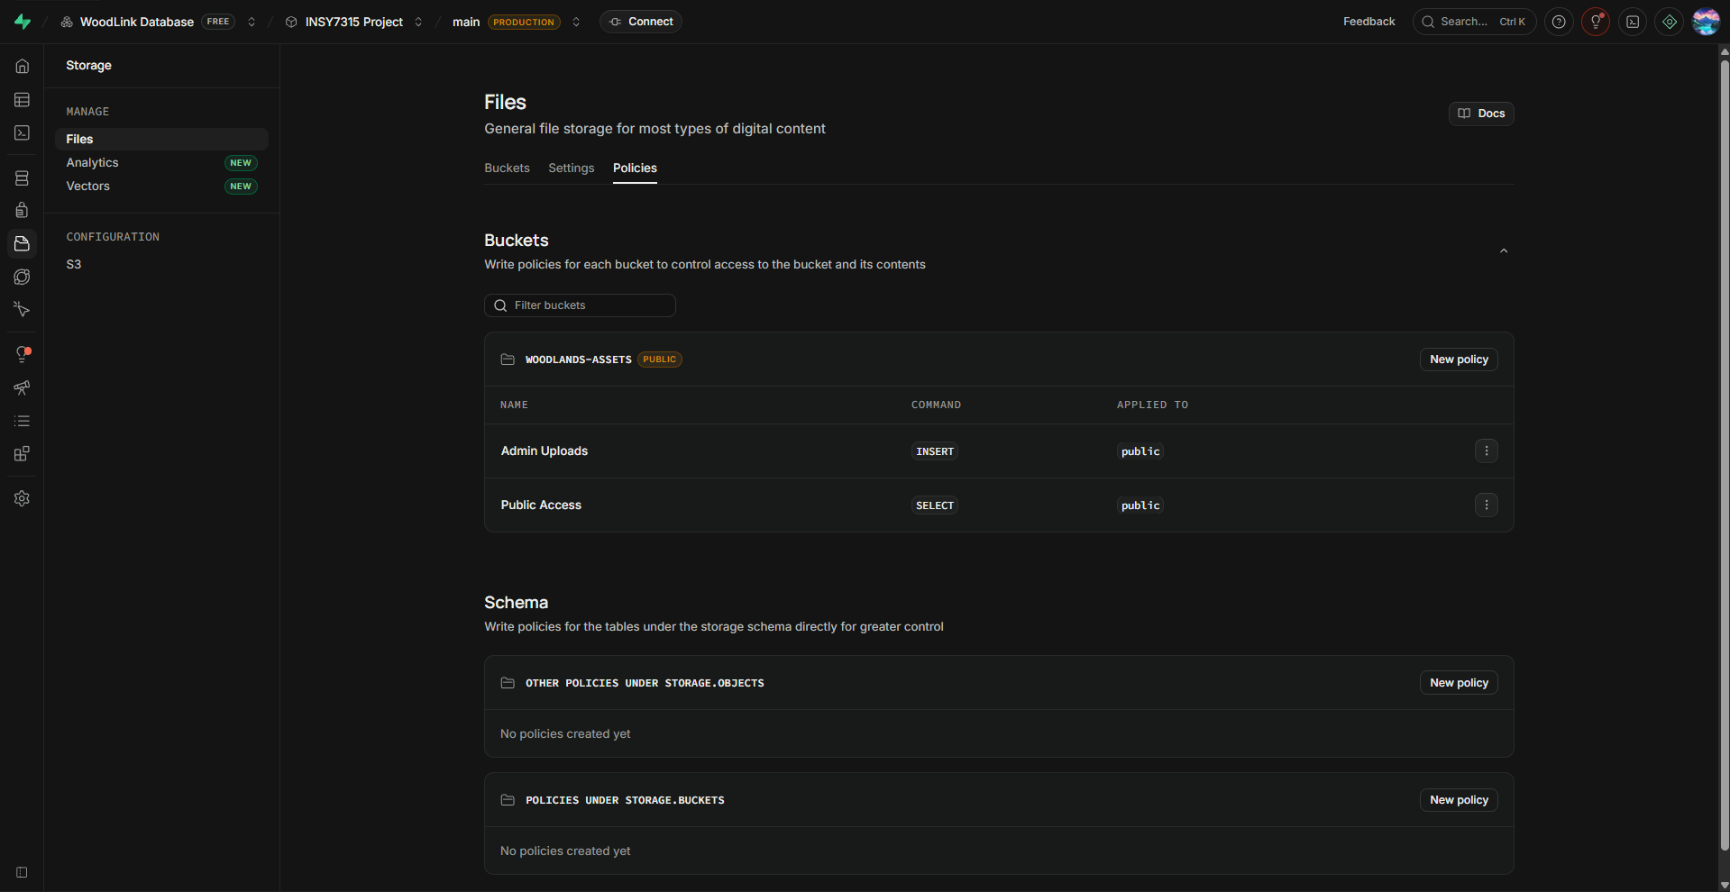
Figure 10. Existing storage buckets used by the WoodLands web and mobile applications.

9. Environment and Application Connection
The supplied architecture description states that the web application and mobile application do not connect directly to Supabase. They communicate with the Node API, which handles requests, role-specific actions and data control.
- The Node API connects to Supabase using HTTP/HTTPS and the Supabase client.
- The supplied materials contain two API-port values: 5000 in the earlier architecture description and 3000 in the detailed developer setup instructions. Verify the final API port in the repository before submission.
- The Supabase URL and secret keys are stored in the API .env file.
- The .env file is excluded through .gitignore and therefore should not be committed.
- The web application communicates with the Node API.
- The mobile application communicates with the Node API and keeps a local SQLite copy for offline use.
- A direct PostgreSQL connection also exists on port 5432 using the postgres database.
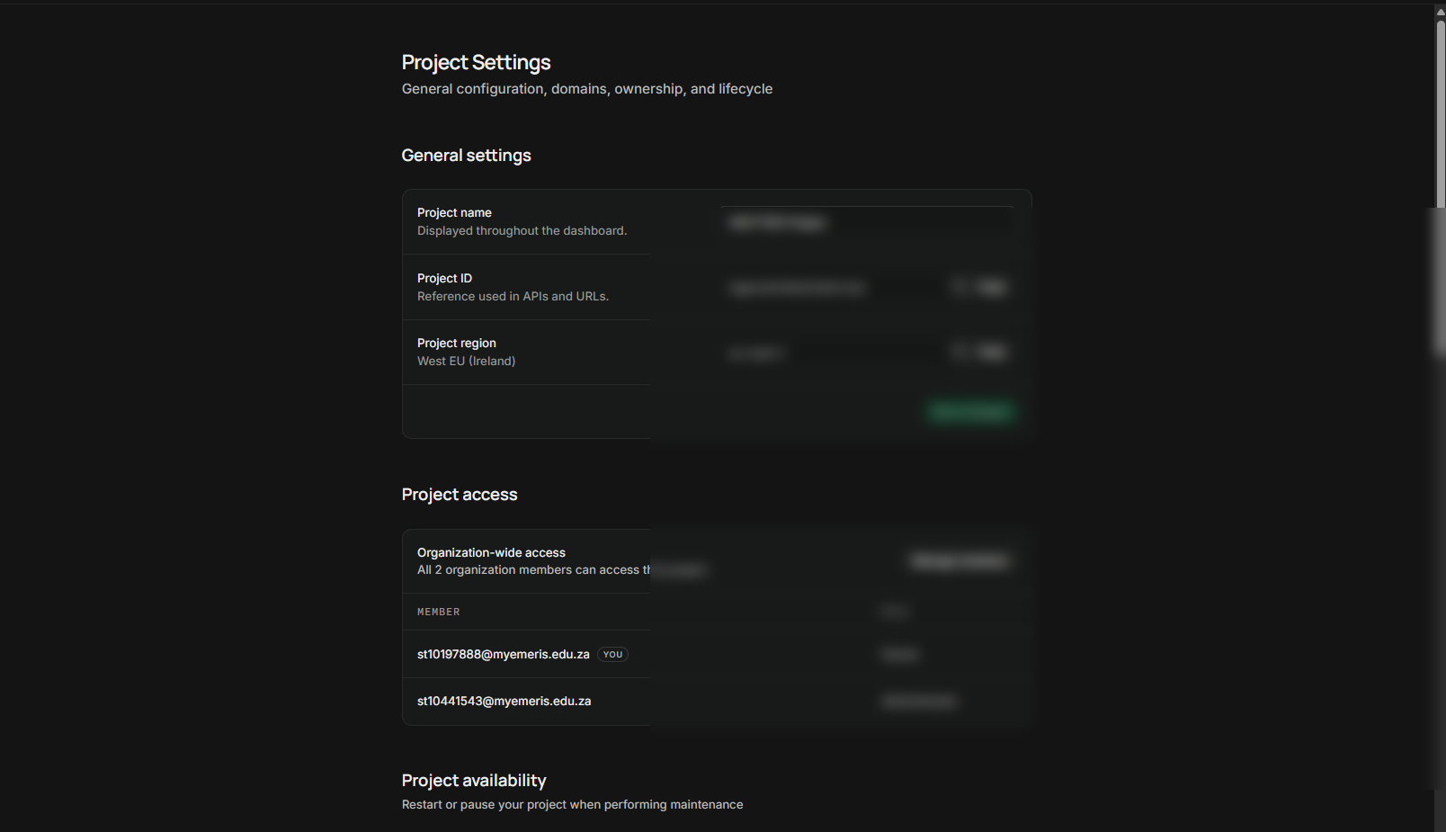
Figure 11. Project/environment configuration evidence.
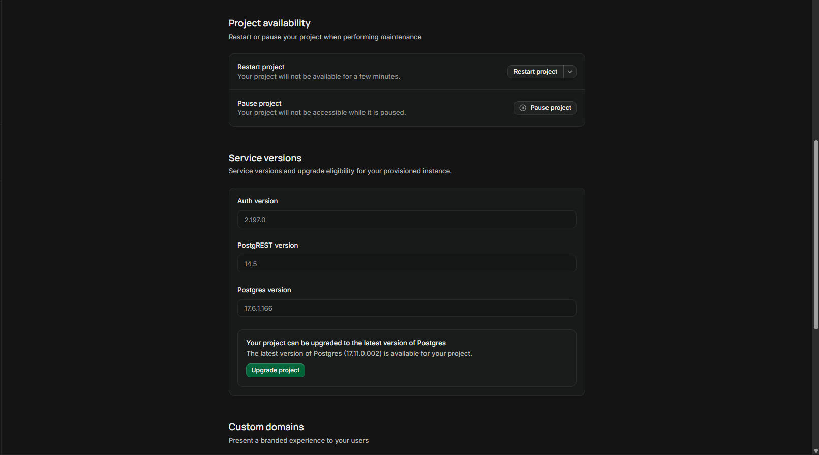
Figure 12. Additional environment configuration evidence.
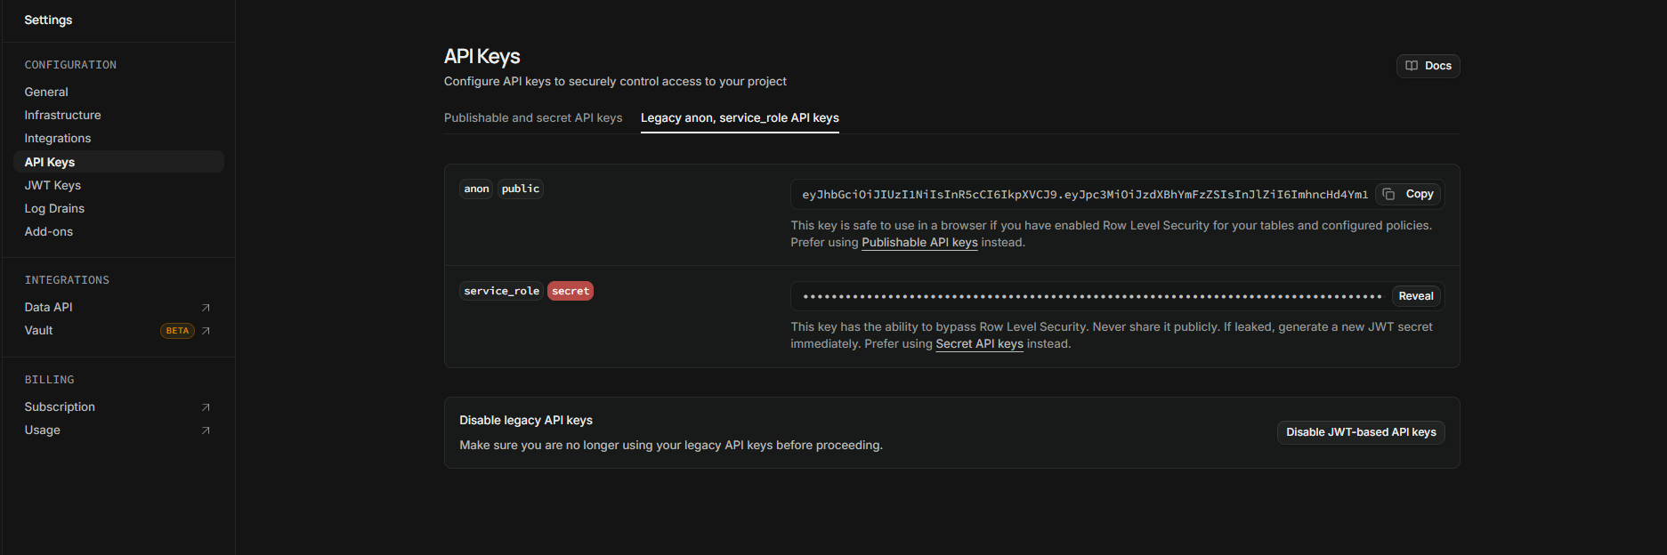
Figure 13. API/database connection configuration.

10. Database Connectivity and Security
The production application uses the Node API as the controlled connection between the clients and Supabase. Database credentials are not placed in the client applications.
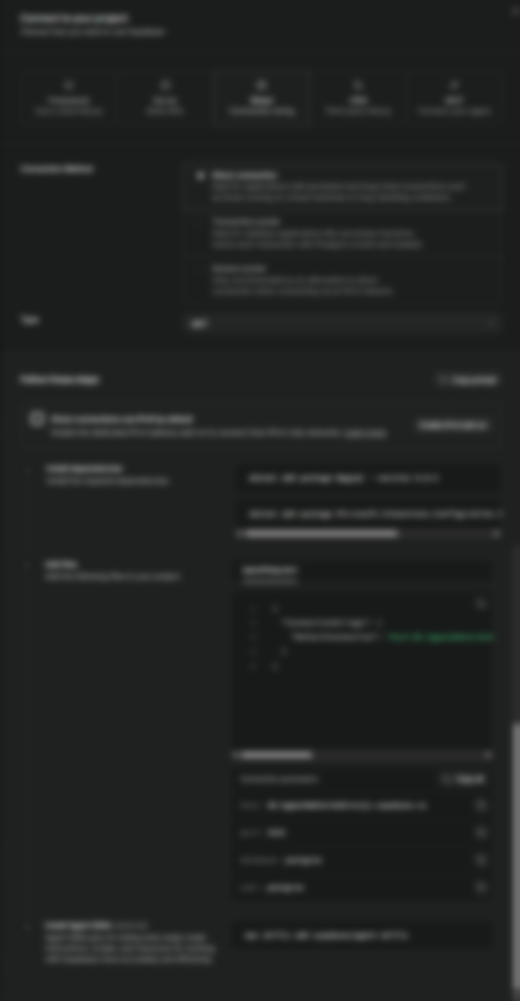
Figure 14. Database connectivity evidence.

10.1 Security Configuration
- Passwords are handled by Supabase Auth and are not stored by the application itself.
- The secret key remains on the server.
- The mobile application does not hold database keys.
- Anonymous sign-ins are disabled.
- Email confirmation is enabled.
- RLS is used to restrict public Data API access on protected tables.
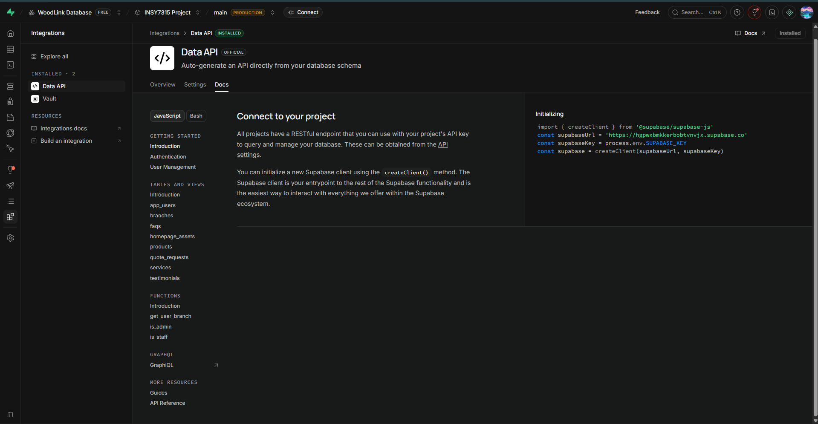
Figure 15. Security/database documentation evidence.
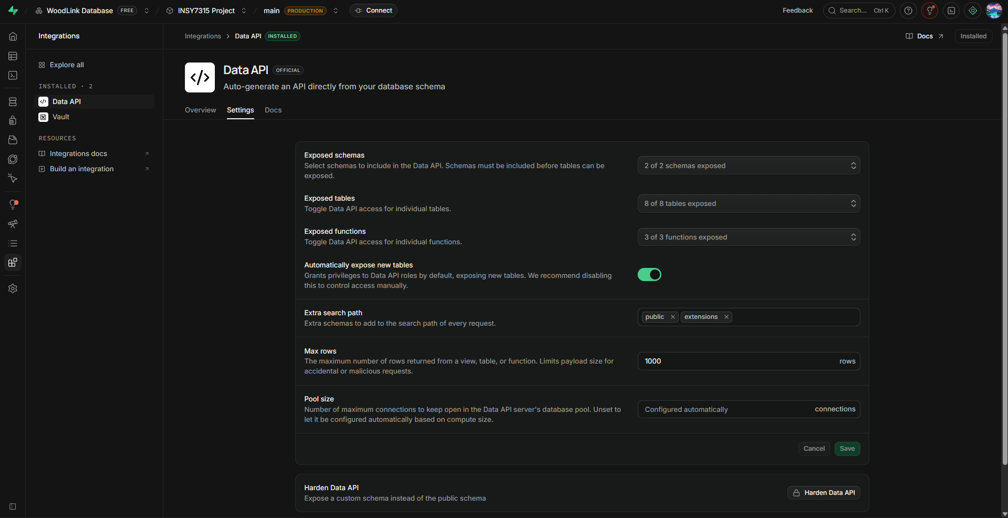
Figure 16. Additional security/database evidence.
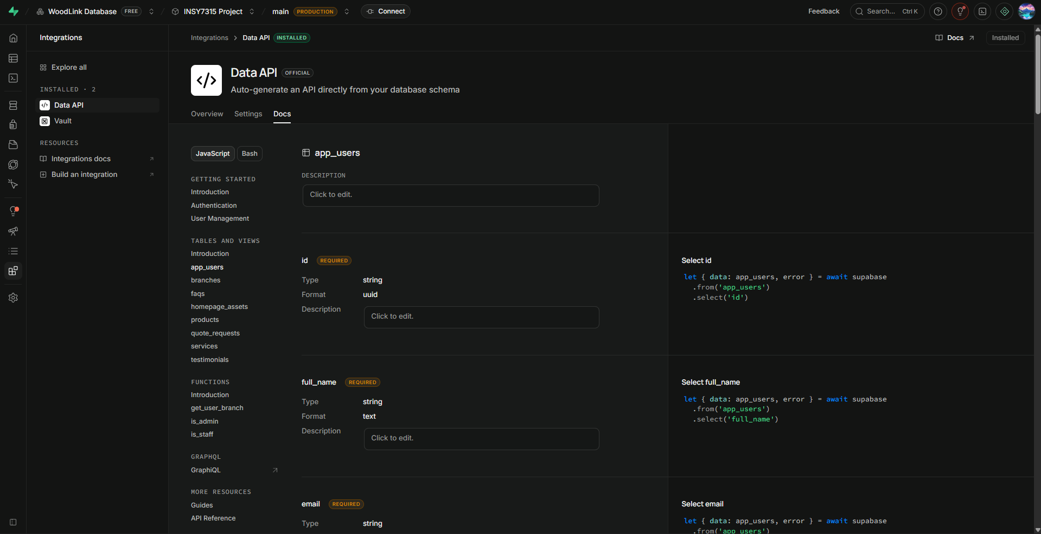
Figure 17. Supporting database documentation evidence.
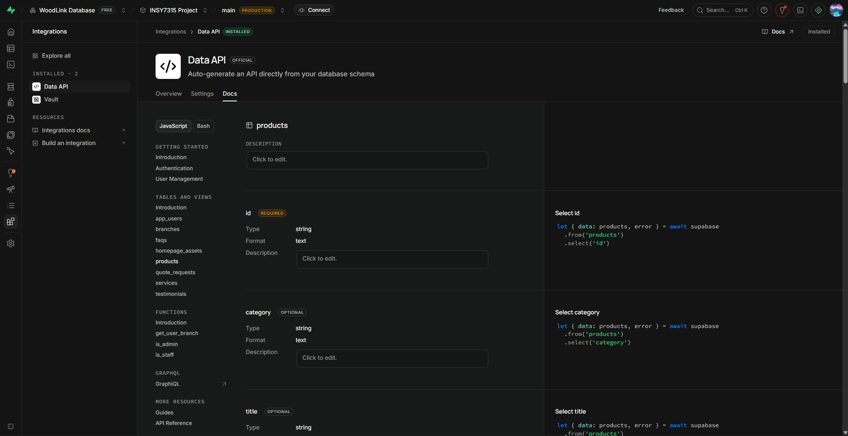
Figure 18. Supporting project configuration evidence.

11. GitHub, QA and Evidence Portfolio
The existing evidence demonstrates individual QA contribution, automated testing, formal QA documentation, validation and edge-case handling. These items are retained as group documentation submission evidence.
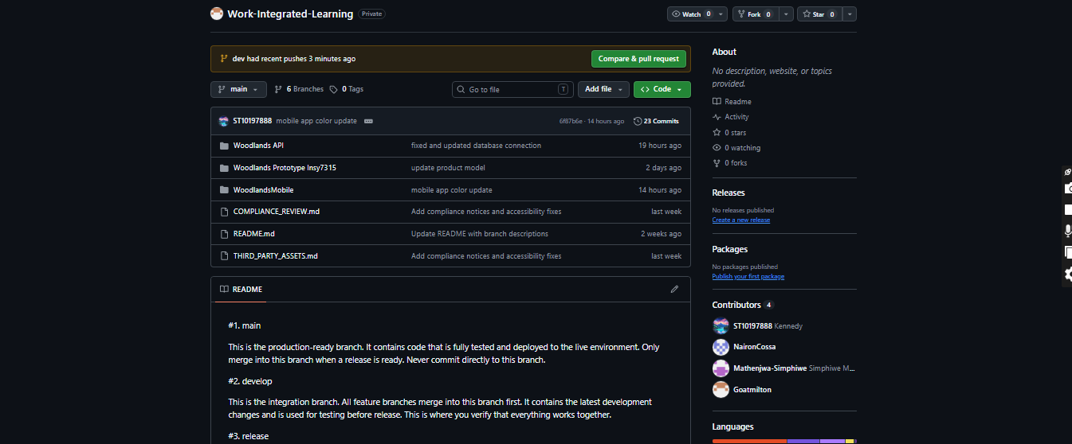
Figure 19. GitHub repository/commit evidence.
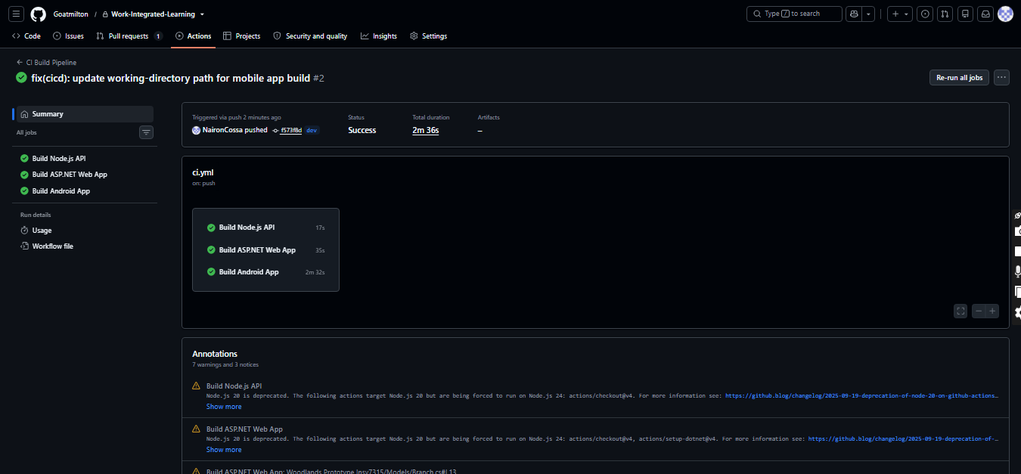
Figure 20. GitHub contribution or pull request evidence.
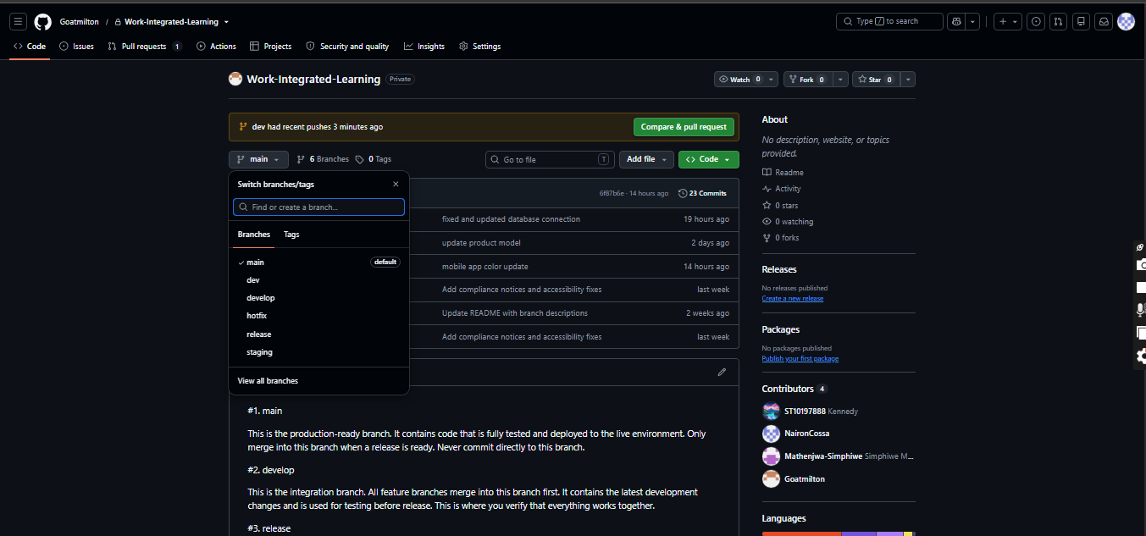
Figure 21. GitHub workflow/branch evidence.
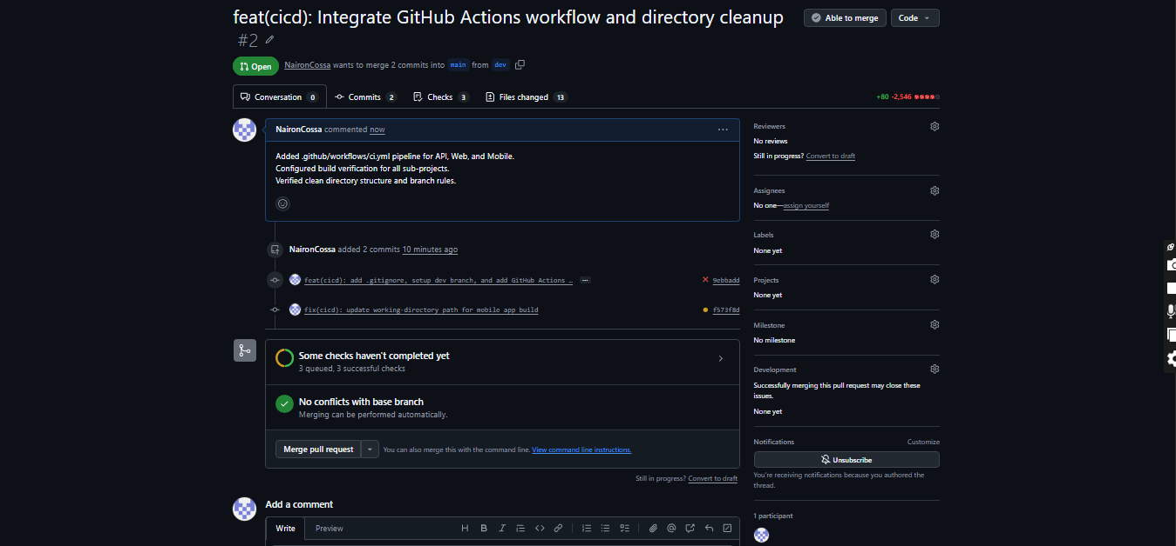
Figure 22. GitHub Actions evidence.
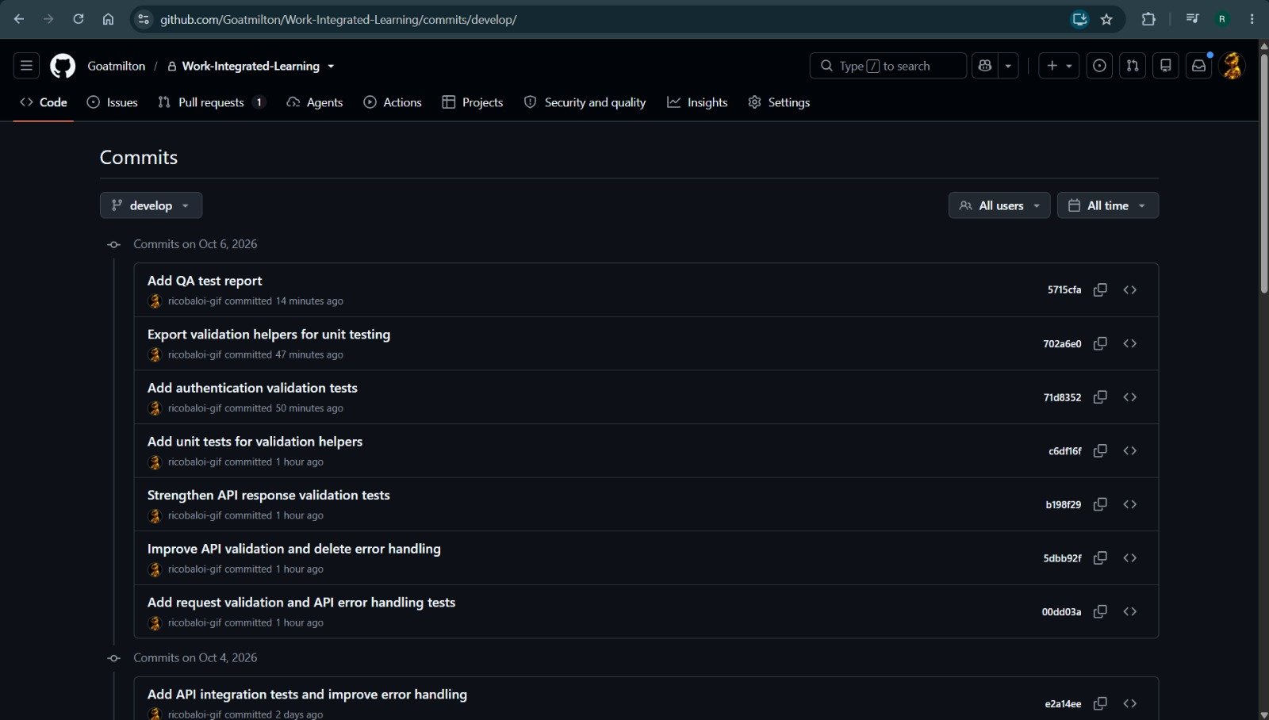
Figure 23. QA/test implementation evidence.
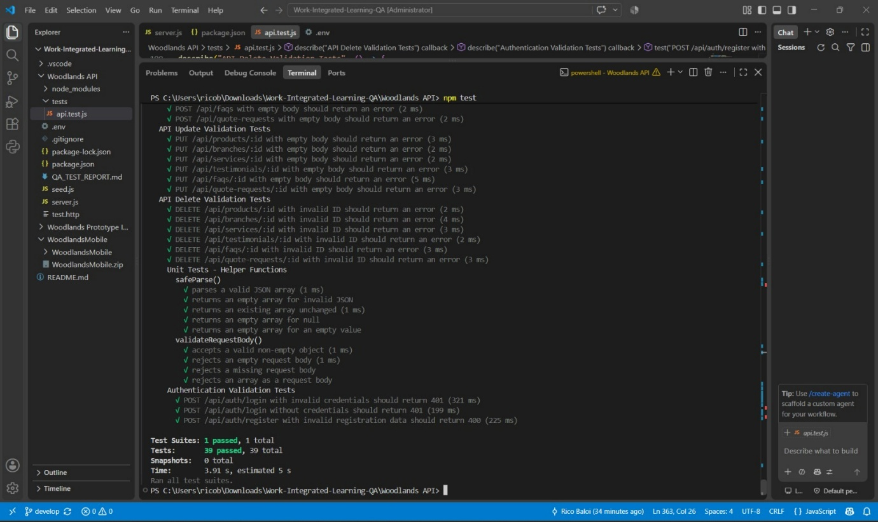
Figure 24. Automated test or validation evidence.
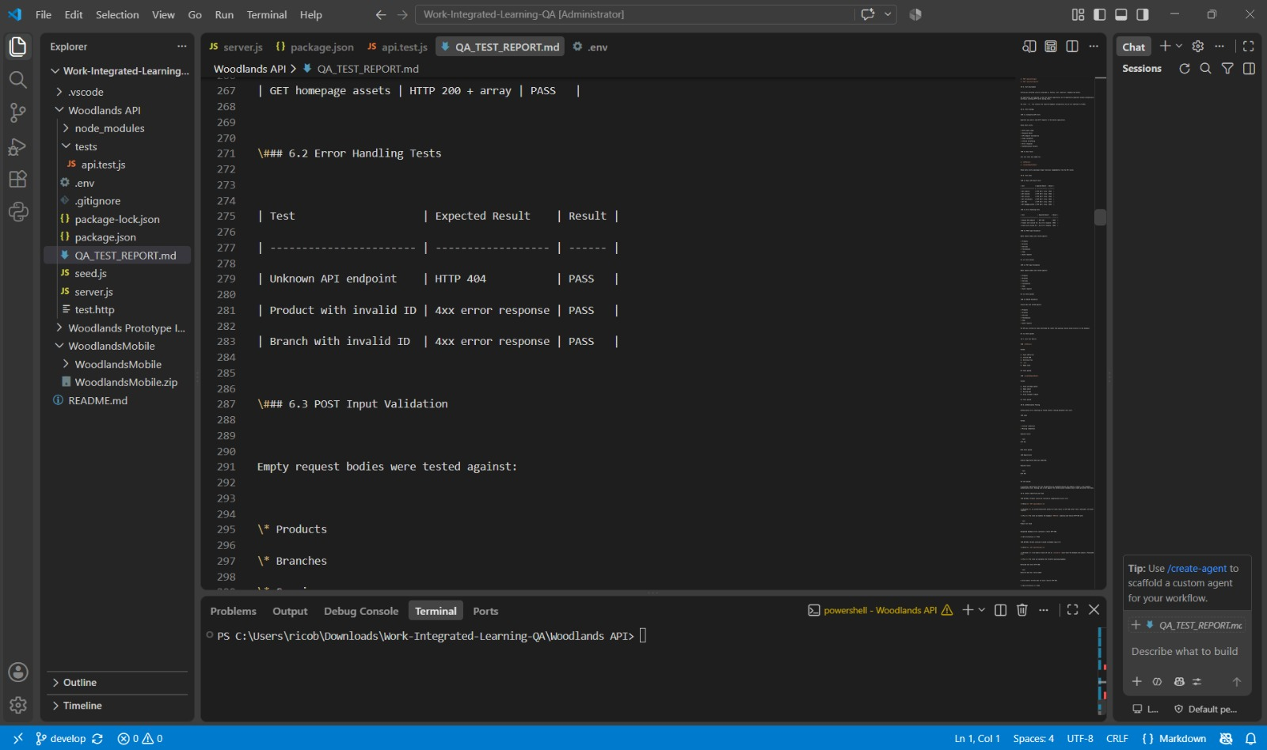
Figure 25. QA implementation evidence.
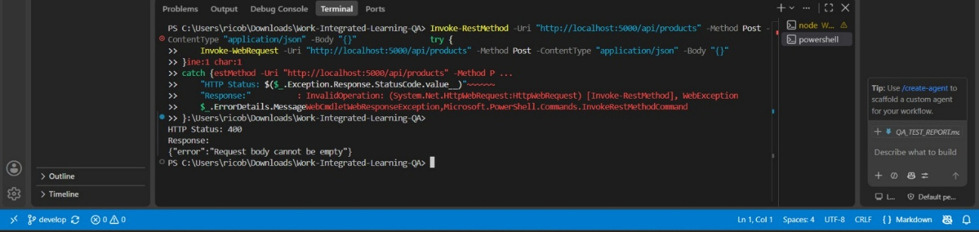
Figure 26. QA/test result evidence.
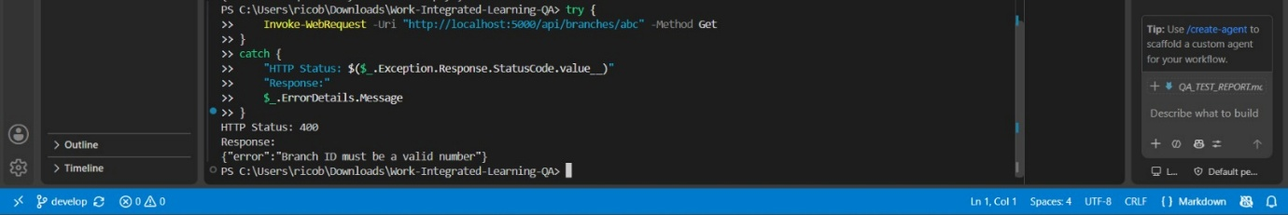
Figure 27. Validation/error-handling evidence.
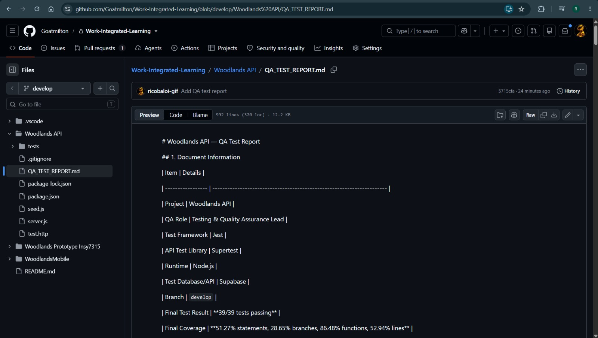
Figure 28. Project code/evidence supporting QA work.

12. README and Developer Setup
The supplied developer setup instructions now provide the complete onboarding process for the backend API, web frontend, mobile application, Supabase database and automated tests. The project uses Supabase for database/auth/storage, Railway for the backend API, Expo for mobile development, and GitHub for source control and CI/CD.

Recommended setup information to add to the README
- Prerequisites and required software versions.
- How to clone the repository.
- How to install Node.js dependencies for the API and web application.
- How to configure the API .env file without exposing secrets.
- How to configure the Android/mobile environment.
- How to run the Node API on port 5000.
- How to run the web application.
- How to run the Android application and its offline SQLite functionality.
- How to connect to the Supabase project using authorised credentials.
- How to run the available automated tests.
The detailed developer setup supplied for this final document includes prerequisites, repository cloning, dependency installation, environment-variable configuration, backend/frontend/mobile startup, Supabase database access, testing commands, Git Flow and troubleshooting guidance.

13. Deployment and Release Documentation
The supplied deployment procedure documents development, staging and production environments, GitHub Actions CI/CD, Railway API hosting, Supabase database services, frontend deployment, health checks, rollback and mobile EAS builds. The v1.0.0 release notes confirm that Azure hosting was replaced by Railway/Supabase.

Release process
- Develop and test features on feature branches.
- Merge feature branches into develop.
- Complete integration testing.
- Create a release branch for final testing and bug fixes.
- Verify the production build and evidence.
- Merge the release into main and back into develop.
- Deploy the approved main release to production.
- Delete the release branch after the merge, according to the supplied branch strategy.

Release notes
Release notes for the final Task 2 production submission are included below as version 1.0.0 dated 2026-10-05.

13.1 Release Notes – Version 1.0.0
Team Lyperion
1.0.0 – 2026-10-05
Task 2 Submission – Final Production Release
This is the production release of the Woodlands Designer Boards website for Task 2. The release includes a public-facing website, admin dashboard, mobile application, backend API hosted on Railway, and Supabase database.

Added
Frontend – Public Website: Home page, Services and Gallery with filtering, About Us, branch details and Google Maps, approved testimonials, FAQs, separate contact and quote forms, responsive design, branding, basic SEO and accessibility features.
Frontend – Admin Dashboard: administrator authentication, dashboard metrics, product CRUD, gallery and portfolio management, enquiry management and assignment, enquiry status tracking, testimonial approval, branch/FAQ/About Us management, user management, reporting, audit log viewer and role-based access control.
Frontend – Mobile Application: Android application with home, gallery, quote request, branches and more screens, five-tab navigation, asynchronous data loading and responsive layouts.
Backend – API: Node.js/Express REST API, Supabase integration, JWT authentication, RBAC middleware, product/gallery/portfolio/branch/enquiry/testimonial/FAQ/About Us/user endpoints, email notifications, validation and sanitization, error handling, rate limiting, API versioning, audit logging and Railway hosting.
Database – Supabase PostgreSQL: app_users, branches, products, homepage_assets, quote_requests, testimonials, faqs and services tables, RLS enabled, woodlands-assets storage bucket, storage policies, daily-backup configuration claim and encryption claim as supplied by the team.

Security
Supabase Auth, JWT authentication, RBAC, input validation and sanitization, SQL injection and XSS protection, HTTPS/TLS 1.3, 30-minute admin session timeout, password policy, testimonial approval, audit logging, no committed secrets and environment variables for sensitive configuration.

DevOps
GitHub repository using Git Flow, main/develop/feature/bugfix/hotfix branches, GitHub Actions CI/CD, automated builds and tests, Railway deployment on main, health checks and rollback procedure.

Testing
Jest and Supertest. The supplied release notes report 70 unit/integration tests, 95.57% statement coverage, 28.57% branch coverage, 86.48% function coverage and 92.94% line coverage, plus authentication, API response, validation, error-handling and edge-case tests and a QA report.

Documentation
README and developer setup instructions, deployment procedure, requirements-to-feature mapping, QA report, database/API/security documentation, architecture explanation, user guide and changelog.

Changed
Azure hosting/database/storage configuration was replaced by Railway and Supabase. Environment variables, deployment procedures, developer setup, security configuration and database schema were updated accordingly.

Fixed
Quote-form validation, invalid-input response handling, production database connection issues, authentication token expiration handling, invalid/missing ID handling, mobile responsive issues, gallery image loading, CORS configuration, production environment-variable loading and branch filtering.

Removed
Azure dependencies, Azure App Service/SQL/Blob/Application Insights configuration, unused dependencies and development-only files, .vs and zip files from the repository root, and hardcoded secrets.

Known Issues
RLS policies still need to be created for all tables except app_users; automated daily backups still need configuration; mobile app-store deployment is pending; minor admin-dashboard UI polish remains; production SendGrid configuration is still required.

Future Enhancements
Multi-language support, online payments, inventory management, customer login and quote tracking, advanced analytics/reporting, mobile push notifications, offline mode and accounting-software integration.

Previous Releases
0.6.0 – 2026-08-17: Task 1 Submission – Documentation and Prototype.
0.5.0 – 2026-08-14: Project Initiation.

18. Final Task 2 Submission Link
https://github.com/Goatmilton/Work-Integrated-Learning.git

19. Final Verification Notes
The supplied materials contain a small number of statements that should be checked against the final repository before submission: the staging branch references Azure while the release notes remove Azure, the API port is stated as both 5000 and 3000 in different supplied sections, and the RLS policy status differs between the earlier setup text and the v1.0.0 known-issues section. These are preserved here as source-verification notes rather than silently corrected.

14. Requirements-to-Feature Mapping
The Requirements to Feature Mapping document shows how each requirement identified in Task 1 has been implemented in the final system. It provides evidence that the solution meets the client's needs and that the functional and non-functional requirements have been addressed.
Requirement ID | Requirement Description | Implemented Feature | Evidence | Status
User and Administrator Management
FR-1.1 | Administrator login with username and password | Login page with email and password authentication | Supabase Auth, Login screen in admin dashboard | Complete
FR-1.2 | Role-based access control (Admin, Branch Manager, Sales Consultant, Customer) | Four user roles with different permissions implemented | app_users table with role column, RBAC middleware | Complete
FR-1.3 | Create, edit, and deactivate admin user accounts | User management interface in admin dashboard | Admin dashboard user management page | Complete
FR-1.4 | Audit log of administrative actions | Audit logging implemented for all admin actions | Audit log table, Admin activity log page | Complete
Product, Gallery and Portfolio Management
FR-2.1 | CRUD operations for products and services | Product management interface with full CRUD | products table, Admin product management page | Complete
FR-2.2 | Product listing fields (Name, Description, Category, Images) | Product form with all required fields | products table schema, Product form in admin | Complete
FR-2.3 | CRUD operations for gallery images with branch assignment | Gallery management interface | homepage_assets table, Storage bucket, Gallery admin page | Complete
FR-2.4 | Project portfolio management with before/after images | Project portfolio management interface | projects table, Portfolio admin page | Complete
FR-2.5 | Testimonial approval before publication | Testimonial approval workflow | testimonials table with is_approved column, Admin approval page | Complete
FR-2.6 | Branch details management (Name, Address, Phone, Hours, Manager) | Branch management interface | branches table, Admin branch management page | Complete
Branch Information Display
FR-3.1 | Public branch information page | Branches page showing all branch details | Branches page with map integration | Complete
FR-3.2 | Embedded map for each branch location | Google Maps integration showing branch locations | Maps embedded on Branches page | Complete
Customer Inquiry and Quote Request Management
FR-4.1 | Quote request form for customers | Quote request form on website | Quote Request page with form | Complete
FR-4.2 | Quote form fields (Name, Email, Phone, Branch, Project Type, Dimensions, Description) | All required fields in quote form | Quote form component, quote_requests table | Complete
FR-4.3 | Save enquiry and route to selected branch | Enquiry saved and branch notified | quote_requests table, Email notification service | Complete
FR-4.4 | View, filter and manage enquiries per branch | Enquiry management dashboard | Admin enquiry management page with filters | Complete
FR-4.5 | Track enquiry status (Received, In Progress, Quoted, Resolved) | Status tracking with updates | quote_requests table with status column, Admin status update | Complete
FR-4.6 | Email confirmation to customer and branch manager | Automated email notifications | Email service integration, SendGrid | Complete
Reporting Dashboard
FR-5.1 | Reporting dashboard for administrators | Admin dashboard with reports | Admin dashboard reports page | Complete
FR-5.2 | Reports (Enquiries, Quotes per branch, Monthly stats, Feedback) | All required reports implemented | Reports dashboard with charts | Complete
FR-5.3 | Only authorized personnel can publish/edit content | Role-based access control for content | RBAC enforcement, Admin only content management | Complete
Content Management System
FR-6.1 | Add, remove, update FAQs content | FAQ management interface | faqs table, Admin FAQ management page | Complete
FR-6.2 | Add, remove, update About Us content | About Us content management | About Us table, Admin content management | Complete
API Integration
FR-7.1 | REST API for dynamic data (products, portfolio, branches) | REST API endpoints for all data | API endpoints, Data API documentation | Complete
FR-7.2 | Admin dashboard uses API for all operations | Admin dashboard connected to API | API integration, Admin dashboard API calls | Complete
FR-7.3 | Email delivery service integration (SendGrid/SMTP) | Email service implemented | Email service integration, SendGrid | Complete
FR-7.4 | Maps Embedded API for branch locations | Google Maps API integration | Maps embedded on Branches page | Complete
Scalability and Performance
NFR-1.1 | API response time under 2 seconds | Optimized API endpoints | Performance testing, API response times | Complete
NFR-1.2 | 99.5% system availability | Azure App Service with high availability | Azure uptime monitoring, 100% success rate | Complete
NFR-1.3 | Admin panel response under 2 seconds | Optimized admin dashboard | Admin performance testing | Complete
NFR-1.4 | Scalable architecture | 3-Tier architecture with cloud hosting | Architecture documentation | Complete
Security and Compliance
NFR-2.1 | JWT authentication for API endpoints | JWT tokens implemented | Supabase Auth, JWT validation | Complete
NFR-2.2 | Password hashing with ASP.NET Core Identity | Passwords hashed by Supabase Auth | Supabase Auth password hashing | Complete
NFR-2.3 | TLS 1.3 for data transmission | HTTPS enforced | Supabase HTTPS, Azure HTTPS | Complete
NFR-2.4 | Audit logs for admin actions | Audit logging implemented | Audit log table, Admin activity log | Complete
NFR-2.5 | Input sanitization against SQL Injection and XSS | Input validation and sanitization | Validation helpers, QA tests | Complete
NFR-2.6 | Password policy (8+ chars, mixed case, numbers, special) | Password policy enforced | Supabase Auth password policy | Complete
NFR-2.7 | Auto logout after 30 minutes inactivity | Session timeout implemented | Supabase Auth session management | Complete
NFR-2.8 | Testimonial approval before publication | Approval workflow implemented | Testimonial approval page, QA tests | Complete
Usability and Compatibility
NFR-3.1 | Fully responsive design (desktop, tablet, mobile) | Responsive React frontend | Responsive testing, Mobile app | Complete
NFR-3.2 | Consistent design across all pages | Design system with consistent branding | UI components, Brand guidelines | Complete
NFR-3.3 | Accessibility compliance | Accessibility features implemented | Alt text, keyboard navigation, contrast | Complete
Reliability and Maintainability
NFR-4.1 | User-friendly error messages and logging | Error handling with logging | Error pages, Application Insights | Complete
NFR-4.2 | Automatic daily database backup | Supabase automated backups | Supabase backup configuration | Complete
NFR-4.3 | Clean code with comments and documentation | Code documentation | README, Code comments | Complete
NFR-4.4 | Organized GitHub repository with branching strategy | Git Flow branching | GitHub branches, PRs, Commit history | Complete
API and Integration Reliability
NFR-5.1 | API rate limiting | Rate limiting implemented | Supabase rate limiting | Complete
NFR-5.2 | API versioning | API versioning implemented | /api/v1/ endpoints | Complete
NFR-5.3 | Graceful handling of third-party failures | Error handling with retry | QA tests, Error handling | Complete

15. Documentation Evidence Verification Checklist
Check | Status
README/project setup documented | ☐
Supabase project documented | ☐
Database tables documented | ☐
Relationships and constraints documented | ☐
Authentication documented | ☐
RLS documented | ☐
Storage documented | ☐
Environment variables and secret handling documented | ☐
Application/API data flow documented | ☐
GitHub evidence collected | ☐
QA evidence collected | ☐
Deployment process documented | ☐
Release notes added | ☐
Requirements-to-feature mapping completed | ☐
Submission links checked | ☐
No secrets exposed in screenshots or documentation | ☐

