ГОСУДАРСТВЕННОЕ ОБРАЗОВАТЕЛЬНОЕ УЧРЕЖДЕНИЕ

ВЫСШЕГО ПРОФЕССИОНАЛЬНОГО ОБРАЗОВАНИЯ

"ДОНЕЦКИЙ НАЦИОНАЛЬНЫЙ ТЕХНИЧЕСКИЙ УНИВЕРСИТЕТ"

Факультет КНТ

Кафедра ПИ

Лабораторная работа №5

по курсу: «Введение в .Net и Java»

по теме: «Работа с форматом XML и сериализация»

Выполнил:

ст. гр. ПИ-19а

Саевский О.В.

Проверил:

Артёменко О.Г.

Ногтев Е.А.

ДОНЕЦК – 2021

Задание

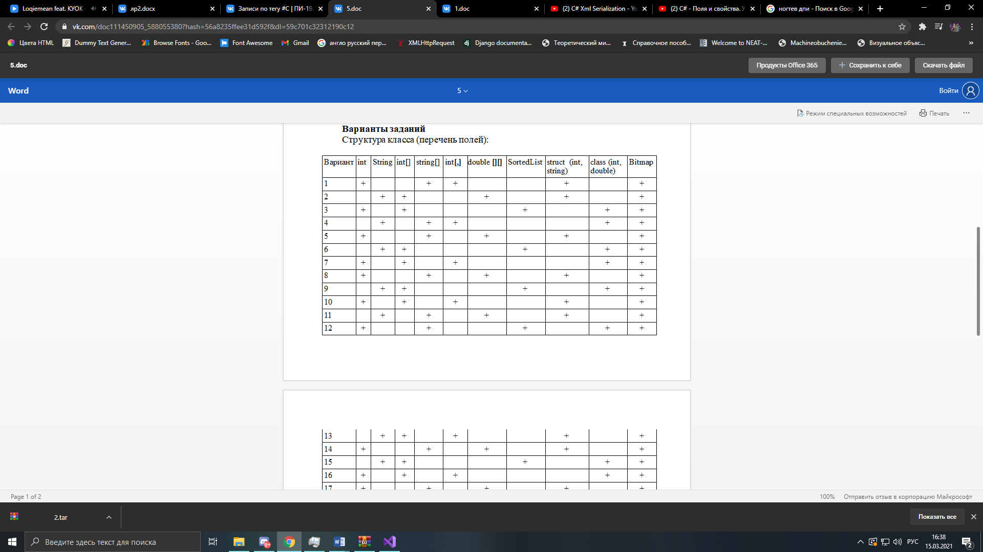



Код программы:

Form2.cs

using System;

using System.Collections.Generic;

using System.ComponentModel;

using System.Data;

using System.Drawing;

using System.IO;

using System.Linq;

using System.Text;

using System.Threading.Tasks;

using System.Windows.Forms;

using System.Xml;

using System.Xml.Serialization;

namespace _5Lab

{

public partial class Form2 : Form

{

public Form2()

{

InitializeComponent();

ds.Tables.Add("Изображения");

ds.Tables[0].Columns.Add("ID");

ds.Tables[0].Columns.Add("Высота, Ширина");

ds.Tables[0].Columns.Add("Размер в байтах");

ds.Tables[0].Columns.Add("Размер в киллобайтах");

ds.Tables[0].Columns.Add("Property id[0]");

ds.Tables[0].Columns.Add("Property id[1]");

ds.Tables[0].Columns.Add("Изображение");

dataGridView1.DataSource = ds.Tables[0];

dataGridView1.ReadOnly = true;

}

DataSet ds = new DataSet();

DataTable dt = new DataTable();

private Pictures pictures = new Pictures();

private void Form2_Load(object sender, EventArgs e)

{

}

public void AddNode(int id, int[,] hw, int[] prop_id, int bytes, double kbytes, Bitmap bmp)

{

ds.Tables[0].Rows.Add(id, hw[0, 0] + " " + hw[0, 1], bytes, kbytes, prop_id[0], prop_id[1]);

pictures.Add(id, hw, prop_id, bytes, kbytes, bmp);

}

private void dataGridView1_CellContentClick(object sender, DataGridViewCellEventArgs e)

{

}

private void Form2_FormClosing(object sender, FormClosingEventArgs e)

{

if (e.CloseReason == CloseReason.UserClosing)

{

e.Cancel = true;

Hide();

}

}

private void SerializeXML()

{

XmlSerializer xml = new XmlSerializer(typeof(Pictures));

using (XmlWriter xmlWriter = XmlWriter.Create("Pictures.xml"))

{

xml.Serialize(xmlWriter, pictures);

}

}

private void button1_Click(object sender, EventArgs e)

{

SerializeXML();

}

private Pictures DeserializeXML()

{

try

{

XmlSerializer xml = new XmlSerializer(typeof(Pictures));

using (XmlReader xmlRider = XmlReader.Create("Pictures.xml"))

{

return (Pictures)xml.Deserialize(xmlRider);

}

}

catch (Exception e)

{

MessageBox.Show("Error. Файл заполнен неверно или не существует");

return null;

}

}

private void button2_Click(object sender, EventArgs e)

{

pictures = DeserializeXML();

if (pictures == null)

return;

ds.Tables[0].Clear();

for(int i = 0; i < pictures.list.Count(); i++)

{

ds.Tables[0].Rows.Add(pictures.list[i].id, pictures.list[i].Hw[0] + ", " + pictures.list[i].Hw[1],

pictures.list[i].size.bytes, pictures.list[i].size.kbytes, pictures.list[i].propertyId[0], pictures.list[i].propertyId[1]);

}

}

public int GetId()

{

if (ds.Tables[0].Rows.Count == 0)

return 1;

else return Convert.ToInt32(dataGridView1[0, ds.Tables[0].Rows.Count - 1].Value)+1;

}

OpenFileDialog fileDialog = new OpenFileDialog();

Image img;

FileInfo file;

private void button3_Click(object sender, EventArgs e)

{

fileDialog.Filter = "Image files (*.jpg, *.jpeg, *.png) | *.jpg; *.jpeg; *.png";

fileDialog.Multiselect = true;

var state = fileDialog.ShowDialog();

if (state == DialogResult.Cancel)

return;

if (state == DialogResult.OK)

{

for(int i = 0; i < fileDialog.FileNames.Length; i++)

{

img = Image.FromFile(fileDialog.FileNames[i]);

file = new FileInfo(fileDialog.FileNames[i]);

int[,] hs = new int[1, 2];

hs[0, 0] = img.Size.Height;

hs[0, 1] = img.Size.Width;

AddNode(GetId(), hs, img.PropertyIdList, (int)file.Length, (float)file.Length / 1024, (Bitmap)img);

}

}

}

private void dataGridView1_MouseUp(object sender, MouseEventArgs e)

{

if(dataGridView1.SelectedCells[0].ColumnIndex == 6)

{

Form1 form1 = new Form1(pictures.list[dataGridView1.SelectedCells[0].RowIndex].image);

form1.Show();

}

}

}

}

PictInfo.cs

using System;

using System.Collections.Generic;

using System.Drawing;

using System.IO;

using System.Linq;

using System.Text;

using System.Threading.Tasks;

using System.Xml.Serialization;

namespace _5Lab

{

public class Pictures

{

public List<PictInfo> list { get; set; } = new List<PictInfo>();

public void Add(int id, int[,] hw, int[] prop_id, int bytes, double kbytes, Bitmap bmp)

{

list.Add(new PictInfo(id, hw, prop_id, bytes, kbytes, bmp));

}

public Pictures() { }

}

public class PictInfo

{

[XmlAttribute]

public int id { get; set; }

public int[] propertyId { get; set; }

private int[,] hw { get; set; }

public PictureSize size { get; set; }

[XmlIgnore]

public Bitmap image;

public byte[] Image

{ get

{

ImageConverter converter = new ImageConverter();

return (byte[])converter.ConvertTo(image, typeof(byte[]));

} set

{

var ms = new MemoryStream(value);

image = new Bitmap(ms);

} }

public int[] Hw

{

get

{

int[] res = new int[2];

res[0] = hw[0, 0];

res[1] = hw[0, 1];

return res;

}

set

{

hw = new int[1, 2];

hw[0, 0] = value[0];

hw[0, 1] = value[1];

}

}

public PictInfo(int id, int[,] hw, int[] prop_id, int bytes, double kbytes, Bitmap bmp)

{

this.id = id;

this.propertyId = prop_id;

this.hw = hw;

this.size = new PictureSize(bytes, kbytes);

this.image = bmp;

}

public PictInfo()

{

}

}

public class PictureSize

{

public int bytes { get; set; }

public double kbytes { get; set; }

public PictureSize(int bytes, double kbytes)

{

this.bytes = bytes;

this.kbytes = kbytes;

}

public PictureSize() { }

}

}

Form1.cs

using System;

using System.Collections.Generic;

using System.ComponentModel;

using System.Data;

using System.Drawing;

using System.Linq;

using System.Text;

using System.Threading.Tasks;

using System.Windows.Forms;

namespace _5Lab

{

public partial class Form1 : Form

{

public Form1(Bitmap img)

{

InitializeComponent();

this.img = (Image)img;

}

Image img;

PictureBox picbox = new PictureBox();

const int SIZE_W = 800, SIZE_H = 400;

private void Form1_Load(object sender, EventArgs e)

{

picbox.Location = new Point(0, 0);

picbox.Name = "Picbox";

picbox.TabIndex = 0;

picbox.TabStop = false;

picbox.Parent = this;

if (img.Width < SIZE_W && img.Height < SIZE_H)

{

picbox.Size = img.Size;

picbox.Image = img;

this.Size = picbox.Size;

}

else

{

int w = img.Width / SIZE_W, h = img.Height / SIZE_H;

if(w >= h)

{

Bitmap bitmap = new Bitmap(img);

Size size = new Size(SIZE_W, img.Height / w);

Bitmap newBitmap = new Bitmap(bitmap, size);

Image img2 = newBitmap;

picbox.Size = img2.Size;

picbox.Image = img2;

this.Size = picbox.Size;

}

else

{

Bitmap bitmap = new Bitmap(img);

Size size = new Size(img.Width / h, SIZE_H);

Bitmap newBitmap = new Bitmap(bitmap, size);

Image img2 = newBitmap;

picbox.Size = img2.Size;

picbox.Image = img2;

this.Size = picbox.Size;

}

}

}

}

}

Пример работы программы:

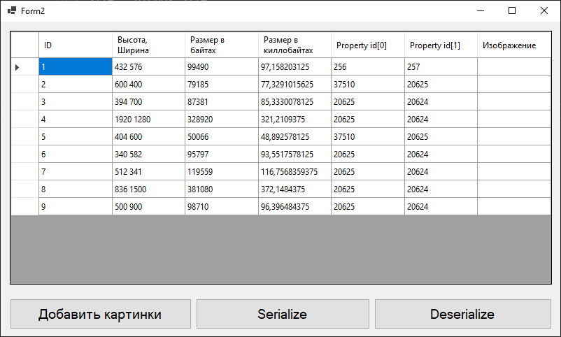

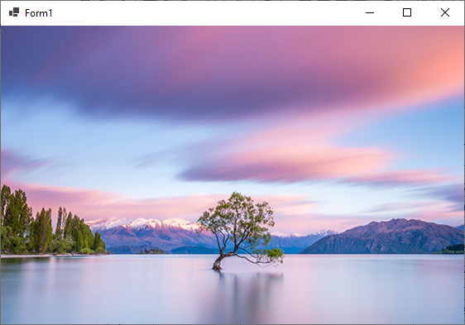

Файл Pictures.xml

