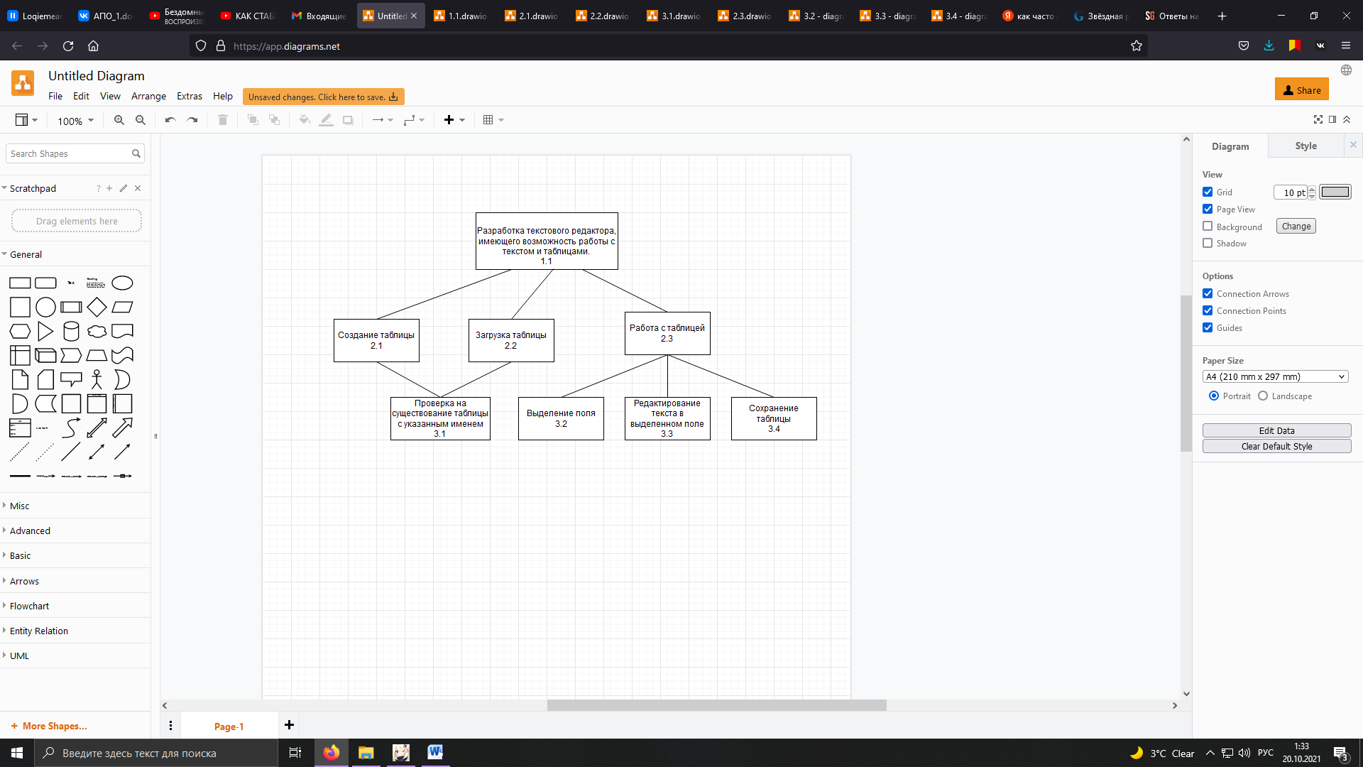

|  |  |  |  |  |  |  |  |  |  |  |  |
| --- | --- | --- | --- | --- | --- | --- | --- | --- | --- | --- | --- |
| Исходные данные | | | Результаты расчета | | | | | | | | |
| Работы  К | Время  изготов-ления  τК. | Fantancies  QK | Вес | Ран-жиро-вание | τК |  |  |  |  |  |  |
| 1.1 | 3 | 1 | 1 | 3.4 | 2 | - | 2.3 | 2 | 0 | -2 | 0 |
| 2.1 | 1 | 1 | 2 | 3.3 | 2 | - | 2.3 | 2 | 0 | -2 | 0 |
| 2.2 | 1 | 1 | 2 | 3.2 | 1 | - | 2.3 | 1 | 1 | 0 | 0 |
| 2.3 | 2 | 1 | 2 | 3.1 | 1 | - | 2.1-2.2 | 1 | 3 | 2 | 0 |
| 3.1 | 1 | 3 | 3 | 2.3 | 2 | - | 1.1 | 2 | 0 | -2 | 0 |
| 3.2 | 1 | 3 | 3 | 2.2 | 1 | 3.1 – 3.2 | 1.1 | 2 | 2 | 0 | 1 |
| 3.3 | 2 | 2 | 3 | 2.1 | 1 | 3.3 – 3.4 | 1.1 | 3 | 2 | -2 | 3 |
| 3.4 | 2 | 2 | 3 | 1.1 | 3 | 2.1-2.3 | - | 5 | 3 | 0 | 0 |