**Alternative Distance Detection with Stationary Computer Vision**

Jayden Chen

**ABSTRACT**

With more advancements in robotics, efficient communication through computer vision has become a subject of interest. The goal of this project is to develop an accurate, low-cost, low energy model for locating multiple objects through cameras paired with computer vision. Existing approaches for distance detection focus mainly on parallax or sonar with visible light, ultrasonics, infrared, or microwave lasers, which are either expensive, not accurate, or close ranged. Other approaches focus on highly trained neural network systems that require tremendous amounts of data and energy. In this paper, I present a method that uses two aligned cameras with object detection, creating a more accessible approach that relies less on the quality of the device and/or the trained machine learning model. Using Google’s Mediapipe for computer vision and two cameras, this method managed to achieve high success rates within three tests. It is theorized that this technology could be used for street infrastructure or other line-like places. In addition, this technology was tested with ROS2 and other computer vision technology, proving it to be a good, efficient component in robotic systems.

**Keywords**

Computer Vision, Machine Vision, Object Detection, Gesture Detection, Mediapipe, Camera Technolgy, MQTT, Robotics, ROS2, Autonomous Vehicles

**INTRODUCTION**

Devices with significant vision computing power are necessary for more efficient autonomous systems. Many uprising, revolutionary robotic systems absolutely depend on complex systems of computer vision and location, such as automatic delivery systems. It is vital for these models to be perfected and therefore valuable to develop powerful camera detection models. However, it is difficult to extract 3-dimensional data from purely visual cameras.

Many models have been developed to extract dimensional and distance data. Computer stereo vision that uses parallax and computer vision is used massively to do this very well (Fan et al. 2012). However, it is expensive and requires both cameras to be absolutely synchronized. Laser detecting and ranging, or Lidar (Wadinger et al. 2005) is another popular method of distance tracking, which calculates the distance through the rebounded light and the time it takes for the light to rebound. This method is also expensive and needs high processing power. Other approaches utilize highly trained neural networks, which require great amounts of data, processing power, and energy (Patterson et al. 2021).

Since the techniques above are either expensive or not easily accessible, this method isn’t viable for street and other types of infrastructure that require high levels of implementation, high accessibility, and low costs. Smart cities that are optimized and automatic have been theorized to reduce threats such as urbanization and population growth (Drepaul 2020). Thus, developing accessible distance-finding technology is appealing.

In this paper, I present a method that uses two aligned cameras with object detection, creating a more accessible approach that relies less on the quality of the device and/or the trained machine learning model.

The contributions of this paper are:

1. Describe an accessible approach to detect distances through computer vision and object detection (Figure 1).

2. Assess the accuracy of such an approach.

3. Prove that it is viable for high-performing robotic systems and other approaches.

4. Discuss the limitations and implementations of such method.

**METHODOLOGY**

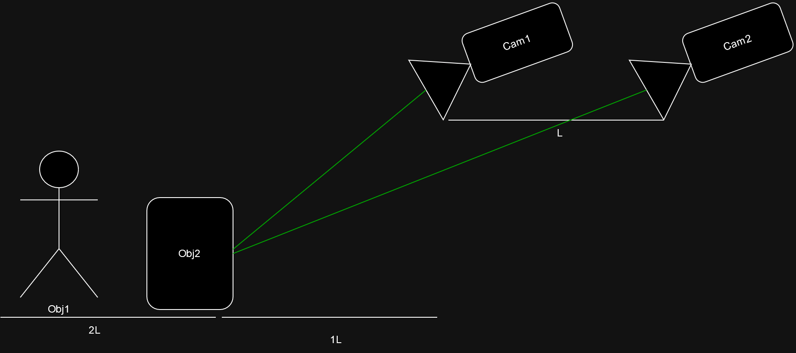

**Figure 1.** A visual demonstration of the approach depicted in this paper. The two cameras are facing the same direction on the same axis. **L** is the distance between the two cameras, which is used as a measuring unit. In the demonstration, it is detecting the distance of Object Two which is around 1**L** away from Camera One, while ignoring Object One.

This method ranges distance through a ratio of two aligned, forward facing camera images (shown in Figure 1). For convenience in this paper, I’ll nickname it Falkor.

**Falkor’s Distance Sensing**

Shown in Figure 1, **L** is the distance between Camera One and Camera Two. **L** will be used as a measuring unit for the distance. Both cameras input a frame into the Falkor program. With computer vision, Falkor can detect Object Two and get a bounding box of Object Two with a pixel width and height value, which is visually shown in Figure 2 (more information on this is below). Thus, we have two object detection results from Object Two. Let’s define ***P1*** as the result from Camera One and ***P2*** as the result from Camera Two. The ratio of ***P2***’s height to ***P1***’s height is ***P1/P2***, which Falkor can gain the distance between Object Two and Camera One using it.

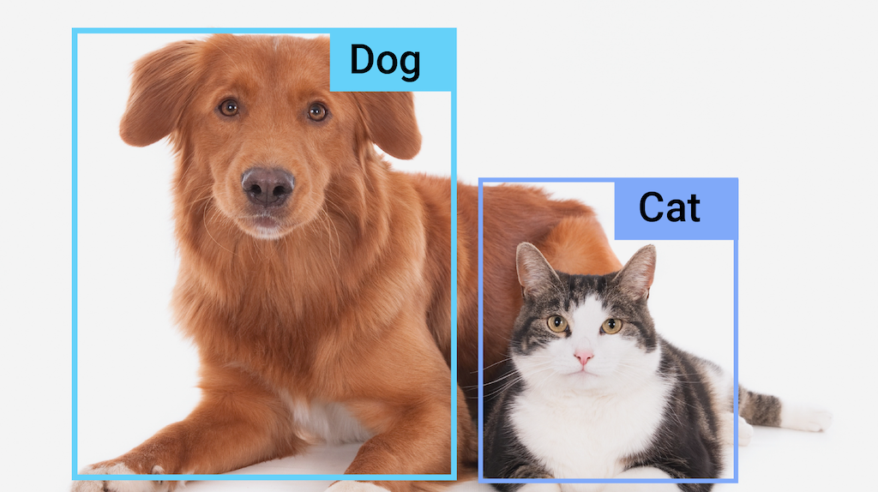

**Figure 2.** A short demonstration of mediapipe’s object detection, which is used for computer vision in this paper. Mediapipe provides a trained object detection model, which returns an object label, bounding box, and probability of success.

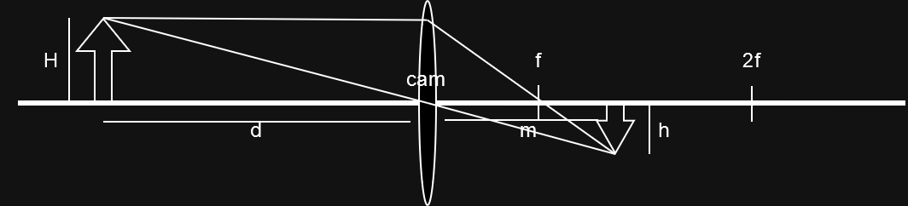

**Figure 3**. This illustrates how the ray changes direction both as it enters and as it leaves the convex lens.

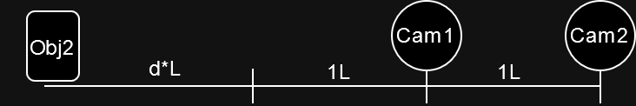

**Figure 4**.

Most cameras use convex lens for optical perception. Figure 3 demonstrates this convex lens. The physical height of the object is ***H***, and the refracted height within the lens is ***h***. The distance between the physical object and the lens is ***d***. The distance between the refracted object and the lens is somewhere between ***f***and ***2f*** or defined here as **m *(1f<m<2f)***. This ignores the depth of the convex lens, but the depth is neglectable above a distance of 1**L**. Using the similar triangle rule, we get the equation:

$$\frac{H}{h}=\frac{d}{m}$$

This in terms of ***h*** is:

$$h=\frac{H⋅m}{d}$$

Assuming that the pixel height of the image, which is ***P1*** and ***P2,*** is the ***h*** times an unknown value of ***α***, the equation of the height of ***P1*** or ***P2*** is:

$$P = \frac{H⋅m⋅α}{d}$$

Figure 4 shows the physical distance between Object Two and Camera One and Camera Two. The distance between Object Two and Camera One (dP1) is ***x + 1***, where ***x*** is the distance using ***L*** as a unit; ***dp2*** is ***x + 2***. Using this, assuming that the two cameras are the same device, the equation for ***P1*** to ***P2*** is:

$$\frac{P1}{P2}=\frac{\frac{H⋅m⋅α}{x+1}}{\frac{H⋅m⋅a}{x+2}}=\frac{x+2}{x+1}=\frac{x+1+1}{x+1}=1+\frac{1}{x+1}$$

In terms of x + 1 (distance of Object from camera one in L units), the distance equation is:

$$x+1=\frac{1}{\frac{P1}{P2}−1}$$

**Evaluation of Falkor**

Small data was gathered to support this claim. The set up is shown in Figure 5, where two Logitech C270 cameras that were connected to a laptop running Mediapipe and Falkor had an L of 0.3 meters (30cm). Using a human hand as an object to detect, Falkor return the following data and graph:

|  |  |  |  |  |  |
| --- | --- | --- | --- | --- | --- |
| Distance from Camera One to Object or x+1  (in L) | P1/P2 of  Trial One | P1/P2 of  Trial Two | P1/P2 of  Trial Three | Average P1/P2 | Falkor’s Distance  (in L) |
| 1 | 1.98 | 1.87 | 2.2 | 2.02 | 0.98 |
| 2 | 1.53 | 1.68 | 1.32 | 1.56 | 1.79 |
| 3 | 1.25 | 1.36 | 1.28 | 1.30 | 3.33 |
| 4 | 1.31 | 1.16 | 1.26 | 1.24 | 4.17 |

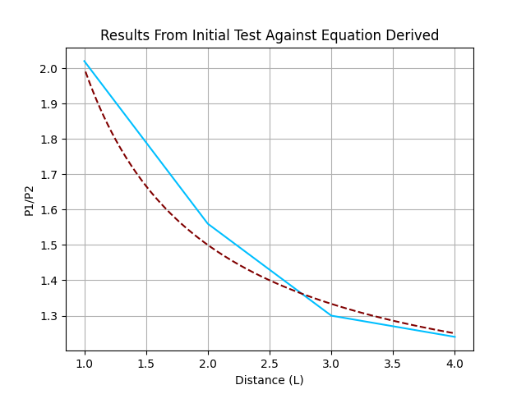

Figure 5. Images made by matplotlib.

From the graph, we can conclude that the relationship between the P1/P2 and the real distance is a reciprocal relationship, which follows the equation above. And from the table, we can see that the distance given by Falkor has a maximum range of 0.33L away from the real distance. Thus, the equation does work. There is a great range of data, which can be explained by the depth of the lens and the instability of object detection for a hand. With a small distance of 0.3 meters, the depth of the lens will have a bigger impact on Falkor. In scenarios where Falkor is needed, L should be at 1 meter or above. A bigger factor would be the bounding box of the hand, which is constantly changing and moving since human hands do move quite often. This explains the big margin of error. Therefore, it is concluded that Falkor is a viable method of distance detection, but it requires stationary object and an L of greater or equal to 1 meter.

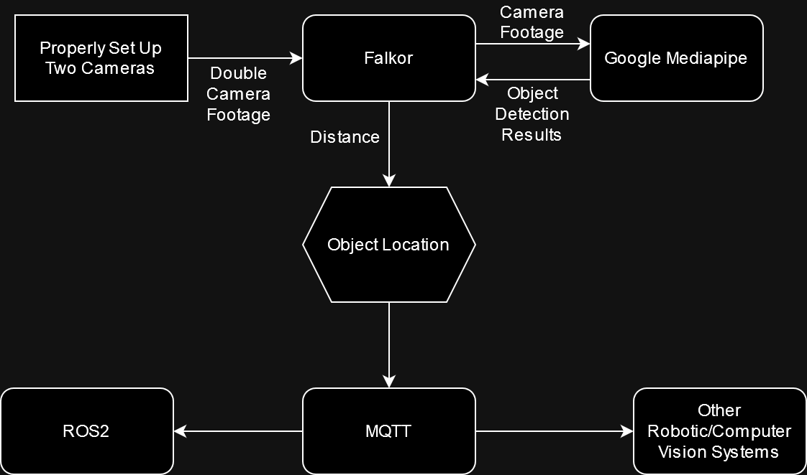

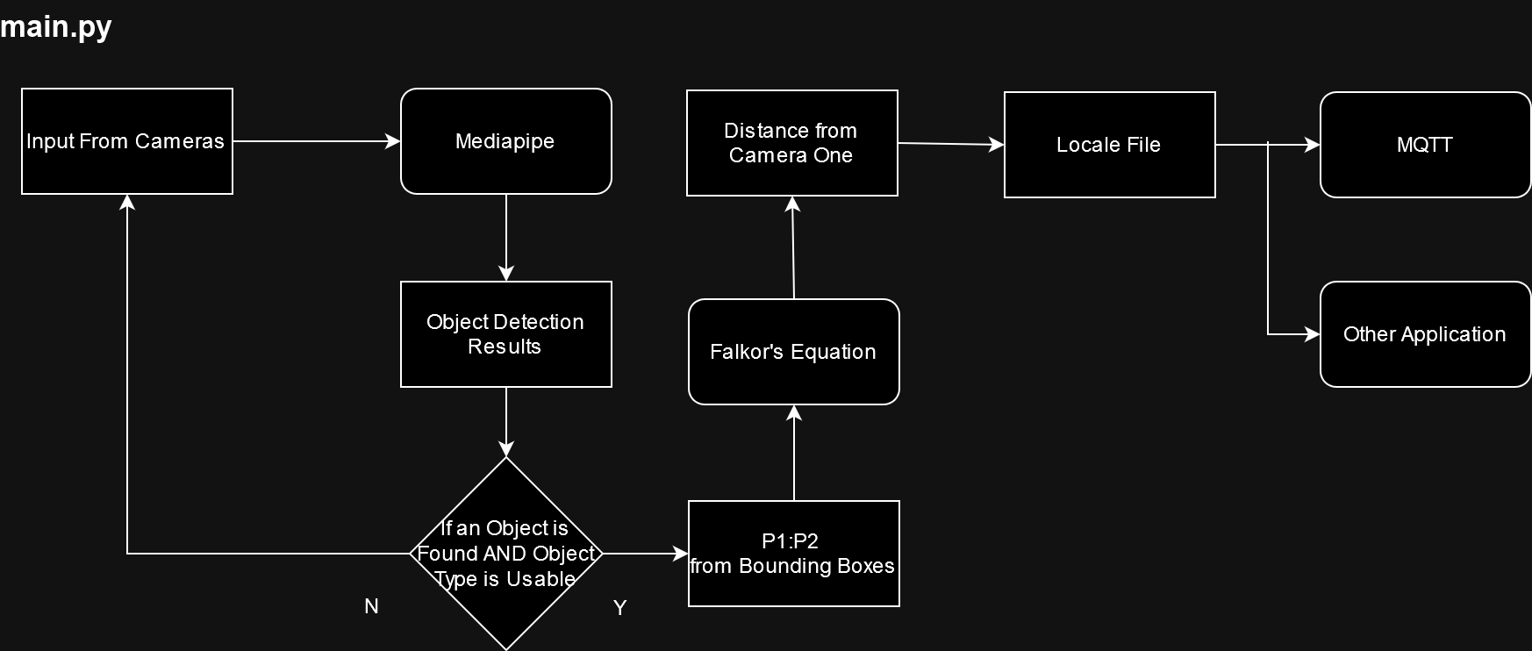

Figure 7:

**Implementing Falkor**

Continuing, an improved set up was made. Two Logitech C270 cameras are stationary placed 1 meter apart (L = 1 meter) with a 0.1-meter height difference on an adjustable camera stand (Figure 6). They are connected to a Raspberry Pi 4 with the 64-bit Raspberry Pi OS. Mediapipe for Python was downloaded to the Raspberry Pi, with the packages necessary for it. This is vital for Falkor, since Mediapipe has systems for object detection with pre-trained models, so that we could get the bounding boxes for P1 and P2 (Figure 2). The overall structure of the program is demonstrated in Figure 7. The program would send the camera footage to Mediapipe and gain the results for P1 and P2, then using the equation to gain the object’s location. More details are shown in Figure 7. The objects’ location would be saved to a locale file. Any other program would use MQTT to publish the location of the object. MQTT works on a publisher-subscriber model, where the results are sent to a server’s directory and then to any subscribers subscribed to such directory. This would allow robotic systems like ROS2 to gain the location of the object.

**RESULTS**

After the initial test, two tests were done on this technology. The second test aimed to validate Falkor’s ability to gain the location of an object. The third test aimed to show that such technology could be used with robotic systems or other computer vision systems.

Figure 8

The setup shown in Figure 6 was put in front of a 4-meter aisle. Using 1. meter (1L), 1.25 meters (1.25L), 1.5 meters (1.5L), 1.75 meters (1.75L), and 2 meters (2L) from Camera One as intervals, a suitcase was put under adequate lighting. This is shown in Figure 8. For each interval, the suitcase was rotated 90, letting the cameras detect different sides. This is shown in Falkor gained the data shown below:

|  |  |  |  |  |
| --- | --- | --- | --- | --- |
| Distance from Camera One (in L) | Trial One Results  (in L) | Trial Two Results  (in L) | Trial Three Results  (in L) | Average  (in L) |
| 1 | 0.97 | 1.04 | 1.05 | 1.02 |
| 1.25 | 1.23 | 1.28 | 1.26 | 1.26 |
| 1.5 | 1.54 | 1.54 | 1.47 | 1.52 |
| 1.75 | 1.79 | 1.75 | 1.69 | 1.74 |
| 2 | 2. | 1.96 | 2.22 | 2.05 |

Figure 9

The results from Figure 9 are promising. Most of the distances were very close to the physical distances, with the greatest average range being only 5 centimeters away from the physical distance. Some observations were made during this test too. The suitcase needed additional lighting for object detection to return processible results. And many of the results were not fairly accurate, as the object label was constantly showing “refrigerator” instead of suitcase. This could be explained by how the program needed to compress the camera footage into mjpg because of the limited processing power of the Raspberry Pi. Thus, the quality of the object detection would decrease compared to using quality images. This compression could also explain some of the inaccuracies in the table in Figure 9.

Figure 10

The third test focused more on quantitative data to show how Falkor could be a great component for robotic systems. Using the same environment shown in Figure 8, a vehicle running ROS2 was set aside the cameras. A potted plant (plants gave more accurate object detection results) was set at random distances from Camera One. This is shown in Figure 10. Falkor would publish the object’s location through MQTT. After three tests, the vehicle was successful in locating the plant, moved towards its location, and parked either at the plant’s exact location or close to it. The distance equation ran smoothly and returned accurate results. Thus, proving that Falkor could be run with robotic systems with efficiency.

**DISCUSSION**

**Evaluation of Falkor’s Results**

Restating the equation: $$\frac{P1}{P2}=1+\frac{1}{x+1}$$

This reciprocal equation brings us the distance between an object and the camera set up, which allows us to locate the object, which is used in intelligent robotic systems. The initial test shown in figure 5 supports this despite its ranging data. The inaccuracies in the data could be explained by the unstable movement of the hand, resulting in varying bounding boxes, which is the reason the remaining tests used un-moving objects.

The remaining two tests gave promising results. The table of Figure 9 shows even under low-quality photography and object detection, using 1 meter as L returns functionally distance results. The inaccuracy of the data is neglectable, as the distances returned were close to the object’s location. Thus, proving that Falkor is viable for real-life scenarios. The third test proved that Falkor is viable as an element in complex robotic and computer vision systems. It correctly returned the result of distance, sent the results through MQTT, and the ROS2-based autonomous vehicle was able to locate the object and arrive next to the object. It was executed with gesture-based computer vision, despite the quality of the gesture detection. To conclude, Falkor is a viable solution for robotic systems, especially in smart city/building infrastructure.

**Falkor and Robotic Systems in Smart Cities and Buildings**

Falkor may seem inconvenient and almost useless because of its line-like set up. This technology can only be used for specific line-like areas, since it is better for one-dimensional distancing with plenty of light. It could only be used with stationary cameras; so, it cannot be used in autonomous vehicles that require constant quality performance. This technology could only be used on stable objects at rest, as shown in Test One.

It is true that this row of cameras would be useless in a 2D layout, however modern infrastructure, such as streets and alley ways have a line-like layout for vehicles. Falkor takes advantage of this, because it is built as computer vision for line-like layouts and it works with low-cost, low-quality cameras and computers, which makes it more accessible for smart city layouts. In addition, this technology does not require the cameras to be completely synchronized, therefore city streets and building hallways could implement long rows of cameras (demonstrated in Figure X).

In the early stages, an initial idea of airport smart infrastructure was proposed. Suppose Person One was dropped off at the gate of the airport with his suitcase. However, let’s say that the suitcase is too heavy for Person One to carry. If Person One left to obtain a trolley for the suitcase, the suitcase could have been stolen, or someone else could have mistaken the suitcase for their own. It would be helpful if the trolley could almost-magically arrive at Person One’s suitcase. This could be done with intelligent robotic systems, where the system detects a person in need, locates the person, and executes a trolley to arrive at the person’s or suitcase’s location. Falkor could act as an allocation system because it could be integrated with the airport street. Furthermore, the robotic and computer vision technology used in Test Three, shown in Figure X, could be adapted for this situation.

This method would require less resources than other methods, as they would need expensive hardware or highly trained neural network systems. Without a doubt, funds for public infrastructure would be limited, thus low-expense hardware should be used. Neural networks create a large portion of carbon emissions and professionals have vouched for “greener” neural network systems (Patterson et al. 2021); thus, simpler methods of distance detection should be considered instead of machine learning models.

With more innovative, futuristic cities, this method could be used for many robotic systems, such as delivery services, transportation, and cleaning systems. A great example of this would be the in-development city, The Line, as Falkor is designed to work in “a line” (Hurst 2022). Strong infrastructure is one of the key drivers of thriving smart cities (Veselitskaya et al. 2019). Internet of things and similar technologies is an innovative way to reduce many problems that would arise in smart cities, such as overcrowding, citizen stress, and safety (Drepaul 2020). Some developing countries lack the resources for infrastructure (Roy 2016) and Falkor allows intelligent robotic systems to be more accessible. Falkor and its associating technologies could be strong components for these smart systems and thus should be considered in these projects.

**ACKNOWLEDGMENTS**

All code can be found in this GitHub repository: <https://github.com/fa1k0or/Distance-Detection-with-Stationary-Computer-Vision>

**SOURCES**