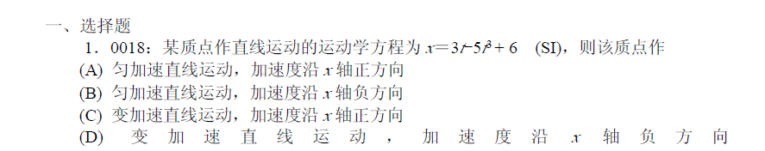

**D**

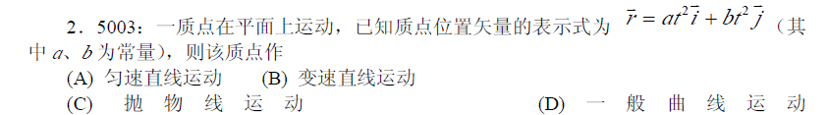

**B**

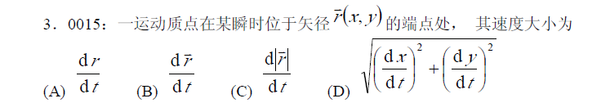

**D**

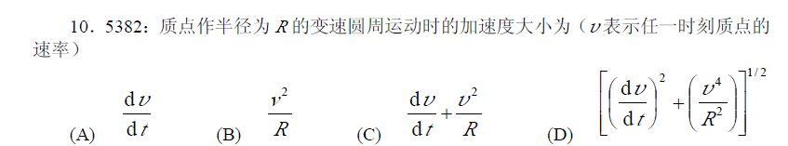

**D**

**A**

**E**

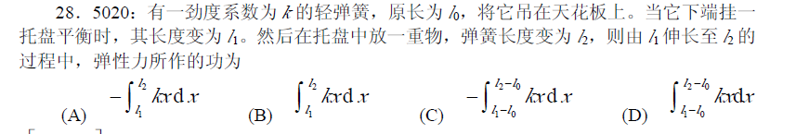

**C**

**D**

**B**

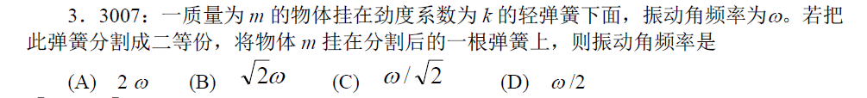

**B**

**D**

**E**

**B**

**C**