Placement Empowerment Program

Cloud computing and devops

BUILD AND RUN A CUSTOM DOCKER IMAGE.

Name: Bhuvana K

Dept : cse

INTRODUCTION

Containerization revolve the way of application developed and deployment .It provides a light weight efficient to package application to all dependencies ensuring different environments.

OVERVIEW

Create a dockerizedstatic website using NGINX

Build a custom docker image

with html file

Run it

Access the webpage [http://localhost:9000](http://localhost9000)

Steps

1)Install docker (if not installed)

Open command prompt to check it **docker —version**

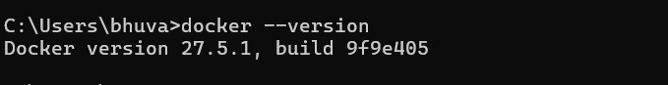

2) create a project directory

Open cmd prompt to run

**mkdir my-docker-html && cd my-docker-html**



3) create html file

Run

**type nul>index.html**

Open the notepad

**notepad index.html**

Add content and run it

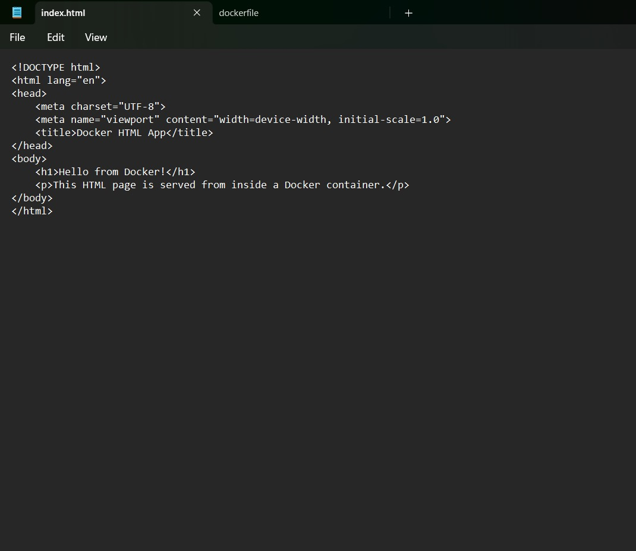

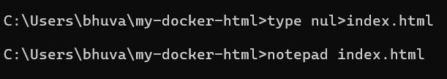

4) create docker file

**type nul>Docker file**

Open file in note pad

notepad Dockerfile

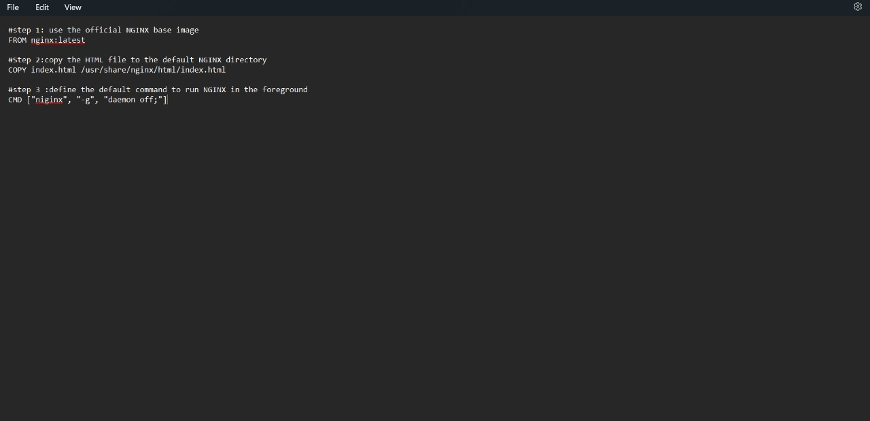

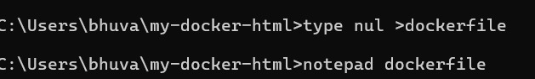

5) build docker image

**docker build -t my-html-image**

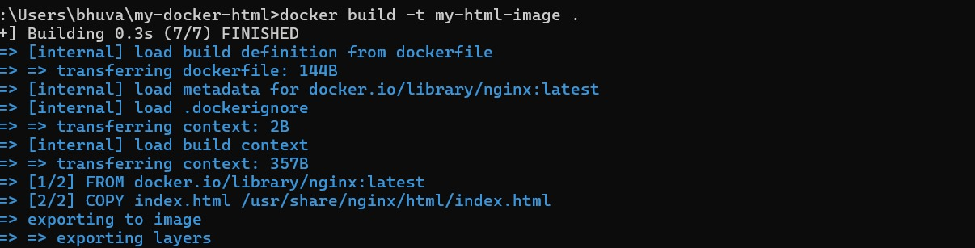

6)run the docker image

**docker run -d -p9000:80 my-html-image**

7)open a browser

<http://localhost:9000>

You should see hello from docker



OUTCOME

1..Successfully built and ran the docker container host html webpage

2.. Accessed the webpage

3..Gained a practical experience using docker