1] Given an array of integers and an integer k, you need to find the number of unique k-diff pairs in the array. Here a k-diff pair is defined as an integer pair (i, j), where i and j are both numbers in the array and their absolute difference is k.

**package** Expanion; ODD number:

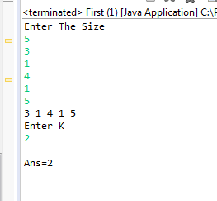**import** java.util.Scanner;

**public** **class** First {

**public** **static** **void** main(String aa[])

{

Scanner h=**new** Scanner(System.***in***);

System.***out***.print("Enter The Size");

**int** n=h.nextInt();

**int** loc;

**int** a[]=**new** **int**[n];

**int** i=0,j;

**int** count=0,t=0,m=0;

**for**(i=0;i<n;i++)

{

a[i]=h.nextInt();

}

**for**(i=0;i<n;i++)

{

System.***out***.print(a[i]+" "); Even Number:

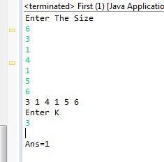}

System.***out***.println("\n"+"Enter K");

**int** k=h.nextInt();

**if**(n%2==0)

{

**for**(i=0;i<n;i+=2)

{

**if**(a[i]-a[i+1]==k||a[i+1]-a[i]==k)

{

count++;

}

}

}

**else**

{

**for**(i=0;i<n;i+=2)

{

**if**(i!=n-1)

{

**if**(a[i]-a[i+1]==k||a[i+1]-a[i]==k)

{

t++;

}

}

**else**

{

**if**(a[0]-a[n-1]==k||a[n-1]-a[0]==k)

{

m++;

}

}

}

}

loc=count+t+m;

System.***out***.println("\n"+"Ans="+loc);

}

}

2] A sorted array is rotated at some unknown point, find the minimum element in it.

**package** Expanion;

**import** java.util.*;

**public** **class** Second {

**public** **static** **void** main(String aa[])

{

Scanner k=**new** Scanner(System.***in***);

System.***out***.print("Enter size");

**int** n=k.nextInt();

**int**[] a=**new** **int**[n];

**int** temp=0,i=0,j=0;

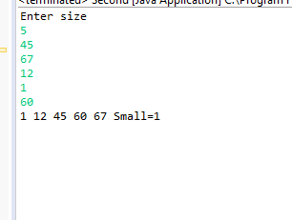**for**(i=0;i<n;i++)

{

a[i]=k.nextInt();

}

**for**(i=1;i<n;i++)

{

**for**(j=0;j<n-1;j++)

{

**if**(a[j]>a[j+1])

{

temp=a[j];

a[j]=a[j+1];

a[j+1]=temp;

}

}

}

**for**(i=0;i<n;i++)

{

System.***out***.print(a[i]+" ");

}

System.***out***.println("Small="+a[0]);

}

}

3]Given an array of integers, find if the array contains any duplicates

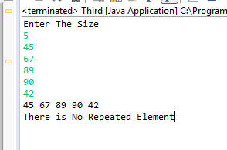**package** Expanion;

**import** java.util.*;

**import** java.util.Scanner;

**public** **class** Third {

**public** **static** **void** main(String aa[])

{

Scanner k=**new** Scanner(System.***in***);

System.***out***.print("Enter The Size");

**int** n=k.nextInt();

**int** a[]=**new** **int**[n];

**int** i,j,temp=0,c=0;

**for**(i=0;i<n;i++)

{

a[i]=k.nextInt();

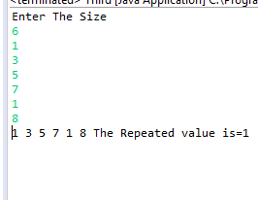}

**for**(i=0;i<n;i++)

{

System.***out***.print(a[i]+" ");

}

**for**(i=0;i<n;i++)

{

**for**(j=1+i;j<n;j++)

{

**if**(a[i]==a[j])

{

temp=a[i];

c=c+1;

}

}

}

**if**(c!=0)

{

System.***out***.println("The Repeated value is="+temp);

}

**else**

{

System.***out***.println("\n"+"There is No Repeated Element");

}

}

}

4]Find a pair with maximum product in array of Integers

**package** Expanion;

**import** java.util.Scanner;

**public** **class** Fourth

{

**public** **static** **void** main(String aa[])

{

Scanner k=**new** Scanner(System.***in***);

System.***out***.print("Enter The Size");

**int** n=k.nextInt();

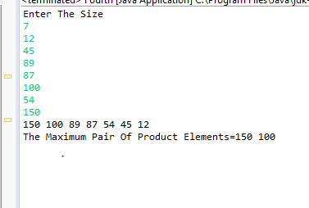**int** a[]=**new** **int**[n];

**int** i,j,temp=0,c=0;

**for**(i=0;i<n;i++)

{

a[i]=k.nextInt();

}

**for**(i=1;i<n;i++)

{

**for**(j=0;j<n-1;j++)

{

**if**(a[j]<a[j+1])

{

temp=a[j+1];

a[j+1]=a[j];

a[j]=temp;

}

}

}

**for**(i=0;i<n;i++)

{

System.***out***.print(a[i]+" ");

}

System.***out***.println("\n"+"The Maximum Pair Of Product Elements="+a[0]+" "+a[1]);

}

}