**Solution 4.6.4**

**a)**

Shirley Tighman

John Doerr

Arthur Levinson

Al

Gore

Andrea Jung

Steve Jobs

Susan Hockfield

b) Consider following affiliation network. This is different from that given in a) but resulting projecting graph is same for both.

Amazon

John Doerr

Shirley Tighman

Google

Susan Hockfield

Andrea Jung

Steve Jobs

Al

Gore

Arthur Levinson

Apple

Disney

General Electric

**Solution 5.6.4**

Consider 1st farmer. According to given rules, the 21st farmer is his enemy and 19th farmer is his friend. But 19th and 21st must be friends among themselves. So, we get following balance graph:

+

19

1

+

-

21

Clearly, the structural balance property is violated in the above subgraph. This, graph is unbalanced.

**Solution 6.4.4**

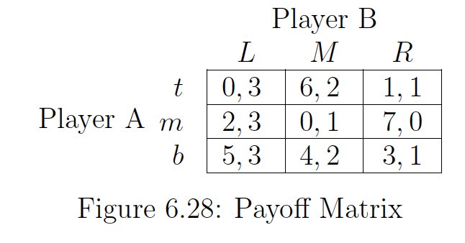

**a)**

**Player B has a strictly dominant strategy of playing L**, as this is the best response to every possible strategy by Player B.

**Player A has no** **strictly dominant strategy.**

**b)**

There is only one pure strategy Nash equilibrium i.e. (b, L) with payoffs as 5 for player A, and 3 for player B.

**Solution 6.4.7**

**a)**

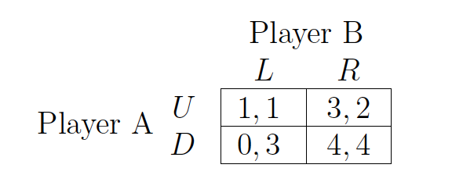

(D, R) is the only Nash Equilibrium

**b)**

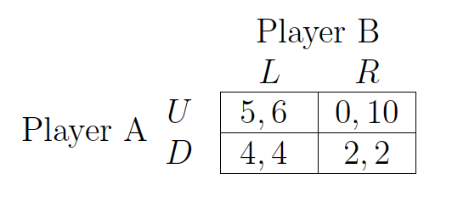

Since neither player has a dominant strategy, we need to find mixed strategy Nash equilibrium.

Let *q* be the probability that Player A chooses U. Now, since strategies must have equal payoff, we have:

5*q* + 0(1-*q)* = 4*q* + 2(1-*q*)

* *q* = 2/3

Similarly, let *p* be the probability that Player B chooses L. Again, since strategies must have equal payoff, we have:

6*p* + 4(1-*p*) = 10*p* + 2(1-*p*)

* *p* = 1/3

Thus, the mixed strategy Nash Eq. is:

**A chooses U with probability 2/3 and B chooses L with probability 1/3**

**Problem 6.11.15**

**a)**

None

B

A

None

B

A

|  |  |  |
| --- | --- | --- |
| **-10, -10** | **10, 10** | **15, 0** |
| **10, 10** | **5, 5** | **30, 0** |
| **0, 15** | **0, 30** | **0, 0** |

**b) True.** Although, it might not guarantee best possible outcome for Firm 1, playing and choosing B will generate at least $5 million profit, which is better than nothing.

**c) False.** Let assume firm 1 & 2 decided to choose B according to the proposed logic. Now, firm 1 has an incentive to produce A, as it will increase its payoff. This, proposed strategy is not a Nash Eq.

**d) (A, B) and (B, A) are the only two pure strategy Nash Eq.**

**e)** The maximum sum of profits (social optimality) will be achieved only if one of firms produces B, while other does not produce anything. However, since such a play is NOT a Nash Eq., a merger is needed for socially optimal outcome.

**Problem 8.4.1**

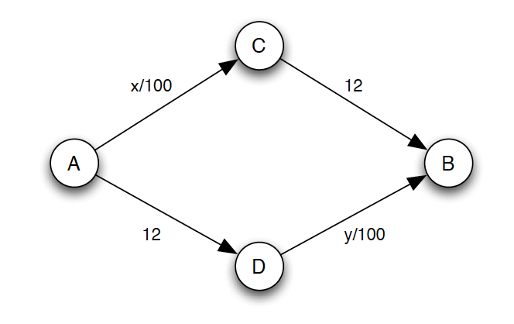

**a)**

Given *x* as the number of cars who choose route A-C-B &

Given *y* as the number of cars who choose route A-D-B,

There are 1000 cars in total, and so we have,

*x* + *y* = 1000 ---- (1)

For Nash Eq., neither of these category of cars would have any incentive to change their route. i.e., time for both routes would be same:

*x*/100 + 12 = 12 + *y*/100 ---- (2)

Using equations, (1) and (2), we have

*x* = *y* = 500

**b)**

 

In this case, the dominant strategy for all drivers would be to choose route A-C-D-B i.e,

*x* = *y* = 1000

This is because at node A, path A-C (with payoff *x*/100) will always be better than A-D (with payoff 12) as x is in range [0, 1000]. Similarly, at node C, path C-D-B (with payoff (0+*y*/100) will always be better than C-B (with payoff 12) as y is in range [0, 1000].

This, path A-C-D-B is also the Nash Eq. for this new game.

Previously,

Cost per car => 500/100 + 12 = 17 mins

Thus, Previous Total Cost = 17000 mins

Now,

Cost per car => 1000/100 + 1000/10 = 20 mins

Thus, New Total Cost = 20000 mins

**c)**

For Nash Eq., all *x* & *y* cars must have not incentive to change.

At node A, there are two path choices: A-C & A-D

If *x* people choose A-C then 1000-*x* will choose A-D.

Since, none of them should have incentive to change, payoffs must be equal.

i.e.,

*x*/100 = 5

* *x* = 500

The people who chose A-D (count = 500) must pass through D-B also. So,

*y* >= 500

Now, at Node C, there are two path choices: C-B & C-D-B.

Let *z* be the people that choose C-D-B

Cost of C-D-B = 0 + (*y*+*z)*/100

>= 500/100 + *z*/100

>= 5 + *z*/100

Cost of C-B = 5

Since, cost of C-D-B will be greater than C-B for any z > 0, z must be zero.

Thus, at Node C, everyone (count = 500) will choose path C-B.

Thus, travel time per car = 500/100 + 5 = 10 mins

Total travel time = 10000 mins

**Solution 8.4.2**

**a)**



10 + (80 - x)

10 + x

60

60

**b)** At Nash Eq., payoff of both routes must be equal. i.e.,

60 + 10 + *x* = 10 + (80 - *x*) + 60

* *x* = 40

**c)**



At Nash Eq., Route A-D-B will have 30 cars

Route A-C-B will have 30 cars

Route A-D-C-D will have 20 cars

So, the value of x for new Nash Eq. will be 50.

**d)** Total time increases after introducing new road.

Time after new road = 120*80 = 9600 mins

Time before new road = 110*80 = 8800 mins

**e)**

Let 60 users use route (A-C-D-B) and remaining 20 users use route (A-D-C-B).

In this case, total travelling time will be 60*20+120*60 = 8400 mins

This is less than total travelling time of original Nash Eq.

**Solution 9.8.1**

Firm should submit bid value as *c.* In a sealed-bid second price auction, being truthful is the dominant strategy. This is true irrespective of number of other bidders.

**Solution 9.8.8**

**a)** The bidder with highest value will win the auction, and would pay the amount equal to second highest bid. If valuations are drawn such that:

*v*1 > *v*2 >*v*3

Then, bidder 1 with value *v*1 will win the auction, and pay the price equal to *v*2

**b)** This will not affect the behavior of other bidders. Since, being truthful is still the dominant strategy.

**c)** Let x be the change in *v*3

x => (*v*3+1)/2 - *v*3 = 0.5 - *v*3/2

Since *v*3 is in range [0, 1], we have x>=0

If Bidder 1 was going to lose earlier, he will still lose i.e. change in payoff would be 0

However, if he was going to win earlier,

* he will lose now if *v*3 now exceeds *v*1
  + if *v*3 was second highest earlier, the change in payoff would be (*v*3 – *v*1)
  + if *v*3 was second highest earlier, the change in payoff would be (*v*2 – *v*1)
* he might win but with lesser payoff if *v*3 is the second highest bidder.
  + If *v*3 was second highest earlier too, then change in payoff would be (*v*3-1)/2
  + If *v*3 was not second highest earlier, then the change in payoff would be ((*v*3+1)/2– *v*2)
* he might win with equal pay off if *v*2 is the second highest bidder. This is because of that fact that value of *v*3 has only increased, *v*2 must have been the second highest bidder earlier too.