**Solution 10.7.11**

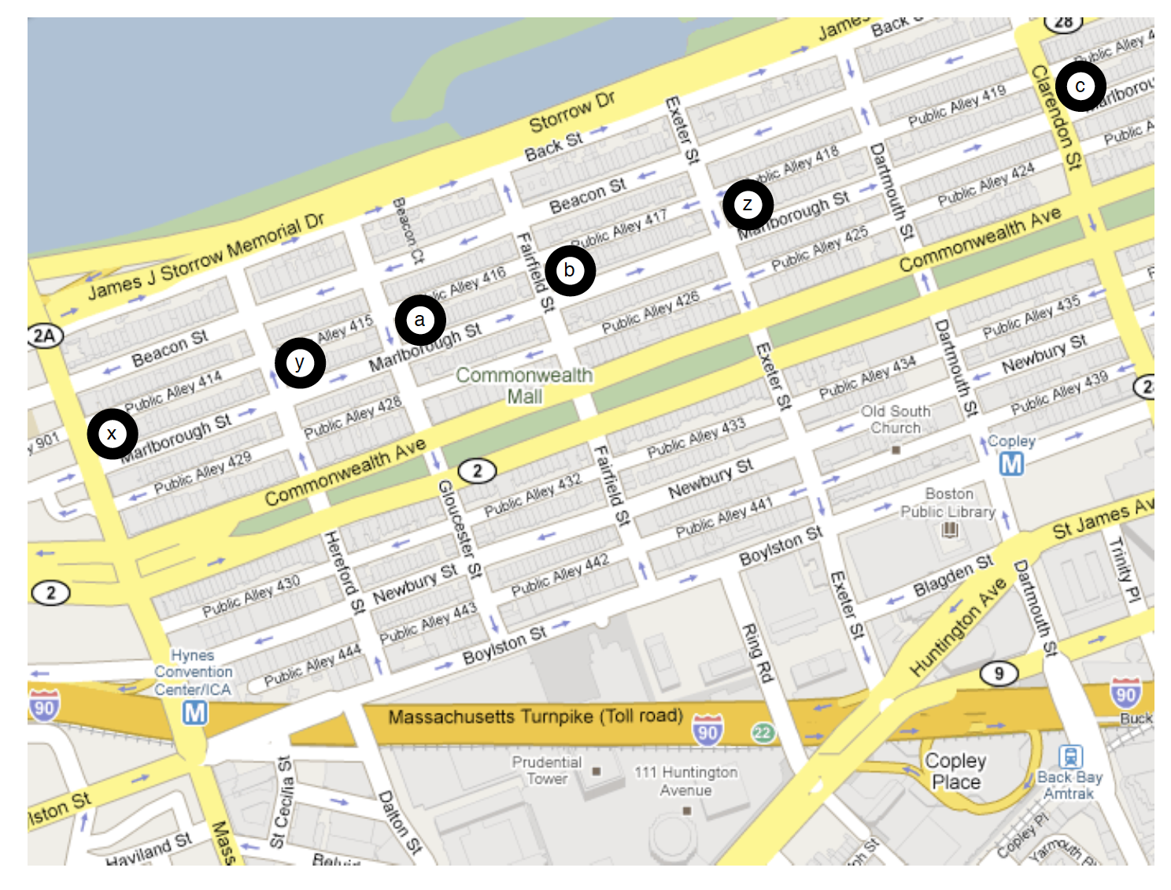

**a)** Consider a seller graph where parking slots represents the sellers and residents represents the buyers. The valuations are shown as:

**6, 5, 2**

x

a

**7, 6, 3**

y

b

**6, 7, 6**

z

c

**b)** Initially all prices would be 0.

Round 1: 0 0 0

6, 5, 2

0

x

a

7, 6, 3

0

y

b

6, 7, 6

0

z

c

Round 2: 1 0 0

6, 5, 2

1

x

a

7, 6, 3

0

y

b

6, 7, 6

0

z

c

Round 3: 2 1 0

6, 5, 2

2

x

a

7, 6, 3

1

y

b

6, 7, 6

0

z

c

At the end of Round 3, we get the **market clearing prices as a=2, b=1, c=0**.

**c)** Intuitively, the valuation of a parking spot is dependent on the distance needed to walk. The closer the parking spot, more would be its value. Parking spot a is the closest choice for majority of people, so it is priced higher (more in demand). Parking spot c is very away for everyone, so it is priced lower (less in demand).

**Solution 15.10.4**

**a)** This is socially optimal assignment in this case:

Valuations:

16, 12

x

a

12, 9

y

b

4, 3

z

If x were not present,

-> y would get value 12 instead of 9, so harm is 3

-> z would get value 3 instead of 0, so harm is 3

Total harm caused by x’s presence is 6, so **price of a (for x) is 6**

If y were not present,

-> x would still get previous value, so harm is 0

-> z would get value 3 instead of 0, so harm is 3

Total harm caused by y’s presence is 3, so **price of b (for y) is 3**

**b)** This is socially optimal assignment in this case:

Valuations:

16, 12, 8

x

a

b

12, 9, 6

y

c

4, 3, 2

z

If x were not present,

-> y would get value 12 instead of 9, so harm is 3

-> z would get value 3 instead of 2, so harm is 1

Total harm caused by x’s presence is 4, so **price of a (for x) is 4**

If y were not present,

-> x would still get previous value, so harm is 0

-> z would get value 3 instead of 2, so harm is 1

Total harm caused by y’s presence is 1, so **price of b (for y) is 1**

If z were not present,

-> x would still get previous value, so harm is 0

-> y would still get previous value, so harm is 0

Total harm caused by z’s presence is 0, so **price of c (for z) is 0**

**c)** The revenue in first case = 6 + 3 = 9

Revenue is second case = 4 + 1 + 0 = 5

Since, revenue in first case is more, the search engine should prefer to NOT add the third slot.

**Solution 13.6.2**

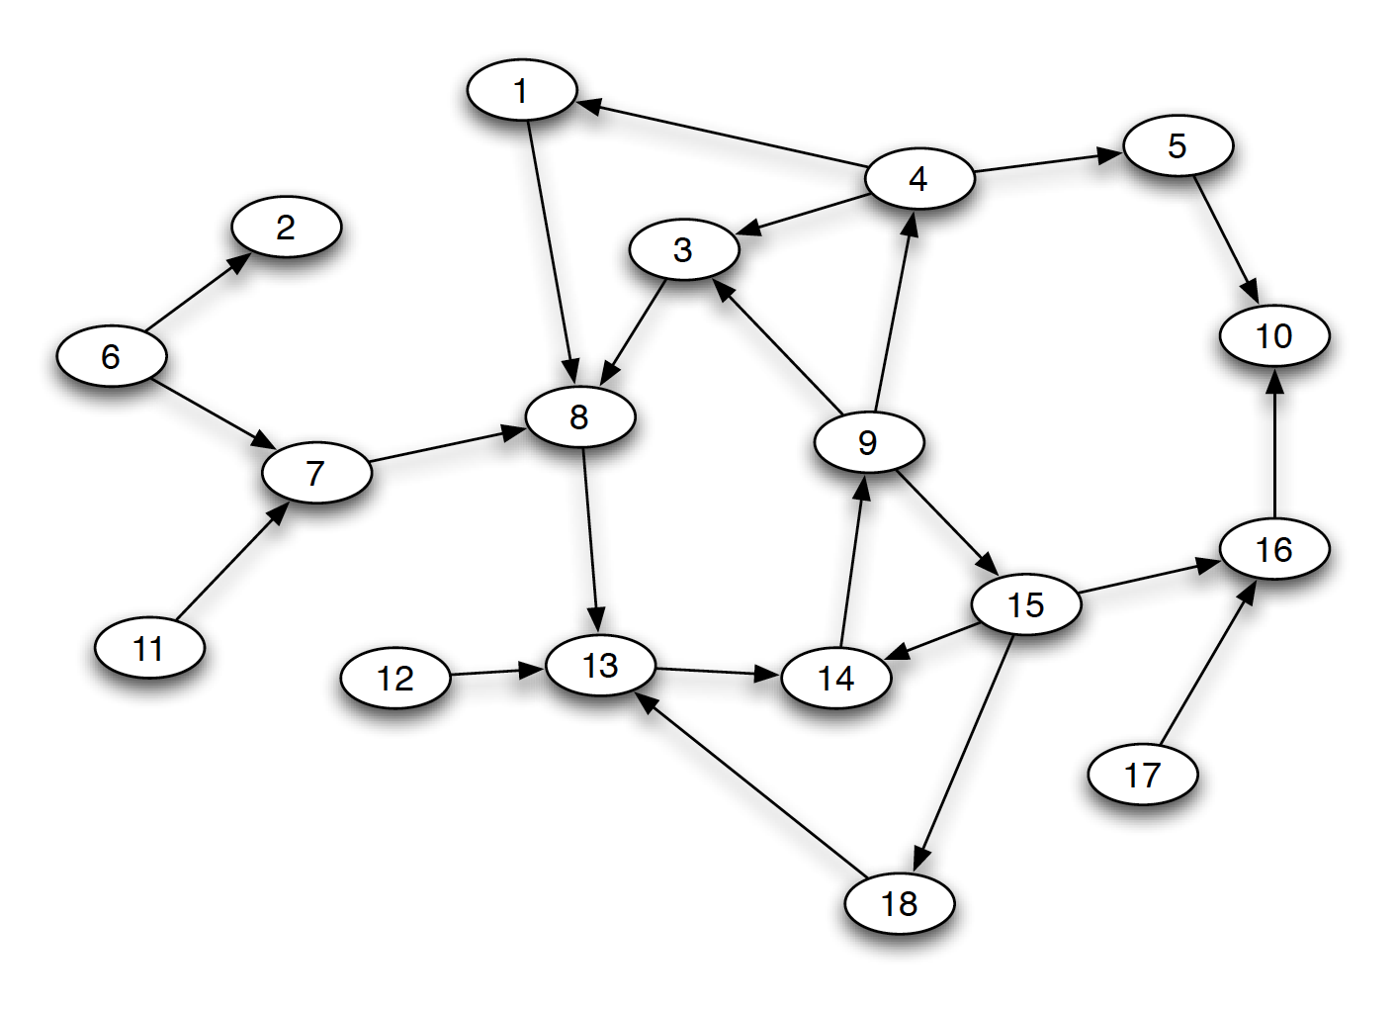

The original configuration (without blue edge) is:

IN: 6, 2, 7, 11, 12

OUT: 5, 10, 16, 17

SCC: 1, 3, 4, 8, 9, 13, 14, 15, 18

**a)**  Adding an **edge from 10 to 9**, will make the configuration as:

IN: 6, 2, 7, 11, 12

OUT: 17

SCC: 1, 3, 4, 8, 9, 13, 14, 15, 18, 5, 10, 16

**b) Deleting edge from 4 to 1**, will make the configuration as:

IN: 6, 2, 7, 11, 12, 1

OUT: 17

SCC: 3, 4, 8, 9, 13, 14, 15, 18, 5, 10, 16

**b) Deleting edge from 1 to 8**, will make the configuration as:

IN: 6, 2, 7, 11, 12

OUT: 5, 10, 16, 17, 1

SCC: 3, 4, 8, 9, 13, 14, 15, 18, 5, 10, 16

**Solution 14.7.4**

**a)**

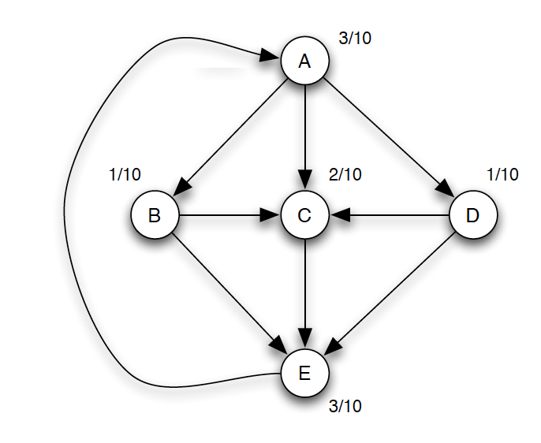

Yes, it forms an equilibrium. This is because when the PageRank values are recalculated, we get the same PageRank Values. There is no change in the values and hence it is an equilibrium.

**b)**

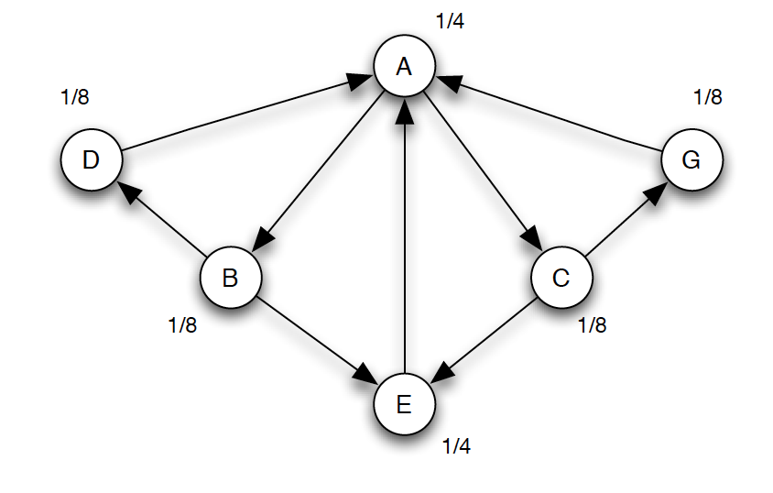

No, it does not form an equilibrium. This is because on recalculating the PageRank values, we get changed values for the following nodes:

A = ½

D = 1/16

E = 1/8

G = 1/16

**Solution 16.8.3**

**a)** First person will choose Accept if he gets a High Signal.

P(A) = P(H) = P(H | G) * P(G) / P(G | H) = ¾ * 1 / 1 = ¾

P(R) = 1 – P(A) = ¼

**b)** The probabilities are:

P(A, A) = P(A) * P(A) = ¾ * ¾ = 9/16

P(A, R) = P(A) * P(R) = ¾ * ¼ = 3/16

P(R, A) = P(R) * P(A) = ¼ * ¾ = 3/16

P(R, R) = P(R) * P(R) = ¼ * ¼ = 1/16

**c)** Cascade will occur if majority of choices are same (either A or R). Earliest this majority can occur is for the third. In this case, both previous would have made same decision.

i.e.,

P(Cascade) = P(A, A) + P(R, R) = 9/16 + 1/16 = 10/16