Stegräknare

Diverse info

2017-03-22

Dennis Bunne  
Johan Kämpe  
Simon Karlsson

Mjukvaruutvecklare inbyggda system  
Mölk Utbildning

# Komponenter

## MPU9250

Kombinerad Accelerometer/Gyro/Temperatur/magnetometer (kompass?)

Ut/Ingångar:

|  |  |  |
| --- | --- | --- |
| Pin Label | Pin Function | Notes |
| SCL | I2C serial clock SPI serial port clock | 100 or 400 kHz I2C Up to 1 MHz SPI (20 MHz in certain cases) |
| SDA | I2C serial data | Can also be used for SPI serial data input (SDI) |
| VDD | Power supply | +2.4V to +3.6V |
| GND | Ground reference | +0V |
| AUXDA | Ground reference | I2C master serial data, for connecting to external sensors |
| FSYNC | Ground reference | Frame synchronization digital input. Connect to GND if unused. |
| AUXCL | Ground reference | I2C Master serial clock, for connecting to external sensors |
| INT | Interrupt signal | Interrupt digital output (totem pole or open-drain) |
| CS | Chip select | Chip select (SPI mode only) |
| AD0/ SDO | Address selection | I2C Slave Address LSB (AD0):    Low: 0b1101000 ➫ 0x68    High: 0b1101001 ➫ 0x69 SPI serial data output (SDO) |
| VDDIO | Power supply for I/O pins | +1.71V up to VDD |

Adresser för att hämta data via I2C

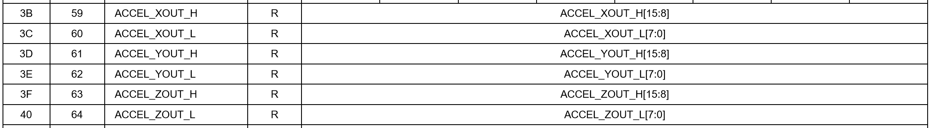

**_H & _L** indikerar de första och sista 8 bitarna för en 16-bit data. För att hämta data anropar man båda registerna och shiftar / OCH-ar in bitarna till en 16-bitars variabel.

Exempel i Arduino med wire.h

