Tile/Actor Types

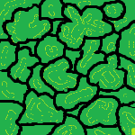 Forrest, passable, can be used to gather lumber with the addition of a lumber mill.

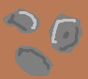 Rocks, passable, no resources can be gathered from it.

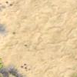 Sand, passable, can be used to mine metals with the addition of a mine.

 Water, a non-passable tile

 Non-combat unit, used to gather resources and build buildings. Can fight but not as strong as combat unit.

 Combat unit, used to fight other enemy units and buildings.

E:\win 7 stuff\programs\eclipse-standard-kepler-SR1-win32-x86_64\eclipse\configuration\Programs\cultu-sim\Resources\Structure.png Building, represents a mine or lumber mill.

E:\win 7 stuff\programs\eclipse-standard-kepler-SR1-win32-x86_64\eclipse\configuration\Programs\cultu-sim\Resources\City.png City, the main building of each faction. Each faction can only have 1 city.

\*NOTE: Any faction owned actor will have all white the sprite change to the faction color.