**一**

1.float\double\int

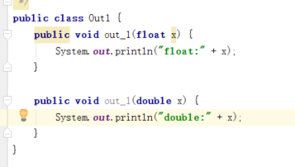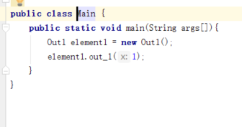

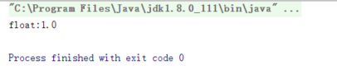

2.多接口重名方法

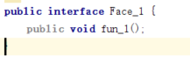

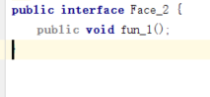

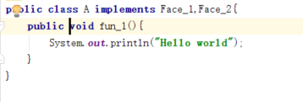

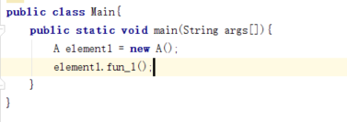

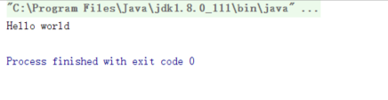

3.继承

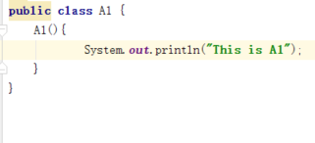

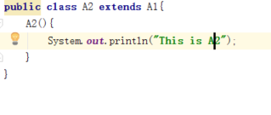

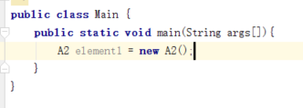

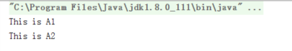

**二**

1. **主键**

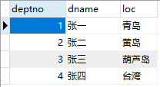

Update dept

Set deptno=deptno*10;

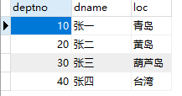

1. **Static 可否修饰内部类**

Java里面static一般用来修饰成员变量或函数。但有一种特殊用法是用static修饰内部类，普通类是不允许声明为静态的，只有内部类才可以。被static修饰的内部类可以直接作为一个普通类来使用，而不需实例一个外部类

1. **增删查改**

增

**package** dao;

**import** java.sql.DriverManager;

**import** java.sql.SQLException;

**import** org.junit.*;

**import** com.mysql.jdbc.Connection;

**import** com.mysql.jdbc.Statement;;

**public** **class** EmpDao {

**private** **static** **final** String ***DriverName*** = "com.mysql.jdbc.Driver";

**private** **static** **final** String ***url*** = "jdbc:mysql://127.0.0.1:3306/test";

**private** **static** **final** String ***user*** = "root";

**private** **static** **final** String ***password*** = "root";

**static** {

**try** {

Class.*forName*(***DriverName***);

}**catch**(ClassNotFoundException e) {

System.***err***.println("加载驱动失败："+e.getMessage());

}

}

@Test

**public** **void** addEmp() {

String sql = "insert into dept(deptno,dname,loc) "+

" values(50,'张五','济州岛')";

//建立到数据库的连接

**try** {

Connection connection = (Connection) DriverManager.*getConnection*(***url***, ***user***, ***password***);

//建立传输SQL语句的Statement

Statement statement = (Statement) connection.createStatement();

statement.executeUpdate(sql);

connection.close();

}**catch**(SQLException e) {

e.printStackTrace();

}

}

}

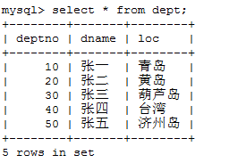

删

**package** dao;

**import** java.sql.DriverManager;

**import** java.sql.SQLException;

**import** org.junit.*;

**import** com.mysql.jdbc.Connection;

**import** com.mysql.jdbc.Statement;;

**public** **class** EmpDao {

**private** **static** **final** String ***DriverName*** = "com.mysql.jdbc.Driver";

**private** **static** **final** String ***url*** = "jdbc:mysql://127.0.0.1:3306/test";

**private** **static** **final** String ***user*** = "root";

**private** **static** **final** String ***password*** = "root";

**static** {

**try** {

Class.*forName*(***DriverName***);

}**catch**(ClassNotFoundException e) {

System.***err***.println("加载驱动失败："+e.getMessage());

}

}

@Test

**public** **void** addEmp() {

String sql = "delete from dept where deptno = 50";

//建立到数据库的连接

**try** {

Connection connection = (Connection) DriverManager.*getConnection*(***url***, ***user***, ***password***);

//建立传输SQL语句的Statement

Statement statement = (Statement) connection.createStatement();

statement.executeUpdate(sql);

connection.close();

}**catch**(SQLException e) {

e.printStackTrace();

}

}

}

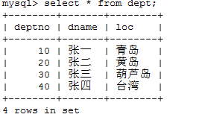

改

**package** dao;

**import** java.sql.DriverManager;

**import** java.sql.SQLException;

**import** org.junit.*;

**import** com.mysql.jdbc.Connection;

**import** com.mysql.jdbc.Statement;;

**public** **class** EmpDao {

**private** **static** **final** String ***DriverName*** = "com.mysql.jdbc.Driver";

**private** **static** **final** String ***url*** = "jdbc:mysql://127.0.0.1:3306/test";

**private** **static** **final** String ***user*** = "root";

**private** **static** **final** String ***password*** = "root";

**static** {

**try** {

Class.*forName*(***DriverName***);

}**catch**(ClassNotFoundException e) {

System.***err***.println("加载驱动失败："+e.getMessage());

}

}

@Test

**public** **void** addEmp() {

String sql = "update dept set dname='王五' where deptno = 50";

//建立到数据库的连接

**try** {

Connection connection = (Connection) DriverManager.*getConnection*(***url***, ***user***, ***password***);

//建立传输SQL语句的Statement

Statement statement = (Statement) connection.createStatement();

statement.executeUpdate(sql);

connection.close();

}**catch**(SQLException e) {

e.printStackTrace();

}

}

}

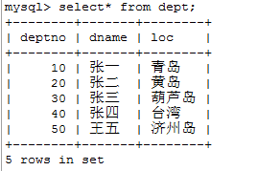

查

**package** dao;

**import** java.sql.DriverManager;

**import** java.sql.ResultSet;

**import** java.sql.SQLException;

**import** org.junit.*;

**import** com.mysql.jdbc.Connection;

**import** com.mysql.jdbc.PreparedStatement;

**import** com.mysql.jdbc.Statement;;

**public** **class** EmpDao {

**private** **static** **final** String ***DriverName*** = "com.mysql.jdbc.Driver";

**private** **static** **final** String ***url*** = "jdbc:mysql://127.0.0.1:3306/test";

**private** **static** **final** String ***user*** = "root";

**private** **static** **final** String ***password*** = "root";

**static** {

**try** {

Class.*forName*(***DriverName***);

}**catch**(ClassNotFoundException e) {

System.***err***.println("加载驱动失败："+e.getMessage());

}

}

@Test

**public** **void** addEmp() {

String sql = "select * from dept where deptno=?";//?+?+?

//建立到数据库的连接

**try** {

Connection connection = (Connection)DriverManager.*getConnection*(***url***,***user***,***password***);

//建立传输SQL语句的Statement

//Statement statement = (Statement) connection.createStatement();

PreparedStatement Pt = (PreparedStatement)connection.prepareStatement(sql);

Pt.setObject(1,50);

ResultSet resultSet = Pt.executeQuery();

**while**(resultSet.next()) {

String string1 =resultSet.getString(1);

String string2 =(String)resultSet.getObject(2);

String string3 =(String)resultSet.getObject(3);

System.***out***.println(string1);

System.***out***.println(string2);

System.***out***.println(string3);

}

connection.close();

}**catch**(SQLException e) {

e.printStackTrace();

}

}

}

