Project Report - Hospital Management System

Author
Name: Rtamanyu N.J.
Roll No.: 24f3001383
Email: 24f3001383@ds.study.iitm.ac.in
About: I am pursuing dual degree, B-tech in Artificial Intelligence and Data Science in Amrita Vishwa Vidhyapeetham, Bangalore and BS in Data Science in IIT-Madras. I am a passionate coder and love developing projects

Project Details

Title: Hospital Management Web App

Problem Statement:
To design and build a web-based application that allows administrators, doctors and patients to manage hospital workflows — user accounts, appointments scheduling, department and doctor management, and simple treatment records. The application should provide calendar-based availability, prevent double-bookings, and expose a compact public API for availability checks.

Approach:
The app was built using Flask with a modular structure. Server-side rendering (Jinja2) provides baseline UX; richer interactions are implemented with embedded JavaScript. A REST API (Flask-RESTful) complements the UI for AJAX interactions and the public availability endpoint. SQLAlchemy ORM manages persistence to a local SQLite database.

AI / LLM usage
Around 15-20% AI was used (ChatGPT) to assist with code refactoring, suggestions, iterative code generation for complex UI (Calendar), and helping in documentation.

Description
A minimal Hospital Management web application built with Flask that supports three roles (admin, doctor, patient).
This application allows patients to register and manage their profile, browse available doctors by department, view doctors' availability on a calendar-style interface, and book 30-minute appointment slots. Doctors can view their upcoming schedule, see basic patient details for booked slots, mark appointments as completed, and add treatment notes. Administrators can create and manage departments, add/edit doctor and patient profiles, and blacklist accounts when required.
The booking engine ensures that no two non-cancelled appointments exist for the same doctor/date/time combination. Avatars are stored as binary blobs in the database and served via dedicated avatar endpoints; a default placeholder image is returned when an avatar is missing. The frontend follows a progressive enhancement approach: core interactions work with server-rendered pages while richer experiences (dynamic appointment refresh, calendar UI) are powered by embedded JavaScript that consumes JSON endpoints.

Technologies and Frameworks Used
Technology / Library | Purpose
Flask | Core backend web framework
SQLAlchemy | Object Relational Mapper for SQLite database
Jinja2 | Template engine for rendering dynamic HTML pages
Bootstrap 5 | Frontend styling and responsive design
Flask-Login | User authentication and session management
Flask-RESTful | Lightweight REST API framework
SQLite | Lightweight local database for storing user data

DB Schema Design
Tables
- Login: stores credentials (username, password, role, blacklisted)
- Patient: Stores patient details (ID, username, f_name, l_name, ph_no, profile_pic, created_at)
- Doctor: Stores Doctor details (ID, username, specialization_id, f_name, l_name, ph_no, profile_pic, created_at)
- Department: Stores Department Details (department_id, department_name, description, doctors registered, dep_pic)
- Appointment: Stores appointment details (ID, patient_id, doctor_id, date, time, status)
- Treatment: Stores the treatment details of a specific appointment (ID, diagonosis, prescriptions, notes)
- Admin: Stores Admin details (ID, username, f_name, l_name, profile_pic, created_at)
Relationships
Many-to-many:
- Doctor -> patient
- Doctor -> Appointment
- Patient -> Doctor
- Patient -> Appointment
One-to-Many
- Department -> Doctor
One-to-one
- Appointment -> Treatment
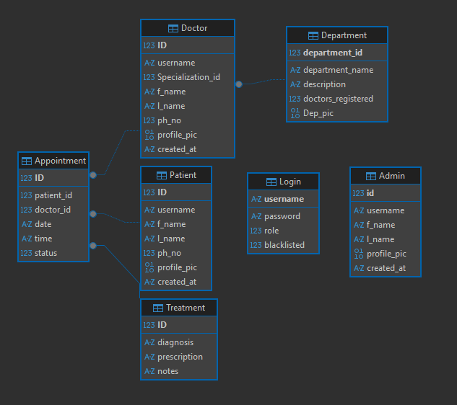

API Design
Implemented REST API endpoints using Flask-RESTful
Endpoint | Method | Description
/api/login | POST | Authenticate user and generate session
/api/activities | GET | Fetch logged activities for a user
/api/activity/add | POST | Add new activity entry
/api/summary | GET | Return daily/weekly analytics summary

Architecture Overview
The project is organized into clear components; key files and folders:
- main.py – main Flask application entry point
- application/models.py – database models using SQLAlchemy
- application/controllers.py – Flask routes and controller logic
- application/api_appointments.py – RESTful API resources for appointments
- templates/ – Jinja2 HTML templates
- static/ – CSS, JS and client assets (calendar, AJAX handlers)

Implemented Features
- User registration and login
- Daily appointment booking and calendar availability
- Doctor dashboard with appointment management
- Admin management for doctors, patients and departments
- Profile avatars with upload and fallback handling
- Input validation (client and server) and blacklist controls

Additional Features
- Public availability API for external schedulers

Detailed Features
- Registration and Authentication:
Users register using an email (used as username). Password strength checks are enforced on both client and server. Flask-Login manages session authentication. Admins, doctors and patients have distinct dashboards and route protections.
- Appointment Booking & Availability:
Doctors expose 30-minute slots between 09:00 and 20:00. Patients can view a 7-day default window (configurable) and book free slots. Server-side checks prevent double-booking and validate date/time formats. A public API endpoint exposes booked/free slots for a doctor for integration with external systems.
- Doctor & Admin Workflows:
Doctors can view their schedule; mark appointments as completed and add treatment records linked to appointments. Admins can CRUD doctors, patients and departments. Deletions are guarded (e.g., a department cannot be deleted if doctors exist).
- Avatar and Media Handling:
Profile pictures are uploaded as multipart form data and stored as BLOBs. Avatar endpoints detect image type and return appropriate content type; missing avatars redirect to a default asset. Cache-busting is performed on client-side when profile images are updated to ensure freshness.
- Validation & Security:
Input validation (email, phone, password strength) is implemented on both client and server. SQL injection risk is mitigated by using SQLAlchemy ORM. Blacklist functionality allows admins to disable accounts. Passwords are currently stored in plaintext in the DB schema and should be migrated to hashed storage before any production use.
- REST API:
A set of Flask-RESTful endpoints provide JSON access to appointment data. Authenticated endpoints require session login and enforce role-based access. A public availability endpoint returns a compact availability structure for third-party integrations.
- UX & Frontend:
The frontend uses Bootstrap 5 for layout and responsiveness. The patient dashboard contains tabs for Upcoming and Past appointments which are updated dynamically via AJAX calls to the server.
Future improvements: move to hashed passwords, add API tokens or OAuth for programmatic clients, add pagination and filtering to APIs, and include automated tests and CI/CD for deployments.

Video
Video link:

