MODULE 1: - Understanding of Hardware and Its Components
Section 1: Multiple Choice
1. Which of the following is NOT a component of the CPU?
1. ALU
2. RAM
3. CU
4. 1 and 3 both
Ans: -2. Ram
note: - separate component used for temporary data storage
2. What is the function of RAM in a computer?
Ans: -RAM is your computers short-term memory it stores data and programs that the CPU is currently using so the system can access them quickly and work smoother and faster.
3. Which of the following is a primary storage device?
1. HDD
2. SSD
3. SD card
4. 1 and 2 both
Ans: - Ram
4. What is the purpose of a GPU?
Ans: - The purpose of GPU is to render images and videos faster and better. It also boost performance in tasks like gaming, video editing, 3D rendering, etc.
Section 2: True or False
5. True or False: The motherboard is the main circuit board of a computer where other components are attached.
Ans: -True
note: -because other components like RAM, CPU, GPU and storage devices attached.
6. True or False: A UPS (Uninterruptible Power Supply) is a hardware device that provides emergency power to a load when the input power source fails.
Ans: -True
note: -A UPS (Uninterruptible Power Supply) is a device that gives emergency power to your computer or other equipment if the main power goes out.
7. True or False: An expansion card is a circuit board that enhances the functionality of a component.
Ans: -True
note: -An expansion card is a circuit board that you add to a computer to improve feature, like better graphics, sound card, network card.
Section 3: Short Answer
8. Explain the difference between HDD and SSD.
Ans: -
Feature | HDD (Hard Disk Drive) | SSD (Solid State Drive)
Speed | Slower (80–160 MB/s) | Faster (500 MB/s – several GB/s)
Technology | Magnetic spinning disk + moving parts | Flash memory with no moving parts
Durability | Less durable (can be damaged by drops) | More durable (shock-resistant)
Noise | Makes noise due to spinning disk | Completely silent
Power Consumption | Higher | Lower (better for battery life)
Size/Form Factor | Usually larger (2.5” or 3.5”) | Smaller and lighter (can be very compact)
Lifespan | Can degrade over time with heavy use | Longer lifespan with normal use
Price | Cheaper (per GB) | More expensive (per GB)
Capacity | Higher (up to 20 TB or more) | Lower (commonly up to 4 TB for consumers)
Boot Time | Slower (30–60 seconds) | Faster (10–20 seconds or less)

9. Describe the function of BIOS in a computer system.
Ans: -BIOS (Basic Input Output System) is the program that start when you turn on computer. It checks POST (Power On Self-Test) Hardware, loads the operating system, and allows you to change the system settings. It also helps the OS communicate with the hardware device.
10. List and briefly explain three input devices commonly used with computers.
Ans: - 1. Keyboard: -
1)It is used to type alphabets, numbers, special characters
2)It is also used to type text, commands and function keys and also entering data.
2. Mouse: -
1)It is used to control the movement of the pointer on the screen
2)Allow user to click, drag, and select items. It often includes right/left clicks button and scroll wheel for navigation.
3. Scanner: -
1)Converts the physical document or image into digital format for the computer to use.
Section 4: Practical Application
11. Identify and label the following components on a diagram of a
motherboard:
- CPU
- RAM slots
- SATA connector
- PCI -E slot
Ans: -
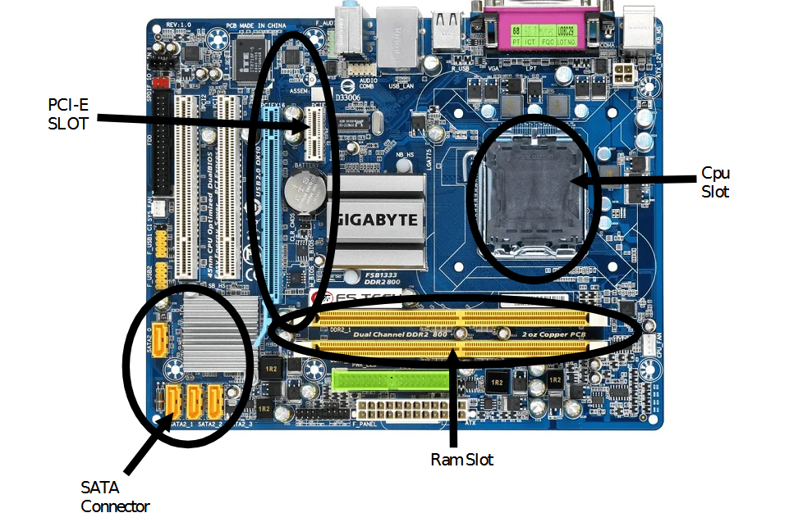
12. Demonstrate how to install a RAM module into a computer.
Ans: -
1. Turn Off and Unplug the Computer
2. Open the Computer Case
3. Locate the RAM Slots on the Motherboard
4. Check RAM Orientation
5. Insert the RAM Module
6. Close the Case and Reconnect
7. Power On the PC
8. Verify In the Operating System

Section 5: Essay
13. Discuss the importance of proper cooling mechanisms in a computer system. Include examples of cooling methods and their effectiveness.
Ans: - Proper cooling is vital to keep computer components running safely and efficiently. When a computer operates, especially during demanding tasks like gaming, video editing or data processing, it produces heat. Without cooling, this heat can cause performance- drops, crashes or even permanent hardware damage.
Keeping components like the CPU, GPU, and Power supply at safe temperature ensure the system runs smoothly and extends its lifespans of the hardware.
COMMON COOLING METHODS: -
1. AIR COOLING: -
Air cooling uses fans and heat sinks to remove heat from the component. It is the most used common method found in desktops and laptops.
It is affordable, reliable, and easy to maintain butt less efficient for very high-end system
Good for everyday use, gaming, and general workloads.
2. LIQUID COOLING: -
Liquid cooling uses water or coolant to transfer heat away from the component, usually through a radiator and fans.
Better performance but more expensive and harder to install; it is also have a risk of leaks.
It is more efficient than air cooling, especially for powerful CPUs and GPUs
14. Explain the concept of bus width and its significance in computer architecture.
Ans: -A bus is a communication system that transfer the data between components inside a computer like between cpu, memory, and other.
But it measured in bits (e.g. 8-bit,16-bit, 32-bit, 64-bit)
It represents how many bits of data transferred at one time between component.
Types of buses: -
1)Address Bus: -
It carries memory address from CPU
2)Control Bus: -
It carries control signal
3)Data Bus: -
It transfers data between cpu and ram

